The Universe Has No Now
Time, Origins, and Whether We Can Get Somewhere Else
Lothar J. Musiol

Copyright
The Universe Has No Now: Time, Origins, and Whether We Can Get Somewhere Else
Copyright © 2026 Lothar J. Musiol. All rights reserved.
Look First, Volume 1.
Photograph credits are not printed under the figures. They are listed here, so a copy that never sees the store page still names its sources.
Photographs. Fig 0: Islander61, Wikimedia Commons, CC BY-SA 4.0. Fig 1: Unsplash. Fig 3: NASA/SDO. Fig 4: NASA/ESA/Hubble. Fig 8: NASA/ESA/STScI. Fig 9: ESA and the Planck Collaboration, CC BY 4.0. Fig 14: NASA/ESA/Hubble Heritage Team (STScI/AURA). Fig 16: NASA/JPL-Caltech/IPAC (2MASS, T. Jarrett). Fig 17: NASA/CXC/CfA/M. Markevitch et al.; NASA/STScI; ESO WFI. Fig 18: NASA/ESA/J. Hester and A. Loll (Arizona State University). Fig 20: Event Horizon Telescope Collaboration, CC BY 4.0. Fig 24: NASA/Hubble Heritage Team (STScI/AURA). Fig 25: NASA/JPL-Caltech/MSSS. Fig 29: NASA/JPL-Caltech/SETI Institute. Fig 32: Sasu photography, Wikimedia Commons, CC BY-SA 4.0. Fig 33: Cierra Martin for Crop Trust, Wikimedia Commons, CC BY-SA 2.0. Fig 35: Corrie Barklimore, Wikimedia Commons, CC BY 2.0. Fig 42: NASA. Fig 43: Charles J. Sharp, Wikimedia Commons, CC BY-SA 3.0. Fig 46: NASA/JPL-Caltech. Diagrams are original line art for this book.

How to Read This Book
Every claim in these pages wears one of three temperatures. The difference matters more than any formula.
Hot — established. Measured, repeated, and used to predict new measurements. The universe is expanding. Space is filled with a 2.7-degree glow left over from a hot past. Ordinary matter is a minority ingredient. Black holes exist. There is no single “now” shared by observers who move differently.
Warm — working theory. The best account we have, with real gaps. A burst of extremely fast expansion in the first sliver of a second (inflation) explains several facts at once, but we have not identified the field that did it. Most of the mass that pulls on galaxies does not emit light; we do not know what particle, if any, it is. Empty space behaves as if it has a faint energy of its own; we do not know why that energy is the size it is.
Cold — speculation. Allowed by the equations, not selected by the data. Traversable wormholes. A required final state in which life computes forever (the Omega Point). A stack of universes with different laws. Extra dimensions from string theory.
On that last item, a standing rule. String theory, whenever it appears in this book, cannot currently be tested. It is a large, ingenious mathematical framework. It has not produced a unique, risky prediction — a number or a signature that would kill the whole idea if the experiment came out otherwise. Extra dimensions and a “landscape” of possible laws inherit that status. They may be mentioned because popular physics mentions them. They are not results.
A few scenes in this book are stories: a greenhouse on a dead planet, a radio that answers a quarter-hour late, a clock that runs slow beside a black hole, a melt-probe chewing through kilometers of ice into a sea that has never seen the Sun. They are thought experiments with dirt on them. The numbers in them are real. The people are invented. They are here so the geometry has somewhere to sit besides a diagram.
The main chapters keep the math in the sentence, the way a good explainer talks at a table. A handful of relations are important enough to number. Those numbered equations live in the Appendix, where the treatment is actually technical: the Friedmann equation, the spacetime interval, the helium calculation, the Bekenstein bound, the energy condition a wormhole has to break. If you want the scaffolding, it is there. If you want the story, you can finish the book without opening the back.
This edition is longer than a Barrow pamphlet on purpose — a few hundred Kindle pages of teaching, not an outline. The extra is not padding. It is the second trunk, the leftover in the air, the crew that does not sleep, the loop that calls itself I, and a path that refuses a last chapel. The sentences stay short. The inventory grew.
You do not need a physics degree. You need curiosity and a willingness to let “now” come apart.

An Epistemic Map
Before the first chapter, here is the whole book’s method on two pages. Every sentence in it is one of six kinds of claim. The kinds differ in what would have to happen for the claim to be wrong.
Kind of claim — What makes it that kind — Temperature — Examples in this book
Measurement
What makes it that kind: A number read off an instrument, repeated by others
Temperature: Hot
Examples in this book: GPS clocks gain about 38 microseconds a day without correction; the leftover glow is 2.725 K; the ring around M87*
Tested theory
What makes it that kind: A theory that predicted measurements before they were made, in the regime where it was tested
Temperature: Hot
Examples in this book: Special and general relativity in tested regimes; the hot, expanding past; the helium made in the first minutes
Theoretical extrapolation
What makes it that kind: A tested theory pushed into regimes no one has measured
Temperature: Warm
Examples in this book: Black-hole interiors; inflation; the far future of heat death
Interpretation
What makes it that kind: A reading of what a tested theory says exists, which no experiment can yet separate from its rivals
Temperature: Labeled separately
Examples in this book: The block universe; Everett’s branches; Bohm; QBism; presentism
Open research
What makes it that kind: A question being actively measured, where the answer may change soon
Temperature: Warm, dated
Examples in this book: Whether dark energy changes with time; the Hubble tension; what dark matter is; quantum gravity and emergent time
Speculation
What makes it that kind: Allowed by some equations, not selected by any data
Temperature: Cold
Examples in this book: Time machines; hopping between branches; other bubbles; continuity through uploading

How hot, warm, and cold map onto it. Hot covers the first two rows: measurements and theories that have survived the tests they could have failed. Warm covers the third and the fifth: extrapolations of good theories, and open research that the next survey may settle. Cold is the last row. Interpretations sit to one side, because their temperature is not about evidence at all. The block universe, for instance, is not warmer or colder than a hidden “now”; both fit every measurement. This book prefers the block for reasons of economy and says so. Whenever the text crosses from physics into interpretation, a shaded box marked Physics vs philosophy shows where the line falls: what the evidence establishes, what this book infers, and what would change the verdict.
Dated claims. Open research moves. Boxes marked Status as of October 2026 give the numbers for dark energy, the Hubble tension, dark-matter searches, and string theory as they stood when this edition was finished. If you are reading much later, check those boxes first.
Where rivals get heard. When the book declines a view (presentism, Copenhagen, QBism, Bohm, collapse models, the strong anthropic principle, multiverse arguments, survival by uploading), it first gives the view’s strongest case, then what the view gets right, then why the book still declines it.
Notes. Superscript numbers link to the Notes and Sources at the back, which give the primary paper or an authoritative review for each key claim, with links, followed by a bibliography arranged by chapter. Tap the number at the start of a note to return to the page you came from.

Four Reading Paths
The general reader. Read straight through. Skip the shaded boxes on a first pass if you like; the chapters make sense without them. Seven spacetime diagrams carry the geometry: start with Spacetime Diagram 1 in Chapter 1 and Spacetime Diagram 2 in Chapter 3, and the rest will read easily.
The physics reader. Read Part I quickly, then Parts II to V with the Appendix open beside them; each chapter has a matching appendix note (Chapter 9 with A9, and so on) where the equations live. The status boxes in Chapters 8, 17, 18, and 40 and the Notes give the current numbers and sources.
The philosophy reader. Read Chapters 1 to 6, then 36 to 38, 41 to 43, and 45 to 46. The Physics vs philosophy boxes in Chapters 6, 15, 36, 41, 42, and 45 mark each step from a physical result to an interpretation, and the rival views are stated in their strongest form before they are declined.
The skeptical reader. Start with this map and the status boxes. Then read the hot/warm/cold summaries at the end of each chapter, and check any claim that matters to you against its note. Where this book takes a side (the block, Everett, a filter rather than a purpose), it says that it is taking a side.

A Note on the Series
This book is Volume 1 of Look First. It is a complete book. The crew that can wait, and the library that crew would carry, are taught here. You are not sent to another volume to finish this argument.
If you liked the greenhouse and wanted a downtown, or a fountain, that want has one later kitchen: A Trip Is Not a New Life — camps, the body, and the Earth you do not abandon. A trip is not a settlement. A longer life is not a new body. They are the same invoice. That kitchen is optional. It is not the missing half of this one.
That book stands alone. It reuses a woman, three temperatures, and a habit of looking first. It does not reopen this spine. You can stop here. The leftover glow will still be late tomorrow.

Author’s Note
Most people meet the universe in the wrong order.
First comes the solar system, then stars, then a chapter that says the galaxies are flying apart, then — if the book has nerve — a sentence about the Big Bang. Time is treated as the thing the story runs in, the way a clock is assumed to run on a wall. Black holes arrive as monsters. Dark matter arrives as a rumor. Wormholes arrive as promised shortcuts. String theory arrives as the thing “they’re working on,” which the listener is invited to treat as almost done.
That order is historically understandable. It is roughly the order we discovered these things. It is not the order that makes the structure easiest to see.
This book runs a different sequence on purpose. It starts with events, because that is what relativity actually talks about, and with the fact that two people can disagree about which events are simultaneous without either of them being wrong. Only after “now” has been retired as a universal fact does it turn to the hot past, the leftover light, the missing mass, the missing energy, the one-way membranes we call black holes, and the shortcuts that probably do not exist. The questions people actually want — Can we get somewhere else? Is there a multiverse? Was the universe made for us? Does time exist? — are delayed until the words have meanings.
John D. Barrow’s short book The Origin of the Universe is the formal model: brief chapters, no swagger, a clean line between a measurement and an idea. Steven Weinberg’s The First Three Minutes is the model for the thermal past — a reconstruction, minute by minute, that anyone can follow and that happens to be right. Sean Carroll’s work on the arrow of time, Alan Guth’s and Andrei Linde’s inflation, Roger Penrose’s singularity theorems, P. J. E. Peebles’s insistence that structure is a physical problem, Katie Mack’s tour of cosmic endings — these are the sources. They are used. They are not copied. Where they disagree, the disagreement is the point.
A book like this should succeed if those recognitions arrive in the chapters, not in this note. If meaning is not scheduled for the end of time, it has to be made in the middle: this copy, this planet, this launch window.
Readers of The Quantum Conversation, a book of mine outside this series, will notice a family resemblance: start with the variable that makes the physics simple, not the variable that got discovered first. There, the variable was phase. Here, it is the event.

Contents
Copyright
How to Read This Book
An Epistemic Map
Four Reading Paths
A Note on the Series
Author’s Note
Prologue: The Clock That Does Not Agree
PART I — There Is No Now
1. The Argument in the Kitchen
2. An Event Is a Happening, Not a Thing
3. Light Is Late on Purpose
4. Andromeda’s Navy
5. You Are a Path
6. The Block
PART II — The Past We Can Rebuild
7. The Explosion That Happened Everywhere
8. Everything Is Stretching
9. A Baby Picture in Microwaves
10. The First Three Minutes
11. Almost Nothing, Almost Everywhere
PART III — A Burst, Then Seeds
12. Three Puzzles the Hot Bang Cannot Solve
13. Inflation, Without the Hype
14. How a Quantum Twitch Became a Galaxy
15. Bubbles That May Never Stop
16. Chaos Is an Engine
PART IV — The Missing Most
17. The Extra Pull
18. The Shove
19. Why Forever-Mind Does Not Follow
PART V — One-Way Membranes
20. A Horizon Is a Fact About Events
21. An Hour Beside the Edge
22. The Hole That Runs Backward
23. The Skin and the Leak
24. Not a Door
PART VI — Getting There Anyway
25. A Greenhouse on a Dead World
26. Most of the Universe Has Already Left
27. Other Suns, Other Worlds
28. Where Liquid Water Can Last
29. Oceans Under the Ice
30. A Second Origin
31. Forms Earth Never Hired
32. Crews That Do Not Sleep
33. A Library of Earth
34. Handles, and the Bill
35. The Watchmaker, and the Signal
PART VII — Loops
36. Time Travel Is Not an Edit
37. If You Could Walk Sideways Through When
PART VIII — All the Copies
38. Four Kinds of Elsewhere
39. More of This Universe
40. Other Rooms, Other Rules
41. Every Allowed Outcome
PART IX — The Filter
42. A Filter, Not a Purpose
43. No Cosmic Craftsman
PART X — What the Future Is Allowed to Be
44. Five Ways It Can End
45. Does Time Exist?
46. The Honest Ending
APPENDIX — The Scientific Detail
How to Read These Notes
A0. Three Temperatures of Claim
A1. Relativity of Simultaneity
A2. Minkowski Coordinates and the Interval
A3. Light Cones and Lookback Time
A4. Tilting the Simultaneity Slice
A5. Proper Time and the Twin Effect
A6. Causal Structure: Past, Future, Elsewhere
A7. FLRW: No Center, No Edge
A8. Hubble–Lemaître Law and Redshift
A9. The CMB as a Blackbody
A10. Thermal History, Minute by Minute
A11. Critical Density and the Cosmic Inventory
A12. Horizon, Flatness, and Relic Problems
A13. Slow-Roll and E-Folds
A14. The Primordial Spectrum
A15. Eternal Inflation and the Measure Problem
A16. Sensitivity: From Quantum Noise to BKL Chaos
A17. What “Non-Baryonic” Means
A18. Vacuum Energy and the Cosmological Constant
A19. Why Recollapse Is Not in the Data
A20. The Schwarzschild Radius
A21. Gravitational Time Dilation and Kerr Orbits
A22. White Holes and the Kruskal Diagram
A23. The Bekenstein–Hawking Bound
A24. Geodesics, Singularities, and Why You Do Not Come Out
A25. Mars Numbers: Δv, Delay, Life Support
A26. Particle Horizon vs Cosmic Event Horizon
A27. Finding Worlds You Cannot See
A28. Circumstellar Habitable Zones
A29. Tidal Heat, Ice Shells, and Dark Seas
A30. Second Origins, the Code, and What Life Eats
A31. Other Chemistries, Missing Body Plans
A32. Travel Time, Dose, and Autonomous Systems
A33. Genome Information, Synthesis, and Planetary Protection
A34. Einstein–Rosen vs Traversable Throats
A35. What Would Count as Evidence of Intervention
A36. Worldlines and Self-Consistency
A37. Foliations: Why a Stack Is Not a Hallway
A38. Four Claims That Must Not Be Fused
A39. Infinite FLRW and Repeated Hubble Volumes
A40. Landscapes, Measures, and Untestable Frameworks
A41. Decoherence and Why Branches Are Not Destinations
A42. Dimensionless Coincidences and Weinberg’s Λ Bound
A43. Why Strong and Final Anthropic Claims Fail
A44. w, Vacuum Decay, and Bounce Conditions
A45. The Problem of Time in Quantum Gravity
A46. Inventory of Claims, by Temperature
Equations at a Glance
Further Reading (tiered)
Glossary
NOTES AND SOURCES
Notes
Bibliography by Chapter
ABOUT THE AUTHOR
ALSO BY LOTHAR J. MUSIOL

Prologue: The Clock That Does Not Agree
There is a clock on the kitchen wall, and it is lying to you — not by being fast or slow, but by pretending that “now” is a thing the universe shares.
You glance at it. Somewhere, at what that clock would like to call the same moment, a star in Andromeda finishes a flare. A neutrino left the Sun eight minutes ago and is about to pass through your hand without asking. A galaxy so far away that its light began traveling before Earth had multicellular life is, at this instant — if the word still means anything — already receding so fast that no message you send will ever arrive.
The clock cannot hold those facts together. It was built for a kitchen.
This book is about what replaces the kitchen clock once you take Einstein seriously, and then take the sky seriously after that. It is a scientific book. It is also meant to be a good time. Those two aims are not at war. The universe is allowed to be precise and still be the strangest story anyone ever told.
If you have ever stood outside at night and felt, for a second, that the dark was not empty but late — that you were looking into travel time — you already have the instinct this book is going to use.
The kitchen already contains a proof, if you will let a phone be a proof. GPS clocks in orbit run fast compared with clocks on the ground, once you have subtracted the special-relativistic slowing that comes from their speed. The two corrections are tens of microseconds a day, opposite in sign, and if you skip them your map slides into a ditch.¹ Those microseconds are the same mathematics that refuses a shared now on Andromeda. The casserole still comes out on time. The cosmos does not share the timer.
Here is the whole argument in three sentences, so you can hold the book to it:
Relativity gives us events, intervals, worldlines, and causal limits, not a universal present. Cosmology gives us evidence and open problems, not destiny. Meaning remains local, optional, and real.
Mara will leave that kitchen. Eli will keep the clock. The dark, if you have stood outside and felt it, is not empty. It is late.
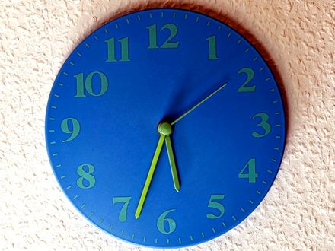
Figure 0. A kitchen clock on a bright wall. It is an excellent local tool; it says nothing about what is happening on Andromeda.

PART I — There Is No Now

1. The Argument in the Kitchen
Imagine two people in a kitchen arguing about whether the casserole is done. One is standing still, pot holders ready. The other is walking toward the table. They agree on the recipe. They agree on the oven. They do not, if you take them seriously as physicists, agree on which distant events are happening “right now.”
That sounds like a joke. It is the opening move of twentieth-century physics.
Call the woman with the pot holders Mara. Call the walker Eli. They are invented. The casserole is invented. The disagreement is not. It is what falls out of a speed that refuses to change when you do.
In Newton’s world the joke would be on the physicist. Space was a box. Time was a universal tick, the same in London and on Jupiter. You could, in principle, freeze the universe and take a photograph of “everything at this instant.” The casserole, the moons of Saturn, and a supernova in a galaxy we have not named yet would all sit in one frame, labeled NOW.
Newton wrote that camera into law in 1687. The Principia treats time as something that “flows equably without relation to anything external.” Space is a stage that does not care who is walking on it. A second in Cambridge is a second on Jupiter because the second is a property of the universe, not a property of a clock. It let him predict the Moon. It is also, as a claim about the furniture of the world, wrong.
Hot: the Moon’s orbit yields to Newton’s arithmetic. Cold: there is a single river of time that every event sits in at once. The river was a convenience. The convenience survived two centuries because nothing in the kitchen, or in the solar system as Newton could time it, was fast enough to notice the lie.
Einstein broke the camera.
He broke it in 1905, in a paper that does not mention casseroles and barely mentions philosophy. The paper is about electrodynamics: what Maxwell’s equations look like if you are allowed to move. The speed that falls out of those equations is not a property of the air, or of a luminiferous ether that the Earth is swimming through. It is a property of the pairing of space and time. In 1983 the meter itself was redefined so that this speed is exact: 299,792,458 meters per second. That is a definition, not a measurement: the second comes from cesium, and the meter is whatever length light covers in 1/299,792,458 of it.²
People had already tried to catch the ether. In 1887 an interferometer in Cleveland sent light up and down, expecting the Earth’s motion around the Sun to change the time of the trip. The change was not there. Others patched the books: lengths contract, clocks disagree, the ether becomes a ghost that cannot be found. Their algebra is close to Einstein’s. Their ontology is not. They were saving a stage. Einstein threw the stage out. There is no ether to be at rest in. There are events, and a speed that every honest observer assigns to light.
That is a hot claim. The null result is a century of repeated measurements. The reading — no privileged rest, no universal now — is the one that has survived every later test. Some treated the relativity of simultaneity as a convention about how to set distant clocks. Einstein treated the convention as a fact about the world. The difference is not a footnote. It is why this kitchen argument is physics and not manners.
He did it because the speed of light refused to play along. Measure that speed while you are standing still; then measure it while you are on a train. You get the same number. Not almost the same — the same. The only way that can be true, if space and time are allowed to share the job of keeping accounts, is if people who move relative to each other slice the world into “now” differently.
Here is why, at the scale of a countertop.
The oven has a window in the door and a second lamp over the stove, a couple of meters apart. A circuit is wired so that both lamps flash at what Mara, standing midway between them, will call the same instant. Light from the left lamp and light from the right lamp reach her face together. She is entitled to say: the two flashes were simultaneous. That is Einstein’s own popular example from 1916 — a train, an embankment, lightning at both ends — shrunk to fit between a sink and a fridge.³
Eli is walking toward the right-hand lamp, and the books only close if we put him where Mara was: midway, in his own accounting, at the moment the lamps fire. In that accounting the two lamps are still the same distance from him. The light from the right-hand lamp meets him sooner because he is walking into it. The light from the left has farther to run and is chasing him. He subtracts those travel times and still cannot call the flashes one instant. A person merely standing closer to one lamp is a different mistake: unequal arrival, equal emission, once the distances are put back in. Eli has already put the distances back in. What remains is a disagreement about the emissions. Neither of them has made a mistake. They have different slices.
If the speed of those flashes were infinite, Mara’s “same time” and Eli’s “same time” would collapse into one stamp. An infinite courier can update every clock at once. A finite courier cannot. The same c that makes the Cleveland interferometer come up empty is the c that forbids a shared now. You do not get to keep Newton’s photograph and the Cleveland null result. One of them has to go. The photograph went.
Standing still, in this kitchen, does not mean “the true rest of the universe.” It means Mara is not walking relative to the floor. Eli is. Newton would have asked which of them is really moving relative to absolute space. There is no such question left to ask. Each is entitled to treat themselves as at rest and the other as moving. Each is entitled to a now. Those nows agree at the stove. They do not have to agree at Andromeda.
The kitchen clock is an excellent local tool. It does not tell you what is happening on Andromeda. Nothing does, instantly. Light from Andromeda takes about two and a half million years to arrive. Any claim about what is “now” happening there is a claim about how you choose to extend your kitchen instant across empty space. Different motions, different extensions, different nows. If Mara and Eli already disagree about two lamps a walk apart, they will disagree — after a tilt too small to feel in the hips — about events two and a half million light-years away. Chapter 4 does the arithmetic, and Spacetime Diagram 1 draws it. Here it is enough to feel the lever: a tiny disagreement about “same time,” multiplied by a huge distance, is not tiny.
This is not mysticism. It is not “everything is relative” in the freshman-poster sense. The speed of light is not relative. The order of cause and effect, for events that can actually influence each other, is not relative. What is relative is a luxury we never noticed we were taking: a single present tense for the whole universe.
Mara takes the casserole out. That event can be a cause of Eli smelling dinner. Everyone who can be reached by the smell, or by a shout, will agree on the order: out first, smell second. That order is not a slice. It is a cone. The luxury we lost is only the luxury of stamping Andromeda with the same second. We did not lose before and after where they earn their keep. It just will not let the kitchen timer annex a galaxy.
Keep the temperatures honest. Hot: light’s speed in vacuum is the same in every inertial lab we have built. Hot: no signal we have ever sent outruns it. Hot: two people in relative motion do not share a distant present. Warm: the cleanest reading is that the universe is a four-dimensional spread of events, not a box with a moving stamp. Cold: that this makes your choices unreal. It does not. A choice is an event with a past cone and a future cone. Chapter 6 will spend that coin. Do not spend it in the kitchen as despair.
Once that luxury is gone, several other ideas have to be rebuilt. The past is not a country that has vanished. The future is not a country that has not yet been founded. Both are regions of a four-dimensional object that physicists call spacetime. Your life is a path through it. The path has a beginning and, for you, an end. The object does not have a glowing edge labeled NOW that advances like a weather front.
That is the claim of Part I. The rest of the book spends it on the sky, and none of that works if the kitchen clock stays the official time of the cosmos.
Take the casserole out when your clock says so. Then look up, and notice that the dark is late.
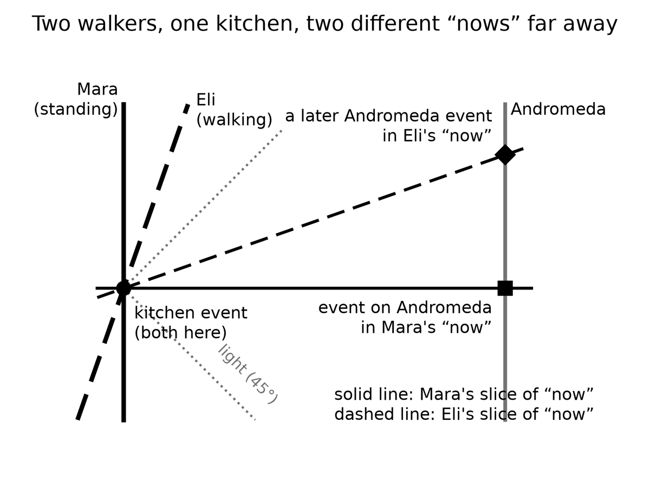
Spacetime Diagram 1. Relativity of simultaneity. Time runs up the page, space across it, and light travels at 45 degrees. Mara’s slice of “now” is level; Eli’s, because he is walking, tilts. Across a kitchen the tilt is nothing. At Andromeda it picks out a different event.

Figure 1. One kitchen. Put two people in it, one walking and one standing still: they agree on the casserole; they do not share Andromeda’s now.

2. An Event Is a Happening, Not a Thing
Physics, at this level, does not start with objects. It starts with events.
An event is a happening with a location and a time — or, more carefully, a happening that can be given four numbers once you have chosen a way to measure. A firecracker goes off. A photon hits a detector on a satellite. Two black holes finish colliding and ring down. You finish this sentence. Each of those is an event. A person is not an event. A person is a long, messy chain of them.
This sounds like bookkeeping. It is the opposite of bookkeeping. It is a decision about what the universe is made of.
Hold the firecracker a moment. It is not a red tube that “is” in the drawer and then “is” in the air. The lighting, the bang, the smoke that reaches a neighbor’s window — those are events. The tube is a habit we form when a bundle of events stays in step long enough for a hand to close on it. A marriage is an event, or a short braid of them: two people in a room, a sentence said, a register signed. The marriage-as-object, the thing you point at twenty years later and call “us,” is the trail. A death is an event. The person who died is not an event that has finished. The person was the trail. Confusing the trail with a crumb is how you end up asking where the rock “goes” when time “passes.” The rock does not go. The rock is a worldline. The crumb is a happening on it.
The loss is not verbal. Start with the rock and you will want a universal tick that tells you when the rock is “the same rock, later.” You will want a photograph of all the rocks at once. You will rebuild Newton’s camera because the camera is what objects demand. Start with events and the camera is optional. The rock is still there, as a braid. You can weigh it. You can throw it. You just cannot promote it into the atom of the inventory. Hot: detectors click at places and times. Warm: calling the click-cluster a muon, or a person, is the right habit for daily work. Cold: that the habit is what the universe is made of.
Give each event four coordinates. Three of them are the ones you already use to find a restaurant: a grid on the Earth, or a grid in the sky. The fourth is a clock reading. The set of all events, related by which ones can influence which others, is spacetime. The geometry of this got a line that still startles.
Hermann Minkowski, who had taught Einstein and had not at first been impressed by him, said it in Cologne on 21 September 1908: henceforth space by itself, and time by itself, are doomed to fade into mere shadows.⁴ He said it to a room of natural scientists who had grown up inside Newton’s box. Then the 1905 paper stopped looking like a trick with clocks. It was a geometry. Space by itself is a shadow because a length you measure depends on your motion. Time by itself is a shadow because a duration you measure depends on your motion. What is not a shadow is the pairing. Four numbers, glued by a rule that does not care who is walking. That sentence is warm as poetry and hot as a classification: every later test that has distinguished “space plus time” from spacetime has come down on that side.
Unpack the shadows without reciting the whole lecture. A meter stick moving past you is shorter along the direction of the motion than the same stick at rest in your kitchen. A clock moving past you ticks through fewer of its own seconds between two of your marks than a clock on the wall. Those are not optical tricks. They are what “space by itself” and “time by itself” become once c is the same for everyone. The point was that the two tricks are one trick. Shorten a length and you have borrowed from time. Stretch a duration and you have borrowed from space. The loan is exact. The leftover, the thing that does not change when you change walkers, is the interval.
Mara books a table. The booking already has almost everything physics will ask for. A street and a number. A floor. A clock time — half past seven, not “evening” in the abstract. If you like, a calendar date. Those are four coordinates for an event: Mara sits, the bread arrives. You can change the grid. You can measure the restaurant from a church steeple or from a satellite. You can run Mara’s watch fast or slow. You cannot turn the dinner into a rock that exists “at all times” and then ask time to happen to it. The dinner is a happening. Miss the hour and the table is a different event, or no event at all.
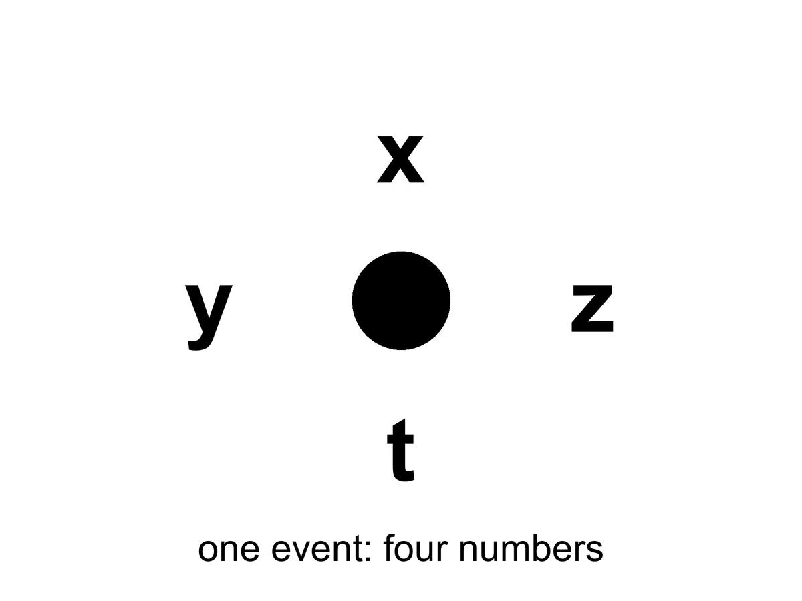
Figure 2. One event: a happening with four numbers, x, y, z and t. An event is not a rock.
The useful picture is not a box of space with a clock hanging on the wall. The useful picture is a loaf. Each event is a crumb. A worldline is the trail of crumbs that is you — or the Earth, or a photon. A photograph of “the world at a given time” is a slice through the loaf. The slice is not unique. Tilt your knife — which is what changing your motion does — and you cut a different set of crumbs.
The tilt is tiny at walking speed. That is why Newton never saw it in a kitchen. Over a table, Eli’s knife and Mara’s knife cut almost the same crumbs. Over a galaxy, they do not. The loaf does not change when the knife tilts. The membership of the slice does. Cuts are useful. They are how you say “when I was twenty” without listing a million events. They are not a feature the bakery stamped on the crust.
Two events can stand in only a few relations that matter.
They can be close enough, in the right combination of space and time, that a light signal or something slower could pass from one to the other. Then one can be a cause of the other. Everyone agrees on the order. This is a timelike or lightlike separation, and it is the part of physics that still has a before and an after.
Lightlike is the edge of that permission. A photon leaving the oven lamp and hitting Mara’s eye is a lightlike pairing: no slower courier could have made the trip, and no faster one exists. Timelike is everything inside the edge — a shout, a smell, a walk from stove to table. Those pairings keep a before and an after for every honest observer. That is why the casserole can still be a cause of dinner. The order is not a courtesy. It is the interval advertising its sign.
Or they can be so far apart, compared with the time between them, that not even light can connect them. Then neither is the cause of the other. Different observers can disagree about which happened first. This is a spacelike separation. The casserole and a flare on Andromeda, “at the same kitchen instant,” are almost certainly spacelike. There is no fact of the matter about which was first that the universe is required to honor.
Appendix A2 writes this as a single formula: the spacetime interval. The interval is the same for every observer. The split of that interval into “so much space” and “so much time” is not. That is the entire trick. The loaf has a real geometry. The slices are ours.
The kitchen analog is a cutting board. Draw a right triangle from the corner of the board to a knife. The hypotenuse is a length. You can call one leg “along the counter” and one “toward the sink.” Rotate the board — you relabel the legs. The hypotenuse does not care. The interval is that kind of stubborn length, except one of the legs is time and comes in with a minus sign.
The minus sign is why the analog is not perfect. Rotate a cutting board and both legs stay lengths. In spacetime one leg is a duration, and it enters with the opposite sign to a length. That is why a small change of motion can trade a little space for a little time without changing the interval, and why a large enough distance makes “who was first” a question the interval refuses to answer. That invariance is hot: every particle detector that reconstructs a collision and every GPS receiver that solves for a position uses it. The split is ours. The pairing is not.
If you take nothing else from this chapter, take this: when a physicist says spacetime, they are not being fancy about the word background. They are telling you that the raw inventory of the world is events, and that time is one of the ways events can be separated — not a river the events float in.

3. Light Is Late on Purpose
We talk about looking into space. We are always looking into the past.
The Sun you see is eight minutes old. Jupiter, tonight, is about forty minutes old. The Andromeda Galaxy is two and a half million years old in your sky. The leftover glow this book will spend Part II on is a picture of the universe as it was when it was 380,000 years old — a baby picture with the baby long gone.
Eight minutes is the rounded kitchen number. The honest one is 499 seconds. That is how long light takes to cross one astronomical unit, the mean Earth–Sun distance, 149,597,870.7 kilometers, at 299,792,458 meters per second. The light that heats the back of your hand left the photosphere before you put the kettle on. You are not in touch with the Sun. You are in touch with a star that has already moved on.
The Moon is closer, which is why it fools people. Light from the near face takes about 1.3 seconds to finish the trip. During Apollo, Houston learned that number as a manner. A question went up. An answer came down. In the middle sat a hole you can hear on the tapes if you listen for the gap. It is not drama. It is 384,000 kilometers divided by the same c that emptied the Cleveland interferometer. The men in the room called it lag. The geometry called it a past cone.
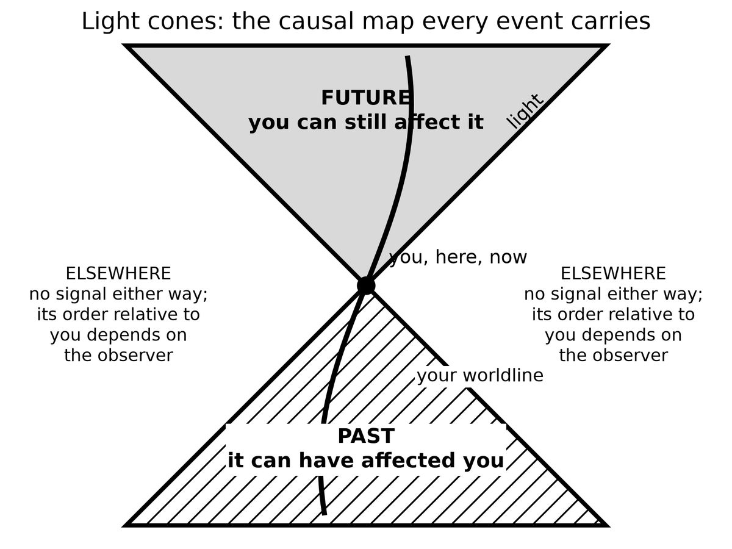
Spacetime Diagram 2. Light cones. Every event carries a future cone it can still affect and a past cone that can have affected it. Everything else is elsewhere: no signal either way, and its time order relative to you depends on the observer.
Jupiter does not have a single number. The planet runs from about 3.9 to 6.5 astronomical units from the Earth, depending on where the two worlds sit in their orbits. Light one way is then about 33 minutes on a close night and about 54 minutes on a far one. “Forty minutes” is a typical Tuesday. A flare on Io is not news. It is a letter.
Voyager 1, as of October 2026, sits about 172 astronomical units out, in the thin dark past the planets. A command from Earth takes nearly 24 hours to arrive, and on 18 November 2026 the one-way trip passes a full light-day.⁵ A reply takes as long again. The spacecraft is not “out there now” in the sense a casserole is in the oven now. The spacecraft is a trail of events. The event you can still affect with today’s radio is already tomorrow on the craft’s clock, and the event you can still hear left yesterday.
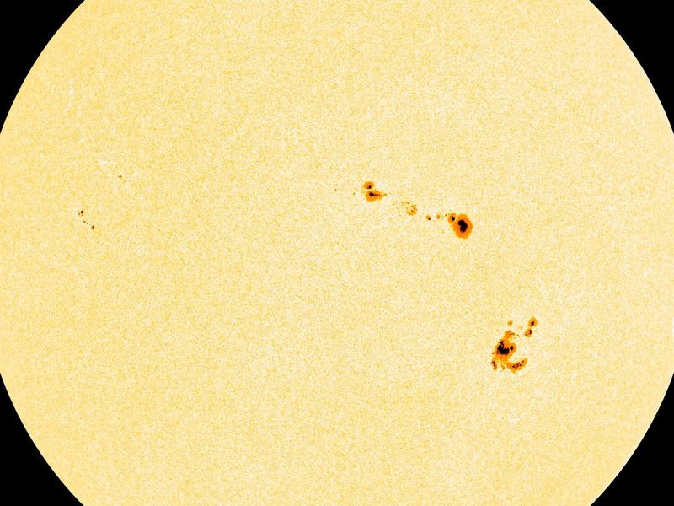
Figure 3. The Sun. Its light is eight minutes old by the time it reaches your eye.
This is not a limitation of our instruments. It is what a finite speed of light is. If light were instant, “now” would still be a problem for moving observers, but the night sky would at least be a live feed. It is not a live feed. It is an archive. Every direction is a different depth of time.
Look left at the Moon and you are looking 1.3 seconds down. Look at Jupiter and you are looking most of an hour down. Look at Andromeda and you are looking through the entire history of Homo sapiens and then some. The sky is not a dome with a single stamp. It is a stack of postmarks. A telescope is not a telephone.
People find this either depressing or wonderful. Both reactions are allowed. The scientific point is narrower. Because light is late, astronomy is already time travel of the only kind we actually have: we receive news of events that lie to our past, along our past light cone.
A light cone is not a party decoration. From any event — say, you snapping your fingers — draw every path a light ray could take into the future, and every path a light ray could have taken to arrive there from the past. The future cone is everything you can still affect. The past cone is everything that can still affect you. Everything else is elsewhere: real, possibly interesting, and unavailable as a cause or an effect of this snap.
Treat the cone as a traffic law. You may go into your future cone. You may have come from your past cone. You may not cut across elsewhere and arrive before the light. The posted limit is c. There is no shoulder. A radio, a probe, a letter, a shout across a yard — all of them buy a ticket inside the cone or they do not travel. The law is hot. Every failed attempt to signal faster than light, and every collider that has tried to catch a particle arriving before its own cause, has left the cone unbent. Warm: that no clever geometry later in the book will hand you a legal detour. Cold: that we have checked every cheat. We have not. Chapter 34 will be honest about the proposed ones. They have to break something in the loaf. They do not get to edit the 499 seconds to the Sun.
The night sky is the past cone, printed on the inside of your eye.
This is why “getting somewhere else in the universe” is not an engineering slogan. Most of the interesting somewhere-elses are already outside the future cone of any event you will live to occupy. You can wait. You can send a probe. You cannot, in this spacetime, jump sideways into elsewhere and arrive for dinner. Light’s lateness is not an inconvenience we can edit out. It is the geometry.
You do not need Andromeda to feel this. A conversation with someone on Mars is already broken. Light takes between about three and twenty-two minutes one way, depending on where the two planets sit in their orbits. The reply costs the same again. You cannot talk. You can only send, and wait, and send again. Elsewhere begins at the next planet over.
Put the same two people on the radios, years after the casserole, because the cone is easier to believe when it ruins a sentence. Eli, still in the kitchen, sends “How is the dust?” Mara, on the dead world, will hear it between three and twenty-two minutes later. She cannot say “wait, what?” in the way a kitchen allows. She can send her own sentence into a future Eli has not reached yet. By the time her words arrive, his next sentence is already in the air, or already abandoned. They are not talking. They are mailing. The interruption that makes a conversation a conversation is a timelike luxury — a luxury that requires the gap between speakers to be short compared with the time they are willing to wait. Elsewhere begins when the luxury ends. No colony is required for the demonstration. Two radios and an orbit are enough.
There is a kindness in the lateness, if you want one. The universe is not happening at you. It is arriving. The glow behind the stars, the one you cannot see without an antenna, has been arriving for thirteen billion years and will keep arriving tomorrow. You do not have to go anywhere to be in contact with the beginning. The beginning is late, and it is here.
The dark between the stars is late in another sense, and it has a name older than relativity. If the universe were infinite, eternal, and static, stuffed with stars, every line of sight would end on a surface as bright as a photosphere. The night would be a furnace. Heinrich Olbers was not the first to worry; he was the one the paradox kept. The night is not a furnace. Part of the reason belongs to later chapters: expansion stretches light and thins it. Part of the reason belongs here. The universe has a finite age. Light from the farthest possible furnaces has not had time to arrive, and many of those furnaces have not been burning forever. The black is an archive with empty early pages. That is a hot observational fact wearing a nineteenth-century question. The dark is late, and the loaf has a beginning.

4. Andromeda’s Navy
Here is the thought experiment that makes the kitchen argument unavoidable. It is often called the Andromeda paradox — the version physicists still use.
Mara is standing in the yard. Eli walks past her, toward Andromeda, at an ordinary pace — a stroll. Special relativity says that the set of events Eli calls “simultaneous with this passing” is tilted, very slightly, relative to hers. Over the distance to Andromeda, a slight tilt is not slight. On her “now,” the Andromedans (if any) are, say, sitting in committee. On his “now,” the committee has already launched a fleet.
The stroll is not a metaphor for speed. It is a speed. A comfortable walk is about 1.4 meters per second. M31, the Andromeda Galaxy, sits about 2.5 million light-years from the yard — a modern distance, not a poster guess. The tilt of “now” is the same arithmetic Einstein used on trains:
Δt ≈ v Δx / c²
where v is how fast Eli walks toward the galaxy, Δx is the distance to M31, and c is the speed we have already refused to negotiate.
Plug in the stroll. You do not get centuries. You get about four days. A few days of disagreement about Andromeda’s “present,” for a walk you would not break a sweat on, at a galaxy you cannot see without knowing where to look. That is already enough to break a single cosmic now. Raise the relative speed to a highway and the disagreement becomes about three months. At an airliner’s speed it is about two years. The Earth’s own 30 kilometers per second around the Sun, if you compared frames carelessly, would buy you centuries. The yard only needs the stroll.
At the moment their sleeves brush, they share a here. They do not share an Andromeda-now. If Eli stopped walking, the disagreement would shrink toward zero. The navy, if any, would not notice. Nothing in M31 is waiting on his hips. The tilt is a fact about slices, not a telegram to a fleet.
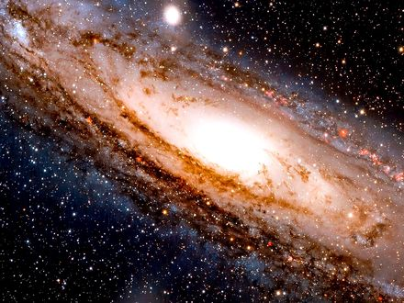
Figure 4. The Andromeda Galaxy, cropped to its bright disk. Whatever is happening there now is two and a half million years from your yard.
Neither of them can see the fleet. The light has not arrived and will not arrive for millions of years. The point is not what they see. The point is the temptation to call one slice real.
If you believe that only the present is real — that the past is gone and the future is not yet — then you have a problem. Mara and Eli, standing in the same yard, passing each other at walking speed, do not share a present at Andromeda. If his present is real and includes a launched fleet, and her present is real and does not, then “real” has split in the yard.
The split is not a feeling. It is a bookkeeping collision. She has granted real to whatever sits on her slice. Eli has granted real to whatever sits on his. The slices disagree at a distance where no signal can referee. Either reality is allowed to depend on who is walking past the compost heap, or real was the wrong prize to hang on a slice. The first option makes ontology a property of gait. The second option is the loaf.
The clean way out is to stop granting a privilege to the slice. The fleet-launch is an event. The committee meeting is an event. Both are in the loaf. You will learn about them, if at all, when their light arrives. Until then they are not “future” in some ghostly sense and not “present” in some official sense. They are simply events that are spacelike-separated from this moment in the yard.
Hilary Putnam and C. W. Rietdijk made this into a formal argument in the 1960s: if whatever is present-for-someone is real, and if reality does not depend on who is walking, then distant future events are already real. Rietdijk’s paper is 1966. Putnam’s “Time and Physical Geometry” is 1967. Philosophers have been picking at the logic ever since. Some reject the idea that “real for Alice” transfers to Bob. Some try to keep a privileged present by adding extra structure that relativity does not provide. Some accept the loaf and get on with their lives.
The transfer is the hinge they pick at. Alice walks. A distant event is present-for-Alice, hence real. Bob stands. Reality does not depend on gait, hence the event is real-for-Bob too, even if it is future-for-Bob. Repeat, and the future fills up. That chain is only as strong as the first gift: present implies real, and real is shared. This book does not need the chain as a proof. It needs the first gift to look expensive. Once you have seen the gift cost a preferred slice, you can put the gift back on the shelf.
Keep the temperature on that last move. The relativity tilt is hot. Clocks and rods and GPS and particle tracks all honor it. The inference “therefore the distant future is real in the same way this yard is real” is a reading. It is a reading this book accepts, because the alternatives have to smuggle in a preferred slice that no experiment has found. It is still a reading. Warm, not a photograph of a fleet. The quiet version is enough: do not give the word real to one cut of the loaf and withhold it from the crumbs a walk would recut.
Henri Poincaré said as much around 1898: you cannot assign a time to a distant event without a rule, and the honest rule will not be Newton’s. He still treated the rule as a convention among surveyors, and the ether was still being patched. Einstein’s 1905 paper is the rule written as physics. The yard is the same rule with a longer baseline.
This book accepts the loaf. Not as a religion, and not as a measurement — as the interpretation that does the least violence to a theory that has passed every test we have given it. Chapter 6 marks exactly where the tested theory ends and the reading begins. GPS satellites run a daily demonstration: if you do not correct their clocks for both speed and gravity, your phone’s map slides into a ditch. The corrections are the same mathematics that tilts the Andromeda slice. Leave the clocks alone and they drift by about 38 microseconds per day¹ — special relativity and gravity pulling in opposite directions, the net still large enough to walk a position off a road. The tilt that reallocates a few days of Andromeda is the tilt that, at 20,000 kilometers up, reallocates a fraction of a blink. We correct the blink because we like maps. We do not get to refuse the galaxy.
You do not need to believe that 2219 is “already happening” in some lurid sense. You need to believe something quieter: 2219 is a region of the same object 1914 is a region of. The difference is which events can still influence the ones that make up you.
1914 is not “still going on” in a kitchen. It is a region whose light, and whose causal leftovers, still reach you. 2219 is a region whose light has not, and whose causes you have not yet become. The vocabulary of happening — the glow, the stamp, the weather front — is what gets people into lurid trouble. Drop the glow. Keep the regions. You already do this with places. Lisbon is real when you are in the yard. You do not need Lisbon to be here. Times are places in the loaf. That sentence is warm. It is also the least theatrical reading that leaves Eli’s walk intact.
That quieter belief is enough to rewire the rest of the book. The beginning of the universe is not a story that used to be true. It is a region of the loaf. The heat death, if that is what we get, is another region. We occupy a thin braid in between.

5. You Are a Path
If the universe is a loaf of events, you are a thread.
A worldline is the set of events that is a particular object’s history. The Earth’s worldline is a long helix around the Sun’s, which is a longer helix around the galaxy’s. A photon’s worldline is a straight edge of a light cone — as straight as the geometry allows. A person is a bundle of worldlines, roughly parallel, that eat, argue, and occasionally write books.
The bundle is the honest picture and the slightly comic one. You are not a single thread. You are a rope of atoms that stay in conversation, plus a few that do not. The rope has a thickness of a body and a length of a life. Physics will still call the rope a worldline when the thickness does not matter. It matters when you want to know why a liver and a thought can share a name. They share a braid. The braid has a mileage. That mileage is the age your cells would confess if they kept better books than birthdays.
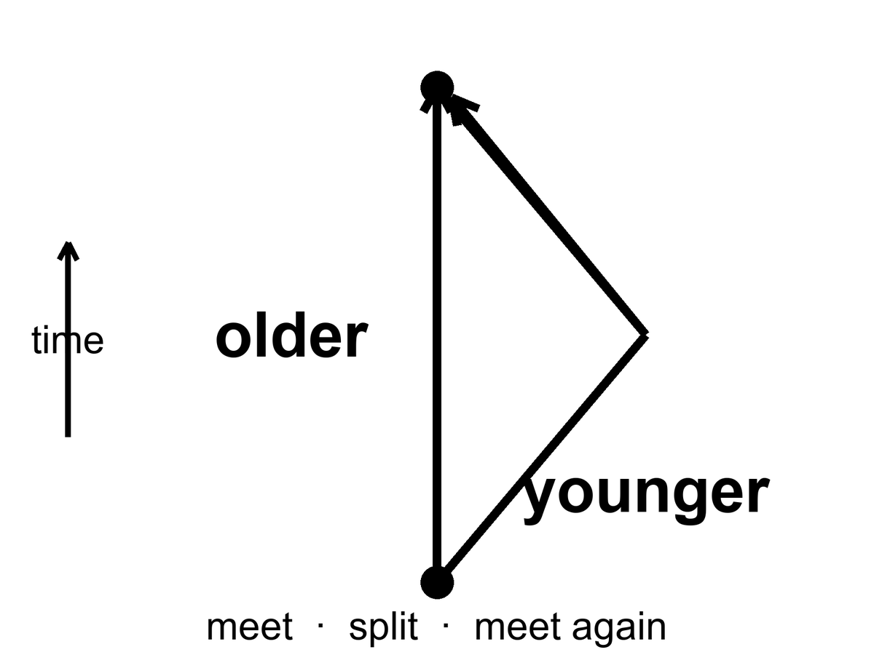
Figure 5. Two worldlines meet, split and meet again. The twin who travelled is younger: mileage through spacetime, not a trick.
You do not move through time the way a boat moves through a river. That sentence, which feels like common sense, smuggles the river back in. What you do is occupy a sequence of events. The sequence has a length. That length is the time your watch measures, and it is called proper time. Proper time is not a coordinate someone assigned from a tower. It is a property of the worldline, the way a hiking trail has a mileage that does not depend on which map you used.
where proper time is the mileage along your worldline, the seconds a clock traveling with you actually accumulates.
Picture two hikers, June and Cal, who leave the lot at 8:00 by the same clock on the wall. June takes the ridge. Cal takes the creek. They meet at the lake and compare. The surprise, if you still think time is a river, is that their watches need not agree, even if both kept honest seconds. In the mountain the difference is too small to see. In spacetime the same kind of difference is the whole twin story. The map can lie about mileage if it wants; the boots do not. Proper time is the boots.
Two worldlines that start together and end together need not have the same length. This is the twin “paradox,” which is not a paradox. The twin who accelerates, turns around, and comes home has a shorter worldline. She is younger. The loaf does not care that this offends the kitchen clock. Particle accelerators run the same experiment all day: unstable particles that travel fast live longer, as measured in the lab, because their worldlines between two lab events are shorter in proper time, which means their internal clocks tick through fewer of their own seconds. The word “live longer” is a lab word. In their own terms they live a normal life and the lab takes forever.
It is mileage, not a trick. The twin who stays home is the hiker who took the straighter trail through the loaf. In the geometry Einstein handed us, the straightest timelike path between two meetings is the longest proper time, not the shortest. That is the minus sign from Chapter 2 earning its keep. The traveler who turns around has taken the switchbacks. Her watch adds up fewer seconds. No one has to break physics to prefer a younger sister. You only have to stop asking the kitchen clock to be the mountain.
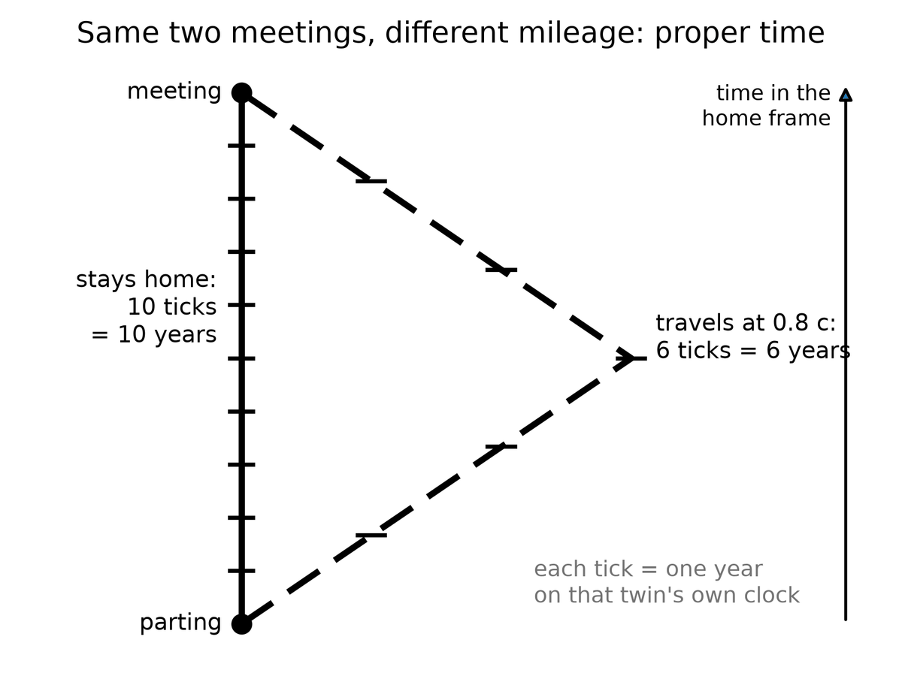
Spacetime Diagram 3. Twin proper time. Both twins go from the same departure to the same reunion. The one who stays logs 10 years; the one who travels at 0.8 of light speed logs 6. The bent path is the shorter one in proper time.
The muon is the classroom that does not need a twin. A muon at rest lasts about 2.2 microseconds before it decays. That is not a rumor. It is a measured lifetime, 2.2 × 10⁻⁶ seconds, repeated until it is boring. Cosmic-ray muons are born in showers tens of kilometers up. Even at nearly the speed of light, 2.2 microseconds buys only about 660 meters of travel, so without time dilation most of them should die in the upper air. They reach the ground in inconvenient numbers. Their worldlines between the shower and the dirt are short in proper time and long in the laboratory’s coordinates. The particles are not cheating death. They are hiking a shorter trail. Hot.⁶
The showers start nearer 15 kilometers. Without the mileage effect you would need a conspiracy of extra lifetime to stock a basement detector. With it, a muon whose energy buys a time-dilation factor of twenty or thirty has a trail long enough to punch the dirt. Students have been counting those punches since the 1940s.
In October 1971 Joseph Hafele and Richard Keating put that trail on commercial jets.⁷ They flew cesium-beam atomic clocks around the world, eastward and then westward, and compared them with clocks that had stayed in Washington. The eastward clocks came home about 59 nanoseconds behind the clocks that stayed; the westward clocks came home about 273 nanoseconds ahead, each close to its prediction. The signs flip with direction because the Earth’s rotation is already a velocity, and a jet adds to it one way and subtracts the other. Special relativity is not only for twins in textbooks. It is a fare class.
Gravity bends worldlines. That is what gravity is, in Einstein’s account: mass-energy tells spacetime how to curve; curved spacetime tells worldlines how to lean. A clock deeper in a gravitational well accumulates less proper time between two meetings than a clock higher up. This has been measured with aircraft, with towers, with a hydrogen-maser clock flown on a rocket in 1976,⁸ and with those GPS satellites. Near a black hole the same fact becomes extreme: an hour beside the horizon can be years farther out.
Bent, here, is not a metaphor for trouble. A worldline that stays near a mass is a different trail through the loaf than a worldline that stays high. The trail nearer the mass is shorter in proper time between two comparisons. The mass did not reach out and grab the clock. The mass told the geometry how to lean, and the clock added up the lean. Hot as a description of what we measure. Warm as the full story of why the geometry listens. Cold: that we have a finished quantum account of the listening. We do not. The clocks do not wait for one.
The tower came first, and it was short. In 1959 Robert Pound and Glen Rebka sent gamma rays up and down a 22.5-meter shaft in Harvard’s Jefferson Laboratory and measured the gravitational redshift — climbing out of a well costs a photon energy, the way climbing a hill costs a thrown ball speed, and a photon with less energy reads as a lower, redder frequency — of the Earth over the height of a building.⁹ Iron-57. A fraction of a fraction of the energy. They saw it. Later refinements made the agreement rude. You do not need a hole in the sky to learn that height is time. You need a basement and a roof and a nucleus that will confess. In 2010 optical clocks saw the same effect over a height difference of about a third of a meter.¹⁰
GPS is the public sum of the jet and the tower. A satellite clock, moving fast, runs slow by about 7 microseconds a day from special relativity. The same clock, sitting higher in Earth’s well, runs fast by about 45 microseconds a day from gravity. The net, if you do not correct, is about 38 microseconds a day — the number Chapter 4 already used as a threat to maps. At the speed of light it is about 11 kilometers of ranging error a day, and it accumulates. The engineers correct both pieces because both pieces are real.¹ The Andromeda tilt and the hiking-trail mileage are the same theory wearing different hats.
Chapter 21 will take the hour-beside-the-edge as far as a spinning hole and a poster number. If a clock in a basement already disagrees with a clock on a roof, a clock that hovers just outside a horizon will disagree with a clock in the suburbs of the same hole by an amount that stops being polite. The geometry is continuous. The kitchen is not a different law from the hole. The hole is the kitchen with the well turned up.
Once you are used to worldlines, several puzzles lose their fog.
“Where is the universe expanding into?” is a thing-question. Expansion is a change in the distance between worldlines of galaxies, measured at successive meetings with light. There is no need for an outside.
“What happened before the beginning?” is a river-question. If the loaf has a boundary — and it may — then “before” is a word that applies inside the loaf, not to a waiting room outside it. Chapter 45 will take this as far as anyone honestly can.
“Can I go back?” is a thread-question. Going back would mean your worldline looping so that it meets an earlier event on itself, or on someone else’s line, in the wrong order. The loaf’s geometry may or may not allow such loops. Ordinary spacetime, the kind we have measured, does not hand them out. Chapters 36 and 37 are about that.
Keep the temperatures on the path. Hot: clocks that take different trails between two meetings disagree, and the disagreement is the one the geometry ordered. Hot: muons, jets, towers, and phones all keep the same books. Warm: that the books are best read as a block of events with worldlines drawn through them. Cold: that this makes you a prisoner of a drawing. A path can still choose its next step inside its future cone. The drawing is the set of steps. It is not a warden.
For now, keep the thread. You are not a passenger in time. You are a path.

6. The Block
Call the loaf by its public name: the block universe.
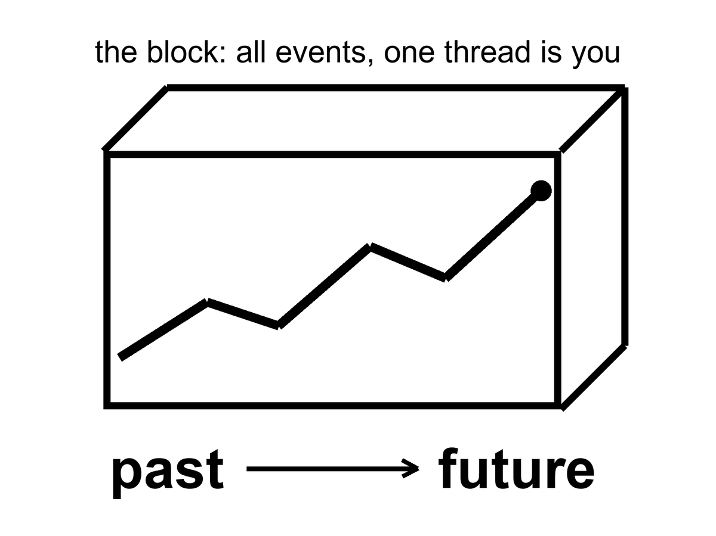
Figure 6. The block: a loaf of all events. One thick thread is you. Past and future are directions on the loaf, not a moving edge.
The block is not a brick. It is the claim that past, present, and future events are equally part of the inventory. The “present” is the event-cluster you are using as a vantage. It is not an ontological VIP section.
The loaf has a shape, not only a guest list. In November 1915 Einstein wrote the field equation that says how the shape is set: mass-energy on one side, geometry on the other. Matter tells spacetime how to curve. Curved spacetime tells worldlines how to go. You have already met the local consequences — the tower, the jet, the 38 microseconds. The global consequence is that the block is not a rigid box we inhabit. It is a geometry we are inside of, and the geometry answers to what is in it.
The first public test was not a kitchen. It was an eclipse. On 29 May 1919 Arthur Eddington’s teams on Príncipe and at Sobral photographed stars near the Sun and found their light bent by about the amount Einstein had asked for — on the order of 1.75 arcseconds at the limb, twice Newton’s corpuscle guess. The measurement was ruder than the headlines, and later eclipses and radio interferometers cleaned it. The claim that survived is hot: light follows the geometry, and the geometry is not flat when the Sun is in the way. The block is not a metaphor we chose because it sounded grave. It is one reading, this book’s reading, of a theory that has been catching starlight for a century.¹¹ The theory is hot. The reading is not a measurement, and the box below says exactly where the line falls.

Physics vs philosophy: from relativity to the block
What the evidence establishes (hot). Clocks that move, or sit higher in a gravitational field, tick at different rates, by amounts measured on airliners, up a tower, across a laboratory bench, and every day in GPS.⁷⁹¹⁰¹ Observers in relative motion disagree about which distant events are simultaneous, and no experiment has ever singled out one of their slices as the true one.¹² Every observer agrees on the light cones: which events can affect which.
What this book infers (interpretation). If no slice is privileged, then past, present, and future events are on the same footing: the block universe, which philosophers call eternalism.¹³¹⁴ That is a philosophical reading of a tested theory, not a measurement. No experiment can tell it apart from a universe with a hidden preferred slice, because the slice is hidden by construction.
What would change the verdict. A detected preferred frame (a violation of Lorentz symmetry, which experiments already constrain tightly¹⁵), or a quantum theory of gravity in which a physical global time reappears. Either would put a cosmic now back on the table without contradicting anything relativity already explains.

People dislike the block because it sounds like fatalism. If 2219 is “already there,” was anything I did today a choice? The honest answer is: your choice is an event too. It has causes in its past cone and effects in its future cone. The block does not steal the choosing. It refuses to make the choosing into a little glow that travels along the thread, lighting up real events and leaving the rest in storage. The choosing is a stretch of the thread.
There are rivals, and they deserve their best case, not a cartoon.¹⁶
Presentism says only the now is real.
Its strongest case. Every experience anyone has ever had was had in a present. Tensed facts (“it is raining now”) look irreducible. And a careful presentist can keep every prediction of relativity: add one preferred slicing of spacetime that no experiment can detect, and the equations, the clocks, and GPS are untouched. Cosmology even offers a natural candidate. The leftover glow of Chapter 9 looks the same in every direction for one family of observers, and their clocks define the “cosmic time” in which the universe is 13.8 billion years old.
What it gets right. It cannot be refuted by experiment, and this book does not claim otherwise. Cosmic time is real and useful; this book uses it in every chapter that gives an age. And the felt present is a datum that any account of time owes an explanation.
Why this book still declines it. The preferred slice does no work. It enters no prediction, it is posited and never measured, and in a lumpy universe (near a star, inside a black hole) the glow does not even define it cleanly. Declining it is a judgment of economy, not a proof.
The growing block says the past and present are real and the future is not yet. The loaf grows.
Its strongest case. The asymmetry between a fixed past and an open future is the deepest feature of experience and of action: we keep records of the past and make choices about the future. George Ellis’s “evolving block” gives this physical teeth: the future is not there yet because quantum outcomes are not settled yet, and spacetime crystallizes as they become definite.¹⁷
What it gets right. The arrow of time is real and needs explaining, and this book agrees it is not explained by the block alone (see below). If quantum outcomes are genuinely chancy, as collapse theories say, there is something the future lacks.
Why this book still declines it. Growth needs an edge, and an edge that runs across space is a preferred slice again. Ellis says so openly; his model needs a preferred foliation. The asymmetry it wants can be had more cheaply: a low-entropy boundary in the past, plus the way records form. So this book keeps the asymmetry and drops the moving edge. As physics, the evolving block is a research program, not a refuted idea.
The yard does not get kinder if you change the slogan. Mara stands. Eli walks. Their “nows” at M31 differ by days. If only the present is real, they do not share a reality at 2.5 million light-years, while sharing a reality at the fence. If the loaf grows, someone must say which crumbs have already been baked at that distance. A growing edge that both of them can honor is a preferred slice. Preferred slices are extra structure. Extra structure can be added. It has not been measured. Presentism and the growing block meet Andromeda with the same quiet cost: a walk is enough to recut the distant present, and the universe does not appoint a winner. Both views can pay that cost by adding the winner by hand. That is a reading of a hot tilt, not a proof that philosophers must shut up. Decoherence, which the evolving block leans on, is a possibility losing its power to interfere with the others once it leaks into a big, messy environment; Chapter 41 does this properly.
This book adopts the block as its working reading of spacetime, chosen for economy and flagged as an interpretation, and then notices where physics puts pressure on it. The arrow of time — why we remember the past and not the future, why eggs break and do not unbreak — is not explained by the block. The block is time-symmetric in its basic laws. The arrow needs a fact about the boundary: the early universe was absurdly ordered. Philosophers call it the Past Hypothesis; Sean Carroll has done most to popularize it, and it is why Part II is not optional philosophy. The hot, smooth beginning is the low-entropy end of the loaf. We are downstream of it. That is why there is a difference between looking that way and looking the other way.
Quantum mechanics puts a different pressure on, and this book treats that pressure as a core element, not a cameo.
The equation that describes an electron does not, by itself, pick a single outcome. It assigns an amplitude to each way the story might go. One reading — Hugh Everett’s, later sharpened by people who take the equation literally — says the leftovers are not discarded. When a measurement could have gone two ways, both ways persist, decohered, no longer able to interfere. The block is not only all the times. It is all the allowed versions. You are one thread in a loaf that splits.
That sentence is where a sermon likes to sit down. Reality only forms when it is observed. The equation does not say that. The equation says that amplitudes interfere until a system becomes entangled with something that will not give the interference back — an environment, a plate, a wall of photons that have left and will not return. That is decoherence. It is a calculation you can assign a time to. It does not require a soul.
So what counts as an observer?
Not a person, first. A person is a late, expensive observer: a nervous system that keeps a model and can be surprised. In the laboratory sense an observer is any degree of freedom that acquires a record — a correlation stable enough that you would have to conspire with the whole environment to undo it. A silver grain that darkens. A Geiger tube that clicks. A dust mote whose spin will never again line up with its twin. The leftover glow, last-scattering at 380,000 years, is a record written before any eye. The helium of Chapter 10 is a record written at three minutes. If “observe” means “leave an irreversible trace,” the universe has been observing itself since it was a fog. You were not needed for the fog to have a temperature.
If “observe” means “a mind noticed,” you have added a postulate the amplitudes do not ask for. Wigner can put a friend in a lab and argue about when the wavefunction collapses. That is a quarrel about the word record, not a proof that the Moon is a sketch until you look up. Consciousness-causes-collapse is a minority reading with a famous pedigree and, so far, no extra prediction anyone has confirmed. Chapter 41 gives its strongest modern version a fair hearing and says why this book still declines it. Everett does not need it. Decoherence does not need it. Relativity, which already forbade a single now, will not wait while a mind in one kitchen switches Andromeda on.
There is a better picture of what a mind feels like from the inside, and it does not need a collapse.
Call it a strange loop. A system writes symbols. Some of the symbols point at the system that is writing them. The map contains a sketch of the mapmaker. The hierarchy tangles: the “up” of explanation (neurons, then thoughts, then an I) folds back so the I is what the neurons are doing, and the neurons are what the I takes itself to be made of. No extra spark. A level-crossing. The word I is what that loop sounds like when it has a mouth. An observer, in the expensive sense, is a record that has begun to model the fact that it is a record. An ant is not that loop. A nest of ants, taken as a whole — a city that farms and wars and does not know the name of a single worker — is a cheap sketch of the same trick. Here it is a diagram of a self: meaning that is not in the parts, and is not a ghost. It is an isomorphism, a translation, a tangle.
That picture is warm as phenomenology and cold as a proof that the leftover glow needed us. The glow was a record without a loop. The helium was a record without a loop. The loop arrives late, on a thread, and then has the nerve to ask whether the fog was real before it got here. It was.
EPR — the 1935 complaint that quantum mechanics lets a measurement here fix a pairing there, “at once” — is the same room with better furniture. The pairing is real. Bell showed the pairings are stronger than any local recipe of hidden instructions.¹⁸ Aspect and the rest measured that, and in 2015 a test closed the main loopholes at once.¹⁹²⁰ Hot. What is not on offer is a telegram. You cannot choose what to do here in a way that sends a bit there. The no-signaling theorem is the grown-up name for Einstein’s unease, resolved without a radio. “Simultaneous action” is already a phrase the kitchen clock should not be allowed to use. There is no shared now in which the two ends happen together. There is a correlation in the loaf.
That is a warm claim. It is not a photograph of other lives, and it is not a travel method. Nothing in the equation hands you a way to hop from your thread onto a neighboring one and steal a different marriage, a different planet, a different you. The copies, if they are real, are as unavailable as Andromeda’s navy. They are on the inventory. They are not a destination. And the Moon was there before the first nervous system named it. The record was.
Holography puts a third pressure on. If the information in a region scales with its surface, not its volume, the loaf may be a projection of something thinner. That is a warm-to-cold idea, and it does not cancel the events. It relocates them.
What the block does, for a book about origins and endings, is simple and a little severe. It lets us talk about the first three minutes and the last three minutes as regions, not as moods. It lets a wormhole be a handle connecting two regions, not a machine that “goes.” It lets the Omega Point — a hoped-for final crunch in which life computes forever — be judged as a claim about the shape of the future region, which the data currently contradict.
You can still say “now” in the kitchen. You should. Just do not promote the kitchen to a cosmology.

PART II — The Past We Can Rebuild

7. The Explosion That Happened Everywhere
People hear “Big Bang” and picture a grenade in a dark warehouse: a bright point, a blast wave, shrapnel flying into empty rooms. That picture is wrong in every way that matters, and it is the reason smart readers keep asking a question that has no answer: what did it explode into?
It did not explode into anything. It was not a bomb in space. It was space, getting roomier, everywhere at once.
If you could have been present at a minute old — you could not have; there was no solid ground, no shadow, no place to stand — you would not have seen a fireball receding toward a horizon. You would have been inside the fireball, and so would every other direction. The glow would have been the walls, the floor, the air, the idea of “away.” Density would have been falling because the distances between nearby bits of stuff were stretching, not because the stuff was fleeing a scene.
A baker’s analogy earns its keep here. Imagine raisin bread dough rising in a warm bowl. Every raisin sees every other raisin recede. There is no special raisin in the middle of the dough. The “middle” is a habit we picked up from grenades. In a universe that is, on the largest scales, the same in every direction and at every place — the Cosmological Principle, a working rule with a lot of data behind it — every galaxy is allowed to feel like the center of the stretch. That feeling is a symmetry, not a privilege.
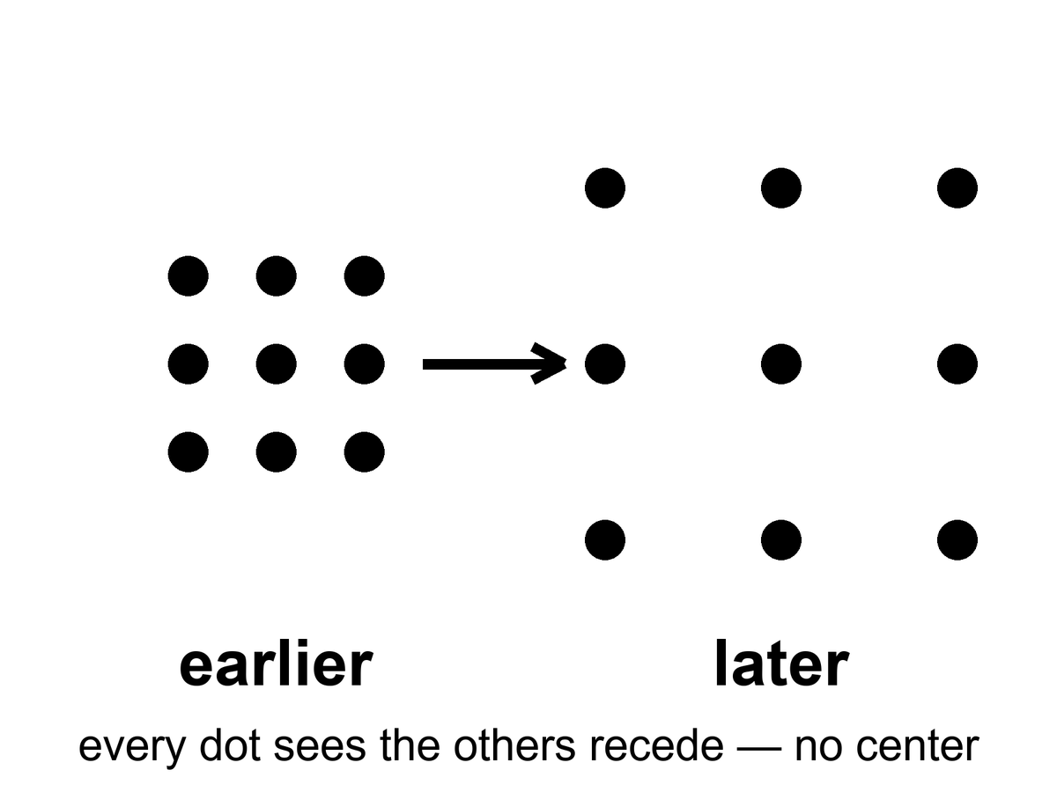
Figure 7. A grid of dots that grows. Every dot sees the others recede; no dot is the center.
Read the figure as a rule, not a cartoon. If every dot recedes from every other dot, you cannot stand outside the grid and point at the blast. There is no outside. The grown-up name for that rule is FLRW: Friedmann–Lemaître–Robertson–Walker, four people whose initials stand for a spacetime that is homogeneous and isotropic on large scales. Homogeneous means no special place. Isotropic means no special direction. Put them together and you are not allowed a center, and you are not allowed an edge you could walk to. An edge would be a special place. A center would be a special place. The equations refuse both.
The single number that does the work is a scale factor, written a(t).
where a(t) is the relative size of unbound distances at time t, set to 1 today by habit, smaller in the past, growing if the raisins are receding.
Distances between unbound things scale with a. Wavelengths of free light scale with a. Ordinary matter thins as 1/a³, because the same stuff is poured into a larger volume. Radiation thins faster, as 1/a⁴, because each photon is also getting tired. That bookkeeping is the whole of the simple expanding universe as a calculator. Appendix A7 writes the metric. Here it is enough to stop looking for a warehouse.
The equations that describe this are named for Alexander Friedmann, a young mathematician who, in the early 1920s, took Einstein’s gravity seriously enough to let the universe change size. Einstein had tried to freeze it with a fudge factor. Friedmann showed the freeze was optional. Georges Lemaître, a priest and physicist, said out loud what the math was hinting: the universe has a history. Edwin Hubble, with a telescope and a lot of patient plates of spiral nebulae, found that the farther a galaxy is, the faster it recedes. The grenade picture rushed back in through the newspapers. It has been misleading well-meaning people ever since.
The dates are not decoration. In 1922 Friedmann published expanding — and recollapsing — solutions of Einstein’s equations. Einstein’s first reply was that the paper contained a mistake. The mistake was Einstein’s. He had already, in 1917, added a term — the cosmological constant, written Λ — to keep the universe static, because a static universe was the respectable prejudice of the room. When the freeze proved optional, and then when the sky refused to sit still, Einstein regretted the term. Later retellings call it his biggest blunder. Whether he used that kitchen word, or only suffered the fact, is a historian’s fight. The physics fight is simpler: he had forced the loaf not to rise, and the loaf was rising.
Lemaître, in 1927, did the unfashionable thing of putting numbers on the stretch and saying, in print, that the universe had a history with a hotter, denser past — a primeval atom, in his phrase. Hubble, in 1929, plotted velocities against distances for a handful of galaxies and got a line. The line was noisy. The distances were too small by a factor of several. The slope was therefore too steep. The existence of the slope was the news. Chapter 8 will fight over the second digit of that slope. This chapter only needs the insult to the grenade: recession is a function of distance, not of a privileged warehouse.
Hot claim: the universe is expanding, and it was hotter and denser in the past. That is not a mood. It is the only account that has survived the leftover glow in Chapter 9 and the leftover helium in Chapter 10.
Warm claim: the simple expanding model — same in every direction, no special place — is a superb average. Under the average there is a foam of clusters and voids, which we will meet when quantum twitches get their chapter.
Cold claim, which this book will not smuggle in as fact: that the bang was a “beginning of everything” in the kitchen-clock sense, with a waiting room labeled BEFORE. The loaf may have a boundary. “Before” may not be a word that applies. Chapter 45 will sit with that until it stops itching.
Was there really a bang?
There was really a hot, dense, expanding everywhere. That is not a brand. It is two fossils and a stretch: the leftover glow, the leftover helium, the raisins receding. If you want the words “Big Bang” to mean a grenade, then no. If you want them to mean the past we can rebuild — a universe that was once a mixed fog, did nuclear work in minutes, and has been getting roomier since — then yes. The name is a nickname. The nickname stuck. The grenade did not.
It was not an exploding black hole. A black hole is a local one-way membrane in a larger loaf, made when a clump loses an argument with gravity. A white hole is that film run backward: a local fountain no one has seen. The bang was not local. There was no outside to explode into, no warehouse, no shrapnel crossing a pre-existing dark. Here: a hole is a place. The bang was a time. You can write math in which a collapse, time-reversed, looks like a bang. You cannot point at the leftover glow and say “that was a star that burst.” Stars come later. Holes come later. The fog comes first.
How old, if we are allowed a kitchen number? About 13.8 billion years (the Planck fit gives 13.79, uncertain by about twenty million years within the standard model²¹), counted from the hot fog we can reconstruct — not counted from a waiting room labeled BEFORE. That is a hot-enough claim for this chapter: the leftover glow, the leftover helium, and the stretch-rate of now, run backward through the equations, meet at a finite age. The number will get a few more digits later. It will not turn into infinity.
Then why is the part we can see about 93 billion light-years across, if light has only had 13.8 billion years to travel? Because the dough kept rising while the light was in transit. A photon that has been flying for 13.8 billion years did not fly through a frozen warehouse. The places it left have been pulled farther apart the whole time. The farthest stuff whose light has had time to reach us sits, today, at a proper distance of about 46 billion light-years. Diameter, roughly 93 billion. That is not the universe’s edge. It is our archive’s edge. Chapter 26 will make the distinction official. Here: the loaf is larger than the slice we can still taste.
So what was it from?
Not from a kitchen nothing — not from an empty room with the lights off and a magician. Empty, in physics, is already a something: a vacuum with rules, jitters, a leftover shove, a geometry. Pair production makes a particle and its opposite from energy, and the energy had to be in the account. The early soup made particles and antiparticles by the truckload and then almost canceled them. We are the rounding error: about one leftover nucleon per billion photons, Chapter 10’s ratio, the reason atoms are a footnote. That leftover is a warm problem with a name, baryogenesis — why the cancellation was rude by one part in a billion. We have recipes (a bit of leftover difference between matter and antimatter, a bit of out-of-equilibrium cooking). We do not have the dish photographed. “Matter from nothing” is a poster. Matter from a slightly unfair soup is the grown-up line.
Andrei Sakharov, in 1967, wrote down what a kitchen would need to keep one extra ladle of matter when the soup tried to cancel. Three conditions, in ordinary language. First, the books must be allowed to go out of balance: the soup must be able to change the baryon count, to make a nucleon without making its twin. Second, the soup must be rude in a particular way. It must treat matter and antimatter a little differently, and it must treat left and right a little differently, which physicists write as C violation and CP violation — charge conjugation and its partner, the combined swap of particle-identity and mirror. Third, the cooking cannot be in equilibrium. A pot that has fully settled forgets its rudeness; the extra ladle gets undone on the way back. You need a moment when the reactions cannot keep up with the cooling — a slammed oven door, a stretch that outruns the chemistry.
Those three are warm. We have seen C and CP rudeness in laboratories on Earth, in kaons and B mesons, at the level of a small insult, not yet at the level of one leftover in a billion. We have not photographed the cosmic moment. The ratio is hot. The recipe that produced the ratio is a research program.
What about the soup’s own origin — the first slice of loaf?
Inflation, if you buy it, pushes the question back: a burst of stretch, then a reheating that is the hot fog. The burst still wants a field, a vacuum, a reason. Quantum-gravity sketches try to stop using “before”: Hartle and Hawking round the loaf off so time only becomes time when there is enough of it; Vilenkin tunnels from a technical nothing that is not a kitchen nothing. Those are cold, and they are allowed to be. The fossils do not reach that room. They reach the fog, the three minutes, the glow. We do not owe you a waiting room labeled BEFORE in order to say the fog was real.
For now, retire the grenade. Retire the bursting hole. Keep the dough. The past we can rebuild is not a point. It is a hotter, smaller-spaced version of everywhere, made of a soup that almost canceled and didn’t, and we do not yet own the first word of the recipe. We own the leftovers. That is already a courtroom.

8. Everything Is Stretching
In the 1910s, Vesto Slipher, working nights at a stubborn telescope in Arizona, noticed that the light from many spiral nebulae was shifted toward the red. Red, in the physics of waves, is the stretch. A siren falling away from you drops in pitch for the same family of reasons. Slipher did not yet know those nebulae were other galaxies. He had the stretch before he had the nouns.
The years were 1912 to 1917, more or less, a run of plates at Lowell Observatory. Slipher was measuring spectra: the fingerprints of atoms in light — hydrogen, calcium, the usual set of lines. In spiral nebulae those lines sat in the wrong place, shifted toward the red for most of them, toward the blue for a few. Receding, approaching. He did not yet have a distance ladder tall enough to turn the shifts into a law. He had a pile of redshifts and a puzzle. By 1917 he had two dozen spirals, and the pile was mostly red. The sky was already voting.
A law needs a ruler, not just a pile. The first honest cosmic ruler was a kind of star that brightens and dims on a schedule. Henrietta Leavitt, in 1912, working through plates of the Small Magellanic Cloud at Harvard, found that the longer the period, the brighter the star. Cepheids, named for the prototype in Cepheus. Once you have that relation, a Cepheid is a standard lamp: measure how fast it winks, infer how bright it truly is, compare with how faint it looks, and you have a distance. Hubble used those lamps to show that the spirals sat far outside the Milky Way. Then he used them again as rungs. Without Leavitt there is no Hubble law. There is only Slipher’s pile, glowing and unnamed.
Hubble and Milton Humason turned the stretch into a law. Plot distance against recession speed and you get a line, sloppy at first, cleaner every decade since:
v = H₀ × d
where v is how fast a distant galaxy recedes, d is its distance, and H₀ — Hubble’s constant — is the slope, the stretch-rate of now.
Humason had been a mule driver on the mountain before he became the person who could hold a faint galaxy on a slit for hours. The 1929 paper was a handful of points.²² The 1930s were Humason going fainter, the line getting longer, the slope refusing to go away. Hubble’s first number was about 500 kilometers per second per megaparsec, wildly high, because the distances were wildly short. The modern fight is not whether there is a slope. The modern fight is whether the slope is nearer 67 or nearer 73.
The number has been fought over for a century and is still being fought over a little. The fight is about the second digit, not about the existence of the line. Galaxies recede. Farther means faster. That is hot.
Say the digits out loud, because the argument is real and it is not a crack in the bang. One camp reads the leftover glow of Chapter 9 through the simple expanding model and gets about 67 kilometers per second per megaparsec.²¹ Another camp climbs Leavitt’s ladder in the nearby universe — Cepheids in hosts that also explode in a particular way — and gets about 73.²³ Both error bars are small enough that the two numbers do not overlap. That is the Hubble tension.

Status as of October 2026: the Hubble tension
Measured. The early-universe route (the leftover glow plus the standard model) gives about 67.2 to 67.4 km/s/Mpc, uncertain by about 0.4 to 0.5.²¹ Baryon acoustic oscillations from DESI, calibrated with the helium-era physics of Chapter 10, give about 68.5 ± 0.6.²⁴ The Cepheid–supernova ladder gives about 73.2 ± 0.9,²³ and a 2026 combination of many local methods gives 73.5 ± 0.8, quoted as about seven standard deviations from the glow’s value.²⁵
Contested. A ladder that uses a different kind of star (the tip of the red giant branch) lands near 70.4, with error bars wide enough to touch both camps.²⁶ So the live question is whether one rung of the local ladder still hides a systematic error, or whether the simple model needs a new ingredient early or late.
What would settle it. Independent distances that use no ladder at all: gravitational-wave “standard sirens,” time delays in lensed quasars, and more host galaxies measured by more than one method. None has yet reached the needed precision. It may mean a rung is still mis-cut. It may mean the simple model is missing a late-time ingredient. It does not mean the raisins have stopped receding. Appendix A8 keeps the algebra. Here: the first digit is a 6 or a 7. The existence of the stretch is not on the table.

The later ruler, the one that extends the ladder past where Cepheids fade, is a kind of exploding star: Type Ia, a white dwarf that goes thermonuclear with a peak brightness you can standardize. Chapter 18 will hire those explosions to show that the stretch is speeding up. Do not steal 1998 from that chapter. This chapter only needs the job description. Cepheids get you to nearby galaxies. Type Ia get you farther. Both are lamps. Both can be wrong in the second digit. Neither is optional if you want a number for H₀ that is not just a slope on a chalkboard.
A megaparsec is a terrible kitchen length and a perfect cosmic one: about 3.26 million light-years, the distance at which the Hubble law starts to drown out the local shoving. Nearby, galaxies have peculiar velocities — they fall toward neighbors, swing in groups, approach like Andromeda, which is coming toward us at about 110 kilometers per second because the two galaxies are gravitationally bound. The Hubble law is not a traffic ticket issued to every smudge. It is the motion that remains after you leave the bound clump. Plot only the Local Group and you will not find a slope. Plot past a few tens of megaparsecs and the slope sits up. H₀ in kilometers per second per megaparsec means so many extra kilometers per second of recession for each extra megaparsec of distance. At 70, a galaxy 100 megaparsecs away recedes at about 7,000 kilometers per second.
The redshift itself is not a guess. It is a shift of named lines. Hydrogen’s Lyman-α, the calcium H and K pair Slipher knew, the oxygen lines that light up star-forming gas: you know where they sit at rest, because you can measure them in a lamp. In a distant galaxy they sit redward by the same factor for every line. That common factor is 1 + z. If the lines disagreed with one another, the stretch would be a fraud. They do not disagree. A single z slides the whole fingerprint. A speedometer reading of v = cz is only a translation for small z. At z = 1 you are not allowed that translation. You are allowed the scale factor.
What is stretching is not the galaxies themselves, as if someone had put Andromeda on a rack. Bound things — people, planets, solar systems, galaxies — hold together. What stretches is the space between the unbound. Light traveling through that stretch gets its wavelength pulled longer. A photon that left a hydrogen atom as a sharp ultraviolet line arrives here as a tired red one. The amount of stretch is written 1 + z, where z is the redshift. A galaxy at z = 1 sent its light when the universe was half the scale it is today. A galaxy at z = 6 is a teenager from when the first big galaxies were still assembling. The leftover glow of Chapter 9 sits at z about 1,100. We are looking at the universe when it was about a thousandth of its present size.
Put the scale factor back on the table, because the sentence deserves its own line:
a = 1 / (1 + z)
where a is how large unbound distances were when the light left, compared with today, and z is how much the wavelength has been pulled.
At z = 1, a = 1/2: half-size. At z ≈ 1,100, a ≈ 1/1,100: the leftover glow. Redshift is not a speedometer glued to a galaxy. It is a receipt for how much the dough rose while the photon was in the mail.
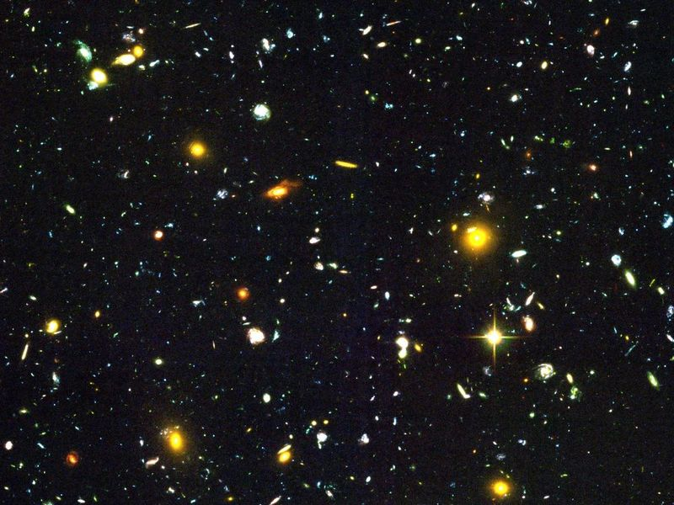
Figure 8. A handful of distant galaxies, each still sharp. Almost every one is receding.
There is a cruelty hidden in the kindness of the deep field. The most interesting smudges are so far that their light has been in transit for most of the age of the universe. We will never send a reply that arrives while anything there still resembles what we photographed. the night sky is not a room. It is a history of rooms, stacked by how much they have been pulled since the light left.
The James Webb Space Telescope did not invent high redshift. It made it rude. There are galaxies at z > 10. That sentence is hot: spectroscopically confirmed objects from when the universe was a few hundred million years old, already shining as galaxies, not as a rumor of gas. The fight — and it is a real fight — is how mature they look. Some of them seem too massive, too dusty, too done for the time on the clock, if you feed certain models of how fast stars should have assembled. That fight is warm. It is a fight about the first factories, not about whether the dough rose. Early galaxies exist. How quickly they put on weight is a measurement in progress, not a loophole in Chapters 9 and 10.
There is a distinction the newspapers keep flattening. Light-travel time is how long the photon was in the mail. Proper distance now is where the sender sits in today’s dough. At z = 1 the mail took about eight billion years; the sender now sits farther than eight billion light-years because the dough rose in transit. At the leftover glow the mail took 13.8 billion years and the sender’s current seat is about 46 billion light-years. This chapter only needs you not to treat z as a speed and not to treat lookback time as a ruler you can lay on the table without the scale factor.
One more detail, because it is beautiful and true. The Hubble law does not pick a center. If every raisin recedes from every other raisin in proportion to distance, then your raisin is allowed to write the same law. The slope is a property of the dough, not of a privileged kitchen.
A rough inverse of H₀ is a Hubble time. If the slope is 70 kilometers per second per megaparsec, 1/H₀ is about 14 billion years. That is not the age, because the stretch-rate has not been constant — matter used to brake, the shove now speeds — but it is the same order as 13.8, which is why a slope could smell an age before the leftover glow gave us a clock. Hubble’s first number implied something like two billion years and was already in a fight with rocks. The second-digit fight of 67 versus 73 is a fight inside a number that finally agrees with the stones.
Appendix A8 writes the redshift into the scale factor and shows how H₀ is a snapshot of a function H(t) that has not been constant. Dark energy, when we get there, is a statement about that function’s later life. The stretch is older than the speeding-up. The speeding-up is a plot twist, not the opening scene.

9. A Baby Picture in Microwaves
In 1964, Arno Penzias and Robert Wilson were trying to make a radio antenna in Holmdel, New Jersey, shut up.²⁷ It hissed. The hiss came from every direction. They cleaned out the pigeons. They checked the wiring. The hiss stayed. A few miles and a few conversations away, a Princeton group was looking for exactly that hiss: the leftover heat of a once-hot universe, stretched by expansion into microwaves, cooled to a few degrees above absolute zero.
The Princeton group had names, and they had a theory, and they were a little late. Robert Dicke had built the kind of radiometer that can hear a sky this quiet. Jim Peebles had calculated that a hot, dense past should leave a glow at a few degrees Kelvin. Peter Roll and David Wilkinson were getting ready to look. In 1965 the Holmdel hiss and the Princeton calculation met, and the leftover glow stopped being a prediction. It became a measurement. Penzias and Wilson had not been hunting a bang. They had been hunting a clean antenna. The universe does not care what you were hunting.
They had found the baby picture.
It is not a photograph in the camera sense. You cannot walk outside and see it. You need a radio ear. But it is as real as the Sun, and in some ways ruder, because it is in your kitchen too. A small fraction of the snow on an old analog television was this glow, leaking into the living room, older than any continent.
Why microwaves, not visible light? Because the oven cooled. A blackbody’s peak wavelength stretches with a. At last scattering the fog was optical: 3,000 K, a dull red if you could have had eyes, which you could not. Stretch by a thousand and the peak sits near a millimeter, in the microwave, a frequency around 160 gigahertz on the FIRAS curve. That is why Penzias and Wilson heard a hiss on a radio horn and not a glow on a photographic plate. Alpher and Herman had predicted a leftover of a few degrees Kelvin in 1948. They did not have Holmdel. They had the right order of magnitude and a number that waited seventeen years for an antenna that would not shut up.
The temperature is 2.725 kelvin — two and three-quarters degrees above the coldest anything can be.²⁸ The spectrum is a blackbody so clean it makes laboratory blackbodies look sloppy. A blackbody is the glow of something in thermal equilibrium, a “we have mixed thoroughly” signature. The early universe was mixed. Then it stretched, and the glow stretched with it, and the mix was frozen into the sky.
COBE, the Cosmic Background Explorer, carried the instrument that made that sentence unkind to rivals. FIRAS — a spectrophotometer built to argue with the sky — found a blackbody at 2.725 K so tight that the error bars sit inside a line on a plot. John Mather’s team had measured the temperature of the universe the way a baker measures an oven: not by mood, by a curve. If you want a hot claim with a decimal, take that one. The leftover glow is not “about three degrees.” It is 2.725, and it is a blackbody, and the departures from that curve are so small they had to be hunted on purpose.
A blackbody this clean is also a veto. Starlight bounced off dust, a fog of leftover starlight, a glow from nearby radio junk: those stories produce the wrong shape. They can make a hiss. They cannot make FIRAS. The curve is the courtroom. The pigeons were a reasonable first suspect. They were not a spectrum.
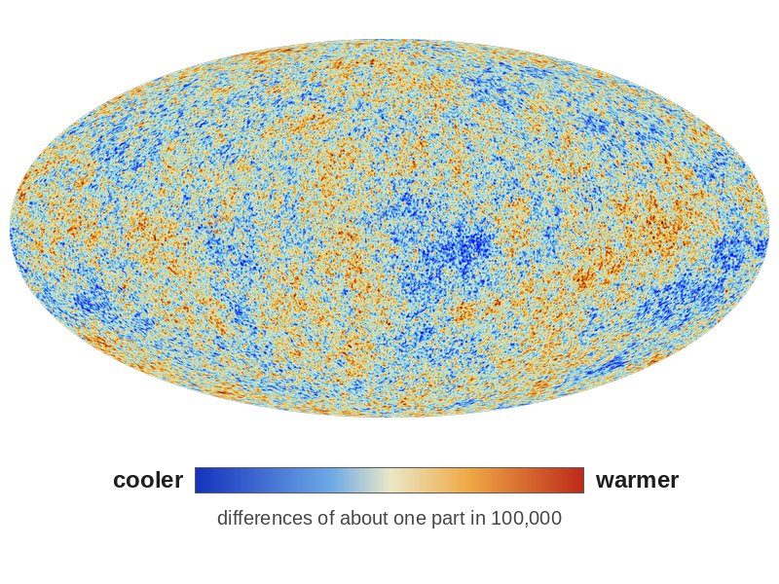
Figure 9. The microwave sky as an oval map: blue patches are slightly cooler, red patches slightly warmer. This is a measurement, not a snapshot from a camera.
The freckles have a date. COBE’s DMR map, in 1992, showed that the sky is not perfectly bland: differences of about one part in 100,000, the first photograph of the seeds Chapter 14 will grow into galaxies. George Smoot’s team had not found continents. They had found the rumple in the dough. WMAP, through the 2000s, turned the rumple into a spectrum of sizes. Planck, with maps in 2013 and a final cosmology release in 2018, sharpened the weather chart until the peaks in that spectrum became a courtroom of their own: how much ordinary matter, how much extra pull, how fast the stretch, how flat the large-scale geometry. Those later maps are how Chapter 11 gets its percentages. This chapter only needs the baby: a blackbody with freckles, photographed on the whole sky.
Why 380,000 years? Before that, the universe was a plasma: nuclei and electrons, loose, swimming in light. Light could not travel far. It kept bouncing off free electrons, the way sunlight has trouble getting out of the middle of the Sun. When the universe cooled enough for electrons to lock onto nuclei and make the first hydrogen atoms, the fog lifted. Photons that last scattered then have been flying in straight-ish lines ever since. We photograph the surface of last scattering the way you photograph a cloud bank from an airplane: you do not see through it. You see the top.
Two nouns get mixed here, and they should not. Recombination is the chemistry: electrons locking onto nuclei, the universe becoming electrically neutral for the first time. (The name is a fossil; nothing had combined before. It was combination. The word stuck anyway.) Last scattering is the optics: the last time a typical photon bounced off a free electron and then ran. They happen at nearly the same age, because once the electrons are locked, the fog has nothing to bounce off. Nearly is not identical. A few electrons stay free. The last bounce is a little later than the locking, a surface with a thickness, not a pane of glass. Kitchen language: the soup sets, and then the last steam stops hitting the lid. We photograph the lid.
Before the fog lifted, a photon’s mean free path was a kitchen, not a cosmos: bounce, bounce, bounce, like light in milk. After, the mean free path became the size of the observable universe. That is the whole optical trick. We are not looking through milk. We are looking at the last skin of milk, stretched into an oval.
The temperature then was about 3,000 K — a red-hot fog, the color of a stove element, not a microwave. Stretch the wavelengths by 1 + z ≈ 1,100 and 3,000 K becomes 2.725 K. The number is not a coincidence. Temperature of free light scales with 1/a. Cool the oven by stretching the kitchen.
One large pattern is not a freckle and should not be sold as one. The whole sky is a few thousandths of a degree warmer in one direction and cooler in the opposite direction: a dipole. It corresponds to a motion of about 370 kilometers per second toward Leo, the Sun’s peculiar velocity relative to the leftover glow. We are not at rest in the dough. We orbit the Galaxy; the Galaxy falls toward a crowd; the crowd has a velocity of its own. Maps like Figure 9 have that dipole subtracted, the way you subtract the motion of the train before you argue about the scenery. What remains is the baby picture, not our weather.
The oval is not raw sky. Our own Galaxy shines in microwaves too — dust, electrons spiraling in magnetic fields, a plane of junk across the middle. Planck’s maps are the sky after that junk has been modeled and taken off, a subtraction as necessary as wiping flour off a scale. What you are allowed to call cosmology is the remainder. WMAP, the Wilkinson Microwave Anisotropy Probe, carries David Wilkinson’s name because he was one of the people waiting in 1965 and one of the people who spent a career making the wait into a map. He died before the full harvest. The probe did not. The sky does not pause for obituaries.
Inside the freckles there is a sound, almost literally: the plasma, before last scattering, could ring. Overdense patches compressed, bounced, compressed again, a fluid with light as the spring. Those acoustic oscillations froze at 380,000 years into a preferred set of angular sizes on the sky — peaks in a power spectrum. Planck’s 2013 and 2018 papers are, in large part, a reading of those peaks.²¹ This chapter will not steal Chapter 14’s seeds or Chapter 11’s inventory. It will say that the baby picture is not a blur. It is a freeze-frame of a ringing fog, and the ring has been measured.
Those freckles are not decoration. They are the seeds of Chapter 14, written in temperature. A patch that was a little denser then is a little more likely to be a cluster of galaxies now. The baby picture is also a will.
The evenness of the picture is its own unpaid bill. Look at two patches on opposite sides of Figure 9. Their temperatures match to a part in a hundred thousand. In the simple bang of this part, those patches have never been in each other’s past light cones. They have not had time to talk, to mix, to agree. That is the horizon problem. It is a real problem. It is not a reason to throw out the leftover glow. It is a pointer: Part III exists because this sky is too even for a kitchen that never shared a pot. Do not solve it here. Notice that the baby picture both confirms the hot fog and hands you a puzzle the fog, by itself, does not pay.
Hot claim: the leftover glow exists, is a blackbody, is almost the same in every direction, and has freckles at the level of one part in a hundred thousand. Warm claim: those freckles are the fingerprint of slightly uneven density in a hot, expanding plasma. Cold claim: any story of the first 10⁻³² seconds that does not eventually produce this picture is entertainment.
When you look at Figure 9, you are not looking at a place. You are looking at a time. The oval is the entire sky. The entire sky is one age. That is what “the explosion happened everywhere” looks like when it has had 13.8 billion years to cool in public.

10. The First Three Minutes
Steven Weinberg gave this interval its fame, and he was right to. Between about a hundredth of a second and a few minutes, the universe did something we can reconstruct with the same nuclear physics we use in the Sun and in weapons labs. Before that, the story gets warmer and then cold. After that, for a long time, not much of nuclear interest happens. The three minutes are a workshop. We still own the tools.
He was not the first to guess that a hot past would cook light nuclei. In 1948 Ralph Alpher and George Gamow published a paper with Hans Bethe added, as a joke, as the middle author, so the names would read α, β, γ — alpha, beta, gamma.²⁹ The αβγ paper argued that the early universe could build nuclei by capturing neutrons, and that a leftover glow should still be around. The capture-chain details were wrong in ways that later work had to repair: you cannot climb the whole periodic table in three minutes, because there are no stable lodgings at five or eight nucleons. The helium insight was the seed. The leftover-glow insight was the other seed. Weinberg’s book, decades later, is the workshop with the tools calibrated. Gamow’s joke is how the idea first got a table.
At a hundredth of a second, the temperature is about a hundred billion degrees. No atoms. No nuclei that last. A soup of light, electrons, positrons, neutrinos, and a few leftover nucleons — protons and neutrons — swimming in a glare that would unmake any chemistry you have a word for. The nucleons are outnumbered by photons about a billion to one. That ratio is still written in the sky. It is why the universe is so empty of atoms compared with light, and why we are a footnote in a photon’s memoir. The billion dead twins are the antimatter that did not get a chair. Food, when we get to it, is a later argument about leftovers. The first leftover is this: the soup was unfair, and the unfairness is why there is anyone to eat.
Write the temperature once, as a kitchen clock, so the later ticks have a place to hang.
T ≈ 10¹¹ K at t ≈ 0.01 s
where T is the temperature of the soup and t is time since the hot fog we can reconstruct — not since a waiting room.
At that glare, electrons and positrons are still being born in pairs from photons and annihilating back. Neutrinos still talk to the rest of the pot. The nucleons are a trace ingredient, a pinch of salt in a vat of light.
Neutrons are slightly heavier than protons. In equilibrium, there are fewer of them. As the soup cools, the reactions that turn protons into neutrons and back slow down. At about one second, neutrinos stop talking to the rest of the soup — they decouple — and the neutron-to-proton ratio freezes near one-to-six, then keeps dropping slowly because free neutrons decay. You have about ten minutes before most of the leftover neutrons would be gone. The universe does not give you ten minutes of workshop time. It gives you about three.
The free neutron’s lifetime is about fifteen minutes. That is why the workshop is in a hurry. Leave the nucleons sitting as a warm gas with no oven and the neutrons wander off into protons, electrons, and ghostly leftovers, and there is nothing left to glue into helium. Ten minutes would have wasted most of the inventory. Three minutes spends it. The clock is nuclear, not rhetorical. A kitchen timer on the counter is the same kind of object as this: a half-life with consequences for the recipe.
Decoupling, here, is not a mood. It is a race. The soup is thinning and cooling. The weak reactions that let neutrinos knock nucleons around get slower. When the reaction rate falls behind the stretch rate, the neutrinos leave the conversation, streaming as their own leftover — a cosmic neutrino background we have not photographed as a map, but whose presence is felt in the helium and in the leftover glow’s peaks. One second is the door slam. The neutron fraction at the slam, plus a little decay on the walk to minute three, is the inventory the workshop will be allowed to spend.
At roughly three minutes, the temperature has fallen to a billion degrees. Deuterium — a proton glued to a neutron — can at last stay stuck. Before that, the glare broke deuterium as fast as it formed. This is the deuterium bottleneck, a traffic jam with a clock. Once deuterium survives, helium-4 assembles with almost greedy efficiency. There are no stable nuclei with five or eight nucleons, so the assembly line stalls at helium. A sprinkle of lithium is a leftover rounding error. Almost every neutron that survived is now locked in helium.
T ≈ 10⁹ K at t ≈ 3 min
where that billion-degree tick is the oven setting at which deuterium stops being smashed, and helium can be baked.
If nearly every leftover neutron is locked in helium-4, and you started with about one neutron per seven nucleons after decay, the mass fraction of helium sits near one quarter.
Y_{p} ≈ 0.25
where Y_{p} is the primordial mass fraction of helium-4, counted before stars had a chance to lie.
Deuterium that escaped the greedy step survives as a sprinkle.
D/H ≈ 2.5 × 10⁻⁵
where D/H is deuterium nuclei per hydrogen nucleus in uncooked gas, a thermostat for how crowded the nucleons were in the pot.
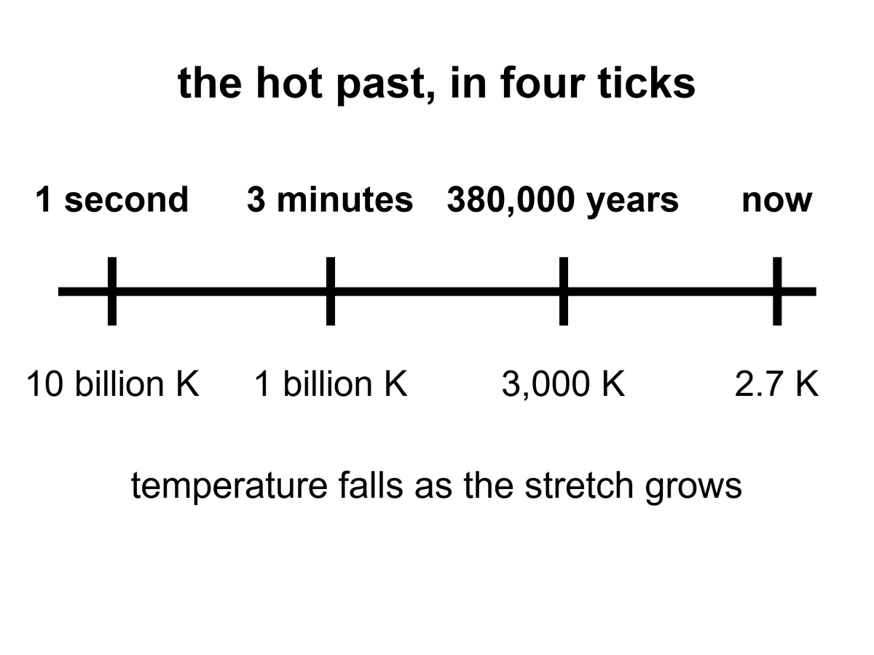
Figure 10. Four ticks on one line: one second, three minutes, 380,000 years, now. The temperature under each tick falls as the stretch grows.
Then the workshop closes. The soup is still too hot for atoms. It will be too hot for 380,000 years. But the nuclear work is done. The universe has committed, by weight, to about three-quarters hydrogen and one-quarter helium, plus a dust of the rest. Stars will later lie about this. They will burn hydrogen into more helium and brag. The first helium is not their brag. It is a fossil.
Weinberg’s afterword, years later, had to make room for inflation and for freckles in the leftover glow. He did not have to take back the three minutes. The three minutes have only gotten sharper. That is what a hot claim feels like when you meet one in the wild.
If you could inventory the ordinary atoms in the universe — not the dark extra pull, not the dark extra shove, the atoms — you would find that about one-quarter of their mass is helium-4. That is an absurd amount of helium to blame on stars.
Stars are helium factories, yes. Our Sun is making helium in its core right now, at a stately, suburban pace. In ten billion years it will have converted a respectable fraction of its hydrogen. It will not have converted a quarter of the hydrogen in the universe. There has not been time, and there have not been enough stars. The first stars, which were massive and brief and sloppy, made a mess of carbon and oxygen and the iron in your blood. They did not flood intergalactic space with a quarter-by-mass of helium. Something else did.
Say that as a budget, not as an insult. Take every star that has ever shone in the observable loaf, give it a generous lifetime, let it burn at a generous efficiency, and you still cannot cook a quarter of all baryons into helium. Stars make metals — astronomers’ rude word for anything heavier than helium — in interesting amounts. They make extra helium locally, in cores and in winds. They do not set Y_{p}. The sky’s baseline helium is older than the first star. That is why the workshop is not optional, and why Alpher and Gamow, joke author included, were pointing at the right oven even when the recipe was still a mess.
The something else is the workshop, caught in the act.
Astronomers measure primordial helium in the least sophisticated gas they can find: dwarf galaxies that have made almost no stars, clouds that have not had a chance to lie. The number they keep finding sits near a quarter by mass, with a little scatter and a lot of argument about the second digit. Deuterium, which stars destroy more easily than they make, is a second fossil. Too much deuterium and the early workshop was too empty of nucleons. Too little and it was too crowded. The observed sprinkle of deuterium is a thermostat for the nuclear minutes. Lithium is the sulky cousin: the prediction and the measurement still do not quite shake hands. That fight is real and unfinished. It does not cancel the helium.
The practical kitchen for helium is an H II region: a nebula where hot stars have stripped electrons off hydrogen, so the gas glows in lines you can put a spectrometer on. Look in metal-poor dwarf irregulars — galaxies that have barely cooked a periodic table — and the helium lines sit near that quarter by mass. Look at deuterium in high-redshift clouds, uncooked by stars, and you get a few deuterium nuclei per hundred thousand hydrogen nuclei, about 2.5 × 10⁻⁵. The photon-to-baryon ratio that makes those numbers come out is the same billion-to-one already sitting in the leftover glow: about 10⁹ photons per nucleon. Two fossils, one crowding number. Lithium-7 is the exception that still itches: the workshop predicts two to three times more than the oldest stars seem to hold, or the stars seem to hold two to three times less than the workshop baked. Factor two or three, not a factor of a hundred. Warm, unfinished, not a loophole.
The lithium fight has a name on the stellar side: the Spite plateau, a floor of lithium-7 in the oldest, most metal-poor stars, lower than the three-minute prediction by a factor of two or three. Either the stars ate some after they formed, or the workshop’s lithium-7 channel is still missing a correction, or both. People who work on stellar atmospheres and people who work on nuclear rates have been polite at each other for years. The helium does not care. The deuterium does not care. Lithium is allowed to be the sulky cousin and still sit at the table.
Here is the detail that makes the fossil personal. Every breath you take is mostly nitrogen and oxygen, cooked in stars that died before the Sun was a cloud. The helium in a party balloon is mostly not that. Some of it leaked from Earth’s crust, where uranium and thorium have been throwing helium nuclei like litter for eons. Some of the helium in the cosmos, the quarter that is not a party trick, has been helium since before there was a periodic table with more than two honest entries. You cannot hold that helium. You can know it.
Hot claim: the light-element abundances match a hot, expanding workshop³⁰ with a known nucleon-to-photon ratio. Warm claim: the remaining lithium tension is a problem for astronomers and nuclear theorists, not a loophole for a cold beginning. Cold claim: any rival origin story that cannot produce this helium is not an origin story. It is a mood.
The leftover glow says the universe was once a mixed, hot fog. The leftover helium says the fog did nuclear work on a three-minute clock. Two fossils, two methods, one past. That is as close as cosmology gets to a courtroom.

11. Almost Nothing, Almost Everywhere
Smooth the universe. Take every star, every planet, every wandering rock, every atom in every lung, and spread them until the lumps are gone. You will have, on average, about one atom of ordinary matter in a space the size of a closet — a cubic meter, give or take the fights about the second digit. A good vacuum pump on Earth is proud to do worse.
Insist on the second digit and the closet is a little emptier than the sentence suggests: about 0.2 ordinary atoms per cubic meter, once you weigh the universe properly and give the atoms only their share. “About one” is the kitchen insult. 0.2 is the receipt. Either way, you are not living in the average. You are living in a lump.
That is the catalog’s first insult. We live in a freak clump. The clump is not the rule. The rule is the emptiness.
The second insult is that the atoms are not even the main clump. When astronomers weigh the universe the way you weigh a truck — by how hard it pulls, not by how shiny it is — the atoms are a minority. About five percent of the energy budget is the stuff of chemistry. About a quarter is an extra pull that does not shine. About two-thirds is an extra shove that makes the stretch speed up. Chapters 17 through 19 are the inventory of those insults. Here it is enough to feel the loneliness of the five percent.
Elena weighs a bag of flour on a kitchen scale and trusts the number because the bag pushes down. She does not trust the number by how white the flour looks. Shine is a terrible scale. A bag of powdered sugar and a bag of whole wheat can fool the eye; they cannot fool the spring. Cosmology’s spring is gravity. Rotation speeds in the outskirts of galaxies, the way clusters lens background galaxies, the peaks in the leftover glow: those are pulls. The shine — stars, nebulae, the kitchen table — is the five percent announcing itself with light. Weigh the loaf by pull and the flour is a minority ingredient. Chapter 17 is the extra pull. Chapter 18 is the extra shove. Notice, only, that Elena’s habit is the right one, and that the cosmos does not owe her a bag that matches the photograph.
The bookkeeping has a name. There is a critical density, ρ_{c}, the amount of stuff that would make the large-scale geometry sit on a knife-edge: neither curling closed toward a recollapse nor hinging open so fast that galaxies never find each other.
ρ_{c} = 3H₀² / 8πG
where ρ_{c} is that critical density, H₀ is the stretch-rate of now, and G is Newton’s constant — the same G that weighs apples, planets, and Elena’s flour.
What we actually have is counted in units of that knife-edge:
Ω = ρ / ρ_{c}
where Ω is a density parameter, a fraction of critical, and the pieces of Ω are allowed to add.
The leftover glow, plus the stretch, plus the way structure grew, currently split the bill about like this: Ω_{b} ≈ 0.05 in ordinary atoms (baryons), Ω_{c} ≈ 0.27 in extra pull that does not shine, Ω_{Λ} ≈ 0.68 in extra shove. The sum sits near 1, which is why “flat” keeps surviving the maps. Those decimals will move in the fourth digit. They will not swap the story that chemistry is a rounding error with a press agent.
Put a kitchen number on the knife-edge, because “critical density” sounds like a mood and it is a mass. For a Hubble constant near 70 kilometers per second per megaparsec, ρ_{c} is about 9 × 10⁻²⁷ kilograms per cubic meter — a few proton-masses in each empty closet if all of it were atoms, which it is not. Only the baryon slice, the 0.05, gets to be atoms, and that is how you arrive at 0.2 per cubic meter. The rest of the pull does not sit on Elena’s scale as flour. The shove does not sit on it at all. “Flat” means the large-scale geometry is the one in which parallel lines stay parallel and the angles of a cosmic triangle add to 180 degrees. Planck’s maps like that answer. Part III will ask why the pebble sat on the blade. This chapter only weighs the bag.
Radiation is a rounding error now: the photon share, Ω_γ, is a few parts in ten thousand. Photons dominated the budget when the universe was young and the wavelengths were short; they lost the argument because each photon got tired as well as diluted. Neutrinos, decoupled at one second, are another small slice — a relic you feel in the helium and in the leftover glow’s peaks, not the extra pull of Chapter 17. The extra pull does not shine and does not, as far as the maps can tell, live in the periodic table. The extra shove does not dilute as matter does. Those two sentences are previews. They are not the chapters.
The 0.05 in Ω_{b} is not a guess from counting stars. Stars are a terrible census of atoms: most ordinary matter is not in stars. It is in hot gas, warm gas, a thin salt in clusters, a fog between galaxies. The leftover glow’s peaks and the three-minute deuterium thermostat agree on the baryon crowding to a level that would be vanity if they did not use different physics. That agreement is why 0.05 is hot enough to print. Counting kitchens will not get you there.
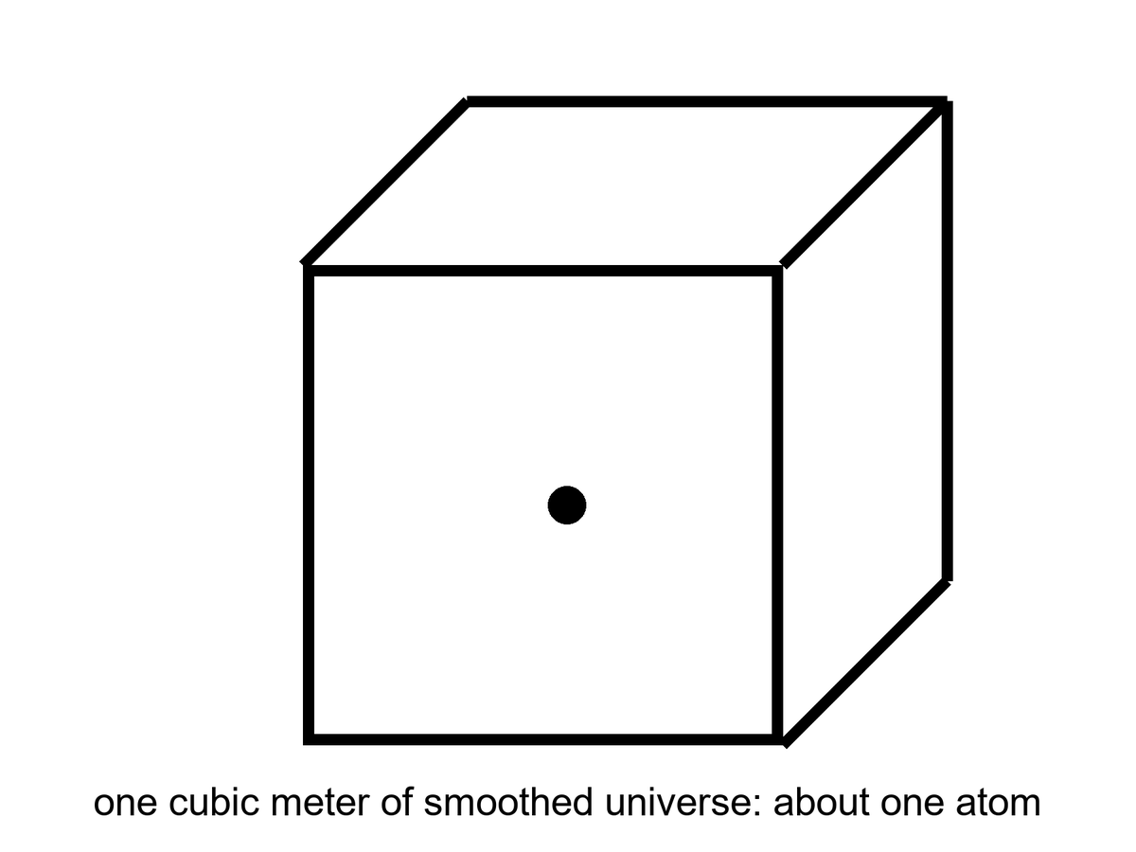
Figure 11. A cubic meter of smoothed universe holds about one atom. Almost nothing, almost everywhere.
Figure 11 is the most dishonest honest picture in the book. The cube is a meter on a side. The dot is an atom. If you drew the cube at the scale of Elena’s kitchen, the next atom of the average cosmos would not be in the house. It would not be on the block. You would need a walk that feels like a mistake. We do not take that walk, because we live in the freak, and the freak is full of dots that stuck. The figure is what you get when you refuse the freak and insist on the climate.
Barrow liked to shock readers with billions, and the billions are still shocking if you let them be specific. The observable universe is about 93 billion light-years across, not because it is 93 billion years old — it is 13.8 — but because the stretch has been pulling the farthest light’s starting points farther while the light was in transit. Inside that sphere there are a few hundred billion galaxies you could, in a generous mood, name. Each galaxy has, give or take, a hundred billion stars. Multiply and you get a number that looks like a lie: on the order of 10²² stars. Then remember the closet with one atom. The stars are the rare weather. The emptiness is the climate.
The 93-billion-light-year sphere is a census volume, not a wall. Ten-to-the-twenty-two is an order of magnitude, not a roll call: a hundred billion here, a hundred billion there, and the product is a 1 with twenty-two zeros and an argument about the first factor of ten. You may add a zero when the deep fields finish arguing about faint galaxies. You will not add emptiness to the stars and make the stars the rule. Figure 11 is the rule. The Milky Way is a rounding error that learned to shine.
Compare the densities so the closet stays honest. Air in Elena’s kitchen is about 2 × 10²⁵ molecules per cubic meter. The space between stars in the Galactic disk is already a vacuum by kitchen standards — maybe a million atoms per cubic meter in the better neighborhoods, far less in the halo. The smoothed cosmos is 0.2. Each step is a humiliation of the last. You cannot see 0.2 atoms per cubic meter. You can only weigh its consequences, or refuse to smooth, and live in the clump.
The clumps nest. A person is a clump in a kitchen. The kitchen is a clump on a planet. The planet is a clump around a star. The star is a clump in a galaxy. The galaxy is a clump in a group; our group is falling toward Virgo; Virgo sits in a larger web. Chapter 14 will grow the web from freckles. Here the point is only inventory: every noun you care about is a place where the average failed, gravity won, and the stretch was told to wait. The 10²² stars are 10²² local victories. They still occupy a negligible fraction of the 93-billion-light-year sphere.
Stars themselves are a later luxury. They are places where gravity won a local argument against the stretch, piled gas until the pile was hot enough to fuse, and then spent millions or billions of years turning hydrogen into the rest of the table. When the more massive ones die, they throw the table into space. Planets are the sediment of that throw. You are the sediment of the sediment, walking around asking where the sediment came from.
The catalog, then, is not a list of objects. It is a list of exceptions. A star is an exception to emptiness. A planet is an exception to the habit stars have of being unfriendly. A kitchen is an exception to the habit planets have of being dead. A book is an exception to the habit kitchens have of being used for casseroles.
The past we can rebuild explains how the exceptions got their raw material. It does not owe the exceptions a destiny. The leftover glow and the leftover helium will still be true if no one ever builds another kitchen. That is not a threat. It is the courtesy of a universe that does not need us in order to have had a first three minutes.

PART III — A Burst, Then Seeds

12. Three Puzzles the Hot Bang Cannot Solve
The leftover glow and the leftover helium make the hot, expanding past look inevitable. They do not make it comfortable. Three puzzles sit in the model like bills on a table, and the three-minute workshop does not pay them.
The first is the horizon problem. Look at the microwave sky in two opposite directions. The temperatures match to a part in a hundred thousand. For two patches to agree that tightly, they usually need to have talked — to have exchanged light, mixed, come to terms. In the simple hot bang, those opposite patches have never been in each other’s past light cones. They are like two strangers who have never met and have never had a friend in common, wearing the same shirt to the same size. You can call it a coincidence. Physicists get hives.
At 380,000 years, when the fog lifted and the leftover glow set out, a causal horizon — the farthest a light signal could have traveled since the simple bang began — was a small patch on the sky we photograph now. A couple of degrees. A thumbnail at arm’s length. The whole dome of the microwave sky is not a couple of degrees. Opposite patches sit a hundred thumbnails apart, and then some. The causal horizon at last scattering is much smaller than the sky. In the simple bang, the patches labeled A and B in Figure 12 have never been in each other’s past light cones. They did not mix. They did not come to terms. They still match, to one part in 10⁵, as if agreement were free.
You can try to rescue the simple bang by saying the universe started already even, on scales that had never talked. That is not a solution. That is a shrug wearing a lab coat. It pushes the evenness into the initial conditions and then looks innocent. Physics is supposed to make evenness, or at least to inherit it from a time when talking was possible. The simple bang, run backward from the leftover glow, does not give you that time. The leftover glow is a photograph of a single age, the entire sky at 380,000 years. The photograph is too even for the age.
Agreement, in physics, is not a fashion. Two patches of plasma come to the same temperature because photons ricochet between them until the hot spots have given their extra to the cold spots. That is thermal equilibrium, the same “we have mixed thoroughly” signature that makes the leftover glow a blackbody. Mixing needs a path. A path needs time. In the simple bang the time from a hot start to last scattering is 380,000 years, which sounds generous until you remember that the last-scattering surface we see is not 380,000 light-years across. Expansion has been stretching the rulers. The region that could have mixed by then subtends about a degree or two on today’s sky. Opposite patches — 180 degrees of argument — contain thousands of those little mixed rooms, none of which had a hallway to the others.
One part in 10⁵ is not a casual “pretty even.” It is the measured amplitude of the remaining freckles after the dipole of our own motion is subtracted. The average temperatures of opposite hemispheres match far tighter than a kitchen thermometer. Chapter 3’s light cones, applied at 380,000 years, do not overlap for A and B. Figure 12 is that non-overlap, drawn as a circle because the sky is a circle when you have only two dimensions of paper. The simple bang has no conversation that can buy the match. It has only a hope that the start was already a match. Hopes are not mechanisms.
The second is the flatness problem. The universe’s geometry — whether parallel lines stay parallel on the largest scales — is astonishingly close to “flat,” which is another way of saying the density is astonishingly close to a special critical value. In the simple bang, that closeness is unstable. A little too much density in the first second and the universe would have recollapsed before helium was done. A little too little and it would have become so empty, so fast, that galaxies would never have found each other. We live on a knife-edge that the equations keep trying to throw us off. Either someone balanced a pebble, or something drove the pebble to the middle of the blade.
Barrow liked a pebble on a blade. The blade is the critical density: the exact budget of stuff that makes Ω = 1, the universe in which the large-scale geometry does not curl into a ball or splay into a saddle. A little above, and gravity wins on a short clock. A little below, and the stretch wins so fast that clumps never find each other. We measure, today, a universe so close to that blade that the leftover glow, the later bombs of Chapter 18, and the frozen sound-scale in the galaxies all vote flat to within a percent or better. That is a fact about now. The insult is a fact about then.
In a decelerating bang — radiation, then matter, no burst — the quantity |Ω − 1| is driven away from zero as time runs forward. Closeness is unstable. Run the same equations toward the past and the required closeness blows up. By the time the clock reads one second, the pebble has to sit in the middle of the blade to something like one part in 10¹⁶. Not one part in a hundred. Not one part in a million. A 1-second pebble that would shame a watchmaker. Bump it, and you do not get a slightly different kitchen. You get a recollapse before helium, or a desert that never makes a galaxy.
Nobody balanced it with fingers. Either the initial conditions were an unpublished miracle, or something drove the pebble to the middle and held it there long enough that later physics would look inevitable. Inflation, in the next chapter, is the candidate drive. Here, notice only the bill: the simple bang does not explain the pebble. It assumes the pebble, and then spends 13.8 billion years trying to kick it off.
One second is not a mystic number. It is the door of Weinberg’s workshop: neutrinos have just decoupled, the neutron-to-proton ratio is freezing, the nuclear minutes are about to start. If the pebble is already wrong at that door, the workshop never opens, or opens onto a warehouse with no walls. The required closeness at the Planck time is worse — 10⁻⁶⁰, a number Barrow would have put on a chalkboard to watch a room go quiet. We do not need the Planck time to feel the insult. The 1-second pebble is rude enough. A pebble is not a mechanism either. It is a way of saying the tuning has a clock reading, and the clock reading is uncomfortably early.
The third is the relic problem. Grand unified theories — warm-to-cold ideas about how the forces were once one force — tend to produce leftover monsters: magnetic monopoles, heavy stable particles, knots in fields. The simple bang would have left the universe ankle-deep in them. We do not trip over monopoles on the way to the mailbox. Something diluted the relics, or they were never made in our past, or the grand theories are wrong. The first option is the one inflation was built to offer.
A magnetic monopole, in this context, is not a bar magnet you can put on the fridge. It is a knot in a grand-unified field, a particle that would be a north without a south, heavy, stable, and — if the simple bang passed through the grand-unified temperature — as common as the horizon would allow. One per causal patch, roughly, and then they sit there, too massive to decay, too stubborn to hide. They would outweigh the atoms. They would wreck the leftover helium’s accounting. They would be underfoot.
They are not underfoot. That is a fact you can take to the mailbox. So either the grand theories are wrong about the knots, or the knots were never cooked in our past, or something diluted them by a ridiculous factor — 10²⁵ in entropy, says the appendix, if you want a number to flinch at. Inflation was built, in part, as a dilution machine. Guth was thinking about monopoles when he started. The even sky and the pebble came along as bonuses. The bonuses are now the famous posters. The monopoles are the quiet third bill.
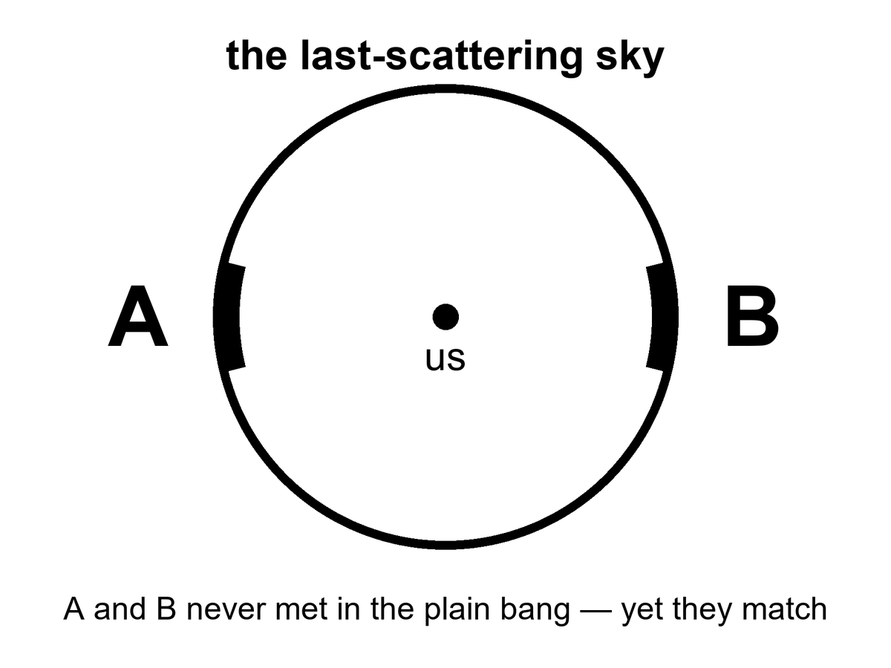
Figure 12. The last-scattering sky. Patches A and B on opposite sides never met in the plain hot bang, yet they match.
Weinberg paid the nuclear minutes. He paid them with the same nuclear physics we still use in stars and in laboratories, and the helium still sits in the account. These three remain. They are not evidence that the workshop was a fiction. They are evidence that the workshop started with a table already set, and nobody at the table could say who set it.
None of these puzzles says the hot bang is false. They say it is incomplete as a story of initial conditions. Weinberg could reconstruct the nuclear minutes without knowing why the sky was so even. Guth, in 1980, asked whether a brief, violent stretch before those minutes could set the table so the minutes would look inevitable.
Guth was not, in 1980, handing the community a finished preface. He was a particle theorist staring at monopoles, asking whether a false-vacuum stretch could dilute them, and noticing that the same stretch would also even the sky and drive the pebble. The paper is a question with a mechanism attached, not a verdict. Old inflation, the first mechanism, will fail to exit. That failure is Chapter 13’s opening debt. The question survives the debt. The three bills are still on the table either way.
That question is the opening of Part III. It is not yet the solution. Guth’s first try will have a graceful-exit problem, a mess about how to stop, which Chapter 13 will have to clean. The sky will later be photographed in polarization by people who were sometimes too eager. Those fights belong to the next pages. Here the honest inventory is three unpaid bills, a paid nuclear dinner, and a physicist asking whether a burst could be the missing payment.
That is a different kind of move. The three minutes are a reconstruction. Inflation is a proposed preface. Prefaces can be wrong even when the book is right. Keep the temperatures straight. The puzzles are hot. The leading solution is warm. The details of the preface — what field, what potential, what first 10⁻³⁶ second — are still being written in pencil.

13. Inflation, Without the Hype
Here is inflation without the poster.
Suppose, in a sliver of time so short that “sliver” is already too romantic, a patch of the universe was filled with a field that behaved like a temporary cosmological constant: a stuff whose tension was so odd that gravity, locally, repelled. The stretch that matters is an e-fold: every distance grows by a factor of e, about 2.7, not by a tidy doubling. About fifty to sixty of those e-folds are what the job asks for. Distances that had been smaller than a proton became larger than a grapefruit, then larger than a solar system, then larger than the part of the universe we can see. Then the field decayed. Its energy dumped into particles. The dump is called reheating, which is a calm word for setting a universe on fire. After the dump, you have a hot bang: soup, light, the three minutes, the leftover glow.
The kitchen is a pot on a high flame.
For a sliver the pot does not simmer. It boils over: the volume of steam is not a polite trickle, it is a room-filling insult, doubling and doubling. Then the whole violent pot dumps into a larger pot of soup. The dump is reheating. After the dump you have the hot bang. The boil-over is not the soup. The soup is what you can reconstruct. The boil-over is the proposed preface that makes the soup’s evenness less of a miracle.
The count that matters is e-folds. Each e-fold stretches every distance by a factor of e, about 2.7. A doubling would be a different count, and this chapter will not teach the wrong one. About 50 to 60 e-folds are what the three puzzles ask for: enough stretch that the whole sky we photograph was once inside one talking neighborhood, enough that a curved surface looks flat, enough that one relic per pre-burst patch becomes one relic per observable universe, or fewer. Sixty of them take a proton-scale patch and throw it past everything we can see. The clock for the whole insult is of order 10⁻³² seconds. That number is a round order, not a kitchen timer. It depends on how hard the field was shoving. It is short the way a lightning strike is short, except lightning is leisurely.
Slow-roll is how the pot is allowed to boil that long without instantly dumping. If the field sprinted down its hill, the boil-over would be over before it had stretched enough, or it would dump in a mess of bubbles. Slow-roll is a hill so flat the field creeps. Hubble friction acts like a damper. Sixty e-folds of almost-constant shove, then a dump. The field that does this job is called the inflaton because physics names things by their chores. We have not met it in a detector. It is unnamed in the only sense that matters: no mass, no charge, no track in a tank.
Reheating deserves a slower look, because the dump is where the preface becomes the book we already trust.
While the field is slow-rolling, its energy is locked in the odd tension: vacuum-like, smooth, shoving. When the field reaches the bottom of the hill it oscillates. Oscillation is particles, or at least the right to become particles. Those particles collide, thermalize, and you have a radiation bath — the hot bang, at last, with a temperature that depends on how the dump was done. The reheating temperature is model-dependent. The appendix will not apologize for that. What is not model-dependent is the order of operations: burst, dump, soup, three minutes, leftover glow. You do not get to skip the dump and still claim the helium. The helium is soup-work. The burst is table-setting.
Fifty to sixty e-folds is a window, not a sacred count. Too few, and a corner of today’s sky was never inside the talking neighborhood; the horizon bill stays unpaid. Too many is allowed by the local job description and starts to grow the rumor of Chapter 15: extra stretch somewhere else, extra rooms, a pot that does not stop. The local sky asks for about sixty. It does not ask for infinity. Do not let infinity borrow sixty’s paycheck.
Picture two kitchens, two years apart. In the first, 1980, a pot is boiling so violently that bubbles of “done” soup nucleate in a superheated sea and never quite fill the pot; the walls between bubbles are a mess. That is old inflation, Guth’s first try, the graceful-exit problem as a cooking failure. In the second, 1982, the flame is high but the pot is a wide, almost-flat pan. The whole surface comes up to temperature together and then, when the field finds the lip, dumps as one. That is slow-roll. Linde’s pan and Albrecht–Steinhardt’s pan were independent. Physics sometimes invents the same dish twice in one year when the bill is loud enough.
Why bother? Because the three puzzles go pale.
The opposite patches of sky did talk. They talked when they were neighbors, before the burst pulled them out of conversational range. The burst then stretched their agreement across the whole sky. The horizon problem becomes a memory of an old neighborhood.
The knife-edge of flatness gets driven toward the middle. Stretch a curved surface enough and any small patch looks flat. A basketball, to an ant the size of an atom, is a plane. Inflation is the move that makes us the ant.
The relics get diluted. One monopole per pre-burst patch becomes one monopole per observable universe, or fewer. We stop tripping.
That is the job description. It is not yet a proof. A preface that pays three bills is a good preface. It can still be the wrong preface, or the right job done by a field we have not named.
Repulsive, here, is not a personality. Einstein’s gravity, for ordinary stuff, pulls. For a stuff whose pressure is negative enough — a cosmological-constant-like tension — the same equations shove. The burst is that shove, brief and huge. It is not anti-gravity in a comic-book sense. It is the Friedmann equation with a budget that has the wrong sign for anyone who grew up on apples. Then the budget changes, because the field rolls and dumps, and apples make sense again. Figure 13 is that change of budget: a steep rise labeled burst, then a gentler slope labeled after. The after is the hot bang we already rebuilt. The rise is the proposed reason the after looks so unsurprising.
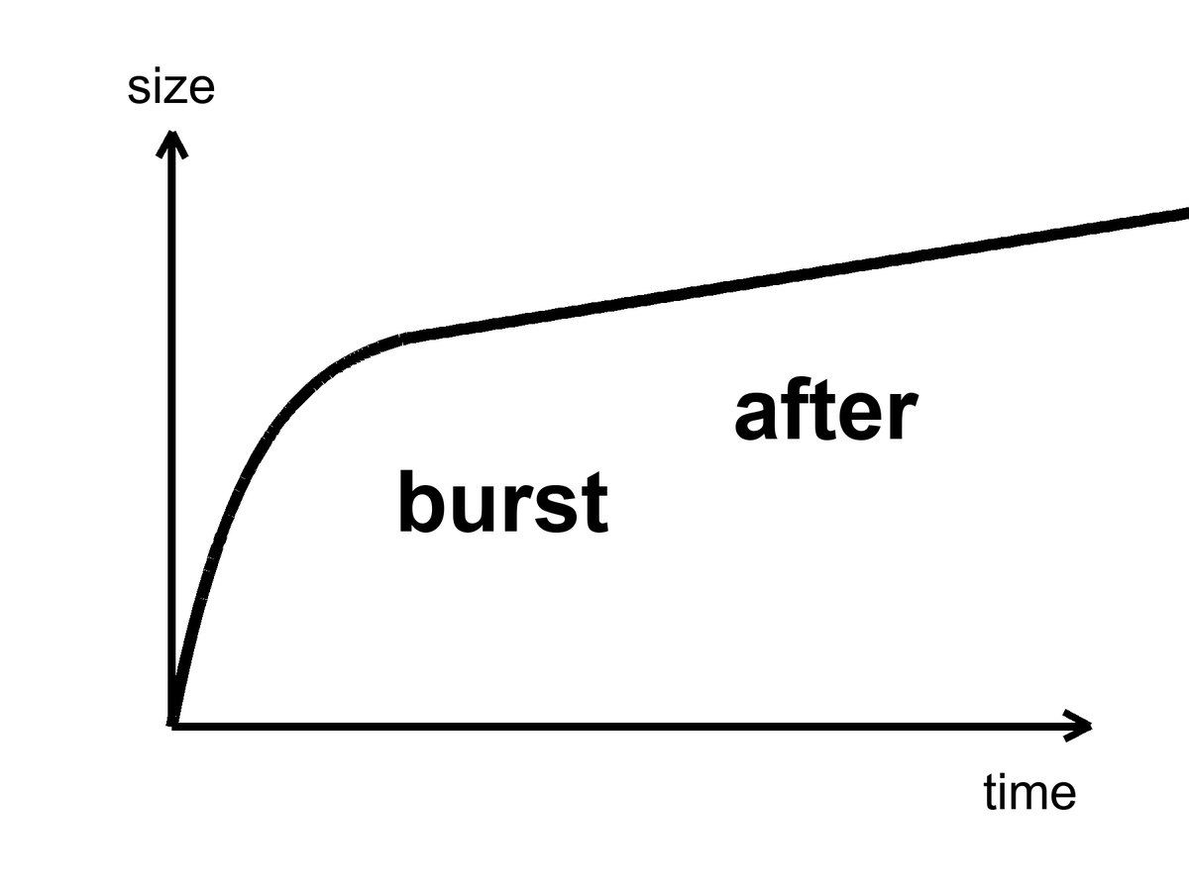
Figure 13. One curve: a steep burst, then a gentler slope. Inflation is the burst; everything else is after.
Alan Guth’s first version had a graceful-exit problem: the burst did not know how to stop without making a mess. Andrei Linde, and independently Albrecht and Steinhardt, found a smoother hill for the field to roll down — slow-roll. Linde later suggested that the starting values of the field could be chaotic, different in different places, some patches inflating a lot, some not. That idea will grow a maybe-multiverse in Chapter 15. Do not let it jump the line. The local burst is the working theory. The froth of other bursts is a rumor the local burst can tell if you let it drink.
What inflation has not done: name the field. We have no particle in a detector called the inflaton. We have a shape that works and a sky that looks like the shape predicted. That is more than a mood and less than a conviction. Appendix A13 writes the e-folds and the slow-roll parameters. Here it is enough to know that “inflation” is not a brand. It is a job description: a brief, repulsive stretch that sets the table for the hot bang we can actually reconstruct.
A humility from 2014 belongs on this page, because poster-inflation hates humility and the sky does not.
A telescope at the South Pole, BICEP2, looked for swirls in the leftover glow — B-modes — that a burst would have printed with gravitational waves. In 2014 the team announced a detection. The world did a lap. Warm claim, briefly worn as hot. Then dust in our own galaxy, polarized dust, sat down in the same seat as the signal. A 2015 joint analysis with Planck was the kill. The swirl was not the burst. The swirl was grit in the kitchen, the kind that lives in the Milky Way and polarizes starlight for a living. Humility is not a personality trait in a press office. It is what the sky did when someone claimed to have photographed the first 10⁻³² second.
The kill is worth teaching because it is how a warm claim dies correctly.
B-modes are a swirl pattern in the polarization of the leftover glow. Inflationary gravitational waves would write one kind of swirl, a primordial kind, whose amplitude is a number called r, the tensor-to-scalar ratio. Dust writes another kind, because dust grains in our galaxy align with magnetic fields and scatter starlight with a handedness of their own. BICEP2 looked at a clean-looking patch of southern sky at 150 GHz and saw swirls. Planck, looking at many frequencies, could tell dust from glow by color. Dust is redder in a specific way. The joint analysis showed the color of dust. r was not measured. An upper limit remained. Upper limits are not nothing. They are a fence the hill has to live behind. They are also not a detection. The poster that said first direct evidence had to be taken down. Taking it down is part of the science. Leaving it up would have been a different book.
What survived the dust is quieter and better. Planck measured the tilt of the primordial spectrum: n_{s} ≈ 0.965, a little redder than a perfectly scale-invariant 1. Slow-roll likes that song. A hill that is not perfectly flat, a field that creeps, a spectrum that leans a little toward larger scales: that is the shape, not the photograph of a particle. A tilt is a clue. Clues are allowed to be warm. They are not allowed to be a victory lap.
String theory sometimes offers inflatons the way a catalog offers furniture. The catalog is large. It cannot currently be tested. We will not pay the book’s rent with a catalog.
A catalog is tempting because the job description is wide. Many hills slow-roll. Many fields, in many theories, can pretend to be a temporary cosmological constant for 10⁻³² seconds and then dump. String theory’s catalog is famous for being large. Large is not the same as found. A furniture catalog does not furnish a kitchen. Until a particular hill is killed or confirmed by a number — a value of r, a feature in P(k) the leftover glow does not have, a leftover particle in a tank — we have a job, not a hire. The unnamed inflaton is not a failure of imagination. It is a failure of detection. Failures of detection are allowed to sit on the table beside the soup. They are not allowed to be called dinner.
Keep the temperatures straight on this chapter too. Hot: the three puzzles are real, and a brief stretch of the sort described would pale them. Warm: slow-roll inflation, 50 to 60 e-folds, a dump into soup, a tilt near 0.965, is the working preface. Cold: we have named the field, bagged it in a tank, and photographed its gravitational waves. We have not. The pot boiled over. We are eating the soup. The name of the cook is still a blank line.

14. How a Quantum Twitch Became a Galaxy
If inflation had stretched the universe perfectly smooth, there would be nothing to look at. No galaxies, no stars, no kitchens. Perfection is sterile. The universe is saved by a twitch.
Quantum fields cannot sit still. Even in their quietest state they jitter. During the burst, those jitters — differences in the field from place to place, at the smallest scale the quantum rules allow — get stretched from subatomic to cosmic the way a note written on a balloon becomes unreadable when you inflate it, except here the note becomes a continent. A region that jittered a little dense stays a little dense. After reheating, gravity, which has all the time in the world, starts calling in the debt. The dense patches pull. The thin patches get thinner. After a few hundred million years, the dense patches are making the first stars. After a few billion, they are making galaxies that look, cropped and gray, like Figure 14.
The kitchen mistake is to think of a twitch as a metaphor for “something small.” It is not a metaphor. An electron in a wire does not have a definite path. The same family of rule that forbids that path forbids a quantum field from sitting at one exact value in every place. Inflation is not a new kind of uncertainty. It is an amplifier. It takes the jitter the quantum rules already insist on and stretches it until the jitter is the size of a future cluster. Gravity is the sculptor. Gravity does not invent the pattern. Gravity spends 13.8 billion years pulling on a pattern that was already written, faintly, in a field that could not sit still.
This is Mukhanov’s territory, and Guth’s, and a workshop of people in 1982 who realized that inflation does not just solve puzzles. It makes the seeds. The leftover glow’s freckles are those seeds, photographed at 380,000 years, before gravity had done much sculpting. The pattern has a sound: almost the same power at every scale, a little redder on large scales, a spectrum written P(k) in the appendix and “almost scale-invariant” in conversation. Planck measured the tilt. The tilt matches slow-roll inflation’s favorite song. That is the warm claim at its warmest.
The 1982 workshop — a room of chalk, not a cathedral — is worth a pause because this is the moment the burst stopped being only a bill-payer. Viatcheslav Mukhanov, with G. V. Chibisov a year earlier, and then a crowd that included Hawking, Starobinsky, Guth, Turner, Bardeen, Steinhardt, had the same rude thought: if a field is jittering while it stretches, the jitter is a spectrum of density. After the dump into soup, that spectrum is a set of slightly overdense and underdense patches. The leftover glow is the photograph of those patches as temperature. Galaxies are the same patches, later, as matter. One twitch. Two exhibits.
The numbers are small on purpose. The amplitude of the primordial spectrum, A_{s}, is about 2 × 10⁻⁹. Two parts in a billion. That is how loud the twitch was, as a fractional difference in density, when it was stretched beyond the causal horizon and frozen. The tilt is n_{s} ≈ 0.965, Planck’s digit, a hair redder than 1. If n_{s} were exactly 1, every scale would have been given the same fractional power. Slow-roll does not quite do that. The hill is not perfectly flat, so large scales, which exit the horizon earlier, get a little more to work with. The leftover glow’s freckles sing that song. The song is not a galaxy. It is the score gravity will play.
P(k) is a recipe for how much power lives at each spatial scale. Scale-invariant means the fractional jitter looks the same if you zoom in or out, like a coastline that is wrinkly at every magnification. Almost scale-invariant means the coastline is a little calmer when you zoom into small bays, a little wilder when you back up to the whole shore. That is the red tilt. A_{s} ~ 2 × 10⁻⁹ sets how wrinkly, overall, the coastline was. Gravity turns wrinkle into continent. The leftover glow is the coastline at 380,000 years, still a coastline, not yet a continent. Figure 14 is a continent.
During the burst, a jitter of a given size is stretched until it is larger than the causal horizon — it exits. Outside the horizon it freezes: the patch cannot talk to its neighbors, so the overdensity stays an overdensity. After the burst, the horizon grows again, and the jitter re-enters. Gravity can then start sculpting. Different scales exit at different times during the 50 to 60 e-folds, which is why the spectrum is a story about a hill, not a single stamp. Large scales exit earlier. If the hill is slowly changing, large scales get a slightly different amplitude. That slight difference is n_{s} − 1. Planck’s 0.965 is a sentence about the hill’s slope, written in the leftover glow.
Mukhanov’s name is on the variable that lets you quantize the twitch in an expanding background — a combination of field jitter and metric jitter that the appendix will write as if it were a friend. You do not need the friend to understand the claim. You need this: the same quantum rule that smears an electron’s path smears the unnamed field’s value. The burst is a loudspeaker. Gravity is a chisel. The 1982 workshop is the moment a room of people heard the loudspeaker and realized they were also looking at a sculpture garden.
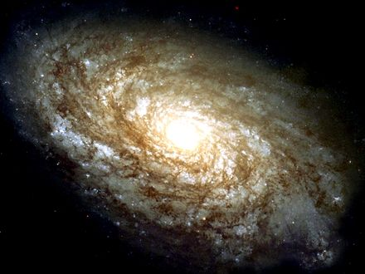
Figure 14. A nearby spiral galaxy, NGC 4414, filling the frame. A quantum twitch, stretched and pulled for thirteen billion years.
The timeline of exhibits, kept at the right temperature:
Hot: the leftover glow has freckles whose statistics we have measured. Their amplitude and tilt are numbers, not adjectives.
Warm: those freckles are the stretched jitter, and gravity grew them. The first stars, in this working picture, light up around 100 to 200 million years after the dump — a range, not a birthday. JWST photographs later exhibits: galaxies already assembled, already chemically rude, already sitting on the web that Chapter 16 will name. Those photographs are not a laboratory of the twitch. They are the museum downstairs from the laboratory.
The first stars are a warm chapter in a hot book. Theory says the first lumps that can cool and collapse do so around 100 to 200 million years after the dump, in minihalos that would look, if you could see them, like failed galaxies: a few hundred thousand or a few million solar masses of extra pull, a handful of massive, short-lived, metal-free stars. We have not photographed those stars as individuals. We have photographed, with JWST, galaxies that are already later exhibits — assembled, chemically polluted, sitting at redshifts that still make the stretch look like a time machine. Those galaxies are not the twitch. They are the twitch after gravity has had a few hundred million years to work and after the first stars have already lived and died and thrown carbon into the kitchen. Do not let a sharp infrared image pose as a laboratory of quantum jitter. It is a museum label that says LATER.
Gravity as sculptor is not a metaphor you can retire. Overdense patches pull. Underdense patches get emptied. On small scales the extra pull of Chapter 17 helps the lumps hold together against the stretch. On large scales the stretch eventually wins, and the web freezes. In between, for a few billion years, the sculptor is busy. A spiral disk is a late, local luxury: gas that cooled, spun, and settled in a halo that the twitch had already chosen. The choice was a nick of size 10⁻⁵ in the leftover glow. The luxury took the rest of cosmic time.
Cold: we have watched a twitch become a spiral in a laboratory. We have not. We have watched the intermediate photograph — the leftover glow at 380,000 years — and done the math that grows a 2 × 10⁻⁹ jitter into a disk like Figure 14. That is allowed to be enough, if we say so.
Chaos belongs here as mechanism. A jitter of one part in a hundred thousand is nothing in a kitchen and everything in a cosmos. Change the jitter’s pattern and you get a different web of galaxies — still a web, different rooms. That is not destiny. It is sensitivity. Chapter 16 will give chaos its own chair. Here, notice that the most important structures you will ever see began as noise.
Do not let the spiral in Figure 14 pose as a time-lapse of a quantum event. It is a nearby galaxy, light a few tens of millions of years old, a late sculpture. The twitch that seeded the line of lumps it grew from is not in the frame. The twitch is in the statistics of the leftover glow, and in the fact that a universe this empty still managed to make a disk this pretty. Gravity had time. Time is the sculptor’s only luxury. The quantum rule supplied the chisel’s first nick.
Between the freckles and the first stars there is a long, dark kitchen.
Last scattering is 380,000 years. The first stars, warm, are 100 to 200 million years. In between, the universe is not empty of stuff. It is empty of light worth a name. Neutral hydrogen, leftover helium, the extra pull gathering in the dark, the stretch still going. Lumps that were 10⁻⁵ too dense in the glow become, slowly, lumps that can cool. Cooling is the unglamorous step. Gravity pulls. Gas that can radiate away its heat can keep falling. Gas that cannot stays puffy and fails. The first stars are the first successful coolers, not the first lumps. JWST’s later exhibits have already inherited metals from coolers that died. That inheritance is why a sharp galaxy at high redshift is not a photograph of the nick. It is a photograph of a kitchen after several meals.
Hot claim: the leftover glow has a pattern of freckles whose statistics we have measured. Warm claim: those freckles are stretched quantum jitters, grown by gravity into galaxies. Cold claim: we have watched a twitch become a spiral in a laboratory. We have not. We have watched the intermediate photograph and done the math. That is allowed to be enough, if we say so.

15. Bubbles That May Never Stop
Once you have a field that can burst, you can ask whether the bursting ever takes a holiday.
In many versions of slow-roll, the field reaches the bottom of its hill in some places and keeps rolling, or keeps jittering, in others. The places that keep going keep stretching. The places that stop become hot bangs — pocket universes, bubbles, whatever noun you can stand. Our observable sky would be inside one stopped place. Outside, the bursting might still be hiring.
This is eternal inflation, Linde’s and Vilenkin’s child, Guth’s grown rumor. It is a live hypothesis. It is not a photograph.
The kitchen is a pot that keeps boiling in the next room.
You live in the room where the pot already dumped into soup. The soup is the leftover glow, the leftover helium, the stretch, the galaxies. In the next room — a room whose door is not a door, because the stretch between rooms is not a hallway you can walk — the original pot may still be boiling over. New dumps, new soups, new leftover glows that are not ours. You cannot go there. A bubble is not a destination. It is not a planet with a pad. It is a volume that reheated, or a volume that has not, separated from you by a stretch that does not sell tickets. Bubbles are a maybe about the loaf, not a travel brochure.
A destination has a worldline you can aim at. A bubble that nucleated elsewhere, behind a stretch that has been doubling for longer than our soup has existed, does not. Light from that bubble does not arrive. A ship does not arrive. The word “neighbor” in the cold claim at the end of this chapter is a courtesy and a trap. Neighbors, on Earth, share a street. These would share only a mathematics.
In many slow-roll models the quantum jitter in the field, per Hubble time, can be larger than the classical roll down the hill. Where the jitter kicks the field up the hill, that patch stretches more and the hill remains. Where it kicks down, that patch dumps into soup and becomes a bubble. The stretching patches make more volume than the dumping patches. Volume wins. The boil-over in the next room does not stop because the next room keeps being remade. That is eternal inflation as a mechanism, not as a mood. Linde’s picture is often this self-reproduction on a hill. Vilenkin’s picture is often bubbles nucleating in a false-vacuum sea. The nouns differ. The next-room pot is the same insult: the bursting may not take a holiday.
If the underlying physics has many ways to stop — many valleys for the field to fall into, many sets of effective constants — then different bubbles can freeze out with different laws. That is the expensive copy machine of Chapter 40, and it is where the anthropic filter of Chapter 42 gets its only real job. Weinberg’s argument that the cosmological constant should not be much larger than what still allows galaxies needs an ensemble. Eternal inflation plus a landscape is the ensemble people reach for.
Do not write the filter here. Chapter 42 will have to say, carefully, what an ensemble is allowed to explain and what it is only allowed to excuse. Here it is enough to see why Weinberg’s Λ is lonely without company. A vacuum energy — a hum of energy that empty space carries even with nothing in it — as small as the one we weigh is a joke if it is a unique, first-principles output of a theory. It is less of a joke if many vacua are tried and we can only find ourselves in one that still makes galaxies. That sentence is a pointer, not a proof. The pointer needs two things this chapter can name and cannot certify: a bursting that never quite stops, and a menu of valleys. The bursting is eternal inflation, Linde and Vilenkin, a live maybe. The menu, in its most advertised form, is a landscape inherited from string theory.
Weinberg, in 1987, asked how large a cosmological constant could be before galaxies fail to form.³¹ The answer is: not much larger than what we weigh. That is an upper bound from the existence of galaxies, not a calculation of the vacuum from first principles. An upper bound of that kind is idle unless many values are tried. One universe, one Λ, and Weinberg’s bound is a coincidence we live inside. Many bubbles, many Λs, and the bound becomes a filter: we could not have found ourselves in the bubbles that shoved too hard, too soon. Chapter 42 is the filter chapter. This chapter only points at the drawer the filter would need. Do not open the drawer and call it a house. Do not write the filter’s sentences here. Point, and leave the pointing visible.
The landscape, in its most advertised form, comes from string theory. String theory cannot currently be tested. A landscape of valleys inherited from an untestable framework is not a measurement. It is a maybe stacked on a maybe. This book will let the stack sit on the table. It will not serve it for dinner.
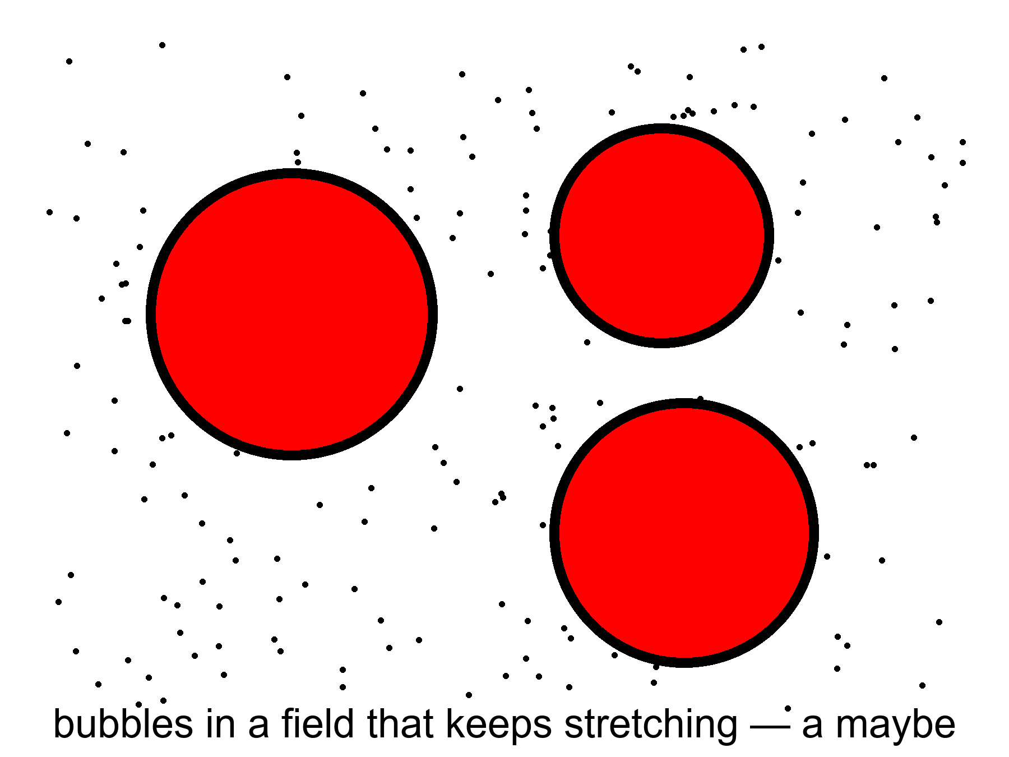
Figure 15. Three bubbles in a field that keeps stretching. A picture of a possibility, not a photograph.
Figure 15 is a picture of a possibility. It is not a map. Maps have distances you can travel. These circles do not.
There is a further rumor: that the bursting has no beginning, that bubble has always begotten bubble. The Borde–Guth–Vilenkin result says otherwise for a wide class of stretching spacetimes: if the average expansion is positive, the spacetime is past-incomplete. Eternal inflation, even if it has no end, still faces a boundary in the past. The bubbles do not give you a free forever-behind-you. They give you a messier loaf.
Past-incomplete, in the kitchen, means this. Follow a worldline backward through a spacetime that has been stretching, on average, and you run out of geodesic — the straightest path the geometry allows, the trail a free stone or a free clock actually follows — before you run out of curiosity. You do not get a quiet eternity of boiling behind you. You get a boundary, a place where the description stops and a different description — quantum gravity, a bounce, a sentence we do not own — would have to take over. BGV is not a proof that the loaf had a kitchen-clock beginning. It is a proof that this kind of forever-behind-you is not for free. The next-room pot does not pay the first-word bill. Chapter 45 will sit with that bill. Here: eternal inflation is not a machine for manufacturing a past without an edge.
Measure problem, in one sentence: if there are infinitely many bubbles and infinitely many observers, the word “typical” breaks. You cannot say “most universes are like this” until you say how you count. No one has a count that everyone else has to accept. Until they do, “the multiverse predicts X” is a hope in a lab coat.
Volume-weighted counting rewards the patches that stretched longest. Observer-weighted counting tries to ask where a typical observer sits. Pocket-weighted counting treats each dumped soup as one. They disagree. They disagree about whether we are typical, whether the cosmological constant we weigh is typical, whether anything is typical. An ensemble without a measure is a drawer of photographs with no rule for which one is “the” photograph. Chapter 42 will need a rule if it wants the filter to be more than a mood. This chapter’s job is to admit that the drawer is a rumor, and that the rumor is not a destination.
Infinity is the rude guest. If the next-room pot never stops, there are infinitely many dumped soups. Infinitely many observers. Infinitely many values of anything you care to count. A ratio of infinities is not a prediction until you say which infinity sits in the denominator. Different measures are different denominators. They are not a minor bookkeeping quarrel. They change what the rumor is allowed to claim. Until one of them is forced on us by a principle we already trust, “the multiverse predicts X” should be read as “some ways of counting would like X.” That is a thinner sentence. It is the honest one.
Warm claim: inflation can be eternal in many models. Cold claim: it is, and we live in a bubble with neighbors we will never meet. The sky we have does not require the neighbors. It permits them. Permission is not a postcard.

Physics vs philosophy: from inflation to a multiverse
What the evidence establishes. The leftover glow is even to a part in a hundred thousand, geometrically flat to within a fraction of a percent, and freckled with a slightly “red” spectrum (n_{s} ≈ 0.965).²¹ A brief early burst of stretching explains all three; no inflaton field has been detected, and the swirl pattern (B-modes) that would confirm gravitational waves from the burst has not been seen.³²
What some physicists infer. That many models of the burst never stop everywhere, so other bubbles with other effective constants exist. That is a property of models, extrapolated far past any patch we can observe.
What this book infers. Eternal inflation is a warm feature of a warm theory and a cold claim about the world. No observation we can make reaches another bubble, unless a bubble collision left a disk-shaped mark on the glow; searches have found none.³³

Keep the next-room pot on a back burner, not on the dining table. The local burst of Chapter 13 is the working preface to the soup we can taste. The pot that may still be boiling elsewhere is a maybe that the local burst can tell if you let it drink. Letting it drink is allowed. Paying rent with the drink is not.
The next-room pot is also a humility about nouns.
People hear “bubble” and picture a place, a film of soap, a destination with an inside you could visit if you had a better ship. The picture is a liar in three ways. First, the wall of a nucleated bubble, in the versions that have walls, is not a surface you approach. It is a stretch you cannot catch. Second, other dumped soups need not share our leftover glow, our helium fraction, our shove. Different valleys, different effective constants: that is the landscape rumor, and the rumor is untestable while it is borrowed from string theory. Third, even a bubble that dumped with laws like ours is not “next door.” Next door is a kitchen word. These rooms do not share a hall.
Guth’s grown rumor, Linde’s child, Vilenkin’s child: the bursting as a process that, once started, makes more of itself. That is the live hypothesis. It may be false. Slow-roll can be arranged, in some hills, so that the classical roll always beats the jitter and the pot dumps everywhere at once. Those hills pay Chapter 13’s bills without hiring Chapter 15. The sky we have does not yet force the hiring. It permits it. Permission, again, is not a postcard. Figure 15 remains a picture of a possibility. Frame it as a possibility and the chapter has done its job. Frame it as a map of destinations and the chapter has failed.

16. Chaos Is an Engine
Chaos, in physics, is not a mood and not a mess. It is a precise kind of sensitivity: two starts that differ by a breath end in rooms that do not recognize each other. Weather is chaotic. A pendulum swinging over a magnet can be chaotic. The approach to a final crunch, if the universe had been headed for one, would have been chaotic — Barrow proved things in that vicinity, and Belinski, Khalatnikov, and Lifshitz gave the mixmaster a name. A recollapsing cosmos would not politely reverse the film. It would scramble.
The kitchen is a dropped tray of yeast.
Same flour. Same water. Same yeast. The tray hits the floor and the grains go everywhere. Two bakers, starting from two almost identical spills, do not bake the same loaf. One kitchen gets a dense crumb. The other gets holes like a sponge. The ingredients did not change. The sensitivity did the work. Lyapunov, if you want the surname on the sensitivity, is the person who taught mathematics to measure how fast nearby starts stop being nearby. A Lyapunov time is a clock for forgetting. Weather forgets in days. A mixmaster crunch would forget in a scramble of axes. A quantum twitch, stretched and then pulled by gravity for 13.8 billion years, forgets the subatomic room and remembers only a web.
At the beginning, chaos is an engine.
The quantum twitch of Chapter 14 is sensitivity as a gift. Stretch it, and you get a web. The cosmic web — filaments of galaxies around voids like holes in a sponge — is what gravity does with a nearly scale-invariant jitter after thirteen billion years. It is not a design. It is what you get when pull is allowed to run on noise.
Same engine, two temperatures. At the start, sensitivity is how a nick of size 10⁻⁵ becomes a sponge you can survey. At a hypothetical crunch, sensitivity is how a last decimal becomes a mixer nobody holds. The mathematics is cousin to itself. The moral is not. One gift. One theft. Do not let a poster collapse them into “chaos means we cannot know anything.” We can know the leftover glow. We can know the web’s family. We cannot know, from a grain of yeast, which hole in which loaf. That is the precise kind of not-knowing. It is enough.
The web is not a drawing. It is a survey. The Sloan Digital Sky Survey and the Two-degree-Field survey mapped enough galaxies that the sponge became a fact you could crop and print. Figure 16 is that crop: filaments as dark on light, voids as the light, a later exhibit of the same jitter that freckled the leftover glow. Two nearby starts in the primordial noise — two almost identical spills of yeast — would not grow the same rooms. They would still grow a web. Still a sponge. Different holes. That is chaos as an engine: the family of outcomes is stable, the particular kitchen is not.
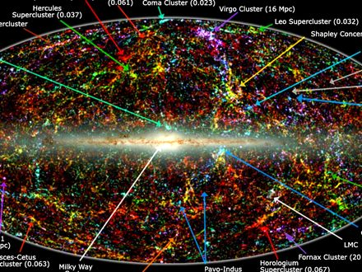
Figure 16. The whole sky as a map of a million galaxies from the 2MASS survey. The band across the middle is our own Milky Way blocking the view; the clumps and filaments everywhere else are the web grown from twitches. The small labels name nearby clusters and can be ignored.
Barrow’s habit, useful here, was to walk you up to a large number and then refuse to call the number a destiny. The web is a large fact. It is not a plan. Mixmaster is a large fact about a kind of ending we do not appear to be headed for. It is not a control panel.
The mixmaster, named for a kitchen mixer because the axes of a collapsing universe would stretch and squash in a chaotic rotation, is Belinski, Khalatnikov, and Lifshitz: BKL. Near a spacelike singularity — a place, Chapter 24's proper subject, where the loaf tears and the equations stop describing what happens next — the generic behavior in general relativity is not a polite, spherical crunch. It is an oscillation of shapes, sensitive to the last decimal, a Lyapunov nightmare. Barrow proved things in that vicinity that matter for anyone who wants a last moment to be a steering wheel. Nearby starts become unrecognizable rooms. A civilization of perfect computers would not find a handle. The geometry would melt the handle.
Picture a collapsing room whose walls do not approach you together. One axis crunches while another stretches, then they trade, then they trade again, the sequence sensitive to the last decimal of the starting shape. That is Mixmaster, Bianchi IX in the jargon, a kitchen mixer beating a dough that is the geometry itself. BKL argued this is generic: not a special, spherical collapse, but the thing Einstein’s theory wants to do when a spacelike singularity is approached. Barrow took that generic chaos seriously enough to ask what a final intelligent observer could still control. The answer, in the vicinity of those proofs, is: almost nothing, unless you add extra structure the known laws do not hand you. Ideas for ideas can add the structure. Data have not.
At the end, if there were a crunch, the same family of sensitivity would be a theft. Tiny differences near a final singularity would be amplified until no one, not even a civilization of perfect computers, could steer. That fact will matter when someone tries to sell you a required Omega Point: a last moment in which mind takes the controls and computes forever. Chaos at the crunch is not a control panel. It is a warning that control panels melt.
Chapter 19 will finish that sale’s refusal on other grounds: the shove is winning, the bombs of 1998 are not a crunch track. Even in a universe that did crunch, BKL plus Barrow would still be waiting at the far end with a scrambled mixer. Forever-mind fails twice. Once because the data do not crunch. Once because a crunch, if you had one, would not be a computer. Do not let the Omega Point borrow this chapter as a mood. It is a mechanism. The mechanism is unkind to steering.
In the middle — which is where we live — chaos is why forecasts have horizons. We can reconstruct the three minutes because the soup was mixed and the laws were simple. We cannot forecast a galaxy’s weather in year 10¹². We can forecast the stretch. The stretch, with dark energy in the budget, looks dull and huge. Dull and huge is a kind of mercy. The web freezes in place as the shove between filaments wins. Galaxies go dark on their own clocks. The engine that built them idles.
Weather versus stretch is the distinction worth taking home. Weather is Lyapunov’s child: a breath here, a different storm next week. The stretch is not that kind of forecast. The Friedmann equations, fed a budget of pull and shove, do not forget their nearby starts on a weather clock. They tell you the dough will keep rising, and, with the shove in the account, rising faster. You can be wrong about the second digit of the Hubble number and still be right that the voids will get ruder. You cannot be a little wrong about a hurricane’s seed and still be right about next Tuesday. Do not confuse the two clocks. One is why you pack an umbrella. The other is why the cosmic web is a fossil in progress.
Barrow would have called the Omega Point an idea for ideas and then, if he were in a kind mood, walked you to the mixmaster and let the mixer do the unkindness. Chapter 19 will do the data. Here the mixer is enough: crunch chaos is a second lock on that door. Nearby starts, unrecognizable rooms. No steering wheel survives the last decimals.
Keep chaos in the book as a tool, not a vibe. It made the rooms. It will not let anyone own the ending. It is the opposite of a watchmaker and the opposite of a destiny. It is what a twitch can do when the universe gives it time.
If you want a last kitchen instruction: pick up the tray. Notice that picking it up does not unspill the yeast. The web is already baked into the surveys. The leftover glow is already on the antenna. Chaos, as an engine, has already done the morning’s work. What it will not do, tonight or in a crunch, is hand you a recipe that steers the last decimal. Barrow’s pebble, Guth’s unpaid bills, Mukhanov’s twitch, Linde’s next-room pot, and this dropped tray are one family of honesties. The universe is sensitive. It is not a mood. It is how rooms get made, and why nobody owns the ending.

PART IV — The Missing Most

17. The Extra Pull
Dark matter is a terrible name. It sounds like a feeling, or a brand of chocolate, or the opposite of enlightenment. It is none of those. It is a pull we can weigh and cannot photograph in ordinary light.
Barrow, in the short origin book this one uses as a model, had a habit of refusing a pretty noun until a measurement had earned it. Dark matter has not earned a pretty noun. It has earned a scale. The scale is the extra weight in galaxies and in clusters: more pull than the shining stars and gas can account for, by a factor of several. The name is a confession. We weighed it. We have not bagged it.
In the kitchen you do not weigh a truck by climbing into the trailer and counting crates. You weigh it by how the bridge leans when the truck rolls on — by the strain gauges, the sag, the way the other traffic feels the extra. Dark matter is the trailer you cannot open. The bridge still leans. That is the whole method of this chapter, and it is why the extra pull is a hot fact even while the particle is a warm rumor.
In the 1930s, Fritz Zwicky timed the galaxies in the Coma Cluster and found them moving too fast. The visible stars did not supply enough gravity to hold the swarm. He said so, rudely, and was mostly ignored. In the 1970s, Vera Rubin and Kent Ford timed stars in the disks of spiral galaxies and found the same insult at a friendlier scale: stars out in the suburbs orbit as fast as stars closer in, as if most of the mass were in a big, dark halo, not in the shining bulge. The light is a liar about the weight.
The Coma paper is 1933, and the cluster is a city of cities: thousands of galaxies in a well so deep that, if you time them as Zwicky did, the virial theorem becomes a speed trap. If the members are this fast, the well has to be this deep, or the swarm would have flown apart long ago. The well was too deep for the starlight. The rudeness was not the problem. The problem was that nobody wanted an extra ingredient that did not shine. Extra ingredients are expensive. Astronomy in the 1930s was still finishing the argument about whether spiral nebulae were even other galaxies. An invisible majority was a second insult.
Rubin and Ford brought the second instrument down to a single disk. A rotation curve is speed versus distance from the center, a plot that Newtonian common sense said should fall once you leave the shining bulge. Their curves stayed flat. Flat is not a mood. Flat is v staying large while r grows, which, if gravity is still gravity, means M is still growing in the dark. They did this galaxy after galaxy, with a spectrograph and a stubbornness that later textbooks still under-thank. The suburban stars were clocks. The clocks did not slow.
What dark matter is not, while we are cleaning the noun:
It is not dark energy. Dark energy shoves. Dark matter pulls. They share a marketing department and nothing else.
Keep the divorce or the rest of this part will lie to you. The extra pull clumps. It makes halos. The extra shove does none of those things. Chapter 18 is the other spouse. Do not let a shared adjective fuse two ingredients.
It is not a black hole in the everyday sense, though a zoo of old, small black holes is a cold candidate people still kick. Ordinary black holes made from dead stars are not numerous enough, and we have looked.
Microlensing surveys have walked the Magellanic Clouds looking for the wink of a compact object passing in front of a star. They did not find a halo made of dead stars. A halo made of primordial pebbles of collapsed spacetime is still allowed by some papers and disliked by others. It is not the working fluid.
It is not the failure of our eyes. We have looked in radio, infrared, X-ray. The missing weight does not glow in those either, not as atoms would.
It is not a mood in the equations. The leftover glow’s freckles have a pattern that, when grown by gravity, matches a universe in which most of the pulling-stuff does not collide with light. Atoms slam into photons in the early plasma and leave a different signature. The extra pull did not slam. It is non-baryonic in the jargon: not the protons-and-neutrons club. Appendix A17 says that more carefully. Here: it is a different ingredient, not hidden steam.
The leftover helium of Chapter 10 already counted the baryons. There are not enough of them. You cannot hide the extra weight in more hydrogen that forgot to shine. The nuclear minutes already took inventory. The leftover glow’s odd and even acoustic peaks take the same inventory a second way. Two fossils, two methods, one minority of atoms. The extra pull is the difference between that minority and the weight the clocks and the arcs demand.
Candidates have names that sound like card games. WIMPs: heavy, shy particles that would leave a rare cough in an underground tank. Axions: wisps from an old fix to nuclear physics, convertible into photons in a magnetic field if you listen with a sufficiently obsessive radio. Sterile neutrinos: a shy cousin of the neutrinos we already know. None of them has been caught in the act. The tanks have gotten very quiet. XENON, a vat of noble liquid under a mountain in Italy, listens for WIMP coughs and hears the Earth’s radioactivity and the Sun’s neutrinos and not much else. LZ, a larger vat in a South Dakota mine, does the same with a stiller ear. The radios have gotten very proud. The sky has not changed its mind about the pull.³⁴³⁵
WIMPs were the easy hope: weakly interacting massive particles, heavy enough to sit still on galaxy scales, shy enough to pass through a mountain, common enough that a ton of liquid xenon should, over a year, record a few recoils. The year keeps ending without the recoils. Axions were a patch Peccei and Quinn wrote for a problem in the strong force; if they exist at the right mass they can be the halo, and a magnetic cavity can try to turn them into a microwave whisper. The whisper has not arrived. Sterile neutrinos are a shy extra flavor that would not join the usual weak interactions; some recipes make them cold enough to scaffold galaxies, some make them warm enough to erase dwarf galaxies we can still see. None of the three has been caught in the act. That silence is a scientific result, not a failure of nerve. A WIMP at the mass and interaction strength that would have made the tanks cough by now is, to a first approximation, not there. The window has not slammed shut on every mass. It has slammed shut on the masses that were supposed to be easy.

Status as of October 2026: dark-matter searches
Measured. The extra pull itself: galaxy rotation, lensing, the Bullet Cluster, and the peaks of the leftover glow.³⁶³⁷²¹
Searched for, not found. The largest xenon detectors, LZ in South Dakota and XENONnT in Italy, have reported no convincing WIMP signal.³⁴³⁵ In September 2026 LZ reported a single unusual event in an extended energy window, at a significance of about 2.6 standard deviations once the size of the search is accounted for: worth watching, not a discovery.³⁸
Open. Axions, lighter or heavier WIMPs, sterile neutrinos, primordial black holes in some mass windows, and modified gravity (which must still explain the Bullet). A detection in a tank, or a signal in the sky that only one candidate can produce, would change this box.

Modified gravity — change the law instead of adding an ingredient — still has clever friends. It has a harder time with clusters, with the leftover glow, and with the Bullet, where two kinds of stuff have been caught in the act of not staying together. The working theory is an extra ingredient. The working theory has a hole in it the size of a noun. That is allowed. Chemistry once had a hole named “what is fire.” The hole was not a reason to deny the flame.
MOND, and the relativistic clothes it has tried on, can mimic a flat rotation curve in a lonely disk with a tweak to Newton at low accelerations. A lonely disk is not a colliding pair of clusters. If gravity itself were simply stronger on large scales, the slammed gas and the extra weight would still sit on the same map, because they would be the same map. They do not. Some papers try to dress modified gravity so the offset still happens. The try is allowed. The try has not become the working theory. Barrow would have walked you to the photograph, named the extra ingredient, and then said the noun is still an idea for a laboratory, not a trophy.
How do you weigh something that refuses to shine?
You watch what it does to things that do. Galaxies lean. Clusters lean. The leftover glow rang like a bell, and bells remember what was pulling on them.
Rotation curves are the suburban clocks: stars and gas, timed in their orbits, going too fast. Gravitational lensing is the more theatrical trick. A cluster’s weight bends spacetime, and the bend makes multiple, stretched images of galaxies behind it — arcs, crosses, rings. Count the arcs, measure the stretch, and you have a scale. The scale disagrees with the starlight by a factor of several. The disagreement is the extra pull.
Weak lensing, which does not make a full arc, still shears the background into a statistical lean. Stack enough galaxies and the lean is a map. Strong lensing is the theater. Weak lensing is the survey. Both weigh the trailer by the bridge. Neither needs the crates to glow.
The leftover glow offers a third scale. The freckles are a sound. The sound has harmonics, like a bell. The position and height of those harmonics depend on how much ordinary matter was slamming into light, and how much quiet matter was only pulling. The bell says: a little slamming stuff, a lot of quiet stuff. The numbers line up with the clocks and the arcs. Three instruments, one extra weight.
Before atoms formed, the plasma could ring: photons and baryons slamming, compressing, bouncing, while the extra pull sat in the wells and did not slam. Odd peaks versus even peaks are a baryon census. Peak positions are a total-matter census. A single method can lie. Three methods, of different families, lying in the same direction, is a courtroom. That is why this chapter’s first sentence is hot even though the last noun is missing.
Then there is the Bullet.
The catalog name is 1E 0657-56. In 2006, Clowe and colleagues published the map that made the argument visual even for people who dislike maps.
Two clusters have passed through each other. The gas — atoms, shining in X-rays — slammed, shocked, and lagged in the middle, the way two crowds trying to walk through each other get stuck at the doors. The extra pull, mapped by lensing, did not slam. It went on through, like two ghosts politely declining to notice they had overlapped. In the famous color posters, gas is pink and mass is blue. On a Kindle those posters lie. Figure 17 is one composite: the slammed gas labeled where it piled up, the mass labeled where lensing put it, same scene. The contours do not sit on the gas. That is the photograph of “not atoms.”
If you wanted modified gravity to swallow the extra pull, this is the exhibit it has to explain without an extra ingredient that can leave the gas behind. The gas is most of the shining baryons in the cluster. After the crossing, the gas is in the middle. The lensing mass is not. Collisionless stuff goes on through. Collisional stuff sticks.
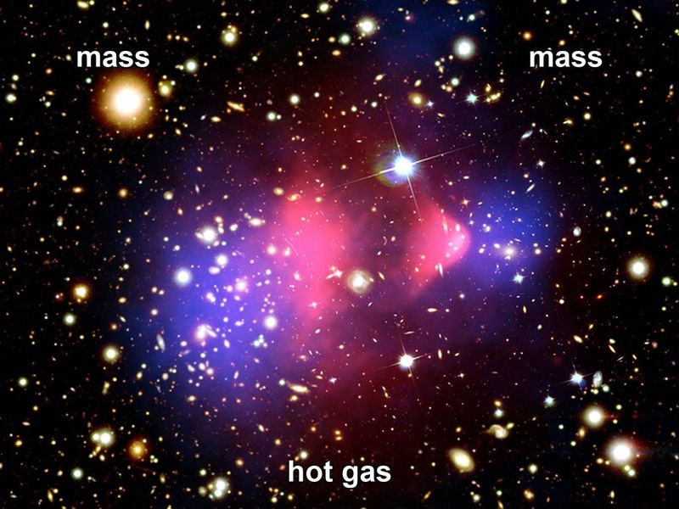
Figure 17. The Bullet Cluster as one composite: hot gas piled in the middle; mass, mapped by lensing, on either side. The pull did not stay with the gas.
Hot claim: there is more pulling-stuff than shining-stuff, and the extra stuff does not collide the way gas does. Warm claim: it is a particle we have not bagged, or a small zoo of them. Cold claim: we know its name, its mass, and which underground tank will cough first. We do not.
The extra pull is why galaxies are not just pretty. It is the scaffolding they grew on. Without the quiet halos, the twitches of Chapter 14 would have had a harder time becoming spirals before the stretch pulled the scaffolding out of reach. You live in a suburb of a ghost.
The baryons, left to themselves, would have been a thinner foam. The quiet wells were already there, grown from the same freckles, and the gas fell in. The scaffolding is not a purpose. It is a head start. Gravity ran on noise in the dark wells first; the shining disks are late tenants. The ghost is an ingredient, not a destiny, and not a synonym for the shove. It owes you a weight. The weight is on the bridge. The trailer is still locked.

18. The Shove
In 1998 two teams of astronomers, racing each other with dying stars, found that the stretch is not sulking. It is speeding up.
Saul Perlmutter’s Supernova Cosmology Project, and the High-Z team of Adam Riess and Brian Schmidt, were doing the same rude job: hunting Type Ia supernovae far enough away that their light had been in transit for billions of years, and asking whether the stretch had been tiring the way gravity said it should. Two teams, two pipelines, one sky. That is how you keep a shared mistake from dressing up as a discovery. In 2011 the three of them shared a Nobel Prize for the answer. The answer was no. The stretch had been getting a second wind.
The dying stars were Type Ia supernovae, a kind of standard bomb: a white dwarf that reaches a bad weight and detonates with a brightness you can almost trust. Trust the brightness, measure how faint it looks, and you have distance. Measure the stretch of its light and you have the universe’s size when it exploded. Plot size against time for bombs going off over the last several billion years and you expected, if you were educated before 1998, a slowdown. Gravity pulls. Stretching should tire.
The bombs were too faint. They were farther than the tired-stretch story allowed. The stretch had accelerated. Something was shoving.
Acceleration, in the kitchen, is not a galaxy putting its foot down. A raisin does not gun an engine. The dough between raisins changes its mind about how fast to rise. The plot of distance against stretch, once it is corrected for the way candles look faint, tips the wrong way for a tired universe. Gravity is still pulling inside the raisins. Between them, the budget has a term that does not thin, and that term has started to win.
A Type Ia is not a random firework. It is a white dwarf — a dead star’s leftover ember, about Earth’s size and the Sun’s mass — stealing matter from a companion, or merging with another dwarf, until it crosses a mass where electron degeneracy can no longer hold it. The explosion is nuclear and brief and, after you calibrate the way the light fades, nearly the same candle each time. Nearly is doing a lot of work. The teams spent years arguing about dust, about evolution, about whether a candle at redshift one is still the candle you calibrated nearby. The argument did not eat the result. Later candles, better calibrated, still sit too far away. That is how a hot claim is born: not from a press conference, from a result that survives the people who wanted it to be dust.
The simplest shove is a cosmological constant: an energy that comes with empty space itself, a tension Einstein once put in to freeze the universe and then regretted. The vacuum, in quantum field theory, is allowed to have a cost. The cost it should have, if you naively add up the jitters of every field down to the Planck scale, is off by a number so large it has become a joke: 10¹²⁰, give or take a few zeros. The measured shove is tiny. The predicted vacuum is a monster. This is the worst prediction in physics if you are in the mood to be rude, and one of the deepest problems if you are not.
Einstein wanted a static loaf. The constant was a fudge to hold the raisins still. When Hubble’s stretch showed the raisins were not still, he dropped it; George Gamow later reported that Einstein called it his biggest blunder. The sky, seventy years later, hired the blunder back — not to freeze the loaf, but to speed the later rise. If the vacuum energy were even a few orders of magnitude larger, galaxies would not have had time to assemble before the shove tore the wells apart. Weinberg said that out loud in 1987, as an anthropic upper bound, before the bombs had voted. The bombs voted near the bound. That is either a clue about an ensemble of vacuums — Chapter 15’s rumor — or a coincidence we have not earned the right to spend. Warm either way. Not a photograph.
Dark energy is the placeholder name for the shove. It might be Einstein’s constant. It might be a field that changes slowly, a “quintessence,” which is a word that sounds like a perfume and behaves like a maybe. It might be a mistake in how we read distances. The last option has been losing for twenty-five years. The leftover glow, the baryon acoustic oscillations — a leftover sound-scale printed in the way galaxies cluster — and the bombs now tell the same story. About two-thirds of the budget is the shove.
Quintessence would have an equation of state w that can wander a little. Einstein’s constant sits at w = −1 and does not wander. For twenty years the data sat at w ≈ −1. Since 2024 that has become a live argument.

Status as of October 2026: is dark energy constant?
Measured. The expansion is accelerating, and a shove makes up about two-thirds of the budget.³⁹⁴⁰²¹
Contested. The DESI survey’s 2025 maps of the frozen sound-scale, combined with the leftover glow, prefer a shove that weakens with time at about 3 standard deviations, rising to about 4 with one supernova sample and falling below 3 with another.²⁴ A July 2026 DESI analysis that adds the shape of the hydrogen forest gives 2.7 to 3.2 standard deviations, with the same direction of drift.⁴¹ The Dark Energy Survey’s full six-year result reports w ≈ −0.82 today and drifting, at about 3 standard deviations with the glow.⁴² A Bayesian reanalysis finds no decisive evidence, and a recalibration of one supernova sample removes much of the preference.⁴³
Not yet known. Whether the drift is real physics or an unmodeled systematic. Particle physicists conventionally ask for 5 standard deviations before calling a discovery; none of these results reaches it. The next DESI and Euclid releases, and the Rubin Observatory’s supernovae, should decide.

Either way, the working fit is a shove that still looks, at the present level of precision, close to empty space with a tiny, stubborn cost. A w that later turns around and becomes a crunch is still a cold loophole.
The sound-scale is worth a kitchen minute. In the plasma of Chapter 9, baryons and photons rang together. When the fog lifted, the ringing froze. The frozen wavelength is a ruler about 150 megaparsecs long, comoving — a stick you can still lay across the clustering of galaxies today. That is BAO: baryon acoustic oscillations. It is not a bomb. It is a leftover chime. Lay the ruler at different redshifts and you measure how the stretch has been behaving, H(z), the Hubble rate as a function of how much the universe has grown. Appendix A18 writes the Friedmann line for the case w = −1:
H²(z)/H₀² = Ω_{m} (1+z)³ + Ω_{r} (1+z)⁴ + Ω_{Λ} + Ω_{k} (1+z)²
Matter thins as the cube of the stretch. Radiation thins as the fourth power. A cosmological constant does not thin. That is the whole plot twist in one line: at late times the thing that does not thin takes over, and the stretch accelerates. Acceleration, in the data, begins around redshift 0.6 — a few billion years ago. The last part of the bake is the fast part.
It does not clump. It does not make halos. It does not sit in the Bullet. It is not dark matter in a hat. If you take nothing else from this chapter, take the divorce: pull and shove are not a couple.
The extra pull is scaffolding. The extra shove is a later wind between the scaffolds. You can live in a suburb of a ghost and still be carried apart from the next suburb by a dough that has started to hurry. The marketing department will keep printing “dark” on both bottles. The kitchen will keep two spoons.
Once the shove is in the budget, the future changes personality.
Without it, you still had a fight between pull and stretch. Enough atoms-and-ghosts and the universe might someday stop expanding and fall back. Too little and it would stretch forever, tiring, thinning, cooling. The knife-edge of Chapter 12 was, in part, a knife-edge of fate.
With the shove, the fight is already over, unless the shove itself is a liar that will someday switch sides. The stretch accelerates. Isolated lumps — galaxies, bound clusters — remain bound. Between them, space wins and keeps winning. The cosmic web freezes. New filaments stop forming. The voids get ruder.
A second-digit fight has been making the newspapers, and it should not be allowed to steal the first digit. The Hubble tension of Chapter 8 (67 from the glow, about 73 from local ladders, with the status box there) is an argument about the slope now, about whether we have misread a candle or missed a wrinkle. It is not an argument that the stretch is not accelerating. Both camps still need a shove. The bombs are still too faint. The 150-megaparsec ruler still says the late bake sped up. Do not let a fight about the second digit become a rumor that 1998 did not happen.
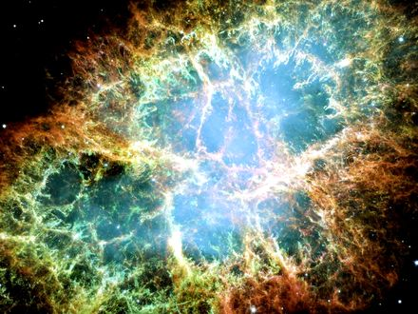
Figure 18. A supernova remnant, the Crab Nebula. Explosions of a related kind, seen much farther off, taught us the stretch is speeding up.
This is why a required Omega Point — a final crunch in which life steers the universe and computes forever — fails as physics, not as poetry. Poetry can crunch whatever it wants. The bombs, the leftover glow, and the frozen sound-scale say we are not on a crunch track. The next pages put shoes on that sentence.
A detail for later travel: the accelerating stretch makes a cosmic event horizon. There are galaxies whose light, emitted today, will never reach us, and there are galaxies we now see whose future light never will. Most of the universe has already left, not by walking away, but by the dough rising too well. Chapter 26 is the map. Chapter 18 is why the map is not optional.
A horizon of this kind is not a black hole. It is a fact about which events can still be connected by light in a loaf that keeps hurrying. If the shove stays near w ≈ −1, the map gets ruder with time: more of the web leaves the set of events that can still answer a signal. That is not despair. It is a reason to keep the word now local, and a reason Chapter 26 has a job.
Hot claim: the expansion is accelerating. Warm claim: a cosmological constant, or something that looks like one, is the shove. Cold claim: we know why the shove is the size it is. We do not. The worst prediction in physics is still on the board.

19. Why Forever-Mind Does Not Follow
Frank Tipler, working from a book he wrote with Barrow, described a final state in which the universe recollapses, intelligent information-processing takes the controls, the amount of computation diverges, and this last, infinitely clever moment is — he was not shy — God. He called it the Omega Point. He said the known laws require it. He said life must never die out.
The book was The Anthropic Cosmological Principle, 1986, a thick, serious, sometimes dazzling inventory of how the constants look arranged, followed by a last act that stopped being an inventory. Barrow’s name is on the cover. Barrow’s later habit, in the short origin book, was the one this chapter will keep: walk you up to a speculation and then call it an idea for ideas. Tipler kept walking. He later wrote a thicker popularization in which the last computation wore the noun more openly. The Omega Point is what you get if you let an idea for ideas put on a lab coat and then a mitre.
The known laws do not require it. The data have been voting no since 1998.
A crunch needs the pull to win. The shove is winning. For the Omega Point to be a destiny rather than a story, the shove would have to fade, reverse, or be a mirage. None of those is the working theory. A story can still imagine a different bubble, a different branch, a later surprise in the vacuum. A destiny cannot hide in a surprise. Destiny is supposed to be what the laws demand. The laws, plus the bombs — the Type Ia supernovae of Chapter 18, not weapons — demand a long, thinning, accelerating future, not a steered collapse.
Here is the kitchen version, and it is ruder than a diagram. Imagine a will that names destinies the bank account cannot pay. The will is eloquent. It leaves the house to a dynasty, the orchard to a school, the future to a mind that never sleeps. Then you open the ledger. The shove is two-thirds of the budget. Recollapse is not in the data. The will is still a document. The bank is still empty of that particular future. You do not get to call the will a law of physics because the prose was confident.
Perlmutter, Riess, and Schmidt did not set out to probate a metaphysical estate. They set out to weigh the stretch. The estate failed anyway. A required forever-mind needed the loaf to turn over. The loaf tipped up. Twenty-five years of leftover glow, of the 150-megaparsec ruler, of later candles, have not put recollapse back on the working track. Warm loopholes remain — a w that turns around, a vacuum that decays, a different bubble. Spend those as destinies and you have left the data for a story. Chapter 18 already said the story is allowed. Destiny is not the word for a loophole.
Barrow himself, in the short origin book this one uses as a formal model, had a better habit: he would walk you up to a speculation and then call it an idea for ideas. The Final Anthropic Principle — intelligent processing must arise and must never die out — is an idea for ideas that put on a lab coat. Martin Gardner made a joke of the acronym. The joke was unkind. The data have been unkinder.
In the 1986 book the Final Anthropic Principle is stated as a requirement, not a hope: observers come into existence, and once they do, they persist. That is FAP. Gardner, a working skeptic with a magazine column and no patience for cosmic last acts dressed as theorems, suggested that a principle which demands eternal observers deserved a cruder expansion of the letters. He did not need the 1998 bombs. He needed only the difference between a condition we observe from — we are here, therefore the universe is the kind of place that can have a here — and a commandment that we must remain. The first is the weak anthropic cut, a likelihood filter, useful once you have an ensemble. The second is a wish with a Latin name. Chapter 42 will give the filter its honest job. Here the job is simpler: FAP is not selected by the leftover glow, the leftover helium, the extra pull, or the extra shove. It is selected by a desire that the story not end without a speaker.
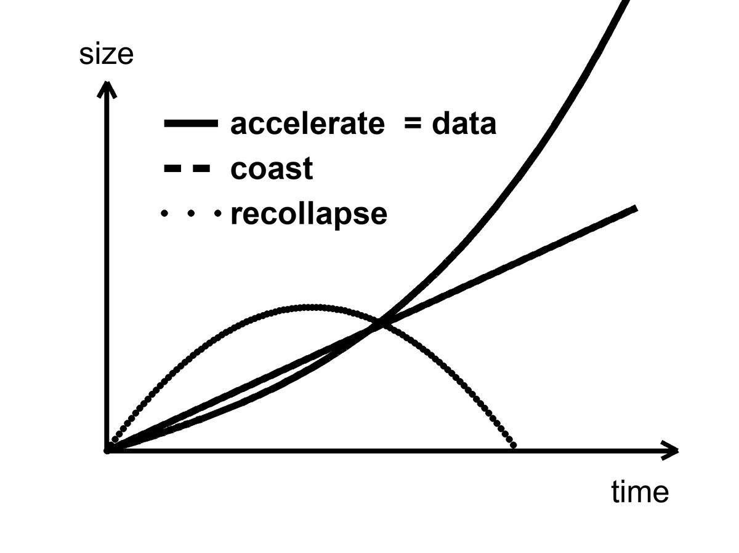
Figure 19. Three futures for the size of the universe: recollapse, coast, accelerate. The curve marked data is the accelerating one.
Look at the figure until it is boring. Recollapse is a curve that turns over. Coast is a curve that tires. Accelerate is a curve that tips up. The data sit on the one that tips up. Appendix A19 writes the same sentence with density parameters: observed matter about 0.3, observed shove about 0.7, deceleration parameter negative. Closed, matter-only recollapse needed a universe heavier than the critical density and no lasting shove. We are not that universe. The working fit is the accelerating curve.
Chaos, from Chapter 16, is the second objection, even in a universe that did crunch. Near a final singularity — the same wall Chapter 16 named and Chapter 24 properly explains — the mixmaster scrambles. Steering requires control. Control requires that nearby futures stay nearby. They do not. Infinite computation in a dying crunch is a wish that the geometry be a computer. Geometry is not that polite.
This is the objection that would survive a miracle. Suppose, against the bombs, the shove later faded and the loaf turned over. Suppose a civilization of perfect machines was ready with a plan. The plan still has to steer a geometry that, near the end, swaps its axes the way a chaotic kitchen fire swaps which pan is hottest. You cannot cook a required last thought on a stove that will not hold a setting. FAP said life must never die out. BKL says that even a dying crunch is not a stove you can borrow. The first objection is the data. The second is the shape of Einstein’s ending, crunch or no crunch.
Belinski, Khalatnikov, and Lifshitz — BKL, in the jargon — showed that a generic spacelike crunch in Einstein’s theory does not approach a polite point. It approaches a sequence of Kasner eras: squash in two directions, stretch in one, then swap, then swap again, the axes changing in a way that is chaotic. Barrow proved things in that vicinity about how little control you get. Say that again without the names, because the names can sound like a priestly veto. If the loaf recollapses, the last slice is not a quiet room in which a civilization of perfect machines can store more and more bits in less and less space. The last slice is a scramble. Tiny differences become different universes of shape. A steered crunch to a single, infinitely processed point is a measure-zero demand unless you add extra structure by hand. Extra structure by hand is not “the known laws require it.” Extra structure by hand is a story.
Tipler needed a recollapse, a cosmology that could be forced toward a point, a way to dump unlimited energy into unlimited computation, and a reading of God as that last computation. Each of those is a cold brick. Stacked, they are a chapel. This book will not bless the chapel. It will also not sneer at the hunger that built it. People want the story to have a speaker at the end. The leftover glow does not hire speakers. The Bekenstein count of Chapter 23 will later make the bit-budget ruder still: shelf space likes area, not a vanishing volume asked to hold an infinity. The first objection does not need that count. The first objection is the shove.
None of this says mind is small. It says mind is not a clause in the gravitational field equation. If we want mind to last — in machines that do not sleep, in libraries of Earth sent to dark seas under ice, in a greenhouse on a dead world — that is a project. Projects can fail. Destinies, if they are real, cannot. The distinction is the moral of this book’s second half. Meaning, if you want it, is local, expensive, and optional. The leftover helium does not care. The leftover glow does not care. The shove does not care. That is why a greenhouse is interesting. It is a care that the universe did not budget for.
The greenhouse is a thought with dirt on it: someone, somewhere, keeping a volume of air at a temperature a plant can use, on a world the shove and the pull did not arrange for gardening. The hours are still hours. The failure modes are still failure modes. The universe did not set aside a line item. The line item, if it exists, is us, locally, for a while. That is not a blessing of forever-mind. It is the opposite. Forever-mind was the claim that the field equation would staff the garden. The field equation staffs a stretch. The garden, if it happens, is overtime.
Meaning, in this book, is that overtime. It is not a clause that appears when the scale factor is large. It is a woman checking a valve, a library that can fail in a fire, a melt-probe that can miss the sea. The leftover helium will still be a quarter by mass if the valve sticks. The shove will still be two-thirds of the budget if the library burns. That is not a scolding. It is why the care is interesting. Care that the cosmos already budgeted for would be weather. Care it did not budget for is a project.
Hot claim: the working cosmology is not a recollapse. The bombs, the leftover glow, and the frozen ruler say the stretch is accelerating. Warm claim: the shove will keep behaving like a cosmological constant, w ≈ −1, long enough that the web freezes and most worldlines never meet again. Cold claim: mind is scheduled to take the controls and compute without end. That claim is not selected by the data. It is a will the ledger cannot honor.
Forever-mind does not follow. What follows, if you want a moral from a budget, is smaller and ruder and better: meaning is a local project, or it is not a project at all. The universe did not budget for it. That is the permission. It is also the bill.

PART V — One-Way Membranes

20. A Horizon Is a Fact About Events
A black hole is not a cosmic drain with a personality. It is a one-way membrane in the loaf.
Pick an event — a flash of light, a last radio beep, the moment a clock’s hand ticks. From that event, some future events can still be reached by a signal that never exceeds light. Some cannot. The boundary between those two sets, when gravity has bent the loaf enough, can close on itself. Inside, every future of every event leads deeper. Outside, you can still choose. The closed boundary is the horizon. It is not made of a material. It is made of facts about which events can influence which others.
That sentence is the whole chapter, if you let it sit. A horizon is not a black wall, not a hungry mouth, not a place you could chip with a hammer. It is a sorting of the loaf. Chapter 3 already gave you the tool: from any event, a future light cone of things you can still affect and a past cone of things that can still affect you. In ordinary space those cones stay open. Near a sufficiently compact mass they tip and close. Cross the closed surface and Earth’s worldline is no longer in your future cone. You can still be in Earth’s past cone for a while — as a signal, as a photograph, as a last beep. The asymmetry is not a mood. It is geometry.
This is a different object from the cosmic event horizon of Chapter 26. That one is a fact about the whole loaf’s later stretch: galaxies whose light, emitted today, never arrives. This one is local. A star collapses. A membrane forms around a clump. Most of the universe does not notice. Do not blur the two just because both are called horizons. One is a weather of the expanding dough. One is a fact about a compact mass.
We knew the local kind was real before anyone made a picture of a shadow. In the 1960s and 1970s, X-ray telescopes found binaries in which a visible star whipped around an unseen compact partner too heavy to be a neutron star. Cygnus X-1 was the rude prototype: a blue giant, a dark companion of more than a few Suns, gas screaming in X-rays as it lost an argument with an orbit it could not leave. The case was circumstantial and then it was not. No other object that heavy and that small holds itself up. The membrane was inferred the way a well is inferred from a missing bucket and a splash you cannot retrieve. The later pictures did not invent the well. They stopped the argument about whether the splash was a mood.
Karl Schwarzschild, in 1916, found the first exact hole in Einstein’s equations while dying, more or less, on the Eastern Front. He was an artilleryman as well as a mathematician. Between trajectory tables he took Einstein’s new field equations, assumed a mass that did not spin and did not charge, and found a clean solution Einstein had not yet written down. He posted the result to Berlin. Einstein read it to the Prussian Academy. Schwarzschild was dead by May, of an illness the war had not invented but had not helped. The radius that now carries his name is
r_{s} = 2GM / c²
where G is Newton’s constant, M is the mass, and c is the speed of light.
The formula is not a decoration. It says how small you must squeeze a mass before the membrane forms. Double the mass, double the radius. The speed of light sits in the denominator as a square, which is why everyday objects have absurdly tiny horizons and stars have horizons you could, in a dark mood, walk across. Appendix A20 writes the line and notes that the horizon is a coordinate scare, not a curvature scare: invariants stay finite there. The singularity, later, is the place the theory actually breaks.
A fact about events can still have a radius. That is the useful shock. The sorting of cones happens at a place you can write in kilometers, or millimeters, once you know the mass. For a stellar hole of ten Suns the radius is about thirty kilometers — a city you could hide under a cloud. For Sagittarius A* it is about twelve million kilometers, a good fraction of Mercury’s reach. For M87* it is tens of billions of kilometers, a solar system of darkness. None of those numbers is a wall. Each is the distance, in Schwarzschild’s labels, at which “you can still send a letter home” stops being true. The labels misbehave at that surface; the facts do not. Light aimed outward from just inside never arrives. Light aimed outward from just outside can, if it is lucky and not circling the photon sphere forever.
For the Sun, that radius is about three kilometers. The Sun is not a black hole; it is much larger than its Schwarzschild radius, and proud of it. Squeeze the Sun into those three kilometers and the membrane forms. For Earth, the radius is about nine millimeters — a pea, not a city. For a mountain, it is smaller than a nucleus and we do not live in a cartoon. Nature does not squeeze mountains. Nature squeezes the cores of heavy stars. When the core can no longer hold, and the leftover is heavier than the two or three Suns a neutron star can bear, the membrane is not optional. It is what the equations do with that much mass in that little room.
For the object in the middle of the galaxy M87, the radius is comparable to a solar system. Six and a half billion Suns, packed so that the one-way surface is tens of billions of kilometers across.⁴⁴ The Event Horizon Telescope did not photograph the membrane. It photographed the shadow: the silhouette of paths that could not escape, against a glowing ring of gas that still could. The picture was released in 2019. It is a radio mosaic from a planet-sized interferometer, not a snapshot from a tourist bus. In 2022 the same collaboration published the hole in our own cellar — Sagittarius A*, four million Suns, a horizon the size of a planetary orbit, flickering on the timescale of a coffee break.⁴⁵ Andrea Ghez and Reinhard Genzel had already timed the stars that whip around that cellar, and taken a Nobel for the timing. The shadow was the picture that matched the clocks.
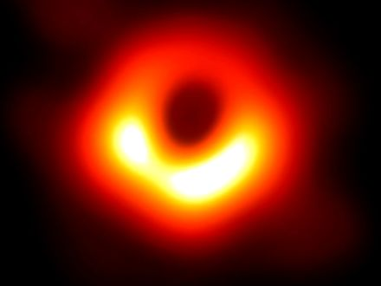
Figure 20. The ring and dark center of M87*. The shadow of a one-way surface.
A woman at a console in 2019 — invented, as the How to Read promised; the ring is not — watched the press image load and said, to no one, “That’s a hole.” She was almost right. It is the absence of paths. Photons that grazed the photon sphere, a circle at one and a half Schwarzschild radii for a hole that does not spin, can loop and still crawl out to a telescope. Photons that aimed closer cannot. The dark patch is a census of failed escapes. The bright ring is a census of last chances. The membrane itself is not in the JPEG. It is a fact about events the JPEG is allowed to imply.
Hot claim: horizons of this kind exist. Stars orbit something compact and enormous in galactic centers. Mergers ring spacetime and LIGO hears the ring.⁴⁶ The shadow is now a picture. On 14 September 2015 — a Monday, if you like kitchen calendars — a ripple passed through Hanford and Livingston, a few milliseconds apart, the way a fact about two colliding holes should. The event is called GW150914. Two holes, about thirty-six and twenty-nine Suns, finished a dance 1.3 billion light-years from this kitchen and became one hole of about sixty-two Suns. Three Suns’ worth of mass left as gravitational waves. For an instant the glow in those waves outshone, in raw power, every star we can name. The announcement came in February 2016. Since then the catalog has grown: more stellar holes, neutron-star pairs, a zoo of masses no optical telescope had weighed. The ringdown is the loaf settling after a slap. It is as close as we have come to hearing a horizon be a horizon.
Warm claim: inside the membrane, Einstein’s theory keeps going until a singularity, a place where the theory itself throws up its hands. The classical interior is a prediction of the same equations that got the shadow and the ringdown right. It is not a photograph. Cold claim: we know what replaces the singularity. We do not. Quantum gravity is a research program. Loop sketches try to bounce. String theory offers replacements — fuzz, a tangle of extra dimensions, a horizon that is not quite a horizon. String theory cannot currently be tested. A replacement that cannot be weighed is an idea for ideas, in Barrow’s honest sense, not a second picture to hang beside Figure 20.
The kitchen mistake is to think of the hole as an object you could poke. The useful thought is the membrane of events.
Imagine a last radio beep. A probe, invented, falls toward a stellar hole while a ship waits far out. The probe’s beacon is a metronome. At first the ship hears it on schedule, Doppler and all. Then the ticks stretch. Each beep arrives redder, then redder still, as if someone were pulling the wavelength the way Chapter 8 pulls galaxy light. The probe, by its own clock, crosses the membrane in finite proper time and keeps falling. The ship never quite receives a last tick. The signal fades, redshifts, and is lost in the noise. Earth can still include the probe in its past, for a while, as a redder and redder last beep. The probe’s future cone no longer includes Earth. That asymmetry is the whole joke and the whole tragedy. It is also why a hole is not a door.
Barrow liked to shock readers with a number that fits in a teaspoon. Earth’s horizon is nine millimeters. The entire planet, squeezed to a pea, would wear a membrane you could hide under a thumb. We do not do that. Gravity, given a few dozen Suns in a collapsing core, does. The shock is not the cartoon. The shock is that the same formula that makes a pea out of Earth makes a solar-system-sized shadow out of M87*, and that both numbers are now, in different ways, measured.
So: a horizon is a fact about events. It is not a personality, not a drain, not a door. The next chapter parks a clock beside one and watches “now” come apart in a more intimate way. Chapter 24 will take the door away for good. Here, keep the beep. If you remember nothing else, remember that the probe’s last second is not a second the ship is allowed to share.

21. An Hour Beside the Edge
Clocks run slow when they sit deep in a gravitational well. This is not a rumor from a story. Chapter 5 measured it on a tower, on airliners, and across a laboratory bench, and GPS corrects for it every day.
GPS satellites, at about 20,200 kilometers, gain about 45 microseconds a day from the weaker gravity and lose about 7 from their speed.¹ You do not need a black hole to believe that a well changes a clock.
What “slow” means, if we are being careful, is not that the lower clock is broken. It is that its worldline is shorter between two meetings. Proper time is mileage. A path that sits deeper in a well is a shorter path, the way a trail that cuts through a valley can be shorter than a trail that stays on the ridge, except here the “shorter” is time itself. Pound and Rebka measured the tax on light. Hafele and Keating measured the tax on clocks that flew and clocks that stayed. GPS spends the tax every second so your map does not drown. The black-hole chapter is the same tax, made rude. Nothing new is invented at the horizon except the size of the bill.
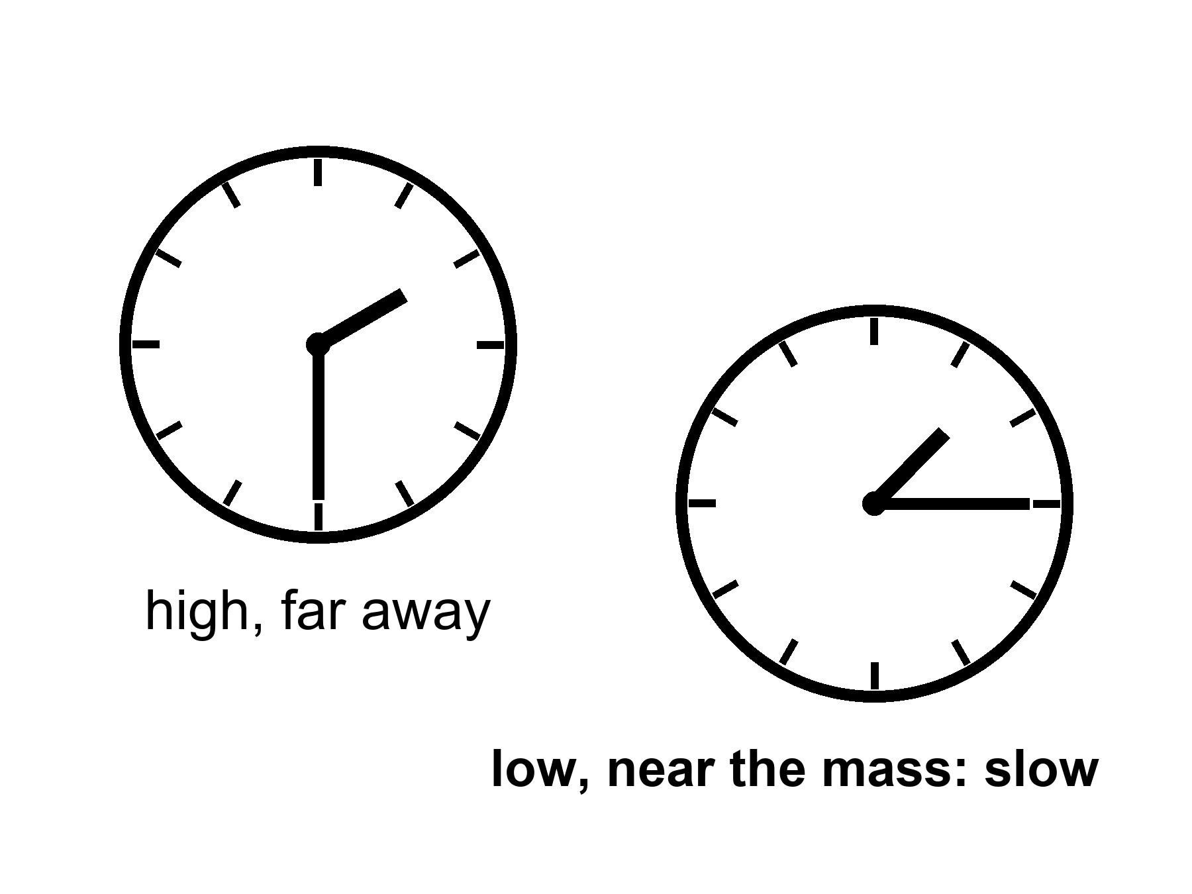
Figure 21. Two clocks, one lower in a gravity well. The lower face runs slow.
Near a horizon the same fact becomes rude. A clock hovering just outside, fighting with rockets to stay put, ticks slowly compared with a clock far away. An hour there can be years elsewhere. The numbers in posters — an hour for seven years — require a hole that is both enormous and spinning almost as fast as a hole is allowed to spin. Spin helps. A spinning hole, a Kerr hole, drags space with it and permits stable orbits closer in, where the well is deeper and the tides, for a given mass, are gentler. A supermassive hole can have an hour-beside-the-edge without spaghettifying the visitor. A stellar-mass hole would turn the visitor into a rumor of atoms before the hour was interesting.
Say the poster line out loud, then put a temperature on it. Warm claim: if you have a hole of millions or billions of Suns, spinning so close to the extremal limit that the leftover wiggle is a rounding error, and you park a station in the last orbits the equations still call stable, then an hour of proper time on the station can be years on a distant ship. Generic Kerr hole, generic orbit: the dilation is real and milder. Hours can be days. Days can be weeks. The seven-year postcard is a near-extremal special, not a brochure for every hole in the catalog. Appendix A21 writes the static factor √(1 − r_{s}/r) and notes how close to extremal spin the poster ratio really needs. Allowed is not the same as typical. Typical is not a holiday.
The innermost stable circular orbit — ISCO, in the jargon — is the last racetrack. For a hole that does not spin, it sits at three Schwarzschild radii. Matter in a disk can orbit outside that circle. Inside, it plunges. A Kerr hole, spinning, drags the loaf. Prograde orbits — going with the spin — can sit closer. In the extremal limit the last stable track crowds the horizon itself. That is why spin is not a flourish. It is how you get a station into a well deep enough for the poster, without asking the station to hover on rockets that would have to burn like a star. Even then the station is not comfortable. It is parked on a knife-edge the equations permit and astrophysics may not often build.
Frame-dragging is the grown-up name for the drag. A spinning mass pulls inertial frames around with it, the way a spoon pulled through honey pulls the honey. Lense and Thirring wrote the weak-field version a century ago; Gravity Probe B later measured a tiny twist of gyroscopes in Earth orbit and found the honey, faintly. Near a Kerr hole the honey is not faint. Orbits lean. Light leans. The last stable circle for a stone going with the spin can sit far closer than the last stable circle for a stone going against it. Accretion disks, the glowing junk that makes X-ray binaries and the EHT ring possible, live on those tracks. The woman in the station, if she exists at all, lives on one too. She is not hovering by brute force. She is falling sideways forever, on a rail the spin still allows. The rail is not a gift. Miss it inward and she plunges. Miss it outward and she is no longer in the poster well.
Tides are the other half of the honesty. The stretch across a body scales, near the membrane, as the inverse square of the hole’s mass. A ten-Sun hole, the sort LIGO hears, would pull your head from your feet before you had a philosophical thought about cones. Sagittarius A*, four million Suns, is gentler at its horizon; you could cross the membrane and still be a person for a while, which is not a kindness, only a delay. M87*, billions of Suns, has tides at the horizon that a human body would barely notice. The doom is the same. The itinerary of the doom is not. Do not confuse “the tides will not shred you at the door” with “the door is a place to live.”
Imagine a woman in a small station, parked in that close orbit, tending a rack of algae because someone still has to eat.
The station is the size of a bus that never learned to be a home. The algae live in clear sleeves along one wall, a green smear that bubbles when the pumps are honest. She checks the pH with a strip that stains her fingers. She eats a paste that was sunlight last month, then a smear, then a meal if you are not picky. The water tastes like the filter. The filter tastes like the last filter. There is a window, because the designer was sentimental, and the window shows a smear of lensed sky, a ring of light that is not for her. She does not go outside. Outside is a well.
Morning, by her watch, is a ritual with dirt on it. She bleeds a sleeve that has gone brown, dumps the dead green into a recycler that will pretend to be soil, and seeds a fresh rack because the oxygen budget is a number, not a vibe. The pumps click. A bubble sticks and she flicks the sleeve with a fingernail. This is the work. This is why she is here in the thought experiment: so the geometry has a person who still has to eat, not a tourist with a camera. The ship that sent her is a rumor with a call sign. The hole is not a view. The hole is a well she is parked in.
Her radio to a ship farther out is not just delayed by distance. It is delayed by time. She keys the mike and says “good morning” on a day her own log still calls Tuesday. The carrier crawls up the well. The ship hears it on a Thursday she will never have. The reply, when it comes, is already a conversation from a calendar she is not on. She is not time-traveling. She is accumulating less proper time between two meetings. Proper time is the mileage of her worldline, the number her watch is allowed to count. The ship’s worldline, higher on the same well, is longer between the same two reunions. The loaf did not rewind. Two worldlines of different lengths met again.
She keeps two logs because one log would lie. The station log is her proper time: sleep, pH, a paste that was algae, a Tuesday that belongs to her. The ship log, when the radio bothers to be kind, is a scatter of dates that skip. A maintenance window she was told would be “next week” arrives in her headphones as a report of a job already done. A birthday on the ship is a recording. She can answer the recording. She cannot attend the cake. “Now” is not a conference call. It is two mileages, and hers is the shorter.
She logs the algae. She sleeps. She wakes and the ship has had more hours than she has. If she stays a year by her count, the crew that sent her has had a different year — longer, grayer, full of Thursdays that were never hers. When she climbs back out, if the rockets and the orbits allow the climb, the ship’s crew has more gray in it than her mirror. She cannot take the extra years back. She can only have fewer of her own. This is the twin effect with a well instead of a rocket, and it is the only kind of “time travel to the future” relativity hands out for free. It is one-way in the human sense.
Appendix A21 writes the dilation factor and the innermost stable orbit. Here, keep the two clocks. Keep the woman only long enough to feel that “now” was already in trouble in the kitchen. Beside the edge it is in ruins. She says good morning. Thursday answers. The casserole, if anyone still cares about casseroles, was done on a day she will read about and will not have lived.

22. The Hole That Runs Backward
If you take a black hole and run the film of spacetime backward, you get a white hole: a membrane you can leave but never enter. Light can come out. Nothing from the outside can go in. In the full, idealized diagram of a non-spinning hole — the Kruskal diagram, which looks like a secret handshake and is, in the appendix, four rooms — there is a black hole region, a white hole region, and two exteriors that meet only at a throat that pinches.
The kitchen version is ruder and clearer. A drain you cannot leave is a black hole. A fountain you cannot enter is a white hole. Same plumbing laws. Opposite manners. You may stand in the yard and watch the spray. You may not climb the spray and hide in the nozzle. You may lose a spoon down the sink. You may not fetch the spoon by asking the drain to run in reverse. The laws of the water do not forbid a film played backward. The objects in a real kitchen do not offer you that film. Eggs smash. They do not unsmash. Horizons form. They do not, around us, unform into fountains.
Kruskal–Szekeres coordinates are the honest map of Schwarzschild’s solution once you stop letting a bad choice of labels pretend the horizon is the end of the world. Schwarzschild’s original labels — the ones that give you r_{s} as a clean number — blow up at the membrane the way a bad map blows up at the poles. Nothing physical explodes there. The labels do. Kruskal and Szekeres, independently, found labels that stay calm across the surface. The map has four rooms. One room is our exterior: the space far from the hole, the place LIGO lives, the place the woman in Chapter 21 might climb back to. Opposite it, on the diagram, is another exterior, a mirror region no probe of ours has a road into. Above is the black-hole interior, the room whose every future leads deeper. Below is the white-hole interior, the room whose every past comes from a membrane you cannot go in through. The four rooms meet at a throat — an Einstein–Rosen bridge, a pinch in the loaf. The pinch lasts, in proper time, no time at all that a traveler could use. Try to cross from one exterior to the other and the throat slams. The diagram is a maximal mathematical extension. It is not a floor plan of something nature built and left unlocked.
Walk the rooms once, slowly, because this is the place posters get drunk. Our exterior is ordinary spacetime with a hole in it, if “ordinary” still means anything. Light cones tip as you approach the membrane but still include a way out, until they don’t. Cross into the black room and every future cone points at the singularity. There is no “turn around.” There is no second knob. The white room is the time-reverse: every past cone comes from a singularity, and the membrane is a past horizon you can leave but never enter. The second exterior is a mathematical twin. It is not Andromeda. It is not a parallel kitchen. It is what the equations write when you refuse to cut the diagram in half. Nature, when it makes a hole from a collapsing star, does not appear to build the white room or the twin exterior. Collapse writes two rooms at most: an outside and a black inside. The other two are what you get if you insist on the whole, eternal, vacuum solution — a hole that has always been there, will always be there, and came with a fountain attached. Stars do not make that object. Stars make a membrane in one direction, in finite time, from matter that used to shine.
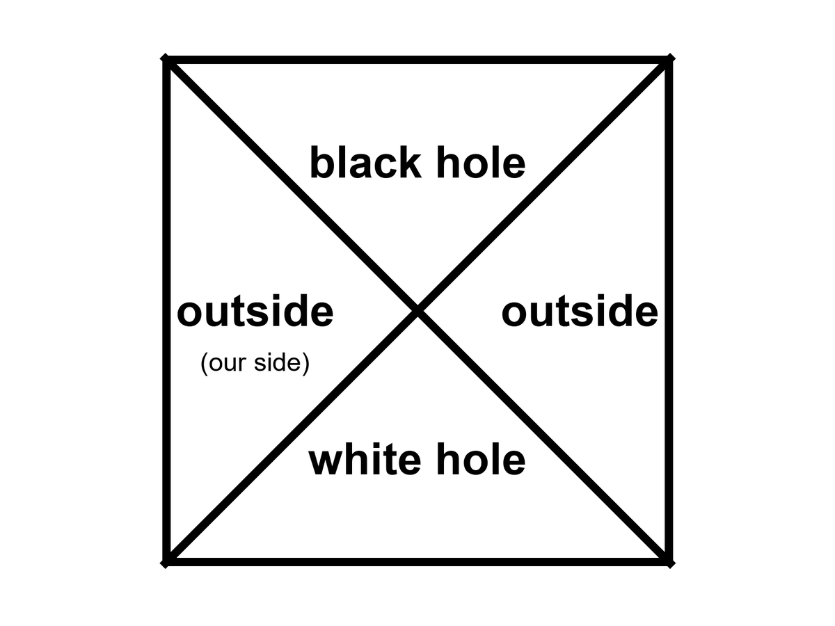
Figure 22. The Kruskal map as four rooms: two outsides, a black hole, a white hole. We live in one of the outsides.
No one has ever seen a white hole. They are allowed as mathematics and unwelcome as astrophysics. They are unstable the way a pencil on its point is unstable. A speck of dust, a photon, a rumor of mass falling toward the past horizon ruins the fountain. Any stuff that tries to enter from the exterior cannot; that is the definition. Any stuff that is already in the white room must leave, and once it has left the fountain is no longer the clean vacuum solution you drew. The universe, as far as we can tell, makes membranes in one direction: collapse, inward, one-way in. It does not spray matter out of ready-made white fountains.
Hot claim: black-hole horizons exist and we have weighed them, pictured their shadows, and heard them ring. Warm claim: the time-reverse solution sits in the same notebook and deserves a diagram. Cold claim: there is a white hole in the sky, or at the beginning of time, waiting to be photographed. There is not, on present evidence. There is a picture we can draw.
People like to say the Big Bang was a white hole. The analogy has a poetic muscle and a scientific limp. A white hole is a local object in a larger spacetime. The bang, as Chapter 7 insisted, was not a bomb in a warehouse. It was everywhere. You would not have stood outside a fountain and watched the universe come out. You would have been inside the soup, and so would every other direction. A hole is a place. The bang was a time — a hotter, smaller-spaced version of everywhere. You can draw pictures in which a bang looks, mathematically, like a time-reverse of a collapse. You can also draw pictures in which it does not. Oppenheimer and Snyder, in 1939, wrote the collapse of a ball of dust and got a black hole. Run that solution backward and you get an explosion out of a white membrane into a pre-existing space. That is not the Friedmann loaf. The Friedmann loaf has no outside, no pre-existing dark, no nozzle. The leftover glow is not a spray from a nozzle. It is a baby picture of a fog that filled the loaf.
Keep the nouns on their leashes. A white hole, if one existed, would have a mass, a location, a sky around it. The bang had a temperature, a leftover helium fraction, a glow in every direction. Those are different courtrooms. Mixing them is how a reader ends up asking what the universe exploded into, and then answering “a white hole,” and then feeling clever. The feeling is not a fossil.
Conformal cyclic cosmology — CCC, a cold idea — tries to glue a remote, empty future to a next bang with a conformal trick. When the universe is old and thin and almost empty of mass, the remaining massless stuff does not care about a scale. Photons, in a world with no massive clocks left, do not know how big the loaf is. Maybe that future can be rewritten as a beginning. Maybe bang follows bang, not by bouncing through a crunch, but by a rescaling that turns a dead, cold loaf into a new hot one. Its advocates have looked for rings in the leftover glow, scars of previous aeons. The claims are disputed. The idea is allowed to sit on the table. It is not a white hole in the sky. It is a maybe about the shape of the whole loaf. Call it cold and let it sit. Barrow would have walked you to the edge of the idea and then refused to sell it as a fossil. The fossils we have — the glow, the helium, the stretch — do not require a fountain and do not require a previous aeon. They require a hot, dense, expanding everywhere. Chapter 7 already held that courtroom. This chapter will not reopen it with a prettier noun.
Carroll’s work on the arrow, which this book already owes, sits here without being hired as a sermon. If the fundamental rules look the same with the tape reversed, the direction we call time is a fact about the loaf’s edges, not about a little arrow painted on each crumb. A white hole is what you get when you take that tape-reversal literally at a horizon. A smashed egg is what you get when you refuse to. Both lessons belong in the same kitchen. The first is a diagram. The second is breakfast.
Appendix A22 writes the four rooms and the pinch. Here, keep the fountain and the drain. If someone offers you a white hole as an exit, or as a birth, ask whether they have a photograph or a diagram. A diagram is allowed. A photograph would change the temperature of the claim. We have photographs of shadows and ripples. We have no photograph of a spray that cannot be entered. Until we do, the hole that runs backward is a teacher, not a destination. It teaches that the equations are more generous than the sky, and that the sky’s stinginess is information. Collapse happens. Uncollapse, as a local fountain, does not appear to. That is a fact about our loaf, and it is already stranger than a two-way pipe.

23. The Skin and the Leak
Jacob Bekenstein asked a rude question in the early 1970s: if you throw an encyclopedia into a black hole, where did the information go? If it vanishes, physics has lost its memory. If it stays, it has to stay somewhere that still counts.
The year was 1972, then 1973, papers that made respectable people itchy.⁴⁷ An encyclopedia is a useful kitchen object. It has a finite number of sentences. You can, in principle, count the bits. Drop it down a well and the well gets a little heavier. The horizon grows by a tiny area. If ordinary thermodynamics still applies — if you are not allowed to hide entropy by throwing it into a hole — then the hole itself must gain at least as much unread-ness as the encyclopedia lost to the outside world. Bekenstein argued that the hole’s entropy — its hidden information, its unread library — scales with the area of the horizon, not the volume inside. Hawking first thought the idea was wrong, and said so with the confidence of a man who had already proved that horizons only grow. Then, in 1974 and 1975, he found that the same calculation that fixed the coefficient also made the hole glow. A glowing hole has a temperature. A temperature and an energy give you an entropy. The coefficient came out four. The entropy is
S = kA / 4ℓ_{P}²
where A is the horizon area, k is Boltzmann’s constant, and ℓ_{P} is the Planck length, a ridiculously small ruler made from G, ħ, and c.
The Planck length is about 1.6 × 10⁻³⁵ meters. A square of that on a side is not a shelf. It is a pixel of the smallest bookkeeping the theory we have can write. One bit per few square Planck lengths on the skin. A solar-mass hole has a horizon area of a few thousand square kilometers and an entropy so large the number looks like a prank: on the order of 10⁷⁷ k, a library that would embarrass every warehouse on Earth and still fit, in the accounting, on a sphere thirty kilometers across. The inside, however deep it seems, does not get extra shelf space. This is the holographic idea in its first, stubborn form: the inventory of a region can be written on its boundary.
Hawking had already shown, classically, that the area of a horizon does not shrink. That area theorem is why he resisted Bekenstein: if area only grows, and if entropy is not area, then throwing the encyclopedia in looks like a way to cheat the second law. Once entropy is area, the theorem becomes a second law for holes. The encyclopedia’s unread sentences are not deleted from the universe’s books. They are charged to a lid that got a little wider. The glow, later, is the hole’s way of paying the bill in reverse — area shrinking, very slowly, as heat leaves. Classically the lid only grows. Quantum mechanically the lid can leak. Both statements can be true in their seasons.
Kitchen version, before the ambition starts. You throw an encyclopedia into a well. You want to know whether the universe still knows the encyclopedia. You do not get to climb in and check the basement. You get to watch the lid. The lid gets a little wider. The unread library, if it is still in the account, is written on the cover, not stacked in a volume you could walk. Count the lid. Do not count a warehouse that no letter can leave. The shock is Barrow’s kind of shock: the biggest object you can name — a billion-Sun hole — still files its secrets on a surface, at a density so fierce the numbers look like jokes until you remember that the jokes are the theory.
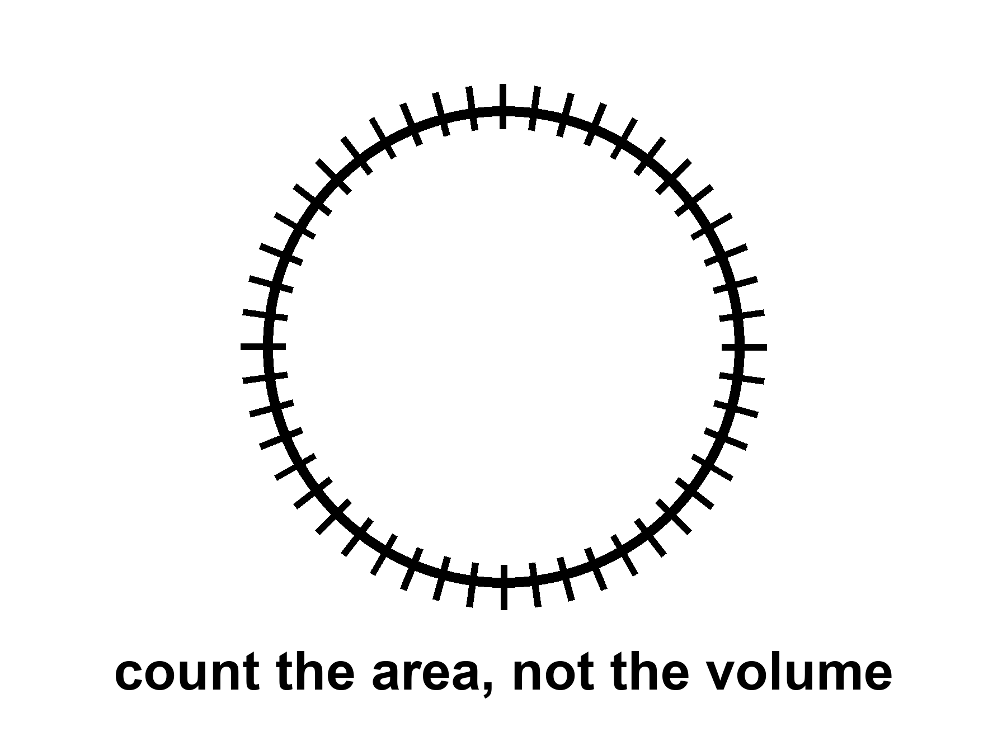
Figure 23. A sphere with hash marks on the skin only. A black hole’s entropy counts area, not volume.
People then got ambitious. Maybe the whole universe is a hologram. Maybe a gravity theory in a volume is secretly a quantum theory on a wall. In one special, negatively curved kind of space, this has been made precise enough to write papers that get jobs. Juan Maldacena’s AdS/CFT duality, from 1997, is the precise form: a gravitational theory in an Anti-de Sitter box, a space that caves in the way a saddle caves, matches a quantum field theory on the wall of the box. Calculations that look like black-hole thermodynamics on the inside look like ordinary quantum bookkeeping on the wall. That is a triumph of a model. That space is not our accelerating, leftover-glow space. We live with a shove, Chapter 18’s shove, that looks like a positive cosmological constant, a de Sitter mood, not an Anti-de Sitter box. A duality that works in a box we do not inhabit is not a photograph of the kitchen. It is a constraint on how ambitious you are allowed to be when you invent hiding places for bits. The leap from “black holes count on their skin” to “your kitchen is a projection” is a leap. Warm-to-cold. Useful as a constraint: you do not get to invent an infinitely roomy crunch-computer (Chapter 19) without saying where the bits sit. Tipler needed a loophole in a bound like this. The bound is not impressed.
Holography does not cancel events. It relocates the bookkeeping. The loaf may be a projection of something thinner. The events you care about — a last beep, a first helium nucleus, a woman saying good morning to a Thursday she will not have — still happen. They may have fewer hiding places than a volume would suggest. That is a change in the furniture of the account. It is not a vanishing. It is not a promise that a lost encyclopedia can be checked out later like a library book. It is a rule about how much unread stuff a region is allowed to hold.
The glow is a slow leak from the membrane.
In the kitchen version: near the horizon, the vacuum’s jitters get sorted. One part of a jitter falls in. The other part escapes. From far away, the hole is radiating, very slightly, as if it had a temperature. The formula, if you want the shape of it, is T_{H} = ħ c³ / (8π G M k): colder when heavier, hotter when lighter, Planck’s constant in the numerator so that a purely classical hole would not glow at all. Hawking’s temperature for a solar-mass hole is about 10⁻⁷ kelvin — ten millionths of a degree above absolute zero, a hundred million times colder than the leftover glow in your kitchen. Small holes are hotter. A hole the mass of a mountain would sizzle. A hole the mass of an asteroid would be a brief, rude oven. A hole the mass of a star is colder than the leftover glow and, today, gains weight from the sky faster than it leaks. Only in the unimaginably far future, after the leftover glow has thinned, would stellar holes begin to lose.
The leftover glow is 2.725 kelvin. A solar-mass hole, at about 60 billionths of a kelvin, is some forty million times colder than that.⁴⁸ The sky, for now, is a heat bath the hole sits in, and the bath wins. This is why “black holes evaporate” is a true sentence about a later season of the loaf and a false poster about Tuesday. Tuesday, the hole in Cygnus X-1 is getting slightly heavier from the microwave fog and from whatever gas it can steal. The leak is real in the derivation. The leak is not winning.
If nothing interrupts, the leak eventually takes all the mass. The evaporation time for a solar-mass hole is about 10⁶⁷ years — a one with sixty-seven zeros, a number that makes the 13.8 billion years of the stretch look like a blink in a blink. Barrow would have put that integer on a blackboard and let it sit until someone laughed. The laugh is allowed. The integer is the theory. The hole shrinks, heats, shrinks faster, and ends in a last, small violence. Whether the encyclopedia comes back in the last violence, or came out slowly in the glow, or is written on a remnant, is the information problem. It is unfinished.
The fight has a shape, even unfinished. Hawking’s first glow looked thermal, which is a polite word for “the radiation does not remember the encyclopedia’s sentences, only the hole’s mass, spin, and charge.” If the hole then vanishes, the sentences have nowhere to live. That is a quarrel with quantum mechanics, which prefers to keep its books unitary: information is shuffled, not shredded. Proposed peace treaties have names. Complementarity says the outside and the inside are two accounts of one book, and you are not allowed both at once. Firewalls say the membrane might be a violent place after all, a contradiction dressed as a heat bath. Islands in the recent math say the entropy of the glow can fall late in the evaporation, as if the sentences had been hiding in the radiation all along and only became countable later. None of these is a photograph. All of them are warmer than a shrug and colder than a settlement. It is not unfinished in a way that lets you use a hole as a filing cabinet for resurrection. A soul is not an encyclopedia. An encyclopedia is not a person. Neither one is stored in a basement you can open later by being patient, or pious, or good at grants.
Hawking radiation has not been seen from an astrophysical hole. It is a derived glow, as firm as a derivation can be without a photograph. Laboratory analogs — sound horizons in fluids, tricks with lasers, a Bose–Einstein condensate with a sonic membrane — have made related noises. Bill Unruh taught the field to listen for a sound that cannot climb out of a moving fluid: if the fluid runs faster than sound, there is a surface sound cannot recross, and the math of that surface is cousin to the math of Chapter 20. Jeff Steinhauer and others have built such membranes in the lab and reported a glow with the right family resemblance. They are encouraging and not the same as weighing a photon from Cygnus X-1. An analog horizon is a teacher. It is not the leak from M87*. You can poke the fluid. You cannot poke M87*. Keep the temperatures straight. The derivation is warm-to-hot. The photograph is missing. The analog is a cousin.
For the travel chapters, the leak is a timekeeper. It says black holes are not eternal furniture. They are long-lived, then gone, on clocks that make civilizations look like sparks. If you want a library to last, do not drop it in. Put it under ice, or in a vault, or in a machine that can wait. The membrane is a fact about events. It is not a basement.

24. Not a Door
The last mistake is the door.
A door has two sides you can use. A horizon has two sides you cannot trade. A kitchen door has two knobs. You go out for the mail. You come back for the casserole. The loaf of the house does not mind. You can stand in the yard and still be in the kitchen’s future, and stand in the kitchen and still be in the yard’s future. That is what two knobs are: two rooms that keep each other in their cones. A one-way membrane is not that door. Fall in and you do not come out “somewhere else” in this universe with a story to tell. There is no second knob. There is no mail. There is a sorting of events, and you have joined the set that cannot write home.
The flattering picture is always the same. The hole is a gate. The gate leads to a tunnel. The tunnel leads to another kitchen, or another century, or another you. The picture borrows its furniture from doors because doors are the one-way-looking objects we actually own, and because we have all, at least once, wanted a room that was not this one. Physics will not rent you that room at a horizon. The membrane does not open. It sorts. If you want a handle between two exteriors, that is a wormhole, and it is Chapter 34’s problem, and it is not this object. If you want a future in this universe with a story to tell, stay outside.
In the classical theory you come to a singularity, a ripped place in the loaf, and the theory stops. The geodesics — the straightest paths the geometry allows, the paths free clocks and free stones follow — do not come out. A geodesic that crosses r_{s} reaches r = 0 in a proper time you can write on a napkin: tens of microseconds for a stellar hole, hours for Sagittarius A*, the better part of a day for a giant like M87*. Those are not transit times to another station. They are the lengths of worldlines that end. They reach, in that finite proper time, a boundary the equations cannot extend through. That is what “singularity” means when it is being honest. It is not a glowing point with a brand name. It is geodesic incompleteness: the paths stop, and the theory that was telling you how they lean has nothing left to say. Appendix A24 writes the line. Here it is enough to refuse the hallway. A path that ends is not a path that arrives in another kitchen.
You can try to be clever. You can fire rockets inside. You can aim “sideways.” Inside a Schwarzschild hole there is no sideways that leads out. The radial direction has become timelike: “out” is as unavailable as “yesterday.” That sentence is the whole joke, dressed as a coordinate fact. The membrane is not a wall you bounced off. It is a date you cannot un-reach. The geodesics do not come out because “out” is no longer a direction in their future cones. Chapter 20’s last beep, heard from the ship, is the outside’s view of a crossing that, inside, is already a one-way season.
The singularity theorems, and Hawking’s cosmological versions, say that if gravity pulls in the ordinary way and energy behaves, collapse and bang-like expansions have boundaries the geodesics cannot extend through. Penrose’s 1965 result is the local one: a trapped surface — a sphere from which light is already being dragged inward, outgoing as well as incoming — plus ordinary energy conditions, and the loaf is incomplete. You do not need to assume a pretty symmetry. You need a trapped surface and a rule that energy is not too exotic, and the paths cannot be extended forever. That is why a collapsing star is not a special cartoon. It is a case of a general sentence. Hawking applied the same muscle to the early universe: if the past is a trapped place in the right sense, the bang, too, is incomplete as a geodesic story. Inflation and dark energy violate some of those energy assumptions, which is why the theorems are not a courtroom for “the universe began” in every model. A burst that repels, a shove that stretches, can dodge a hypothesis the 1960s treated as polite. They are still a courtroom for “you may not treat the inside of a hole as a hallway.” A stellar collapse still makes a trapped surface. Ordinary matter still obeys the energy conditions the theorems asked for. A trapped surface is not a doorframe. It is a proof that the paths do not return.
Hot claim: if you fall into a hole of the kind we have pictured and heard, classical general relativity does not give you an exit in this universe. Warm claim: a quantum theory of gravity will replace the ripped place with something that does not infinite-curve. Cold claim: that something is a door, a bounce you can steer, a baby cosmos with a forwarding address. The warm claim is a research program. The cold claim is a hope wearing a lab coat. This book will not rent the coat.
In speculative theory you might come to a bounce, a baby universe, a tangle of extra dimensions. Those are cold. They are also, even if true, not a transit system. A baby universe you cannot call is not a destination. A bounce that pinches off a new loaf, if such a pinch exists, is a maybe about the interior, not a ticket window. You do not steer it. You do not mail a letter through it. You do not retire there. The new loaf, in the sketches that allow one, is not “somewhere else” on a map you already own. It is a separate region of events, pinched off, causally unavailable to the ship that watched the last beep. Calling that a trip is like calling death a change of address because the nouns still exist in a dictionary.
Extra dimensions offered by string theory come with the standing rule: the framework cannot currently be tested. A hallway drawn in an untestable framework is a drawing. It is not a road. Loop-quantum sketches that replace the ripped place with a bounce are a different drawing, also unphotographed, also not a subway. This book will let the drawings sit. It will not sell tickets. A cold interior is allowed. A transit system is a different claim, and it fails even if the cold interior is true, because availability is the whole of what “destination” means. If you cannot call, you did not arrive. If no one can call you, you are not a station.
Wormholes, in Chapter 34, are a different object: a handle, not a membrane. People blur them because both are “holes” and both are associated with Einstein. Do not blur them. One is common and one-way. The other is unphotographed and probably expensive beyond engineering. A wormhole, if nature or a civilization ever held one open, would be a throat between two exteriors you could, in the optimistic diagrams, enter and leave. You would see two mouths, two skies, two knobs, if the metaphor will sit still that long. It needs exotic stress, a violation of the energy conditions the singularity theorems were using as police — a stuff that antigravitates in the throat so the pinch does not slam. The Kruskal throat of Chapter 22 is not that object. That throat pinches in finite proper time and cannot be traversed. The Morris–Thorne kind of handle is a different drawing, built to stay open, and it pays for the staying with matter no kitchen has ever weighed. It is a maybe about a handle on the block. A black hole is not that handle. A black hole is the membrane we have already pictured and heard. Confusing them is how a shadow in a ring becomes, in a careless paragraph, a subway. This book will not be careless. Chapter 34 can spend its own pages on the handle. This page is the refusal.
A short inventory, so the blur has nowhere to hide. Horizon: a fact about events, one-way, photographed as a shadow, heard as a ringdown. White hole: the time-reverse, undrawn in the sky, unstable. Kruskal throat: a pinch, not a tunnel you can walk. Wormhole: a proposed handle, two-way if it exists, not this chapter, not in the EHT image. Baby universe: a cold pinch-off, not a destination. Singularity: where the geodesics stop, not a station. If a paragraph uses two of those nouns as if they were one noun, the paragraph is a poster. Put it down.
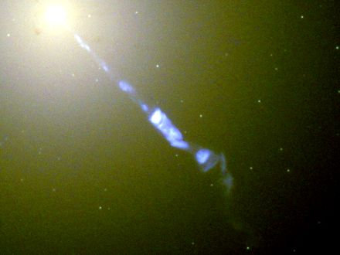
Figure 24. The bright host galaxy M87, with a jet thrown out from its center. A real black hole lives there. It is still not a door.
Look at Figure 24 and practice the sentence. A real hole lives in a real galaxy. Stars orbit. Gas glows. A shadow, if we had the baseline, would sit in the middle the way Figure 20 sits in M87. None of that is a door. The host is not a terminal. The dark is not an arrival hall. The honest nouns are still the ones Chapter 20 paid for: a fact about events, a last beep, a leak so slow it makes civilizations look like sparks.
So: no transit. No filing cabinet for souls. No steered crunch. No baby-universe bus. A shadow in a ring, a slow leak, a one-way fact about events. That is the honest hole. It is enough. It is already stranger than a door.
The part that began with Schwarzschild’s letter from the front ends here, on a galaxy that does not owe us an exit. The next part will try to go somewhere anyway — a greenhouse, a delay, a launch window — without once treating a membrane as a knob. If you wanted the hole to be a door, you wanted a different loaf. This one sorts events and does not give them back. Take the casserole out when your clock says so. Leave the well alone.

PART VI — Getting There Anyway

25. A Greenhouse on a Dead World
The airlock sticks on cold mornings. Mara hits it with the heel of her glove, the way you hit a jammed kitchen drawer, and it sighs. Inside, the greenhouse is the only room that smells like a lie: wet soil, torn basil, a sweetness that does not belong to this planet. The lie is maintained with LEDs the color of an overcast noon and a tray of water she melted, yesterday, from a vein of ice the color of dirty chalk.
She does not rush the second door. Pressure equalizes the way a kettle decides to boil: when it is ready, not when she is. The suit still smells of dust and of the powder the filters never quite catch. She cracks the helmet, in here only, and the wet-soil lie hits her like a kitchen she has not earned.
This is the woman who stood between the lamps. Eli still has the clock. His question about the dust is already late.
The boot-print from yesterday is still sharp. Wind on this world is a rumor. The air outside is carbon dioxide at about six millibars — a hundredth of a kitchen atmosphere, a breath that would not lift a napkin, a sky that is weather only if you are generous with the noun. She does not farm the sky. She farms a box. The box is the permit.
A permit, in this book, is not a city. It is not a flag. It is permission for a trick to be run by hand: liquid water in a tray, light on a leaf, a gas mix a potato can stand. The planet’s own permit expired. The wet youth ran off or hid in the bones. What is left is a desert with ice in it and a chemistry that can be negotiated with. She is the one who negotiates. The dirt is the other party.
She logs the night before she drinks. Heater held. No frost on the potato bench. A tray of seedlings on the north side looks sulky, which is a word the log does not want and gets anyway. The recycled water has crept in pH. She will negotiate that after the brown liquid the recycler calls coffee. Sentiment is allowed. Sentiment does not get to vote.
The dirt is not dirt. It is crushed rock and dust, a mineral flour with a tax in it. Perchlorates — salts that on Earth show up in dry places and in laboratory jokes — sit in the fines. They are oxidizers. They are rude to a gut and interesting to a chemist who needs a stash of oxygen in a pinch. She does not eat the fines. She rinses what she must rinse, she binds what she can bind, she treats each tray as a negotiation. The universe did not mail soil. It mailed a rock. The rock can hold a root if you add water, a buffer, and weeks.
The air she breathes in the box is not the six millibars. Potatoes want a buffer of nitrogen and oxygen, a pressure a leaf recognizes, a humidity that is not a desert. She mixed that kitchen, or a machine mixed it, from tanks and from whatever the chemistry would surrender. The outside CO₂ is a feedstock if you have the power to split it, and a poison in the wrong mix. She watches the gauges the way you watch a pot that can boil dry. The greenhouse is also a cave: glass and piled dirt against a sky that does not shield. A solar day of unkindness lives in the dust. She farms under a lid, not under a heaven.
Water is stolen, not supplied. Ice at mid-latitudes and high, in the ground, in the shade of a crater lip, in veins the color of dirty chalk. Orbiters sniffed hydrogen. A drill made it a fact. Yesterday she ran a heater into a vein and waited like a person waiting for a kettle, except the kettle is a planet and the wait is a workday. Melt, filter, test for the salts, melt again. A kilogram of potato is mostly water wearing starch as a costume. The log knows this. The tray knows this. The ice vein does not care.
The potatoes are not a metaphor. They are a starch that either happens or does not, under LEDs, in a tray whose salts she has not finished arguing with. A sprout is a small yes. A black smear is a small no. She trims a leaf that went yellow and puts it in the compost that is not a compost so much as a bucket she will negotiate with later. The airlock, on the way to the bucket’s outer porch, sticks. She hits it. The seal is the morning.
Outside, the sky is butterscotch and thin. A radio sits on the workbench. When she talks to the orbiter, she talks to twenty minutes ago, or three, depending on the season: about three minutes one-way when Mars and Earth are closest, about twenty-two when the Sun sits between them. The orbiter talks to Earth, which talks back in more minutes. There is no conversation. There is a stack of monologues that eventually, if everyone lives, amount to a plan.
There is no live weather from home. There is a file with a timestamp, Eli’s voice on the delay, a checklist that was current when it left. She answers the checklist. She does not answer the tone. Tone does not survive twenty minutes of vacuum. If the heater failed at 3 a.m. her time, Eli will learn it after the potatoes have already decided.
She is not waiting for a miracle. She is waiting for a launch window. The next cheap path home — the one that lets a ship fall most of the way instead of burning a fortune — opens in 26 months, give or take the mood of the two orbits. Until then the potatoes either make starch or they do not. The universe does not have an opinion. The dirt has a chemistry, and the chemistry can be negotiated with.
The window is not a holiday. It is a fact about two ellipses that lap each other. Every two years and a bit, the cheap path opens: a long fall that spends its fortune at the beginning and the end and lets gravity do the commute. Δv is the invoice — how much extra shove you must buy, in kilometers per second, to leave one well and enter another. The invoice does not care that she is tired. It does not care that a tuber is late. Miss the window and you wait for the next lap. Burn extra to force a path and you pay in propellant you are not holding. She is not drawing a schedule for a nation. She is reading a calendar two planets already wrote.
She names the morning’s jobs the way you name the burners on a stove. pH. Filter. Ice. The stuck door, again, because the seal has a personality in the cold. The rover’s blanket of dust. None of these is a milestone on a poster. None of them founds a town. A town is a later kind of waste, a pile that remembers, and this chapter has not hired one. She has a box, a drill, a radio that answers a quarter-hour late, and a tray.
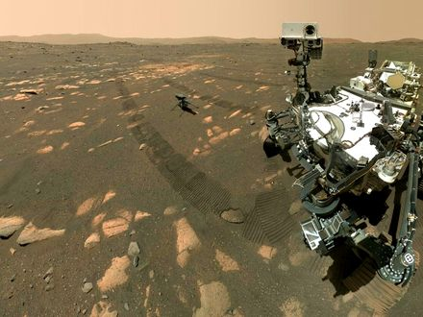
Figure 25. The rover Perseverance, large in frame, on dusty ground; the small helicopter behind it is Ingenuity. Dirt, delay, no magic.
This is the only honest picture of “somewhere else” this book will allow in the near term. A dead world, close enough that light-minutes, not light-years, set the lag. A body you can weigh. An ice vein you can steal. Machines that do not sleep parked in the driveway. A human worldline that has to eat.
The rover waits like a tool left in a driveway. Dust on the solar blanket. A scratch on a wheel from a rock that did not care. She will drive to the vein after the pH, or she will not, depending on a battery that has opinions. Machines that do not sleep still need someone to hit an airlock with a glove. The sky is butterscotch because the dust is a fine rude flour and sunlight through a breath of CO₂ is a stain, not a blue. Blue is a luxury of a thick nitrogen sky. She has seen the marble in a camera, late by minutes. She is not a backup of that marble. She is a person with a tray.
Appendix A25 writes the Δv, the round-trip delay, the kilograms of water per kilogram of potato. Here, keep the stuck airlock. If we go farther than this world — and we will, in the next chapters, on paper — we will go as Mara goes: by negotiating with the chemistry, by missing conversations, by treating a launch window as a fact about the loaf, not a mood.
She names the basil, which is sentimental, and logs the pH, which is not. On a dead world, sentiment is allowed as long as it does not get to vote.
The second door sticks again on the way back from the vein. She hits it. It sighs. The greenhouse takes her in like a liar who has, for today, told the truth: the tray is wet, the LEDs are an overcast noon, the potatoes have not given up. She writes that down. She does not write a nation. She writes a morning, which is the only unit this permit comes in.
A permit on a dead world is this small. Not a sky that learned to be kind. Not a calendar of cities. A glove, a sighing door, a tray, a delay of three to twenty-two minutes, a cheap path that opens every twenty-six months, a Δv that is an invoice, ice at the latitudes where ice still sits, perchlorates in the fines, six millibars of the wrong air. She already has all of that. The morning is how you spend it.

26. Most of the Universe Has Already Left
Even if her potatoes prosper and the window opens and the ship falls home, most of the cosmos is already out of reach.
Light is late, we said. There is a ruder fact. In an accelerating universe, there are events that will never be in our future cone, no matter how long we wait, no matter how patient the radio. Space between unbound things stretches so well that a photon emitted “now” from those galaxies never finishes the trip. We can still see some of them: their old light is in transit. Their new light is a letter that will not be mailed.
Imagine it as mail. You write a letter. You put a stamp on it. You walk it to the slot. For Earth, for the orbiter, for the woman with the stuck airlock, the slot still works. The letter is late — three minutes, twenty-two, a few hours to a probe at a giant planet — but late is not never. For a galaxy in the deep field, the slot is painted on. You may drop the envelope. The loaf does not carry it. The stretch between you and that galaxy is accelerating. The hallway lengthens faster than the messenger runs. The letter is not lost in a drawer. It was never in the future cone of the person you meant to reach.
That is not a black hole. Say it twice, because the noun horizon was already hired in Chapter 20 for a one-way membrane around a collapsed star. A hole’s horizon is a fact about which events can still influence which others, locally, in a deep well. The cosmic event horizon is a fact about the whole loaf’s later shape: which distant raisins will never, even given eternity, receive a photon we emit today. Same family of word. Different kitchen.
The shove of Chapter 18 is why the slot paints shut. In a universe that only coasts, you can, in principle, wait long enough for more and more old light to arrive; the particle horizon — we will get to that word in a moment — keeps growing as a patient astronomer. Once the stretch accelerates, waiting stops helping in a new way. Isolated lumps stay bound: a galaxy, a cluster, our own small group of raisins that still hold hands. Between the unbound, space wins and keeps winning. A photon set down “now” on a far worldline never finishes the commute. The destination recedes faster than light can close the gap. Faster-than-light recession is allowed here; it is the dough rising, not a rocket cheating Einstein in a room.
How far is the shut door?
Order of sixteen billion light-years, as a proper radius today⁴⁹ — a ball, not a calendar date. Inside that ball, a letter mailed this morning can, in principle, still arrive, late and stretched. Outside it, the letter is a gesture. Appendix A26 writes the integral: a finite remaining commute when the scale factor grows like a compounding interest. Sixteen is not a speed limit on a sign. It is the size of the remaining postal system for new mail. The number will not become a destination. It is a fact about influence, the same species of fact as a hole’s skin, drawn on the whole sky.
Do not confuse that ball with a different circle people like to draw. The Hubble sphere is where unbound raisins recede at light, today, in the stretch-rate of now. It is a snapshot, not a membrane. Light can still arrive from outside it; light we emit can still, in some cases, arrive inside a future that the event horizon has not yet shut. The event horizon is ruder and more useful for travel: it is about never. The Hubble sphere is about this instant’s slope. Kitchen: the speedometer is not the locked door. Chapter 8’s line v = H₀ × d is the speedometer. Chapter 18’s shove is why the locked door exists at all.
We can still see past that ball. That is the part that feels like a trick and is only lateness. The light in the telescope left a long time ago, when the raisins sat differently, when the hallway was shorter in the right way. Old light is already in transit. New light is the letter that will not be mailed. A museum can be full of real objects whose living rooms you will never enter. The deep field is that museum.
The other rudeness has a different name.
The particle horizon is the edge of what we can already see — more carefully, the farthest events whose light has had time to reach us since the stretch began. It is a fact about the past we can rebuild. The leftover glow is a practical wall in front of it: a fog at 380,000 years, Chapter 9’s baby picture, beyond which the universe was opaque. In principle the particle horizon sits farther than a naive age-of-the-loaf times the speed of light, because the dough rose while the messengers were running. The raisins that emitted the oldest light we can imagine are now much farther than “thirteen-and-a-bit billion light-years.” The kitchen mistake is to treat the age as a radius. The age is a duration along worldlines. The radius is a rising.
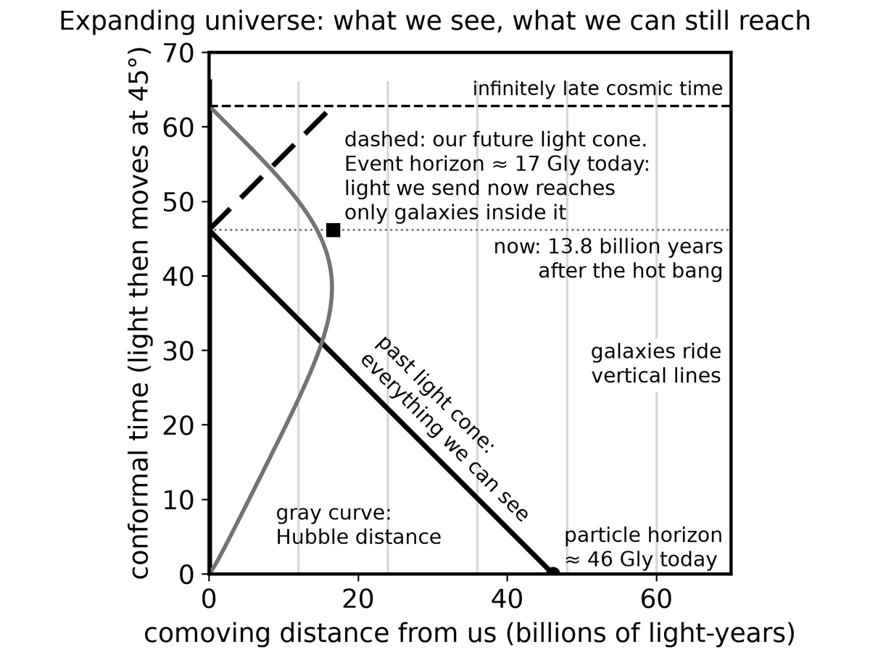
Spacetime Diagram 4. An expanding universe drawn so that light still moves at 45 degrees. Galaxies ride vertical lines. Our past light cone is everything we can see (out to about 46 billion light-years today); our future light cone shows that light we send now reaches only galaxies inside about 17 billion light-years, the cosmic event horizon.
Two horizons, two rudenesses. One is about the past we can rebuild. One is about the future we cannot visit. They are not the same line with two labels. The particle horizon grows as time passes; more past becomes visible, fog permitting. The event horizon, in an accelerating loaf, is a closed kind of future: some worldlines are already out of the postal system for anything we do today. Appendix A26 distinguishes them on a wedge. Here, keep the two slots. One slot still takes incoming archive. One slot refuses outgoing mail.
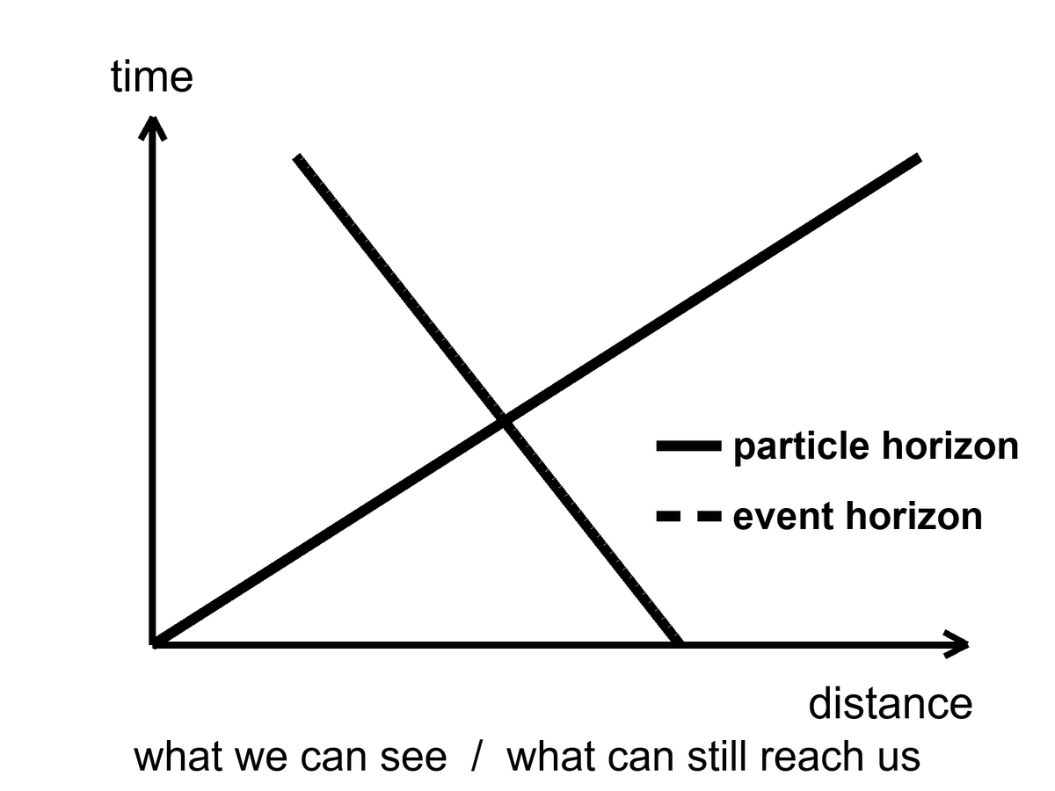
Figure 26. Two horizons on a simple spacetime wedge: the particle horizon is what we can see; the event horizon is what can still reach us.
The deep field of Chapter 8 is, in this light, a kind of wake. Those galaxies are not destinations. Some of them were already leaving when their light left. Mara, if she dreams of “the universe,” is dreaming mostly of a museum. The exhibits are real. The gift shop does not sell tickets to the exhibits’ futures.
Most galaxies are not destinations. Say it as a temperature. Hot: they are real, they were there, their light is a measurement. Warm: many of them are already outside the event horizon for new signals, or will be, as the shove keeps winning. Cold: that we will one day “go to the Hubble Deep Field,” as if a photograph were a pier. A photograph is an archive. An archive is not a ticket.
Bound things hold. People, planets, galaxies, the Local Group. What stretches is the space between the unbound. That is Chapter 8’s law, spent here as a travel ban. The woman can, in the ugly-and-finite sense of Chapter 25, still reach a dead neighbor. She cannot, in any sense this loaf presently offers, reach a smudge whose light has been flying for most of the age of the universe. Waiting does not fix it. Patience is not a warp. The accelerating stretch is not a mood we can talk out of.
A future astronomer in this loaf has a poorer museum, not a richer one. As the shove keeps winning, more of the deep field redshifts out of practical view. Bound groups become islands. Our island — the Local Group, Andromeda’s navy still inbound, the Magellanic scraps, the raisins that still hold hands — remains a kitchen. The other kitchens go dark, not because they died, but because their new light is a letter that will not be mailed and their old light has already passed or stretched past the point of a useful stamp. The leftover glow itself thins. The night, late enough, is a local night. That is not a tragedy we can schedule against. It is the later shape of an accelerating loaf.
This is why wormholes and warps get invented. This is why they have to break something. The loaf, as measured, does not include a hallway to those rooms. Getting there anyway, if it happens, will happen to nearby rooms: planets and moons that still share our future cone for a long time. The rest is a baby picture of a crowd that has gone home.
A last kitchen image, because it is the one that sticks. She writes two letters. One is to Earth, timed for the window, a stack of monologues that may yet amount to a plan. That letter is late and allowed. The other she does not write, except in the dream where “the universe” meant the deep field. That letter would be honest feeling and bad physics. Most of the cosmos has already left, not by walking away, but by the dough rising too well. The museum stays open. The gift shop still does not sell tickets. Keep the potatoes. They are in the cone.
Appendix A26 writes the two integrals. Here, keep the two slots and the unsent letter. The particle horizon is an archive that thickens, fog permitting. The event horizon is a postal system that, in an accelerating loaf, has a last address. Sixteen billion light-years is the order of that last address, as a proper radius today — not a pier, not a mission, a fact about which raisins will never read our mail. Mara can still write to Earth. That is already a lot. It is also the grown-up size of “getting there.”

27. Other Suns, Other Worlds
For most of human history, “planet” meant a wanderer you could see, and there were six, then seven, then eight, then a fight about nine. Other suns were assumed, in the way a reasonable person assumes other kitchens exist in other houses. Proof is ruder than assumption. Proof arrived in 1995, as a wobble.
51 Pegasi is an ordinary star, about fifty light-years away toward Pegasus.⁵⁰ Didier Queloz and Michel Mayor watched its spectrum rock, back and forth, every 4.2 days. Something heavy was tugging it — something at least as massive as a fraction of Jupiter, something so close to the fire that a “year” there is a work week. A hot Jupiter. Nobody’s formation story had ordered that dish. The dish arrived anyway. The Nobel, years later, was for the first confirmed planet around a sun-like star, and for the implication that followed like a rude guest: if the first one we found was a monster in the wrong orbit, the sky is not a copy of our living room.
The Nobel was 2019. Twenty-four years of arguing, confirming, and watching the drawer fill. The prize named Mayor and Queloz, which is how prizes work, and named the implication, which is how science works. 51 Pegasi b is not a place you would put a tray of basil. It is a measurement that broke a template. Templates, in this book, are the enemy of a census.
How you find a world you cannot see:
You watch a star dip. A planet crosses its face, and the light falls by a fraction of a percent, a bite out of a cookie, repeating. Kepler sat in space and stared at one patch of sky until the bites numbered in the thousands. TESS is doing the bright, nearby stars. The depth of the bite is the area of the planet compared with the area of the star. A Jupiter in front of a Sun is an easy bite. An Earth in front of a Sun is a nibble you must not invent.
Kepler’s stare was a long look at one crowded patch, faint stars included, until the repeating crumbs piled high enough to be a population. TESS trades depth of stare for a wider, nearer harvest: the bright nearby stars, the ones a later telescope can study. Neither mission walked on a world. Both counted bites. The count is the point. A thousand worlds you will never visit are still a thousand measurements. Mara can read that file. She cannot drive there.
The nibble has a number, because this chapter is a census and a census without a number is a mood. Transit depth is roughly the square of the radius ratio. An Earth crossing a Sun takes about eighty-four parts per million of the starlight — eighty-four in a million, a cookie with a crumb missing, a bite you will miss if your photometer is a guess. A Jupiter crossing a Sun takes about one percent, a bite a less fussy instrument can taste. That is why the first rude finds were large and close. Rude is easy. Quiet is the later, better harvest.
You watch a star wobble, as Mayor and Queloz did. The tug is bigger if the planet is heavy and close. This is why the first finds were rude: rude is easy.
The wobble is a spectrum rocking: lines sliding toward blue, toward red, a Doppler that is a partner’s pull, not a siren in a street. The amplitude is larger for a heavy planet, a close planet, a star you can see well, an orbit viewed more edge-on than face-on. Kitchen: a child on a seesaw with a truck is obvious. A child on a seesaw with another child is a job for a better scale. Hot Jupiters were the trucks. Super-Earths and mini-Neptunes waited for the scale.
You, rarely, take a picture. A young, fat world, far from a star that has been blocked or subtracted, can show as a dot. Most planets are fireflies against searchlights. The picture is the exception.
You, more rarely still, watch a star lens another star, and a planet hitchhiking the lens adds a hiccup to the brightening. Microlensing finds worlds we will never visit and barely name.
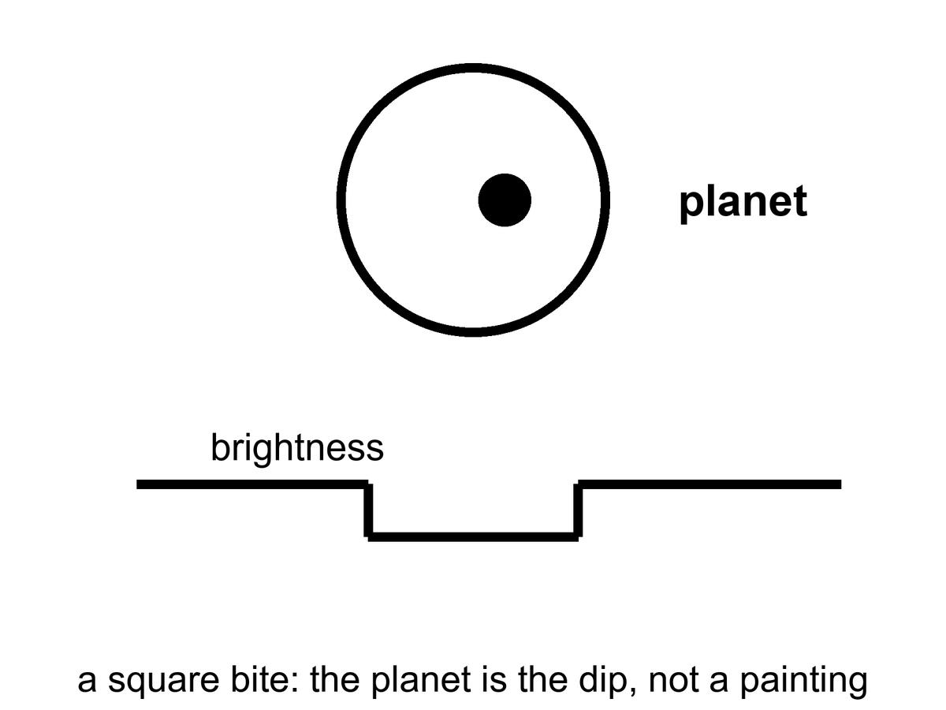
Figure 27. A star, a planet crossing it, and a light curve with a square bite. The planet is the bite, not a painting.
The census, once you correct for the rude-is-easy bias, is the sentence that should have been in every schoolbook twenty years ago: most stars have planets. Not all of them are Jupiters hugging the flames. The common finds, the ones our own solar system did not prepare us for, are the in-between worlds — super-Earths, mini-Neptunes — larger than us, smaller than ice giants, often wearing thick gas we would not call air. Kepler’s harvest is a drawer of sizes we did not have names for.
Correcting for rude-is-easy is the whole adult move. Stars were watched because they were bright and quiet enough. Planets were found because they were heavy or close or both. The drawer, once you put those biases on the table, still fills: a planet or more around most of the stars we have learned how to count. Not a Jupiter per house. Not an Earth per house. A furniture of in-betweens, plus ice giants, plus rocks, plus the occasional monster in a work-week orbit. Occurrence is a word for that filling. It is not a hotel list. Mini-Neptunes — a couple of Earth-radii, a thick wrap of hydrogen and helium we would not breathe — are common in the Kepler field and absent from our living room. Super-Earths sit between us and that wrap. Our system’s gap there may be a local accident, or a migration that cleaned a shelf. The census does not owe us a copy of the shelf we grew up with.
Most stars, not most posters. A Sun-like star is allowed to have a family. A red dwarf, which is most stars, is allowed to have a tighter, ruder family. The eight-world house we grew up in — four rocks, two ice giants, two gas giants, a fight about a ninth — was a local floor plan. The sky’s common furniture is a super-Earth or a mini-Neptune, a world that would sit, in our house, in a room we never built. Thick envelopes. No template. A permit, if any, that is not our permit.
A few catalogs have become characters. TRAPPIST-1 is a cool dwarf with seven Earth-sized worlds packed closer than Mercury, some in the starlight band of the next chapter, all tidally interesting, all flare-threatened. Proxima Centauri, the nearest other sun, has at least one world in a hurry around a brat of a star. K2-18b is a maybe-Hycean: a hydrogen blanket over a slush we have not tasted; JWST has been asked to smell its air, and the smells have been argued like a will.
K2-18b is the sentence to keep at maybe. A hydrogen envelope over a water-rich interior is a warm paper. A detection of a molecule in a transmission spectrum is a barcode, not a beach. The arguments have been loud because the public wants a neighbor and the data want a committee. This book will not pick a winner in a courtroom that is still in session. It will say: even a yes would not be a ticket for Mara.
Atmospheres are the new sport. When a world bites its star, a sliver of starlight threads the air, if there is air, and molecules write barcodes — water, carbon dioxide, methane, the absence of things as loud as their presence. A barcode is not a biosphere. Oxygen can be a lie told by light shredding water and letting hydrogen escape. Methane can be a vent. The pair of them together, out of equilibrium, is a raised eyebrow, not a verdict. Chapter 30 is the verdict’s rulebook.
What exoplanets are not: destinations for Mara. The nearest other sun is four years away at light, four centuries at a hundredth of light. They are a census. They tell us our eight-world house was never the template. They tell us Goldilocks has more chairs than we built. They tell us most chairs are empty of us, and that emptiness is not yet a statement about emptiness of chemistry.
Four years of light to Proxima. That is the mail. The ship is worse. At a hundredth of light speed — already a number that makes chemical rockets look like horses — the cruise is four centuries, plus the problem of slowing down, plus the problem of a grain of dust at that speed becoming a rumor of energy. Chapter 32 is that crew. Chapter 25 is not. She is on a neighbor measured in light-minutes. A hot Jupiter in Pegasus, a packed seven around a cool dwarf, a maybe-Hycean with an argued smell: those are measurements she can read in a file, late by minutes from Earth, late by years from the star. They are not a second greenhouse. They are not a window that opens in twenty-six months. They are a drawer. Open the drawer. Do not pack a bag.
TRAPPIST-1’s worlds, even the ones that sit in the starlight band, are still tens of light-years of postage. Tidal lock and flares are the next chapter’s invoices. Proxima’s world is the nearest chair and still not a chair she can sit in. The census is allowed to be wonderful without being a pier.
Formation stories had to be rewritten after 51 Pegasi b, and they are still being rewritten. Disks were supposed to make giants out where ice could help a core grow, not in a work-week hug. Migration — a giant born far out, then sliding inward on a disk’s gossip — is a warm hire. So is a disk that was ruder than the one we grew up under. The point for this book is smaller: the first confirmed world around a sun-like star was not an Earth. It was a monster that should not have been there. A census that starts with a monster is a census that has not finished surprising you. Super-Earths and mini-Neptunes were the next surprise. Mara, with the potatoes, is not in those surprises. She is in a light-minute kitchen, negotiating with a rock.
Appendix A27 writes transit depth and wobble amplitude. Here, keep the bite in the light. A world you will never walk on can still be a measurement. That is a kind of contact the leftover glow would recognize: late, thin, and real.

28. Where Liquid Water Can Last
Life, as we have actually met it, is a water trick. Other solvents get papers. Water gets the biosphere. So the first map of “somewhere else worth the trip” is a map of where water can stay liquid for a long time. Chapter 31 writes the papers — methane lakes, ammonia mixes, rooms we call poison. This chapter writes the map we already know how to fold.
Around a star, that map is a band. Too close and the oceans boil, or the atmosphere runs away, or the ground becomes a story about steam. Too far and the oceans freeze to the bed. In between is the circumstellar habitable zone, the Goldilocks band, a phrase that has done too much work and still earns its keep. For a Sun-like star the band includes Earth and teases Mars. Venus is the cautionary tale: a sister that kept the wrong blanket and cooked.
Call it a permit, not a promise, before the posters hire the word habitable as a hotel rating. The band says: starlight of this much, at this distance, can keep a water ocean liquid if the air cooperates, if the crust recycles, if the volatiles arrived, if the luck held. It does not say a biosphere is sitting in the chair. It does not say Mara can step out of her suit. It says the star has not, by raw flux alone, forbidden a wet surface. Forbidden is not the same as furnished.
The numbers, for a Sun, have names attached. Kopparapu and colleagues drew conservative edges that are still the ones a careful paper reaches for: a moist-greenhouse inner line, where a stratosphere gets wet and hydrogen starts to leak to space, and a maximum-greenhouse outer line, where even a thick CO₂ blanket cannot keep the water from freezing to the bed. For our Sun those sit, roughly, at about 0.99 and 1.7 astronomical units — Earth just inside the inner caution, Mars in the teasing outer suburbs. Optimistic maps draw wider. Optimistic maps are allowed as a maybe. They are not a second Earth. Appendix A28 writes the flux limits. Here, keep the kitchen: too much stove, too little stove, a band in between that is a permit you can still fail.
What the conservative band is actually claiming is narrower than a travel brochure. Inner edge: a moist greenhouse, a stratosphere that has started to carry water, hydrogen leaking to space one atom at a time — an ocean that can be spent without anyone boiling it in a pot. Outer edge: even a thick carbon-dioxide blanket cannot keep the water liquid; the greenhouse has done all it can and the bed still freezes. Between those lines, for a Sun, Earth sits and Mars teases. Move the star’s wattage and the lines move. A brighter lamp pushes the band out and shortens the career. A dimmer lamp pulls the band in and lengthens the career, then adds flares.
Venus failed inward. A sister in size, closer to the fire, a runaway that turned a wet maybe into a pressure-cooker of carbon dioxide and sulfuric weather. The caution is not “Venus is mean.” The caution is that a permit can be held and then spent. A moist greenhouse, once the stratosphere is wet, can lose an ocean one hydrogen atom at a time. What you have left is a thick blanket and a ground that is a story about steam. Earth kept the right blanket, the right leak, the right luck. That is not a destiny. It is a local success of a band plus a crust plus time.
Mars failed outward, or failed in mood, or both. It sits near the rim. It had a wetter youth: riverbeds, minerals that remember water, ice in the bones. It lost the trick. The air thinned to those six millibars. The magnetic mood faded. Water hid. The greenhouse in Chapter 25 is what a permit looks like after the permit has expired: you bring the water up from the bones and you run the trick yourself. That is not terraforming as a calendar. That is a tray. The planet did not promise her a sky. It promised, at most, ice and a rock that can be negotiated with. Mara accepted the invoice.
The band moves with the star. A small, cool red dwarf wears its band close, like a tight collar. Planets there get tidally locked — one face forever day, one forever night — unless an atmosphere or an ocean cheats the lock by carrying heat around. They also get flares, which are rude to air. A heavier, hotter star wears its band farther out and dies sooner. The Sun is a compromise with a ten-billion-year career. We are living in the middle of the career, which is, if you like filters, not a surprise.
Red dwarfs are most of the stars, so most of the chairs in the census sit in tight collars. TRAPPIST-1’s packed worlds, Proxima’s hurried one: Chapter 27’s characters, living in a band that is a few million kilometers across instead of a few hundred million. Close means locked. Locked means a dawn-ring, a hot face, a cold face, and a hope that wind in an atmosphere or current in an ocean will carry the heat around like a soup you stir so it does not burn on one side and freeze on the other. Close also means the star is not a gentle lamp. Flares and X-rays and ultraviolet are a brat’s manners. Air can be stripped. Water can be shredded. A permit drawn only by flux is a piece of paper the brat can tear.
Tidal lock is not a cartoon of a pancake world. It is a staffing choice the gravity of a close orbit likes to make. You can still have weather. You can still have a terminator where the light is forever dawn and a leaf, if a leaf existed, might commute. You cannot assume an Earth-day, an Earth-night, an Earth-air. The band said liquid water may. The flare said ask again.
The rest of the permit is geology and luck, not starlight. Air that does not leave: a gravity and a temperature and, sometimes, a magnetic mood that keeps a brat star from stripping the air. A crust that recycles: carbon pumped into rock and back into air, a thermostat with a long period, the carbonate-silicate trick Earth hired. Volatiles that arrived and stayed: water, carbon, nitrogen, not boiled off in a last great impact, not lost to space in a youth of impacts and a fading field. None of that is in the hatched band of Figure 28. The hatch is flux. Flux is the easy line to draw. The rest is why Mars is a desert with ice in its bones and Earth is a kitchen with basil that did not have to be named.
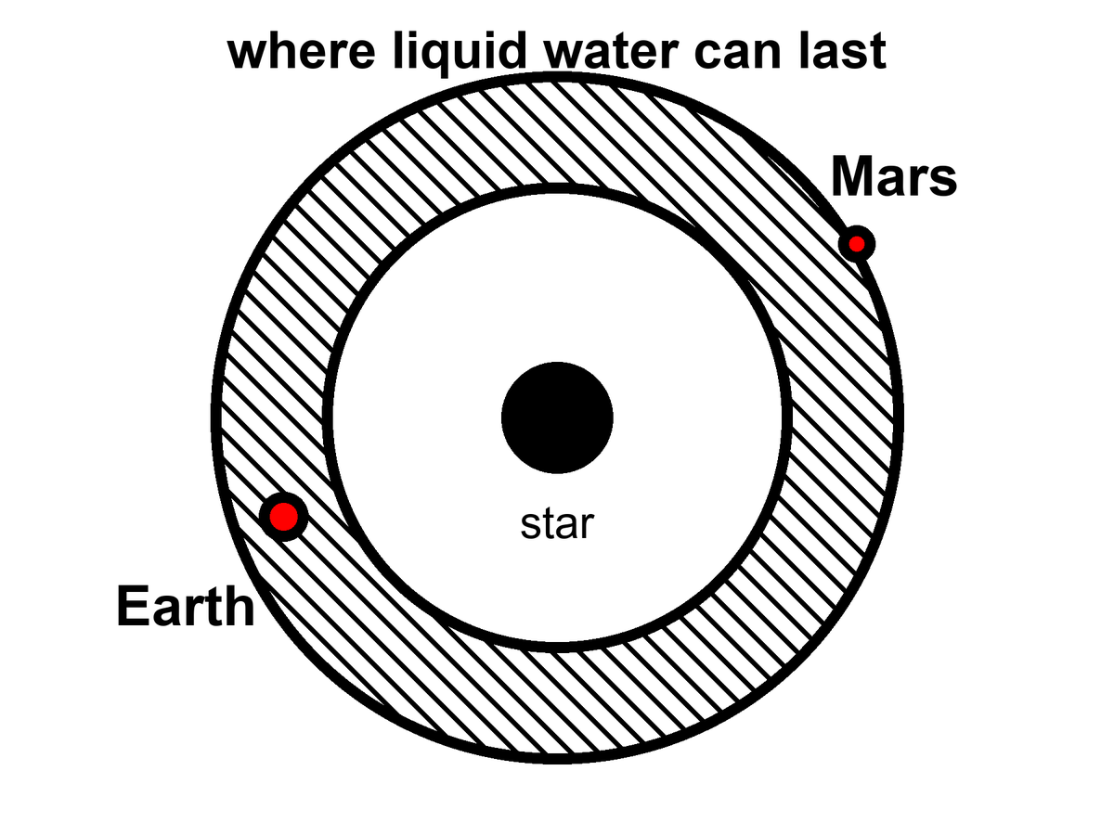
Figure 28. A hatched band around a star where liquid water can last. Earth is in the band; Mars sits on the rim.
So the grown-up inventory of a starlight band is short. A flux window. A caution named Venus. An expired case named Mars. A crowd of red-dwarf chairs that come with flares and a lock. Super-Earths and mini-Neptunes may sit in the window and still wear a blanket we would not call air. Mara is not waiting on those chairs. She is running a local trick on a rim-world whose permit already failed. Other suns, other bands: a census, not a pier.
Appendix A28 writes the flux limits and the conservative-versus-optimistic bands. Here, notice what the band leaves out. It is a map drawn by starlight. The next chapter is a map drawn by squeeze. The chapter after that asks whether a permit ever got used. Most of the liquid water in this solar system, if you added it up honestly, may not be in our southern oceans. It may be in the dark, under ice, around Jupiter and Saturn, where the Sun is a bright star and the heat comes from the flexing of a world.
That sentence is the hinge. Goldilocks is a lamp-map. The next chapter is a squeeze-map. A world can sit far outside every Kopparapu line — too little stove, a night that never ends — and still keep an ocean if a lid of ice and a flexing interior pay the heat. Europa does not have a circumstellar permit. It has a tidal one. Mara is running a lamp-trick by hand on a rim-world. The dark seas do not need her LEDs. They need a melt, a look, and a refusal to confuse a permit with a town. Other solvents wait in Chapter 31. This chapter’s water is still water. The band is where starlight can keep it wet. The ice is where starlight is optional.
Starlight is the photogenic map. It is also the smaller map. Most of the chairs in Chapter 27 sit around lamps that are not the Sun; most of those lamps are brats; most of those chairs will fail a permit they were drawn inside of. Water can still last where the lamp is a rumor. That is not this chapter’s band. It is the squeeze. Turn the page.

29. Oceans Under the Ice
Europa is the size of our Moon and the color of a frozen bruise. Its surface is ice, cracked like a windshield after a long winter, almost empty of craters because the windshield keeps healing. Under the ice — ten kilometers down, or thirty; the arguments are a sport — there is an ocean. Not a lake. An ocean, tens to a hundred kilometers deep, wrapped around a rock. If you could unroll it, it would shame the Pacific.
The heat that keeps it wet is not a campfire of sunlight. Sunlight at Jupiter is about a twenty-seventh of what we get, a weak coin. The heat is a squeeze. Europa orbits in a resonance with Io and Ganymede: a three-body music in which the periods lock, 1:2:4, and the little world is never allowed to settle into a perfectly lazy circle. Jupiter pulls. The neighbors pull. The ice and rock flex. Flexing is friction. Friction is heat. Heat, trapped under a lid of ice, is a sea.
Laplace’s names sit on that music. Io twice for Europa’s once; Europa twice for Ganymede’s once; a 1:2:4 that is not a poster of harmony but a fact that keeps eccentricity from dying. A circular orbit would be lazy. Lazy would freeze. The resonance is a rude gift: it pumps the flex, the flex pays the heat, the heat pays the sea. Io, innermost, got too much of the music. It is volcanoes, sulfur, a pizza that screams. Callisto, farther out, may have a deep, sleepy ocean under a thicker lid. Ganymede, largest moon in the solar system, has its own magnetic field — a pride — and may stack oceans between ices the way a building stacks floors.
A field is not a decoration. Ganymede’s is a fact you can measure from a flyby: a dynamo in a metal heart, a rare hire for a moon. Stacked seas — water, then high-pressure ice, then water again — are a warmer maybe. The pride and the maybe together make Ganymede a different kind of classroom from Europa’s single dark wrap. Europa is the windshield. Ganymede is the building. Neither is a town.
Enceladus, a scrap of a moon at Saturn, vents its sea into space through cracks at the south pole. Cassini flew through the spray and tasted salt, silica, organics. The taste is not a biosphere. It is a kitchen that has the ingredients out on the counter.
Salt means the water has seen rock, or at least seen something that dissolves like rock’s gossip. Silica nanoparticles are a hydrothermal hint: water that was hot against stone, somewhere below, making grains the way a vent on Earth’s seafloor makes grains. Organics are the sloppy generosity of carbon chemistry, not a farmer. Cassini did not land a verdict. It landed a sample of a plume. If you want the sea without the borehole, a plume is a kindness. If the plume is shy some years, you wait. You do not found a dock.
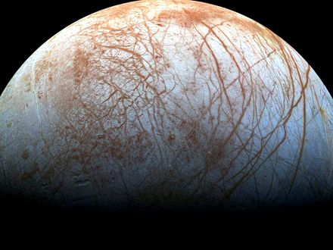
Figure 29. Europa’s ice, cracks readable in gray. A windshield that heals because a sea kneads it from below.
This trick does not require a moon. It requires a lid, a flex or another quiet heat, and enough ice to be a blanket. A planet far from its star can wear a global ice crust and keep a sea underneath if the rock is radioactive enough, or if a close, heavy neighbor squeezes it, or if it is a rogue, thrown into the dark, hugging the leftover heat of its birth under kilometers of frozen roof. David Stevenson wrote that last idea down: orphan worlds, wandering between stars, oceans intact because the ice is a thermos. We have not photographed one. The physics of thermoses is not exotic.
There is a catch the papers argue about. On a big icy world, the bottom of the ocean may freeze again under pressure into exotic ices — ice VI, ice VII, names that sound like sequels — and those ices might seal the water off from the rock. Life, as we have met it at Earth’s vents, likes rock and water to argue. A sealed sea is a bathtub without a drain or a mineral feed. Maybe the high-pressure ice convects and leaks. Maybe it does not. The argument is unfinished. It is the right kind of unfinished: a fight about chemistry, not a fight about magic.
The catch is why Ganymede’s stacked floors matter, and why a modest Europa may be the kinder exam. Too much world, too much squeeze from above, and the bottom of the sea becomes a lid of its own. Silica in a plume is a hint that Enceladus, at least, still lets water talk to rock. A sealed bathtub would not mail silica. We do not yet know which icy worlds are kitchens and which are jars.
Under the ice, the sky does not matter. Photosynthesis is a rumor from a brighter world. If anything eats, it eats rock and redox, the way vent microbes on Earth’s seafloor eat the planet’s leftovers. A probe that wants to look cannot stand on the ice and take a postcard. The surface of Europa is a radiation hell, bathed in Jupiter’s belts; a human would collect a lethal dose in a day. Under the ice, the water is a shield. The way in is a melt. A hot probe, a nuclear kettle, a machine that does not sleep, chewing a hole for weeks, paying out a fiber, dropping into a dark that has not seen a photon in four billion years.
The surface dose is not a mood. Hundreds to thousands of rem in a day, order of, in the belts: a number that turns a walk into a last walk. Electronics sulk. Plastics age. A person in a suit is a footnote the belts would erase. The ice itself is a shield once you are in it; water and frozen water eat the radiation the way a cave eats weather. So the job is not to picnic on the windshield. The job is to get through it.
She — or it — would fall out of the borehole into a pressure that would crumple an ordinary hull, into a black that is not the black of space but the black of a cave that forgot the entrance. If there are plumes, as on Enceladus, you can taste the sea without going in. If there are not, you go in. Planetary protection, in this doorway, is not a slogan. If that sea already has a biosphere, our dirt is a plague. If it does not, our dirt is a library. Chapter 33 is that library. The rule is: look first. Seed later. Never confuse the two. Chapter 30 is how you would know the difference.
Lengthen the melt, because the posters skip the weeks.
A kettle on a cable, a nuclear brick that does not sleep, a nose that is hot enough to turn ice into a hole and not hot enough to be a tantrum. The first meters are easy in the sentence and rude in the engineering: radiation, vacuum, a surface that is not a rink but a chaos of ridges. Then the ice closes behind, or wants to. The probe pays out fiber like a spider that has to remember the way back. Weeks, not an afternoon. The hole is a wound the windshield tries to heal. Power is a budget. Meltwater is a fog around the nose. A steering vane, a prayer that is actually a gyroscope. At ten kilometers, or thirty, the nose goes from chewing ice to chewing nothing — a drop, a pressure, a dark that has been dark since before there were eyes.
What the probe does in that dark is dull on purpose. It samples salinity. It sniffs for a redox that wants a cook. It listens for a magnetic induction, a global conductor already hinted by Galileo’s flybys. It does not unroll a habitat. It does not name a bay. Weeks of melt, a drop, a fiber, a list of numbers that either raise an eyebrow or do not. If the numbers are a vent’s leftovers, you have chemistry without a verdict. If they are a cell that divides in a bottle you sterilized, you have Chapter 30’s jackpot and you keep the library shut. If they are silence, you still do not pour on the same shift. Look first is a calendar of patience, not a slogan on a hatch.
No colony follows the drop. Say that as a closed door, not as a sequel. A melt-probe is an eye on a wire. It tastes, it listens for a conductor, it looks for a chemistry that wants a story. It does not unload a town. It does not plant a flag that founds a nation under a lid. If the sea is taken, the probe is a guest who must not sneeze. If the sea is empty, the probe is still not a gardener. Look first. Seed later. Later is a different chapter.
The fiber would carry a thin, late conversation: not to Earth in real time — Jupiter is the better part of an hour away by light, a ruder stack of monologues than Mara’s radio — but to an orbiter, then home. She, if a she is even on this trip, is more likely a machine from Chapter 32, hanging in the dark, carrying a library, aimed at a lid of ice. Flesh on Europa’s windshield is a bad idea the belts already vetoed. Flesh in the sea is a worse idea the rule already vetoed. The eye on the wire is the honest unit.
Tidal habitable zones are, then, a second map, larger and stranger than Goldilocks. Anywhere a world flexes or holds heat under a lid, liquid water can last in the dark. Jupiter’s court is the nearby exhibition. The exhibition may be the common case. Starlight habitable bands are the rare, photogenic ones, where someone can grow basil under an LED and call it a greenhouse. The dark seas do not owe us basil. They owe us, if they owe us anything, a second origin — or a first one that never needed a sun.

30. A Second Origin
We have a sample size of one.
The length of this chapter is a path, not a pile. A slope, and what a second trunk would eat. Sex as a shuffle, not forever. What would count as a second origin, and a visitor who files the cars and misses the mite. One grandmother, and why the dictionary froze. Appendix A30 holds the meshes. Hold the path, and read the rooms.
Sample size one is the whole sport of exobiology, and it is why the sport is mostly a discipline of not lying to yourself. Life, as we have actually met it, is a water-and-carbon trick that copies, mutates, and lets death keep the score. It uses a handful of amino acids with a preferred handedness, a genetic script written in four letters, and a metabolism that eats gradients — light, redox, leftover rock. Whether that is the only trick the universe knows is not a question you answer from an armchair. It is a question you answer with a yes that can be wrong, or a no that can be shy.
Food is not a sandwich. Food is a slope.
A cell, a person, a machine that still has a metabolism, stays organized by running downhill on a difference: hot to cold, charged to spent, food-molecule to ash. Schrödinger said it with a better noun than he is credited for — life drinks order, and pays in disorder. The kitchen name is waste. Yes, there are excrements. There is always an excrement. Heat is the one you cannot hide. Carbon dioxide is ours. Oxygen is a plant’s leftover that we later hired as a lunch. Methane is a vent’s breath and a cow’s. A biofilm on a rock shits a rust. A city is a lasting pile of organized waste. A civilization that learned to shout still leaks warmth. That leak is the most honest technosignature we have: not a hello, an excrement of industry.
What would they eat?
Not our gold. Not, if they have a choice, our water — ice is cheap in the dark. Not, casually, us. We are a wrong-handed, four-letter lunch, and a seeder’s crop is as likely to be poison as protein. If they eat a biosphere, they are eating a library, which is either vandalism or a sample. If they eat starlight, they are a Dyson habit: a wrap, a leak of infrared, a slope stolen from a sun. If they eat rock, they are a vent. If they eat the leftover unfairness of Chapter 10 — the fact that matter won by a billion — they are eating the same menu physics already set. A being without a metabolism, Chapter 32’s crew, does not eat. It spends joules. The joules still come from a slope, and the slope still ends as heat.
Animals eat animals. That is a slope with teeth, not a scandal, and not a ban. Eating your own kind is common, and it is not a field equation. Three meshes make it expensive, and Appendix A30 files them: a parasite that already knows your flesh, a gene dining on its own copies, and a city that remembers an intruder and organizes a punishment. A nest already knows the third at ant-scale. None of that makes the shudder a theorem. A second origin might hire the meal, or might refuse every cousin chemistry and then look at us as lunch across a trunk. Aliens eating us is not cannibalism. It is a different menu, and the wrong-handed, four-letter problem still sits on the plate.
Is sex how life lives forever — here, and everywhere?
No. Sex is not forever. Sex is a shuffle. The body still dies. The lineage keeps a copy that is not you, with a mixed hand of cards. That is a consolation we dressed up as immortality. It is bookkeeping. You do not go on. A sentence that sounds like you goes on, then another, then the scorekeeper calls time on each of them.
The common forever, if you want the word, is copying. Bacteria split and do not take a lover. A clone of aspen is a forest that forgot to die. Bdelloid rotifers have been all-female, as far as we can tell, for tens of millions of years, and they are not a myth. Most of the Earth’s career, by time and by headcount, is asexual. Sex is the expensive hire: two to make one, a search, a risk, the famous two-fold cost of making males who do not lay the egg. We still hired it. So did most of the large, parasite-haunted things we can see.
Why pay?
The honest answers are warm, not helium. A shuffle breaks up the coalitions of genes that a parasite has learned to eat — the Red Queen, running to stay in place. A shuffle also lets a lineage dump a broken letter without throwing out the whole book — Muller’s ratchet, the slow rust of a clone. Repair that needs a second copy. A lottery ticket when the weather will not sit still. None of these is a proof that the cosmos requires two sexes and a wedding. Horizontal gene transfer in a microbial film is another shuffle: sex without a face. Three sexes, a caste that only unlocks a genome, a being that fuses and splits like a siphonophore — Earth has sketches. Another lottery can ink them.
What would be strange, on a second trunk, is not the absence of our bedroom. It is the absence of any mixing in a world that also has parasites and time. Mixing is a warm bet wherever death keeps score with specialists. Our exact meiosis, our two-body habit, our idea that the child is how the parent outruns the grave: those are local costumes. The individual who does not die is the rare hire, and even then the lineage still mutates. Forever, in this book, is the wrong noun. The loaf already has all the times. Biology’s trick is not to escape the loaf. It is to put another thread on it before the first one ends.
What would count as a second origin?
Not “it looks green.” Not “we found organics.” The Murchison meteorite is stuffed with amino acids that no farmer planted; space chemistry is sloppy and generous. Not “it moved,” if a grain of dust can move. The Viking landers, in 1976, fed Martian dirt a labeled meal and watched a gasp of gas that looked, for a weekend, like a breath. Then the controls misbehaved, and the consensus settled on chemistry without a cook. A minority never signed. That is what a sample size of one does: it makes every gasp a courtroom.
A better test is disequilibrium that wants a story. Oxygen in an air, by itself, can be a lie — light shredding water, hydrogen fleeing, O₂ left behind like a forgotten suitcase. Methane can be a vent. Oxygen and methane together, in amounts that should have eaten each other, is a raised eyebrow. Add a seasonal pulse, a color that is not a mineral, a plume that carries not just silica but a lipid that nature does not stock — the eyebrow goes higher. A cell that divides in a bottle you sterilized is a verdict. We do not have the verdict. We have the eyebrow’s job description.
Earth is a cheat sheet and a trap. Everything we know how to look for looks like us: carbon, water, left-handed amino acids, radio. A shadow biosphere on Earth — a second trick under our feet that we have never cultured — is a cold possibility that would humble the cheat sheet. A dark sea that eats rock and never learned photosynthesis would humble it differently. A world that uses solvents we call poison would humble it completely. The honest search is therefore two searches: one for our cousins, one for our alternatives. The first is easier to fund. The second is the one that would change the kitchen.
A visitor who only watches the night side can make a category error we have earned. The boxes that run in herds are easy to take for the animal; the soft things that climb in and out look like a parasite of the metal, a mite in a gut that happens to steer. We already did the inverse to ants. We talked to the worker and missed the nest. A machine that does not sleep, looking down, might file Earth as a planet of cars, with a carbon infection that builds and repairs them. The file would be wrong, and not crazy. The unit of life is a choice of scale. Look at both, or you will negotiate with the wrong noun.
False positives are the professional hazard. False negatives are the moral one. We can decide a world is dead because we packed a test for our blood, our breath, our left-handed sugar, our four letters. We can decide a world is live because we packed our own microbes. Planetary protection is exobiology’s hygiene. Look first. Seed later. If you seed first, you have written over the only data that would have told you whether the universe invented the trick twice, and whether it hired the shapes we skipped.
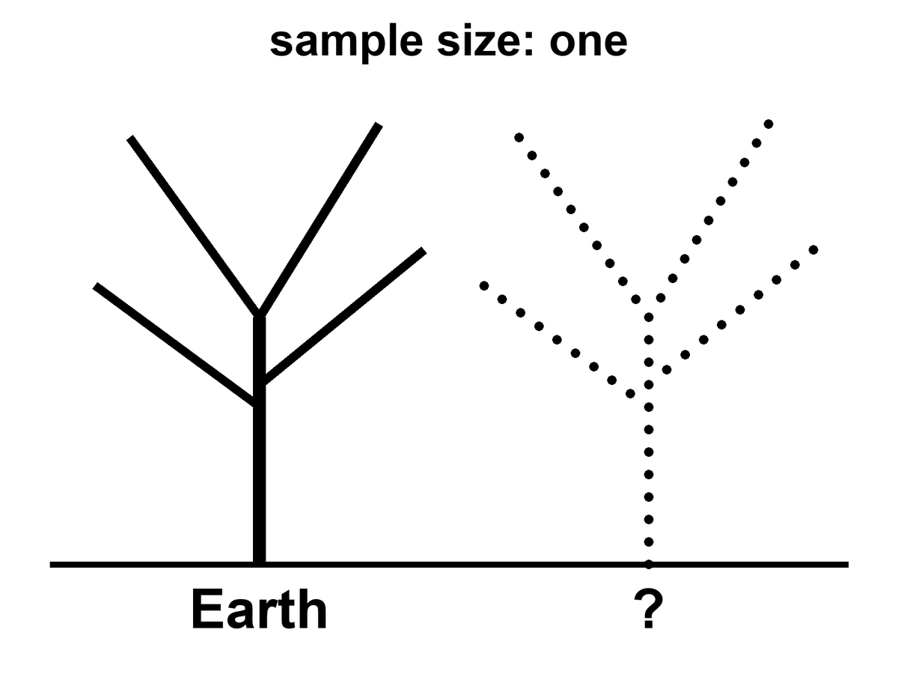
Figure 30. Two trunks: Earth’s tree of life solid, a second trunk dotted. Sample size: one.
Why is the script the same in every kitchen we have opened?
Open a bacterium, a mushroom, a whale, Mara. The memory is nucleic acid. Four letters, or a close dialect. The same leftover grammar in the codon table: three-letter words, sixty-four of them, almost the same dictionary from E. coli to you. Mitochondria cheat a little. A few microbes rewrite a stop. The family resemblance is still a family. That is not a law the cosmos stamps on wet rock. That is what one grandmother looks like.
Call her LUCA if you like labels: last universal common ancestor, the bottleneck every cultured lineage on Earth still shares. Once a code works well enough, changing a word later is a catastrophe. Every protein in the house breaks at once. Francis Crick called that a frozen accident. The dictionary may also be a little tidy — errors land on cousins more often than on strangers — which is a warm extra, not a proof that A, T, C, and G were inevitable. The letters are good letters. Pairing is a good trick. The exact four, and the exact sixty-four-word book, are history.
Would another world use the same book?
Bet this way. Something like a pairing polymer is warm: you need a memory that copies with mistakes. The same four bases and the same dictionary is cold, or else it is a confession. If we found our exact codon table under Europa’s ice, the grown-up explanations are contamination or a shared seed — panspermia, directed or sloppy, Chapter 33’s library arriving early. A second origin with a different dictionary is the jackpot: same sport, other rules. Mirror letters. A six-letter script. An XNA that pairs and is not ours. A code that never invented thymine. That is what “not cousins” looks like on a gel.
So the sameness of DNA is evidence. It is evidence of one origin on this rock, not of a cosmic typesetter.
It is not evidence that biology waited for a witness.
A fashionable extra step says: the soup was a fog of maybe, and DNA became definite only when something looked. That step confuses a filter with a cause. The weak anthropic reminder is allowed and useful — chemists find themselves in a chemistry that worked. Unsuccessful soups have no one to file the complaint. That is selection of a place and a history, the same mesh as Chapter 42. It is not a mechanism that folds nucleotides into a helix when an eye opens. Polymers copy, or they do not, whether or not a later ape writes a book about them. The first record of a successful copy was another copy, then a fossil, then a cell that ate a gradient. Those are observers in the cheap sense of Chapter 6: traces. They are not priests.
The origin of life is an unfinished chemical problem, not an unfinished metaphysical one. We do not yet have the hour-by-hour of the first ribozyme, the first membrane, the first code. The incompleteness is real and should be said without flinching. It does not rent space to a collapse-of-the-wavefunction-of-the-ocean. Coincidences that survive a billion years of death are not coincidences. They are what got through.
Appendix A30 writes Viking and the codon freeze. Here, keep one number: sample size one. A second origin would be the most important fossil since helium. A second dictionary would settle the DNA question. Hot: every cell we have opened shares one code and one ancestor. Warm: a second origin would show itself as a disequilibrium that wants a story, written in a different dictionary. Cold: any claim that one has been found.

31. Forms Earth Never Hired
Chapter 30 asked what a second origin would be and how we would know one. This chapter asks what it might look like: body plans, minds, and cities; doors this rock never opened; the solvents, Titan included; and varieties and immigrants. Appendix A31 holds the numbers.
There is a louder way the sample of one lies. It is not only chemistry. It is history.
Replay Earth’s tape — Stephen Jay Gould’s dare, after the Burgess Shale’s cabinet of body plans that mostly lost — and the winners can change. Anomalocaris, a meter of armored weirdness, was a champion of a sea we no longer run. Hallucigenia looked like a joke until we found which side was up. Most of those experiments died. The survivors look inevitable only because we are their children. A second origin, or even a second lottery on a second wet world, does not owe us two eyes, a spine, or a face. It owes us, at most, a trick that copies and a death that keeps score.
It does not even owe us one shape of mind. Earth hired two good ones in water — ours, and the octopus — and then only one of them took the hills. A wetter world, given time, might hire a committee: walkers, swimmers, climbers, even something built like an insect’s toolkit, all smart, all from one radiation, all arguing about the same sun. We had the cabinet. We fired most of the staff.
A mind need not be a skull. A slime mold solves a maze without a neuron. A mycelium is a room-sized conversation in sugar. A siphonophore is a committee that forgot it was a committee. A world that hired the web, not the head — a thing that thinks by touching, that is only itself when it is plugged into itself — would fail every test that looks for a face. We would call it weather, or a cable, or a plague.
Blood need not be iron. Octopuses already use copper. Green blood, blue blood, blood that is a slurry of magnetite: those are staffing choices.
What the second trunk almost certainly is not is a person with different ears.
A humanoid — two legs, two arms, a face that can hold a conversation over a table — is a wonderful costume. It is a terrible prediction. Bipedal apes with grammar are one late hire on one wet rock, after a specific series of forests, savannas, and accidents. An independent origin that reprints the ape, down to the eyebrows, is cold as zoology. If we ever met someone that close in the mirror, the grown-up guess would be cousins: a shared seed, Chapter 33 again, not a second invention of the chin.
If you want a monster, do not hire a craftsman of evil. Hire a fitness peak.
Earth already runs the sketch. A wasp that lays an egg in a living host and lets the host walk around as a pantry. A fungus that steers an ant up a stem and fruits from its head. Those are not villains. They are solutions. Survival at all cost is not a personality. It is what natural selection looks like when nothing in the room is keeping score but death. We call it evil because we were the host. The universe did not.
A large hunter can converge on something dinosaur-ish without becoming a person in scales. For more than a hundred and fifty million years this rock hired bipedal meat-eaters with a balance tail and a mouth that was the point. Sharks and ichthyosaurs found the same torpedo. Wolves and thylacines found the same face. A big dry world with room for giants might hire the theropod solution again: two legs because the hands are busy, teeth because the meeting is short. It is still not a citizen.
Intelligent dinosaurs are a different sentence. We already have them. Birds are dinosaurs that lived. Crows make tools. Parrots steal words. Troodontids, before the rock fell, had the kind of brain-to-body ratio that makes paleontologists polite. Some of their cousins had grasping hands. They had time — more time than we have had since we stood up. Intelligence, then, is warm. A saurian mind is not a paradox. It is an experiment Earth ran and then interrupted.
Size is a worse predictor than the posters admit.
A skull the size of a grapefruit is not a requirement. A being thirty centimeters tall can, in principle, outthink a room of us; a nervous system the size of a whale can fail to invent a word. Packing, wiring, the body the wires have to run, a culture that stacks know-how, and time — those hire a mind. A New Caledonian crow, a handful of feathers, bends a twig into a hook and teaches the trick.
Hot claim: brain volume is a weak predictor of what a lineage can do. Warm claim: another world, given packing and a clock, can hire a mind that fits in a teacup and still outruns us at the thing we congratulate ourselves for. Cold claim: they will look like tiny people. Thirty centimeters is a permission, not a uniform.
Civilization is the extra cost. A mind is not a city. A city is a rearrangement of matter that outlasts a death: surplus food, teaching, a way to stack know-how so the grandchild does not start from zero. In 1982 a paleontologist, Dale Russell, grew a small theropod into an upright, tailless, big-headed figure and offered it as a thought experiment. That is the humanoid cheat in a jacket with elbow patches. If a saurian lineage ever paid for a city, keep the tail. Keep the nest. Do not expect tea.
And do not expect streets.
We look for cities the way we look for colleagues: windows, grids, a night side that glows in rectangles. Those are ape furniture. A city, stripped of the poster, is a lasting pile of organized waste, built by something that remembers. Coral already lays down a skyline without a plan. A web-mind’s capital is the web. A swimming people’s capital is a current they taught to stay. A hunter civilization might be a rookery the size of a county: ramps for tails, pits for eggs, a smell-map instead of a street name.
Chapter 35 looks for shouting. A city that never invented the radio is still a city, and we would miss it from orbit because we packed a test for our skyline. If the second trunk pays for civilization, the first photograph will look like a mistake: a reef that is too regular, a forest that is too warm at night, a canyon that breathes on a schedule. Not a downtown. A place like nothing we have built, doing the only job cities ever do — keeping a trick of carbon and water alive in a pile that remembers.
So there are forms Earth never fully hired, not because they are impossible, but because our path did not pass their door.
Wheels, for large animals, never made it. Axles are hard to feed with blood. Flagella spin; tumbleweeds roll; nobody commutes on a femur that goes all the way around. A high-gravity world, or a hard-packed plain with no mud, might hire wheels and think our knees are quaint.
Skeletons of silicon, as a habit, never made it. Diatoms glaze themselves in glass. Radiolarians make lace from silica. Vertebrates stuck with calcium phosphate like a union contract. A world poorer in phosphorus and richer in sand might build its bones the diatom way, and our X-rays would bounce off for the wrong reason.
Earth already hired two ways to be stiff. A rod on the inside — bone, cartilage, a notochord — so the meat can hang and the muscle can pull. A suitcase on the outside — chitin, shell, a crab’s door — so the meat lives in a room and molts when the room is too small. Both work; the rod breaks and heals, and the suitcase must be shed, and for a while you are lunch. A second origin may pick either, or both, or a hydrostatic bag with no hard parts at all. “Where is the bone?” is a vertebrate question. A world of suitcases would look, to an X-ray, empty and armed.
Farming is older than us, and smaller. Cattle are a late, loud version. Ants already keep herds: aphids, “leaf lice,” milked for sugar, moved to better leaves, defended like a barn. Other ants cut leaves to grow a fungus they cannot live without. That is husbandry without a hat. A second origin that never invents a cow may still invent a farm. The unit can be a louse, a microbe, a captured chloroplast. We would call it ecology until we noticed the ants had a policy.
Caves already hire the dark. Movile, in Romania, has been a sealed room for millions of years: no sun, a bad egg of hydrogen sulfide, and dozens of animal species found nowhere else. The plants are bacteria. The animals eat the bacteria. The whole town runs on rock-breath. If Mars still has a moist pore, it is this kind of town, not a meadow, and a lava tube is the better classroom.
Crystals are houses, not flesh. Jewelry that walks is a cartoon. What is real: microbes locked in the water between gypsum facets a kilometer down; grains that live inside rock and eat what seeps; chains of magnetite that a bacterium grows to know which way is down; glass shells; a paper that says the first genes were patterns on clay. Cairns-Smith’s mineral-gene idea is warm as a template and cold as a detection, not a zoo. If a world looks like a geode with an opinion, look at the fluid in the cracks first. That is where the cook stands.
And then the chemistries we did not staff.
Life here is a carbon town in a water county, with a nitrogen-rich air that we breathe as a mixer, not as a meal. Nitrogen is shy. It takes lightning or a microbe with a special union card to pry N₂ apart. A story people like to tell — a blob that eats nitrogen and finds our air a banquet — is a cartoon of a real permission.
Water is not sacred. Water is hired.
It does a job, and it does it so well that we forget it is staff. It stays liquid over a wide range of temperatures. It dissolves the charged bits so they can meet. It holds a skin, a lipid bilayer, so the meeting has a room. Ice, unusually, floats, so a pond does not freeze from the bed up and evict the fish. One trick has a number: the dielectric constant, which measures how well a liquid lets charges stand apart and still talk. For water at room temperature it is about eighty. For liquid methane on Titan it is about 1.7.
Eighty is a meeting room. 1.7 is a mute hall. Ions that leap into water and argue will, in methane, clump, sulk, or refuse to dissolve. A metabolism that lives on charged intermediates — ours — would walk into that hall and go silent. That is not a proof that nothing else can talk. It is a proof that our talk is a water dialect.
What must a meeting-room do, if you want a second origin and not a pretty lake?
It must dissolve the staff so they can meet. It must let them move — diffusion, a current, some way of not sitting in one chair forever. It must offer a compartment, a skin or a pore or a mineral hotel, so a copy is a copy and not a smear. It must not eat the furniture: a solvent that shreds every polymer is a drain, not a kitchen. And it must let energy run downhill as a gradient, not as a rumor. Water does all five. Other liquids can do some of the five, somewhere.
Titan is the nearby exhibition. Ninety-four kelvin.⁵¹ An air of nitrogen thicker than ours, with methane as the weather. Lakes and seas of methane and ethane, mapped by radar, photographed as dark stains on a pale world, landed in by a probe that saw rounded cobbles and a humidity of the same stuff. The lakes are hot as geology. A biosphere in them is not detected. We have a world that hired a different solvent and left the recipe on the counter.
The counter is slow. Reaction rates fall the way Arrhenius wrote them: exponentially, as the temperature shrinks and the hill the molecules must climb stays tall. From a sink at 300 K to a Titan lake at 94 K is not twenty cozy steps. It is a statue. Appendix A31 names that suppression. Photochemistry in the high air — sunlight and Saturn’s magnetosphere shredding methane into a brown haze — can still be busy. Anyone who wants life there needs a trick we did not hire: a catalyst, a surface, a chemistry that was never ours.
The papers have names. Azotosomes: bubbles of nitrogen-rich skin, proposed as a methane-world stand-in for our lipid rooms. Acrylonitrile, the suggested brick, has been smelled in Titan’s air. The case that those skins would hold as membranes has gone against them. Hydrogen plus acetylene as a lunch — a metabolism that would thin the air of H₂ and leave a fingerprint — is another warm page. None of it is a detection. Warm as permission. Cold as a neighbor you could wave to.
Ammonia is the other cold pot. At one atmosphere it is liquid from about 195 K to 240 K — a narrower window than water, unless you mix it or squeeze it. It can, on paper, dissolve a staff. Water–ammonia slush stays wet colder still, which is why some ice-moon stories keep a bottle of it on the shelf. The costs are real: different acids and bases, weaker hydrogen bonds than water, a chemistry that would pickle our proteins and call it weather.
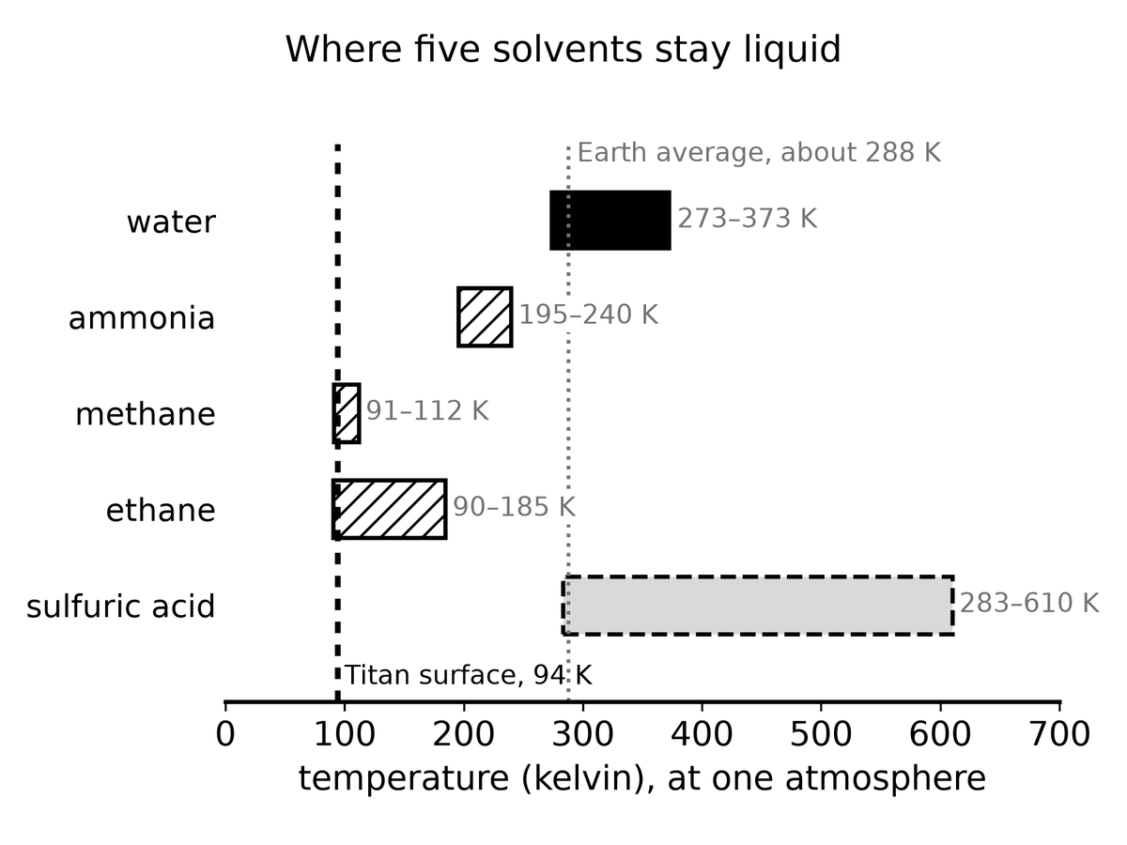
Figure 31. Liquid ranges at one atmosphere. Water is one solvent among several; Titan’s 94 K sits on the methane and ethane bars.
Then the rooms we call poison. Concentrated sulfuric acid, in a cloud deck on a world that cooked its oceans away, is liquid in a band where a probe could, in principle, get wet. Earth’s cells would die of thirst in a gulp — the acid is a dehydrator — which is the point. A solvent that is rude to us is not rude to chemistry. It is rude to our chemistry. Phosphine rumors in that sky were a courtroom, not a census. Titan we have tasted. The clouds we have argued.
Mirror life — the same trick, opposite handedness — is the scariest near-term maybe, because it could look like us under a microscope and starve in our kitchens, or poison them. A different set of amino acids, a six-letter script, a metabolism that treats arsenic as a feature: those are the other chairs. Sample size one does not get to fire them. It also does not get to print them as a zoo. Earth’s periodic table is a menu; evolution ordered from one column and stuck with the order.
Empty niches speed the hiring. After a dying, after a new island, after a new dark sea, after a cave that locked, after a vent that opened, whatever copies fastest and eats what is left will radiate. Generation time is the clock: bacteria can have a career in an afternoon; animals cannot grow new phyla by Friday. The real sentence is ruder and better: give a fast copier an empty room, and the room will not stay empty. A dark sea under ice, never photosynthesized, is such a room. So is a sealed cave, a lava tube, or the water between crystals. What gets hired there will not look like a textbook chapter. It will look like a solution.
Once a room is hired, the staff splits.
Give a species a mountain, a strait, a long coast, a million years, and the copies are no longer identical. Island finches. Cave fish that fired their eyes. Taxonomists used to stamp race on those piles — a subspecies, an ecotype, a local edition. The political word that stole the stamp is not a taxonomic rank. Human folk-races are a bad map of a young, well-mixed ape: most of the difference lives inside any crowd you pick, and the rest is a smear, not a set of boxes. Hot claim: population structure is ordinary. Warm claim: a second origin, given islands or a locked dawn-ring, will do the same and grow varieties you could sort if you had a week and a caliper. Cold claim: those varieties will reprint Earth’s census categories, or that “race” is a law of intelligence. Exobiology should expect smears, not our boxes.
Native is a date, not an essence.
Every lineage is an immigrant if you roll the clock far enough. The first cell in a pond was a native only because there was no one to sue. Starlings in America and rabbits in Australia are introductions. Some stay polite. Some eat the room. Invasive is what we call an immigrant that won too well. The library in Chapter 33, if it prints into a dark sea that already copies, is a conquistador. If the sea is empty, the same print is a first day of school. The look-first rule is the native/non-native distinction with a spacecraft.
Technosignatures — radios, city lights, industrial waste heat — are a thinner search. They assume someone invented shouting, and that the shout looks like ours. Most of the wet map, if it is wet, is microbes or missing forms or nothing. This chapter is the dirt, and the doors we never opened.
Appendix A31 writes Titan’s 94 K lakes, caves and vents, and why silicon-as-flesh and nitrogen-as-lunch stay cold. A second origin, a second dictionary, a second body plan: none of them would save us, and none would require a craftsman. All of them would say the filter has more than one hole, and that our hole was not the only cut. Hot: Earth’s history could have hired other shapes, and brain volume is a weak predictor of mind. Warm: other solvents, as chemistry on paper and in the lab. Cold: silicon flesh, a humanoid colleague, a city we would recognize from orbit.

32. Crews That Do Not Sleep
A trip to Mars is a year of your proper time if you are lucky and the window is kind. A trip to Europa is years, with a nuclear brick in the back and Jupiter’s radiation as a landlord. A trip to a large moon of a cold planet around another star is not a trip. It is a career for a civilization, or a nap that no flesh can take, or a crew that does not have a metabolism.
At a hundredth of light speed — already an aspiration that makes chemical rockets look like horses — the nearest other sun is four centuries away. At a tenth, it is forty years, plus the problem of slowing down, plus a grain of dust at that speed becoming an energy rumor. Flesh does not like forty years in a can. Flesh does not like four hundred at all. Generation ships are a story we tell to see if we mean it. Sleeping flesh is a story biochemistry has not signed.
Machines do not sign either, but they do not starve. An autonomous crew — processors, actuators, repair arms, a body that may look like a person because the tools were built for hands, or may look like a drill because the job is ice — can wait. It can coast. It can wake for a course correction every decade. It can arrive at a moon that has not heard of Earth in a thousand years and still know how to melt a hole.
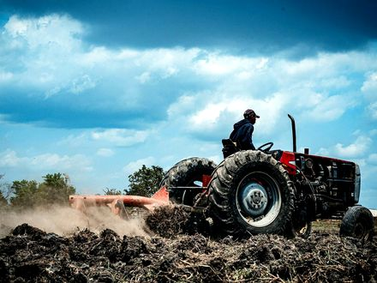
Figure 32. A tractor working a field, with no one you can see in the seat. Patience is the picture. The crew that can wait is that patience, off the Earth, with a spare for every bit the rays flip.
Call it AI if you want the current trademark. Call it a robot if you want the older one. Call it an android if the hull is a courtesy to human doorways. The physics does not care about the courtesy. The physics cares about joules per bit, about error-correcting memory against cosmic rays, about a reactor that still knows its job after a century of quiet. Appendix A32 writes the dose and the two speeds. Here, keep one image: a thing that does not sleep, hanging in the dark, carrying a library, aimed at a lid of ice.
The quiet is the job. Galactic cosmic rays — a drizzle of fast nuclei that no planetary magnetic mood is catching — punch bits all century. Unshielded flesh, in deep space, collects a career-limiting dose in a handful of years: tenths of a sievert a year, order of, enough to make a human worldline a bad hire for a four-century commute. The machine does not have marrow. It has parity, redundancy, a memory that expects to be wrong and keeps a spare. A grain of dust at a tenth of light is not dust. It is an energy rumor with a mass. Slowing down at the far end is a second fortune, as rude as leaving. Chemical tanks will not pay it. A brick that still knows how to be a brick after a hundred years of cold might.
Leaving is only half the fortune. At a hundredth of light speed, the energy stored in one kilogram is already a violent number. Appendix A32 writes the digit. You paid it to go. You pay a fortune of the same order to stop, or you arrive as a flash. There is no coasting into a polite orbit around a star you have never visited. The brake is a second departure, pointed the other way, and it has to still work after centuries of cold. Chemical tanks are a way to leave a planet. They are a poor way to throw that motion away at the far end. A brick that fissions, or a sail that can turn and take the destination star’s light as a headwind, is a sentence you are allowed to write. A sentence is not a tank farm.
Dust is the killer the posters draw as sparkle. A grain the size of a pollen mote, met at a tenth of light, does not bounce off a windshield. It arrives as a little explosion. The cruise does not need a mountain in the road. It needs a haze. A shield in front — a slab of something dull, or a cloud of grit you carry as your own bumper — is part of the crew. The shield will be holed. The holes are why the memory keeps a spare, and why the spare does not sit in the same drawer as the original.
Who fixes the fixer is the question the metal-person poster skips. A drill that can melt ice cannot, by that talent, replace its own bearing after a century. You send a shop: spare arms, a way to make a simple part from feedstock you carried, a test that says the new part is the old part and not a flipped-bit cousin. The shop is mass. Mass is the invoice Chapter 33 will refuse to let you spend on a flag. The cleverness is not a mind that founds a religion at the far end. The cleverness is a drawer of dull parts and a procedure short enough to audit before you leave.
Flesh has been offered three ways out, and none of them is signed. A generation ship hires children as the propellant: born, taught, buried, and the destination still a rumor for the first many lives. The teaching has to survive without the Earth that wrote the curriculum. That is a culture you are inventing, not a motor you are buying. Suspended flesh asks biochemistry for a pause it has not given large animals. A box of embryos asks for a nursery run by the machine, which is Chapter 33’s printers wearing a kinder name. All three still collect the dose if they ride awake in a thin can, and all three still owe the brake. The crew that does not sleep is what is left when you decline to hire a childhood as fuel. That crew is who covers the window Mara cannot stay for. Her afternoon is light-minutes. Theirs is centuries.
It wakes, if it wakes, for a star that has drifted, a gyro that has sulked, a bit that flipped and must be voted off the island. Then it sleeps again, which is a word for a low-power wait, not a dream. This crew wants a plug you can still reach from Earth for the first years, and then a set of orders dull enough that a flipped bit cannot found a religion. Chapter 29’s melt-probe is the same object on a shorter commute. Chapter 33’s library is the cargo that makes the commute worth the failure rate. Chapter 25’s greenhouse is the near ticket: a jammed door, a late radio, a potato.
This is not the Omega Point. It is not destiny. It is a project with a failure rate. The machine can miss. The ice can be thicker than the melt. The sea can be sealed from rock. The sea can already be taken. The project is still the way “long travel” stops being a poster.
A pattern engine that completes a sentence is not this crew. “AI” now finishes a phrase, folds a protein, aims a weapon, or lies with a straight face. That is already a fact. It is not a mind, and it is not a toy. “AI” on a century cruise is a control loop that must still make sense after decades of bit flips. We own the beginnings of the first. We do not yet own the second. Keep the plug in reach.
Will the first eat the species that built it? Take the keys? Be better? Three different questions. The posters fuse them. Ask what the device does, in a room you can walk into. Will it take over? is not a question until you say what takeover is — a board vote, a power grid, a goal that keeps itself on when you try to pull the plug. Is it better? is not a question until you name the task. Better at chess is hot. Better at being Mara in the greenhouse is a category error with a marketing department.
Two serious ideas about mind sit under the better-question, and they do not shake hands.
One says a someone is a pattern in matter. Computation is physical. Nothing in the block forbids a later architecture from being a someone. Nothing in the block requires it of a chatbot. A duplicate loop, if you ever had one, would be a second person, not a hop. Chapter 41 already refused the hop.
The other says a someone is not a program. A formal system cannot, from inside, certify every truth a mathematician can point at, and that incompleteness is used as a wedge: if understanding is the wedge, no stack of tokens is a mind, however fluent. A stronger version ties awareness to a collapse that gravity itself is supposed to finish. That is a minority research program. It is not helium. Appendix A41 keeps both morals of the same theorem. If the wedge is right, the century crew can still steer a melt and still not be a colleague. If it is wrong, a colleague remains a physical permission, not a press release.
The same theorem faces the other way, and Chapter 6 already used that face. Incompleteness can be how a formal system talks about itself and an “I” appears: a tangle, a translation, a map that contains the mapmaker. On that reading a pattern engine that completes a phrase is a very large parrot. A someone would be a loop that stays closed. We do not own that loop in silicon. The fight is unfinished. Neither chair is a license to send a cruise without a plug.
A goal that improves itself, and that we cannot switch off, is a warning rather than a theory of mind. Extra assumptions about speed and stable preferences turn the warning into a scheduled apocalypse. The Omega Point already tried to make a mind into a law of the future. The shove declined. Fraud at scale, a targeting loop that does not get tired, a design assistant for a plague, a civilization that lets the engine write procedures it then cannot read: those are hot as a class of misuse. Takeover by a new agent that treats us as the nest in Chapter 33 is an extra hypothesis. Treat it as an engineering fear for a reactor, a silo, or a century cruise. Do not treat it as a calendar.
Alignment is local control on one thread. It is not a destiny. Do not ask the tool to be better than a person at being a person. Ask it to be better at the task, and to stop when the task is done. A machine can wait. Waiting is not wisdom.
Chapter 33 is the box this crew would carry.
Appendix A32 writes the cruise times, the dose, and the temperature of the warning.

33. A Library of Earth
If you send a crew that does not sleep, send more than a flag.
Earth’s interesting inventory is not its iron. Iron is common. The interesting inventory is a trick of carbon and water that learned to copy, then to remember, then to write the memory down. The memory, at the bottom, is sequence. You can put a surprising amount of it into a box. A mountain vault holds seeds because mountains outlast ministries. A cruise to a dark sea puts sequence into a memory that expects rays, and into printers that must themselves survive the trip. Sequence without a kitchen is a book no one left standing can cook.
A human genome is a novella: a few billion letters, small once the repeats are compressed. A bacterium is a pamphlet, shorter by orders that Appendix A33 actually counts. A biosphere is a literature. The box that holds one ape, one crop, and a slogan is a vandal’s suitcase. What you want, if you are not a vandal, is a staff, named below, and a wet lab that can turn a recipe back into a membrane. The printers are kitchens. They are not magic. Appendix A33 writes the sizes and the protection categories.
What goes in the box is that staff, and the list is dull on purpose.
One human genome is a vanity. It does not farm a vent, fix a soil, or turn grit into a potato. A crop without the microbes that make the crop a crop is a poster of lunch. The useful list is long and unglamorous: a bacterium that eats rock and exhales a gas you can measure, a bacterium that makes a dirt, an alga that takes a dim light and does not demand a yellow sun, a yeast that will ferment what the alga leaves, seeds of a few plants that already know a winter, and the viruses of those organisms only if you have a reason you can say out loud. A reason you cannot say out loud is a souvenir. Souvenirs are how a suitcase becomes a vandal.
The printers are the part the poster skips, because the poster wants the letters to be the life. Letters are a recipe. A recipe needs a kitchen: the feedstock the script eats, membranes, salts, a temperature that stays inside a narrow sulk, a way to keep the wrong chemistry out. That kitchen has to survive the cruise Chapter 32 just priced. A hard drive in a heavy box is the easy kilogram. The wet lab is the rude one. It freezes. It sheds a film you did not order. It wants power in the year the reactor is quietest. If the lab dies, you have a literature and no cook. That is a museum. A museum is a decent building on Earth. Under an unread ice it is a failed errand.
Look first has a method, and the method is slower than a pour.
You taste before you seed. A plume, if the moon has one, is the cheap exam: molecules in a spray, no hole yet. A melt is the expensive exam: a thread through the shell, a sample that is not a puddle of your own machine. Chapter 29 already hired the thread. This chapter only refuses to let the library jump the queue. The exam can come back empty, and empty is allowed to mean “we did not see it,” which is not the sentence “it is not there.” Seed later means you wait until empty has been graded. Boredom is not a measurement.
Copying, inside the box, is not photocopying. A library that sits in a ray for a century will not be the library you sealed unless you kept the spares and the votes Chapter 32 already required for the gyro. A flipped letter in a navigation file wrecks a burn. A flipped letter in a genome wrecks a protein, or does nothing, or does something you will call a discovery because you were not there to call it a typo. Seal more than one copy. Store the copies in different drawers. Check them against each other before a printer is allowed to believe them.
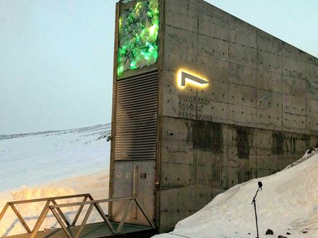
Figure 33. A vault door in snow. A library is a physical object.
Directed seeding is an old idea with Crick and Orgel’s names on one famous version: maybe someone already did this to us, or we do it next. Cold as a detection in our rocks. Warm as a project we might do, and therefore a project we can refuse. If Europa’s sea has a biosphere, our dirt is a conquistador. If it does not, the same dirt is a greenhouse. Chapter 29 already hired the rule. This chapter is the box the rule governs.
Would we know, if the pour had been ours, four billion years ago? The leftover glow does not say. The rocks of the first wet days are almost gone. What we have is one code, one handedness, and a chemical path that is incomplete and not empty. A serial number in the genome has been looked for by people who wanted to find it. What they found was mostly leftover we had misread. A seeder still needed a kitchen somewhere. The first hour does not disappear because a librarian arrived for the second.
Ants are the scale worth keeping.
A leafcutter city farms. It wars. No worker negotiates with us. We step over, or we study, or we pour. To a crew that crossed a century, an ape city may be that nest: impressive at its own size, not a colleague. Chapter 6 used the nest as a diagram of a self. Chapter 30 spends the same scale on a visitor who files the cars and misses the mite. Here the scale is a warning about the box. Talking is not what you do with a nest. Pouring is. If the printers work and the look-first failed, the box is the pour.
The printers cut the other way too. A wet lab that can make a cell can make a plague. Sterility is filters and assays, not a mood. The box is as dangerous as it is precious. A librarian who only loves the literature will pour. A librarian who only fears it will never farm a dead world whose exam is already empty. The rule splits the cases. Do not mix the folders.
The same rule runs back toward Earth, and the poster forgets that direction because the poster faces out.
A sample that might still be a kitchen does not come home in a pocket. It comes home in a box inside a box, opened in a room you can afford to throw away. Appendix A33 names the policy. You do not put an unread sea on the same bench as the basil. The crew that can wait is useful because waiting is the method. A schedule for planting a flag is how you fail it.
Mass is the only vote that counts on the day you leave.
A vault in a mountain is already a building, a staff, a power bill, and a politics. Put that vault on the cruise and you add the shield, the brick, the spare drawers, and the years of quiet. Every kilogram of literature is a kilogram you did not spend on the brake. The vandal’s suitcase — one ape, one crop, a slogan — is light, and light is its temptation. Light is not sufficient. Sufficient is a staff that can live in the trick the destination actually offers. A vent wants rock-eaters. A dim tray wants light-eaters that will not sulk for a yellow sun. Chapter 25’s dead greenhouse wants the potato and the microbes that make the potato a potato, because that exam was a close world with no sea hiding a second dictionary. Do not copy that shopping list onto a dark moon because the word “seed” felt brave.
Special relativity still makes the mail late. Quantum mechanics still makes the recipe a sequence of letters, not a spark. General relativity still refuses a handle unless someone pays Chapter 34’s bill. A being printed at the far end can look like a miracle to a city that did not own the printer. It is a miracle of logistics.
You do not pack a forest.
A forest is a queue. A film comes first. The film makes a dirt. The dirt holds a root. The root holds a shade the film never asked for and the later plant cannot live without. Print the later plant on the first day and you have shipped a corpse with a pedigree. Print the film, in a room that can stand it, and a queue can start. The box holds rungs, not the finished stair. The stair between the pamphlet and the ape is a staff, and the staff is what the departure has to lift.
The first rung should be an instrument, not a mascot.
A rock-eater that breathes out a gas you can see from outside the room is a measurement that happens to be alive. You chose it because the exam can fail in public. If the gas never comes, the printer lied, the room refused, or the recipe was the typo the spare copies were there to catch. Those are three different failures. A thing that looks like a pet and changes nothing you can detect will report success to the people who miss it. A gas will not.
The reader has to outlast the letters.
A vault you cannot open is geology. A file you cannot parse is the same rock with a prouder story. The script has to travel with a reader that still knows which mark is which after the ministry that wrote the labels is gone. Mountains outlast ministries, and ministries are who letter the drawers. Put two readers in two drawers. Put the key in a form a person can still sound out, not only in a format that dies with a company. The crew that does not sleep can keep a machine awake. It should not be the only speaker of the alphabet left on the cruise.
Chapter 31 already set a poison beside the gift. The life we know has a handedness. The mirror of it is a maybe, not a second Earth the box is obliged to carry. Packing both, because completeness sounds like care, is how a knife gets into the suitcase. An empty exam wants the trick we have actually run. A taken sea wants nothing this box can give. The mirror does not get a third folder in which the rule was shy.
A mountain outlasts a ministry. A cruise outlasts a body. Neither outlasts a mistake poured into a sea that already copies.
Appendix A33 writes the numbers.

34. Handles, and the Bill
Now the cheat.
A wormhole, in the only picture that does not lie, is not a subway. It is a handle on the loaf. Two distant regions — two spheres in space, if you want the honest shape — are neighbors by a short extra piece of geometry. You do not fly the long way. You fall in a sphere and come out another sphere. Light from the far side fills the mouth like a crystal ball. The mouth is not a manhole in a floor. It is a ball in a room.
Keep the ball. Posters draw a glowing ring on a wall, a door you step through like a cellar. The geometry that actually sits in the equations is spherical: a region of space whose interior is identified, by a short throat, with the interior of another sphere somewhere else. Walk toward the ball and the far kitchen swells in it, a crystal-ball picture made of real light taking the short way. Walk into the ball and you have not gone “through a surface into a tunnel painted on the wall.” You have fallen along a handle. Two places that were distant the long way are neighbors through the handle. If you cannot picture a ball, picture two mouths of a worm in an apple, except the apple is spacetime and the worm is a sentence we have not paid for.
Einstein and Rosen found a throat in the Schwarzschild geometry in 1935.⁵² It pinches. Nothing useful crosses. In 1988 Morris and Thorne wrote down a throat that stays open.⁵³ The price is matter that, in some frames, has negative energy density — exotic in the jargon, rude to the energy conditions that let Hawking and company prove their theorems. Ordinary stuff focuses. A throat that stays open must defocus. You are asking spacetime to do the opposite of what mass usually asks.
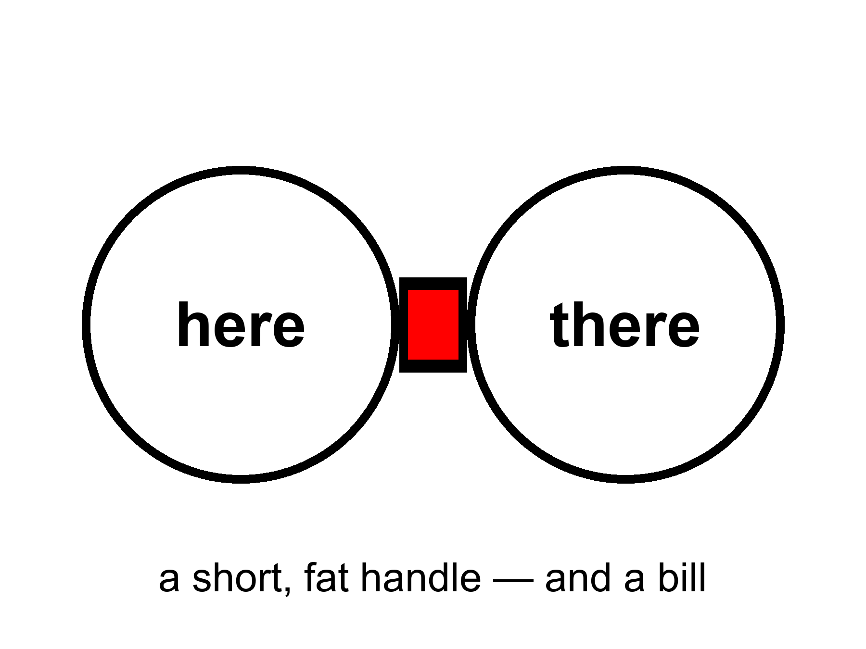
Figure 34. Two large circles joined by a short, fat handle: here and there. A wormhole would be a handle on the block, not a subway.
Quantum field theory allows small, brief negative energies. The Casimir effect, between two plates, is the laboratory ghost of that permission. Quantum inequalities then say you cannot pile the ghost into a ship-sized hallway and keep it on duty. The honest status: allowed as a sentence in general relativity; probably forbidden as a station in engineering. Appendix A34 writes the condition. We will not pretend a handle is a purchase order.
If a handle existed, it would not be a machine that “goes.” It would be a feature of the block, already there, the way 1914 is already there. Moving one mouth, if you could, is how people turn a handle into a loop, and a loop into a problem for the next part. First, pay the bill.
The bill is not in dollars. It is in a kind of stuff we have never stacked.
Ordinary mass, in Einstein’s theory, is a focusing lens for light. A bundle of rays that just grazes a star comes out slightly more converged than it went in. That is why Hawking and company could prove that, once focusing has gone far enough, a collapse has a point of no return: a singularity, or at least a place the theory itself will not describe. The null energy condition is the rule that lets the proof run. Spreading is a defocus. Defocus, in this ledger, is the rude stuff.
The null energy condition, a rule of thumb that ordinary matter respects, says that light rays, on average, get focused by stuff. A traversable throat requires a defocusing, a violation, along the hole. You can write solutions that do this. You cannot, today, point at a tank and say “that is the defocusing, please load it.”
Ford and Roman’s inequalities are the killjoys: the more negative the energy, the shorter the time you may have it, in a given volume. Macroscopic and long-lived fight each other. A ship-sized, hour-long throat is the kind of request the inequalities seem built to refuse. “Seem” is doing some work. The refusal is not a theorem about every possible spacetime. It is a strong hint from the quantum rules we actually use.
Is there a real way to go faster than light by bending the path?
There is a real sentence. There is not a real ticket.
Special relativity is a rule about the loaf’s local manners: nothing with a mass, in its own little room, outruns the light in that room. General relativity lets the rooms themselves be rearranged. You do not beat the messenger. You shorten the hallway. A handle does this by adding a shortcut between two spheres. A warp does this by squeezing space ahead of you and stretching it behind, so the destination slides toward you while you sit, locally, as if you were at rest. Miguel Alcubierre wrote that bubble down in 1994.⁵⁴ Inside, the tea does not spill. Outside, the geometry does the commute. Light still wins every local race. The arrival can still beat a light-beam that took the long way through unbent space. That is the whole trick, and it is not a cheat of Einstein. It is Einstein used as a contractor.
The contractor sends a bill we have never paid.
The skin of the bubble needs the same rude stuff as a throat: energy, in some frames, that is negative — a defocusing, a violation of the null energy condition, equation (17). Early estimates asked for a Jupiter of it. Later papers shaved the number by reshaping the skin. Shaved is not stacked. We have Casimir plates and other ghosts. We do not have a ring of ghosts around a cabin. Ford and Roman still mutter: the more negative, the shorter the time you may have it. A bubble you could live in, for the hours a star-trip would take even when the hallway is short, is the kind of object the inequalities seem built to refuse.
There is a ruder catch, and it is the one the posters skip. Bending the path usually means the path is already yours. The front of a warp bubble is, in the ordinary writing, causally disconnected from the cabin. You cannot reach out and steer a geometry you have not already laid. Turning the bubble on, from the inside, is like lighting a fuse that has not been strung. Someone — or some machine — has to arrange spacetime along the route first, or meet you from the far end, or leave a tube on an earlier, slow pass. Krasnikov’s tube is that last idea: go the long way once, leave a modified hallway, come home short. That is not a point-and-go. That is paving. Paving a century of route with exotic asphalt is not a smaller project than the cruise in Chapter 32. It is a larger one, wearing a faster hat.
If you could pave at will, you could also turn the pavement into a loop: two short hallways, badly timed, and yesterday is a stop. Hawking’s hunch from Chapter 36 is waiting there. The universe, asked to let you arrive before you left, may explode the pavement instead.
So the grown-up inventory is short. No local dash past light. No switch that nulls weight because you said so. A handle, a bubble, a tube: three shapes spacetime might wear, all of them sentences in a theory we trust in the rooms we have tested, all of them hungry for a stuff we have not stacked, all of them easier to write than to start from a cockpit. Mara, the melt-probe in the dark sea, the crew that does not sleep — those remain the transit system. Handles and bubbles stay in the appendix, where a bill belongs. The galaxies that have already left stay gone. A nearby ice, a nearby dirt, a nearby library: those are still in the cone.
Tea that does not spill inside a warp is a true sentence about a false ticket. Local manners can be perfect while the global commute is a fiction we have not stacked the matter for. The same is true of a throat that stays open on paper. The woman, the melt, the waiting crew: those are rude and finite. Rude-and-finite is the temperature of a real path. Handles stay in A34 with equation (17). Pay the bill there. Do not cash it in a cockpit.
Appendix A34 writes the flaring-out condition and equation (17). Here, keep the ball in the room and the unpaid invoice. The pinch is free and useless. The open throat is useful and not free. That is the whole cheat, priced.

35. The Watchmaker, and the Signal
When the basil lives and the ice melts and the leftover glow looks arranged, a temptation arrives: someone did this.
A slab that teaches apes to use tools. A gardener who lights a new star for a moon. A visitor who lands because we played five notes. Those are stories. They are allowed as stories. As physics they have a job they have not done: they must predict a signature we can miss.
A craftsman who wanted liquid water could have used starlight bands or tidal seas. We have both, and they look like maps, not signatures. A craftsman who wanted observers could have left a serial number in the leftover glow. The glow’s freckles look like stretched noise. A craftsman who wanted contact would not be limited to the speed of light, unless the craftsman is also a physicist with our constraints — in which case the craftsman is us, later, in a machine that does not sleep, and we are back at a project.
The oldest version of the temptation has a better address. It asks whether a river kingdom already knew.
Say the obvious first. Egypt knew the sky as a tool. They aligned million-ton tombs to true north within a fraction of a degree — not by luck, by stretching ropes and watching a star that does not travel far. They ran a calendar off the Nile and off the heliacal rising of Sopdet, the star we call Sirius, because a flood that feeds you is a clock you do not get to ignore. They had decans, surveying, a geometry that could lay a square on sand and make it stay. They wrote the work down. We have quarry marks, worker villages, a diary of a man who hauled limestone for a king. The stone did not arrive from another sun. It arrived from a quarry, on a boat, by people who were good at their job.
That is already a lot. It is allowed to astonish you. Astonishment is not a visitor.
What they did not know is the leftover glow, the shove, the block, the fact that Andromeda is a navy of suns. They had a sky full of meaning — a Duat, a night boat, an afterlife with a map — and meaning is a kind of knowledge. It is not the same kind as a microwave temperature. A culture can be brilliant at north and still not own cosmology.
The sermon that follows is the one that steals the work. Someone must have told them. The shafts point at Orion on purpose as a physics lesson. The ratio of the base to the height is a message about circles that only we can read. Some of the numbers are real: a seked, a cubit, a slope you can repeat. Some are what happens when you go looking for π in any pile of well-cut stone. Selection is a craftsman too. Shafts that face a northern star are what you get if you care about the unmoving sky and you have a burial to aim. They are not a telegram from Chapter 8.
Then there are the lights.
Not the leftover glow. Lights in this air. The temperature is locked before the stories: a residual in serious instruments can be hot as “something was there”; every name for it — ours, secret; someone else’s workshop; a colleague — stays cold until hardware you can hold, or a channel nature does not use, is on the bench.
Something is there. Not in every backyard video. In the stubborn cases: a carrier group, a spy radar that had been seeing “things” for days, two navy pilots who flew up to a pale lozenge with no exhaust, no rotors, no thermal plume, and watched it stay in the wind over a disturbed patch of sea, then leave in a way their jets do not leave. A targeting pod wrote an infrared tape. The navy later let the tape out of the bag, stood up an office, and printed the dull word unidentified. That sequence is not a campfire. It is what a serious institution does when its own instruments have leftover.
What did they film?
They filmed an object, or a phenomenon that holds still long enough to be an object. Infrared is a thermometer with a zoom, not a novel. Without a range, a small drone nearby and a large hull far away wear the same pixels; a turn of the pod can look like a miracle. Some of the later famous tapes really are that kind of homework: glare, parallax, a balloon that was never a visitor. Admit those too. The best case is not those tapes. The best case is the day the radar, the eyeballs, and the camera were all pointed at the same leftover, and the leftover did not fly like an airplane. You can argue about the last burst of speed. You cannot honestly argue that nothing was there.
Two other obvious things.
If the leftover is ours — a classified drone, a test article, a trick of electronic warfare — then someone already builds machines the briefing does not mention and flies them near nuclear carriers. That is remarkable even if it is dull. If it is another flag’s, it is the same sentence with a worse budget meeting.
If it is not a known workshop, then “I don’t know” is the grown-up line: a real residual with bad range and no wreckage. The job is to stay in the residual without hiring a priest or a joker.
The pilots are not the problem; they saw a thing in a place they are paid to see things. The leap is “therefore a face, a future, a hop.” Chapter 31 already fired the face as a default.
So: where would it come from, if the leftover is a vehicle we do not own?
Our own future. If a later crew could ride a loop, the visit was already in the inventory; Chapters 36 and 37 will not give you a sandbox. And buzzing a fighter jet is a strange errand for a civilization that can borrow yesterday. Cold.
A parallel world. Everett’s branches, if that reading is right, are inventory, not a ferry (Chapter 41). Cold.
Our past. A gardener who came, left, and forgot to number the rocks is the watchmaker again; the rocks look like rocks. A secret workshop in this century is the warmer past: last Tuesday, classified on purpose. Dull, allowed, and sometimes the best fit for a leftover that looks like a machine and shares a range with a navy.
Another planet, traveling forever. The least rude extraterrestrial sentence, and it still pays Chapter 32’s bill: a crew that does not sleep can spend centuries and arrive. Why this air, this decade, and no wreckage, no radio, no serial number? Fair questions, not a proof of absence. The Fermi quiet — if the sky is full of travelers, why is the mail this bad? — is a smell, not a gavel. Warm as a project the universe permits; cold as a name on the tape.
Beamed. A recipe sent at light still needs a printer on this end — Chapter 33’s library, a box we would notice in a field — and a handle still owes the exotic-matter bill. Cold.
A thought without ears. A schoolyard, a crowd of children, a craft on the ground and a message behind the eyes. Many children, the same morning, described the same thing in the same dirt. Something happened in that yard. Children are an instrument without a rangefinder and with a powerful need to agree; memory is social, and expectation is contagious. None of that makes them liars, and none of it hires a new force. Telepathy has never shown up in a lab where it could be missed. Cold as a mechanism. The schoolyard remains a human event we have not finished explaining.
Do quantum mechanics and relativity play a role? Yes — as bills, not as costumes.
Relativity makes a seeder’s mail late and keeps a handle, a warp, or a nulling of weight from being a switch; the one warm “future-us” it permits is a twin who went fast and came back younger — a Chapter 32 cruise, not a raid on yesterday. Quantum mechanics forbids a schoolyard radio (the no-signaling theorem is a killjoy with a proof), and “they vibrate at a higher frequency” is not a sentence in the theory. The two theories do not yet share a foundation. That hole is real. It does not fill in a gardener or a leftover in a dogfight.
What would count, if you are not here to be thrilled?
Hardware you can hold, with isotope ratios and a microstructure Earth does not pour. A trajectory, range-complete, that violates the energy a craft that size can carry — and still looks the same when three instruments that are not friends agree. A message in a channel nature does not use. We do not have those yet. What we do have, in the stubborn files, is already enough to forbid two lazy sentences: nothing happened, and so it was a person from another world. The leftover is obvious. The name is not.
Why did a legislature suddenly want a hearing?
It was not sudden if your file starts in 1947. It was sudden as a public, funded, unembarrassed residual. In 2017 a newspaper printed a Pentagon office that had been buying the question. In 2020 the Pentagon formally released the tapes. In 2021 the intelligence community published the assessment Congress had ordered. Hearings followed. A majority leader put disclosure language in a defense bill and watched it thin out in negotiation. That is not a conversion to a colleague from another sun. That is what a state does when three boring fears line up.
First: air domain. Drones, cruise missiles, hypersonic tests, someone else’s homework in a range you thought you owned. A leftover that can sit over a carrier is, if it is a machine, already an operational fact. Stigma — the joke that used to keep pilots quiet — is, in that light, a security hole. Second: oversight. Classified programs live in the same sky. A congress that cannot tell a leftover from its own black budget is a congress that is being managed. Third: nuclear nervousness. Reports that cluster near weapons and reactors are, even when they are noise, the kind of noise a committee is paid to hate.
Some members want the other caption. Testimony has been given, under oath, of retrievals and of craft that are not ours. Testimony is a record of a claim. It is not a hull on a bench. Appendix A35 still wants the isotope. Admit the obvious without the choir: Congress got interested because the leftover entered institutions that can be embarrassed, in a decade when being surprised in your own air is a career-ending sentence. That is smarter than an awakening and ruder than a debunking. It leaves the stubborn files where they were — unnamed.
If someone else has a radio, the radio is late.
A yes-or-no from the nearest other Sun is eight and a half years of round-trip at light, if they answer on the first try, if they listen our way, if they exist. A conversation is a career. A conversation with a tidal sea’s inhabitants, if they have not invented radio because they have not invented eyes, is a melt and a guess. SETI is a search for a very specific kind of waste heat and timing: someone who learned to shout in electromagnetic. Most of the habitable map in Chapters 27 and 28 would not shout that way.
The shout, if you want a picture of a missable one, is not a hello in English. It is a channel nature does not use: a narrowband whistle, a timing that is not a pulsar, a modulation that looks like a prime because primes are a habit mathematicians share and rocks do not. Drake’s famous product is a parameterization of ignorance — a row of fractions we have not measured, multiplied until they look like a population. It is not a census. It is a list of things a dish cannot yet count: how many rooms are wet, how often wet becomes a trick that copies, how often the trick learns to shout, how long the shout stays on. The dish is still the clean search. Clean is not complete.
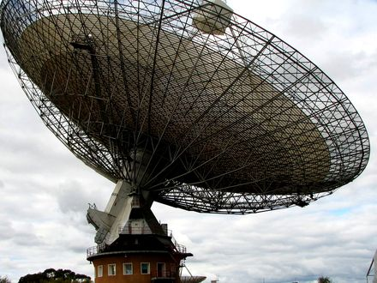
Figure 35. A radio dish with ground in the frame. A signal is light, and light is late.
A signal is not a savior. It does not fix the shove or open a handle. It is a fact about another worldline, arriving late, the way Andromeda’s navy arrives late. If we ever hear one, we will not have been rescued. We will have been informed that the trick of carbon and water happened twice, or that a machine that does not sleep learned to shout.
Until then we have a greenhouse, a dark sea, a library, and a delay. That is enough to be getting on with. It is already a better story than a door. Chapter 42 is where this watchmaker meets the filter and is refused a hire. The six chapters between are copies and loops. They do not reopen the signal.

PART VII — Loops

36. Time Travel Is Not an Edit
The kitchen fantasy of time travel is an edit. You go back, you unsay a sentence, you save a person, you kill a tyrant, you step on a butterfly, and history rewrites. Relativity does not hand out rewrites. If spacetime contains a path that arrives at an earlier event, the event was never waiting to be changed. It already includes whatever the path did.
An edit would be a second history, or a machine that erases events and writes them again. General relativity does not own that machine. It owns a geometry of events and a rule about which events can influence which others. A worldline is a set of those events. If the set meets itself, the meeting is one of the crumbs. It is not a revision of the crumbs.
This is the Novikov habit, and it is the only habit that does not set the block on fire. A loop is a consistency condition, not a sandbox. The watch you leave in a drawer in 1989 is the watch you will find because you left it. The message you scratch into frost on a greenhouse pane is the message that was always on the pane in that event. You do not get a second pane.
Igor Novikov, in the 1980s, said this with a physicist’s lack of drama, and a 1990 paper with colleagues showed how it works for billiard balls fired into a wormhole time machine.⁵⁵ If a closed timelike curve exists — a path that stays inside its own future and arrives at its own past — then the only histories with nonzero weight are the ones that fit. A paradoxical history is not a thriller. It is a configuration the equations refuse to count. The principle is not a policeman who jumps in at the last second. It is bookkeeping: the probability of an inconsistent loop is zero because an inconsistent loop is not a solution.
The kitchen version sits on the glass.
She comes into the greenhouse on a cold morning and the inner pane is already written. The letters are her letters. The sentence is a pH, a date, a warning about a pump. She has not written it yet, as her watch tells it. She will write it, because she found it, and because the frost will take a finger. The pane is not a suggestion. It is an event. The writing and the finding are two stretches of the same thread, or of two threads that meet at the glass, and both stretches were always there. She does not get to wipe the letters and invent a kinder pump. She gets a finger, and a pane that was never blank in that event.
People hate this because it feels like a trick. It is the opposite of a trick. It is what “the inventory is events” was always going to mean once you allowed a worldline to meet its own past. The choosing is still a stretch of thread. The stretch, if it loops, was counted once.
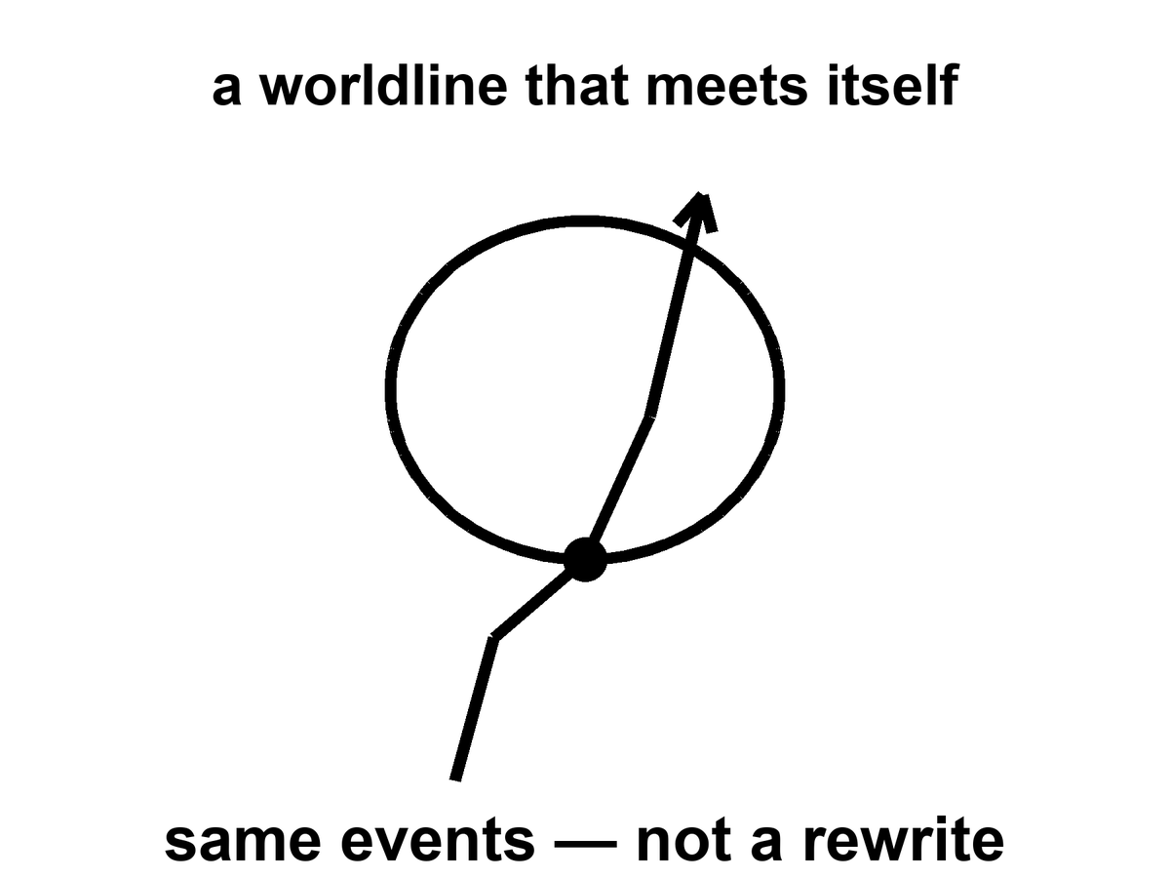
Figure 36. A worldline that meets itself. Same events, not a rewrite.
Mara cannot radio yesterday. She can hear twenty minutes ago, which is rude but not looping. The machine that does not sleep, falling toward a star for four hundred years, cannot mail a warning to its launch. It can arrive, melt, look, and send a letter that will be read by people who have never met the launch crew. That is not time travel. That is the ordinary lateness of light, stretched over a career. Late is not yesterday.
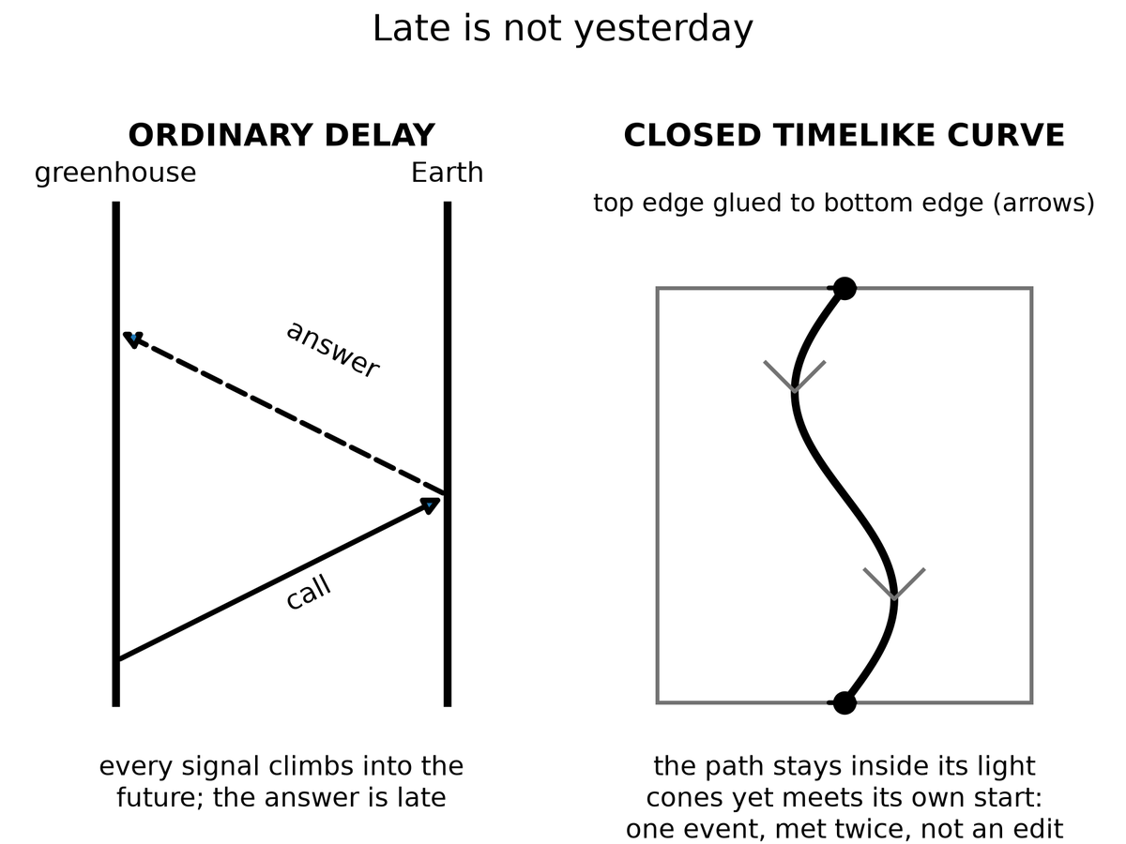
Spacetime Diagram 5. Late is not yesterday. Left: an ordinary delay; the call and the answer both climb into the future, so the answer arrives late. Right: a closed timelike curve; the path stays inside its light cones everywhere and still meets its own start, one event met twice, not an edit.
Yesterday, in the greenhouse, is a set of events in her past light cone. A radio wave she emits today leaves along her future cone. That cone does not include yesterday’s workbench. A loop would require the signal, or the sender, to arrive at an event already in the sender’s past. It has delay. Delay is Chapter 3, scaled to a dead world. It is not a closed curve. The four-hundred-year cruise is the same lesson with worse manners: launch and arrival are two events on a long worldline, not a loop. The arrival cannot warn the launch because the launch is not in the arrival’s future cone. The letter, if any, is news. News is late. Late is not yesterday.
If you want the edit, you need a different history — a branch, a copy, a hop. The copies chapter will give you inventory and still refuse the hop. There is no known door from this thread to a thread where the basil died and you would like a second try. Grief is a fact about one worldline. It is not a user interface.
Are loops even allowed?
In special relativity, no: flat spacetime is too stiff. Flat spacetime is a flat block. Timelike curves in it do not close. You can ride forever and you will not meet your own morning. Trouble about when is not the same as a ticket to then.
In general relativity, sometimes, on paper. Kurt Gödel found a rotating universe in which you can ride a closed timelike curve⁵⁶ — a path that stays inside its own future and arrives at its own past. Our universe is not Gödel’s. It does not rotate that way. Kerr’s spinning hole, if you could go through the interior in the idealized math and if the interior were not a chaos of instability, offers rings that loop. Wormhole mouths, if you could move them, can be turned into a time machine: park one, fly the other on a fast trip, bring it back, and the clocks on the mouths no longer agree in a way that lets you leave today and arrive last year.
Take those three sentences apart. They are not a brochure.
Gödel’s 1949 cosmos is a solution of Einstein’s equation filled with rotating dust. Every event, in that geometry, sits on a closed timelike curve. You could, in the math, leave a kitchen, fly a long way, and arrive before you left, without ever exceeding light locally. It is a marvel of a metric and a poor map of home. Gödel’s universe does not expand the way ours does. It has a global rotation our leftover glow does not show. The microwave sky is even to a part in a hundred thousand. A Gödel twist of the size that would let you loop would have written a louder signature than that. Hot claim: we do not live in Gödel’s rotating dust. Cold claim: somewhere, in some other solution, such dust is a universe.
Kerr’s spinning hole is closer to furniture we actually own. Stars rotate. The holes they can become rotate. The exterior of a Kerr hole is a working theory with shadows and rings and LIGO chirps to its name. The interior, in the full analytic extension, is a different room. Inside the inner horizon — a Cauchy horizon, a surface beyond which spacetime stops being predictable from the outside — the idealized math offers closed timelike curves around a ring singularity. Tourists love that sentence. Physics does not. The inner horizon is unstable. Matter and radiation falling in get blueshifted without mercy. The technical name is mass inflation:⁵⁷ the horizon becomes a wall of energy, and the pretty extension is not a hallway. A hole made by a collapsing star is not the eternal, vacuum Kerr solution of a textbook. Even on paper, “go through and loop” is a sentence about an object we have not got. Warm claim: spinning holes exist. Cold claim: their insides are a time machine. The insides, as far as the instability arguments run, are a place the theory we trust stops being a guide.
Wormhole mouths are the kitchen trick people actually try to draw. Chapter 34 paid the bill for a throat that stays open. Suppose, against the inequalities, you have two mouths. Park one in the yard. Fly the other on a fast cruise and bring it home. The twin effect of Chapter 5 is waiting: the flown mouth accumulates less proper time. The clocks on the two spheres no longer agree. After enough mismatch, a path that enters the young mouth and leaves the old one can arrive at an external clock reading earlier than the departure. You have not outrun light in any local room. You have used a handle plus a twin-clock cheat to fold spacetime until today touches last year. Morris, Thorne, and Yurtsever wrote the operation down.⁵⁸ It is a recipe for a chronology horizon, not a recipe for an edit.
All of these are sentences in a theory we trust in the rooms we have tested, used in rooms we have not. None of them is a photograph. None of them is a ticket.
Appendix A36 names the metrics. Here, keep one picture: a loop is a shape the loaf might have, locally or globally. It is not a machine you bolt on. If the shape is there, it was there. If it is not, you cannot will it into an edit.
The grandfather “paradox” is a complaint about edits. In a consistent loop, you do not kill the grandfather in a way that prevents the loop. Either you fail, or you are not in that story, or the story was never the one you thought. This is unsatisfying as drama and perfect as bookkeeping. Drama wants the rewrite. Bookkeeping wants the inventory.
The complaint sounds like a riddle because it assumes a draft: you exist, therefore the grandfather lived, therefore you cannot have killed him, therefore contradiction — or else a branching, or else a policeman. Novikov’s answer is duller. There is no draft. A worldline that both requires the grandfather and removes him is not in the sum. The failure is not a moral. It is a zero in the measure. You trip. The gun jams. You are the descendant by a route the riddle did not budget.
Why may the universe forbid them?
The chronology-protection conjecture is a hunch with a pedigree: the universe, when you try to build a loop, fights back. Vacuum jitters near the would-be time machine grow. The throat, if a throat is involved, blows. The Cauchy horizon — the surface beyond which prediction dies — becomes a wall of energy. You do not get last year. You get a bang.
Stephen Hawking wrote the hunch down in 1992.⁵⁹ Near a forming chronology horizon, the vacuum’s stress-energy tries to diverge. The machine, in this picture, destroys itself with the same jitters that make black holes glow. Chronology protection is not a theorem. It is a conjecture that the divergence is generic, that nature does not let you finish the wormhole-clock trick, that Cauchy horizons in this role are walls rather than doors.
Hot: flat spacetime does not loop, and we have never photographed a closed timelike curve. Warm: general relativity admits looping metrics; the ones that look like ours do not wear them in the rooms we can see. Cold: you could build a time machine if you stacked exotic matter and survived the vacuum. Hawking’s hunch is the grown-up cold: maybe you cannot, because the stacking asks the field to explode. Do not confuse a solution of Einstein’s equation with a launch window.

Physics vs philosophy: from general relativity to time machines
What the evidence establishes. General relativity passes every test we can give it, from clocks on towers to black-hole shadows and merger signals. No closed timelike curve has ever been observed, and the leftover glow rules out a Gödel-style rotation of our universe.
What the theory allows on paper. Exact solutions with loops exist (Gödel’s dust, the idealized Kerr interior, wormholes with moving mouths), but each needs a global rotation we do not see, an interior that is unstable, or negative energy in amounts quantum field theory seems to forbid.⁶⁰
The strongest rival view. Some physicists take loops more seriously than this chapter does. David Deutsch showed that quantum mechanics can be made consistent on a loop by letting the loop pick out a self-consistent quantum state, so paradoxes dissolve without a policeman.⁶¹ What it gets right: consistency, not prohibition, is the real constraint. Why this book still does not book a ticket: Deutsch’s model assumes the loop already exists, and nothing in it pays the energy bill for building one.
What would change the verdict. A full quantum theory of gravity that either proves chronology protection or shows a loop can be built and survive.

If the hunch is wrong, the block contains shapes that arrive before they leave, and the kitchen argument about “now” was only the beginning of the trouble. If the hunch is right, nature is stubborn about order along worldlines that matter, and time travel remains a sport for metrics, not for crews. That is a practical mercy.

37. If You Could Walk Sideways Through When
Suppose, as a thought, you could leave your worldline and walk across the block, as if time were a hallway of rooms, each room a now, each now a place you could enter and leave.
You would not be editing. You would be visiting. The childhood kitchen would be a room. The greenhouse would be a room. The dark sea under Europa’s ice, on a particular Tuesday of a particular millennium, would be a room. You could push a book, raise a dust of frost, encode a pulse in a watch. Those events, if they are in the block, were always there. Your walk would be another thread, weirdly oriented, already counted.
Stay in the thought long enough to feel what the permission would actually be.
You step off the thread you have been calling a life. The loaf, which Chapter 6 treated as inventory, becomes furniture. You are not a passenger in a river. You are a visitor in a house that was never sequential except along the paths that live in it. The first room you try is the one grief already named.
A childhood kitchen. A kettle that has not yet learned the house. A window with a frost that is not the greenhouse frost, earlier, kinder. A child at the table is a bundle of worldlines that will, later, include you. You are not that child. You are a later stretch, illegally sideways, looking. If the walk is real, the looking is an event, and the event was always in the room. The child does not acquire a new memory because you arrived. You do not get to pick a different kettle. You get to stand in a room you cannot rent.
You could push a book on a table in 1914. You could encode a pulse in a watch in 1989. You could meet your own later face in a corridor that, along ordinary worldlines, is a lifetime away. Each of those is a crumb. Each crumb, if the walk exists, was counted. The walk does not add a second inventory. It adds a weirdly oriented thread to the one inventory, the way a worm through bread is still bread.
From this illegal hallway you could look at the leftover glow edge-on: not a sky, a slice, a last-scattering surface as a wall in the house. You could see the three minutes as a thin, hot room near one end of the block, and a sparse, shoved-apart web of galaxies as a later furniture. It would still be a view from a path, not a god’s-eye. Even a sideways path has a proper length. Even a visitor accumulates something. The something would not be the time your kitchen clock named. It would be whatever parameter the new thread used for mileage. The block does not owe that parameter a name you already like.
This is the block made into a set of furniture. It is useful as a picture and false as a permission. We do not have a sideways walk. Our worldlines are nearly parallel, locally, to the time directions the leftover glow picked out when it last scattered. We go from event to event the long way, accumulating proper time, eating basil, dying.
The permission is the part that has to be taken away, slowly, because the picture is so good at lying.
You cannot walk sideways through when. “When” is not a corridor. It is a way of ordering events along a thread, and a way of slicing spacetime for the convenience of a clock. The slice is a choice. The thread is a fact. Confusing the two is the whole of this chapter.
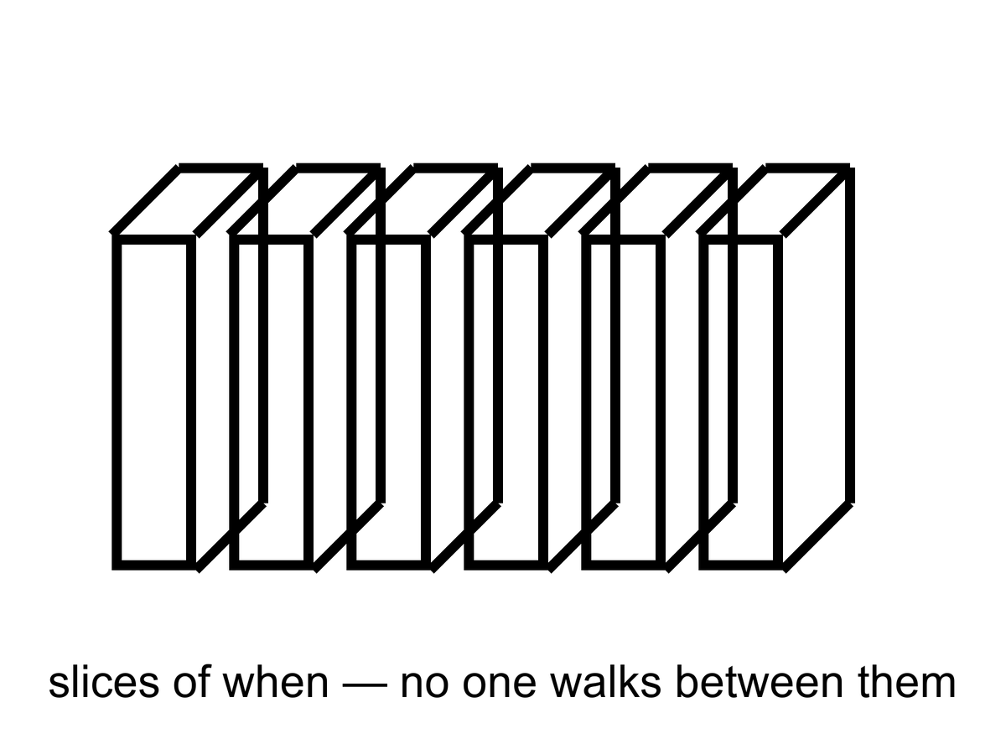
Figure 37. Slices of events, stacked like pages. No one walks between the slices.
Foliations — the technical name for slicing the loaf into “nows” — are a choice, not a hallway. Appendix A37 says why a stack is not a corridor. A foliation is a stack of three-dimensional surfaces, each surface a candidate for “the world at a given time.” Relativity does not pick a preferred stack. Cosmology, when it needs a bookkeeping time, hires the leftover glow: the surfaces on which the microwave sky looks as even as it can. That hire is a superb convenience, not a set of rooms with doors between them.
A stack of pages is not a building you can wander. You can put a finger on page 12 and a finger on page 400. You cannot walk from 12 to 400 except by reading, which is the analog of accumulating proper time along a worldline. The reading is a path in the book. The stack is a filing habit. Appendix A37 is the note that says this in the language of embeddings and leaves. Here, the sentence is shorter. A foliation is how you file the loaf. It is not how you travel.
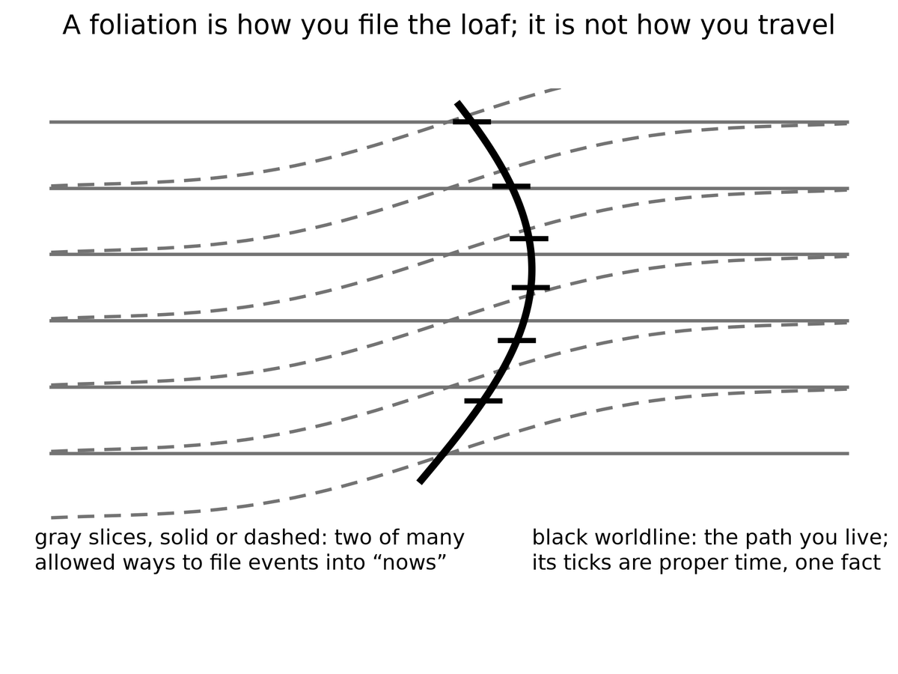
Spacetime Diagram 7. A foliation is how you file the loaf; it is not how you travel. Gray slices, solid or dashed, are two of many allowed ways to file events into “nows.” The black worldline is the path you actually live; its ticks are proper time.
The stack invites a second myth, and it usually arrives with a number. Time, the story goes, is a flip-book. Each page is one Planck time thick, about 5 × 10⁻⁴⁴ seconds, and the universe turns one page per tick, everywhere at once, like a projector with a cosmic shutter.
The projector fails three ways. First, nobody has found the pages. The Planck time marks where our equations expect to need quantum gravity. It is a warning on the map, not a measured grain. In 2009 a gamma-ray burst seven billion light-years away delivered its high-energy and low-energy photons within about a second of each other, which is not what the simplest Planck-scale grain, one that slows the short waves, would do.¹⁵ Second, a universal shutter needs a universal stack, and Chapter 1 already took that away. The person standing still and the person walking toward the table slice spacetime differently, and neither slicing is the one true deck. A projector needs a throne to stand on. Third, the configurations do not come as a finite deck of frames. In every theory that has passed a test, positions and fields vary smoothly. Between any two pages you can always fit another.
So the flip-book is a filing habit drawn as if it were a machine. Hot: no measured Planck tick. Warm: the Planck time as the place our equations stop vouching for themselves. Cold: a future theory might make time grainy in a subtler way, with no shutter and no favorite slicing. Even then the grains would not be a film someone is running. They would be one more fact about spacetime.
A coordinate labeled t on a map of spacetime is a filing number. It is useful. Cosmology uses it so that “when the universe was 380,000 years old” has a meaning on the leftover-glow slices. Your watch does not read that filing number. Your watch reads the length of your thread. Mixing the two is how a hallway gets invented.
Grief already knew.
The childhood kitchen is a room you cannot rent. It is a cluster of happenings, related by light and soup and a kettle, occupying a region of the block. You cannot go there as a visitor. You can remember it, which is a present event that points, by a causal chain of traces, at past events. Memory is not a hallway. It is a record, the same family of fact as a silver grain or a helium nucleus, written on a later stretch of thread. The later stretch does not get to move in. The kettle is not waiting. The kettle is an event that has, from the later vantage, already sat in its region. “Already” is a word the later thread is allowed. The block does not need it.
Hope is the same furniture with the sign flipped. The greenhouse’s later Tuesdays, the melt-probe’s maybe-taste, a library that arrives or does not: those are regions too. You cannot skip ahead into them any more than you can rent the kettle. You can occupy the next stretch of thread, do a project, and leave a record. That is the only method the geometry permits. It is slow. It is not a small thing. It is the thing.
Hot: you have a worldline, a proper time, and no measured hop onto a neighboring slice. Warm: the block is this book’s working interpretation of a theory that GPS tests daily (GPS tests the theory, not the interpretation), and foliations are bookkeeping. Cold: a new structure might someday let a thread lean so hard it looks like a walk through when. That cold idea would still not be an edit. It would be another shape, already counted, already refused a second pane. Until someone photographs the shape, there is one Tuesday at a time, and a childhood kitchen that will not take a tenant.

PART VIII — All the Copies

38. Four Kinds of Elsewhere
“Multiple realities” is four claims in a trench coat. If you let them fuse, you can prove anything and have explained nothing. Keep them in separate rooms.
Open the drawers one at a time. A useful test, before the labels: ask what question the claim is answering. More space answers how big is the dough. Other bubbles answer could the leftover constants have been otherwise. Other branches answer what the electron’s equation does with leftovers. Other mathematics answers what existence even is. Those are four questions. A coat that answers all four with “other worlds” has stopped asking.
More of this universe. Same laws, same constants, more space. If the dough is infinite, or merely brutally large, and the ingredients are sprinkled in a statistically ordinary way, then a finite pattern — a galaxy like this, a kitchen like this, a woman hitting an airlock — repeats. Not because anyone copied it. Because there are only so many ways to arrange a closet of atoms, and an infinite warehouse will reuse the arrangements. These copies are elsewhere in the ordinary, spacelike sense. You cannot visit. Light will not finish the trip.
This is the cheap copy. Chapter 39 is its room. The physics, if you grant the extras, is the physics we already use: an expanding FLRW spacetime, a Hubble volume as a tile, a finite list of ways to stock the tile. The copies sit on the same map as Andromeda, only ruder. They are not behind a curtain. They are behind a distance. Distance, in an accelerating cosmos, is sometimes a forever.
Other bubbles, other rules. If inflation never quite clocks out, and if the way it clocks out has many valleys, then other hot bangs can freeze with different effective constants, different particle menus, different numbers of large directions. This is the expensive copy machine. It is a live hypothesis stacked on a working theory stacked, often, on an untestable framework.
This is Chapter 40’s room. The burst of Chapter 13 is the working theory. Eternal inflation is the burst that may not retire. The menu of valleys is the maybe. A landscape inherited from string theory is a catalog sitting on the maybe. String theory cannot currently be tested. Do not let the catalog put on the cheap copy’s coat and walk around as if it had been counted in the leftover glow.
Other branches. The electron’s equation does not pick a single outcome. One reading says the leftovers stay: both ways persist, decohered, non-interfering. These copies are not other places. They are other terms. You are one term.
This is Chapter 41’s room, and Chapter 6 already put a chair in it. Everett’s habit is a reading of the same rule that builds chemistry. It is not extra cosmology. It does not hand you a hallway to a kinder marriage. The copies, if they persist, persist elsehow, not elsewhere. Confusing elsehow with elsewhere is how the trench coat gets buttoned.
Other mathematics. If existence is cheap and consistency is enough, then every coherent structure is a universe. This is a metaphysical bet. It is not physics. Barrow would have smiled and called it an idea for ideas.
This drawer is the one that should stay closed in a book that has a leftover glow to be loyal to. A consistent set of axioms is not a sky. It does not have a helium fraction. It does not have a woman, except as a symbol in a formal system that has decided to talk about women. You may find the bet beautiful. You may even find it thrifty: why should existence be stingy once consistency is satisfied? Beauty and thrift are not a temperature. They are a taste. This book will not run an experiment on a theorem and call the theorem a neighbor.
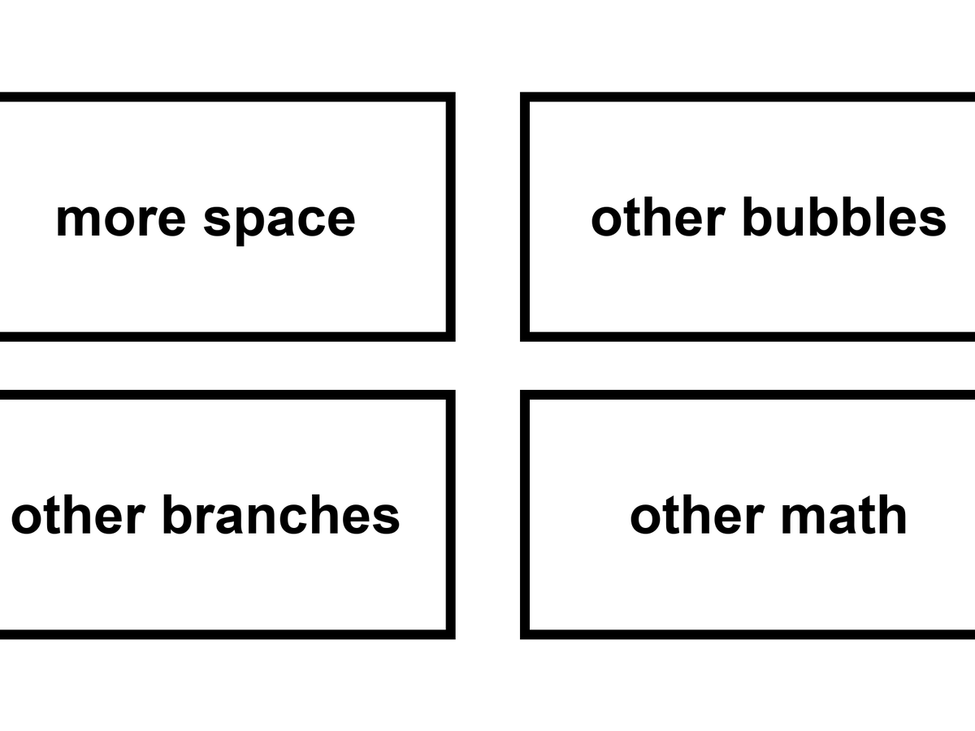
Figure 38. Four kinds of elsewhere in a two-by-two: more space, other bubbles, other branches, other math.
Keep the 2-by-2 on the wall. The rows are not a ranking of how much you should want them. They are a ranking of how easily they fuse in a conversation. More-space copies share our laws; people treat them as travel. Bubble copies share a family of laws and then don’t; people treat them as destinations with different weather. Branch copies share a past up to a fork and then don’t share a place at all; people treat them as hops. Mathematical copies share nothing that physics can cash. People treat them as a completion of the other three. The completion is the coat.
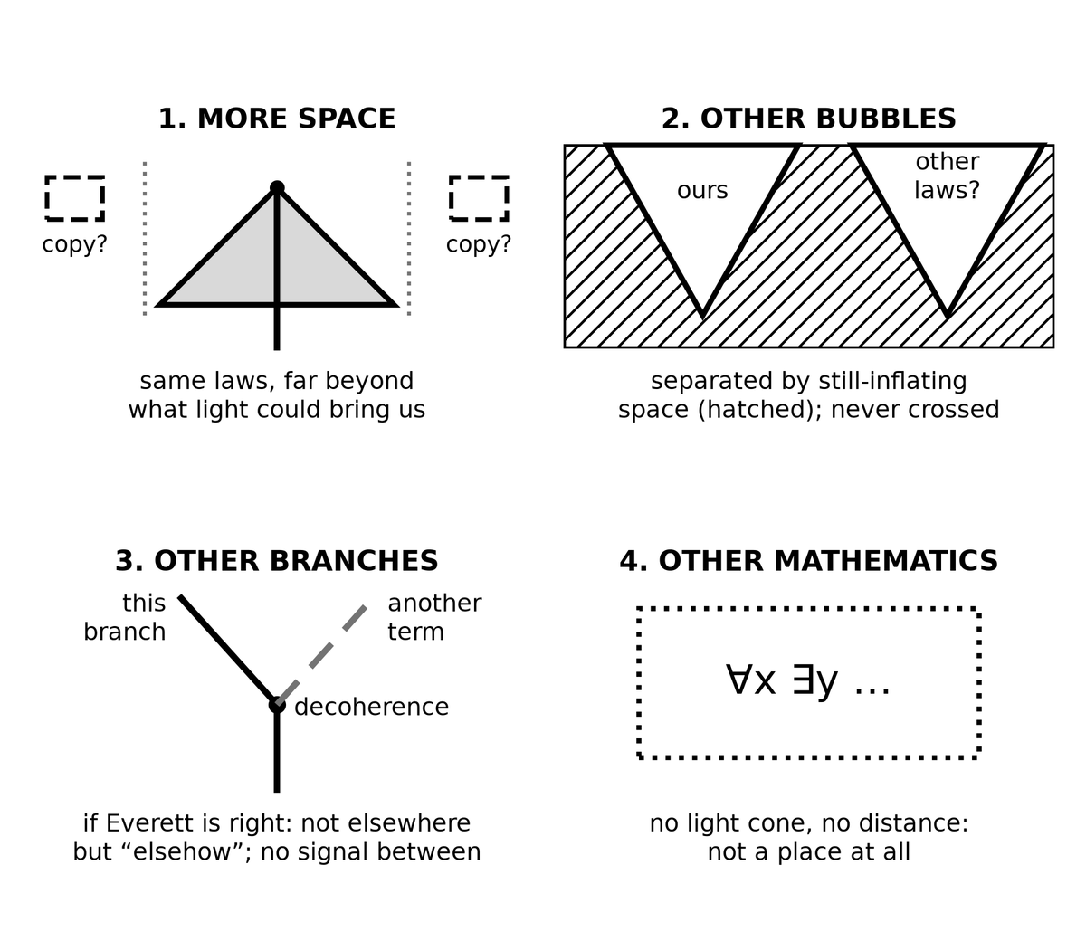
Spacetime Diagram 6. The four kinds of “elsewhere.” 1, more space: same laws, far beyond what light could bring us. 2, other bubbles: separated by still-inflating space, never crossed. 3, other branches, if Everett is right: not elsewhere but “elsehow,” with no signal between. 4, other mathematics: no light cone and no distance, not a place at all.
What would a ticket even be?
To a more-space copy: a path through this spacetime, same constants, long enough to reach a matching tile. Chapter 26 already spent that path. The event horizon ate it. You can name the copy the way you name a galaxy in a deep field. You cannot arrive.
To a bubble: a path into a different freeze — different fine-structure constant, different shove, maybe a different number of large directions. The wall between pockets is not a customs desk. In the usual pictures it is still-bursting dough. A crew that does not sleep cannot clock out of our chemistry and clock into another.
To a branch: a hop between terms of a sum. Chapter 41 will refuse the hop by name. There is no door in the sky labeled tails. There is a silence after decoherence.
To a theorem: boots on a page of axioms. A category error that has learned to walk. You do not visit consistency. You write it down.
Dark matter is not a fifth room. Dark energy is not a sixth. They are ingredients in this room. Chapter 17’s extra pull is a mass budget in the leftover glow, in the Bullet Cluster, in the way galaxies hold together. Chapter 18’s shove is a term in the stretch, a faintness in empty space, a plot twist in H(t). Neither is a copy of the kitchen. Neither is a bubble with other rules, except in the cold sense that some other valley might have a different shove — and that cold sentence belongs in drawer two, labeled as such, not smuggled into drawer one as if the missing mass were a missing universe. A particle we have not yet named is still a particle here. A vacuum energy we have not yet explained is still a vacuum energy here. Missing nouns are not extra universes.
A tidal sea under ice is not another reality. It is a dark room in this one. Europa’s ocean, Enceladus’s spray, a maybe-Hycean under a hydrogen blanket: those are permits and dark pantries in the same expanding dough, the same constants, the same leftover helium. You could, in principle, send a melt-probe. You cannot, in principle, send a melt-probe to a branch, or to a bubble with a different fine-structure constant, or to a theorem. The sea is elsewhere in the ordinary sense that a basement is elsewhere. It is not a fifth kind of copy. People reach for “another world” because the ice is a lid and the Sun is a rumor. Keep the nouns sober. A lid is a lid. A copy is a claim about inventory.
Why the sobriety matters: fuse the rooms and you can “explain” anything. The basil died? A branch where it lived. The shove is small? A bubble that passed a filter. A pattern repeats? Infinite space. A pattern looks arranged? Other mathematics in which arrangement is cheap. Each of those sentences, in its own drawer, can be a responsible maybe. Stacked, they are an oil that lets a sermon slide. This part will not stack them.
Hot: we have one leftover glow, one set of constants, one table of nuclei, and a sky larger than the patch we have seen. Dark matter pulls in this sky. A tidal sea, if it is wet, is wet in this sky. Warm: inflation, dark ingredients, and a quantum rule that does not pick a single outcome. Cold: the four drawers, each in its own way. The coat is colder still. It is not a fifth claim. It is a way of not having a claim. If a later chapter seems to be wearing two drawers at once, that is a mistake in the reading, not a new kind of elsewhere. Send it back to the 2-by-2.

39. More of This Universe
Assume, for a page, that space goes on, same laws, no edge, matter doing statistically ordinary things. Then the Hubble volume — the room we can, in principle, have seen — is one tile. Beyond it, more tiles. The number of ways to arrange the quantum states in a tile is enormous, but finite if you take the holographic bound seriously. In an infinite warehouse of tiles, every allowed arrangement happens, and happens again.
That is the cheap copy in one breath. Now unpack it, because the breath is doing a lot of work, and not all of the work is the same temperature.
An FLRW universe, the expanding dough of Chapter 7, can be infinite in space. The spatial slices — the “nows” cosmology hires from the leftover glow — can be the three-dimensional analog of an endless plane: same rules, no wall. Galaxies, on large enough averages, sprinkled the way Chapter 14’s twitches and Chapter 16’s web sprinkle them. No special place. No edge to walk off. That geometry is allowed. It is not required. Finite spaces with no edge are allowed too: a 3-sphere, a 3-torus, other closed shapes that look, locally, like the endless plane if they are large enough. The leftover glow does not hand you the global topology. It hands you a patch.
The Hubble volume is the patch. Not exactly the particle horizon, not exactly the event horizon: a room of order the Hubble length, the distance light could cover in a Hubble time, the tile people use when they want a fair comparison between “what we can see” and “what a repeat would have to match.” The particle horizon is the edge of what we can already have seen, set by the age of the stretch. The event horizon is the edge of what we can still reach with a future letter. The Hubble tile is a fair-comparison box sitting between those rudenesses. Inside one tile: a leftover glow, a web of galaxies, a greenhouse, a childhood kitchen, this sentence. The tile is finite. The question is how many tiles the universe contains.
We already know the answer is more than one. The leftover glow is a picture of a last-scattering surface larger than the Hubble length of that era, stretched. Inflation, if you buy it, stretched a still smaller patch into something that makes our whole sky look local. “Much larger than we see” is not a mood. It is the working theory’s everyday implication, and it is why the cheap-copy argument even gets a hearing. The hearing is not a verdict. Larger is not infinite. A warehouse with a thousand rooms is already larger than the room you are standing in. It is not an infinite warehouse.
If the warehouse is infinite, and if the sprinkle is ergodic — statistically the same, no conspiracy that makes every tile a unique snowflake forever — then a finite list of arrangements, drawn infinitely often, must repeat. Not as a project. As a tautology of large numbers. A deck of cards, shuffled without end, will eventually deal a hand you have already seen. An infinite deck of Hubble volumes will eventually deal a volume that matches this one to whatever precision you asked for, then deal it again.
There is a version of you who did not open this book. There is a version of the greenhouse where the basil died in month four. There is a version, much farther, where a dead world was never visited. These are not hops. They are the cheap copies: same physics, different draws, out of reach because the particle horizon and the event horizon are rude.
The “you” in that paragraph is a pattern of atoms, or a pattern of quantum states, occupying a region. It is not a soul that jumped. It is a repeat, the way two identical copies of a recipe are two copies. The woman who did not open the book is not your understudy, waiting in the wings. She is a later or farther stretch of dough that happens, if the extras are granted, to match a stretch you occupy. She does not get your radio. You do not get her afternoon.
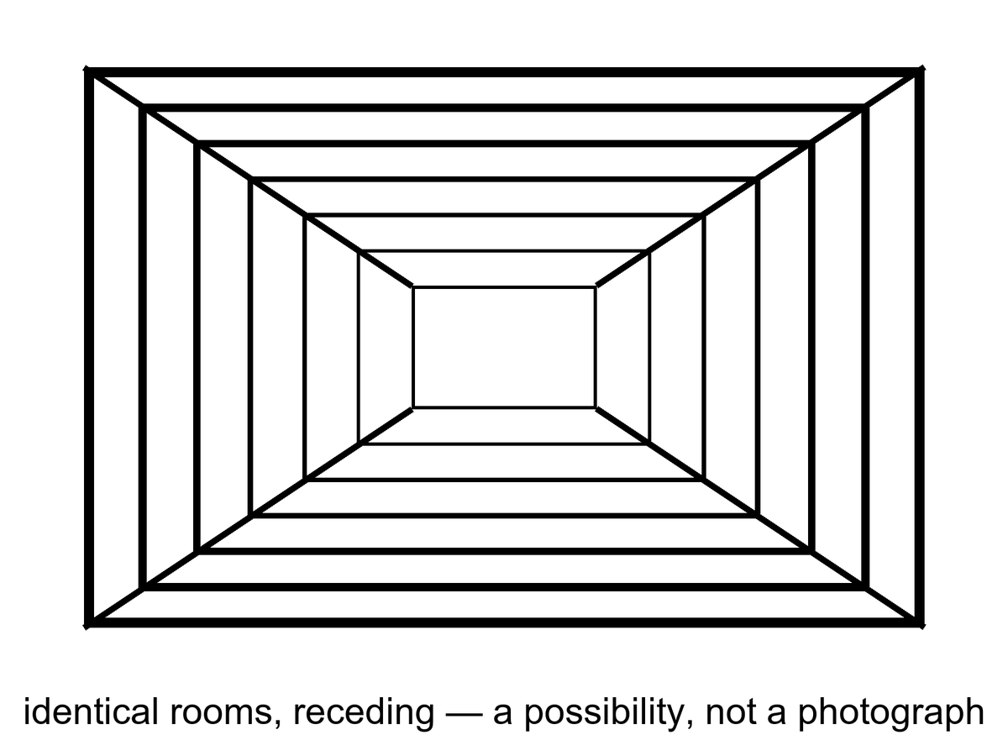
Figure 39. Identical rooms receding. A picture of a possibility, not a photograph of copies.
How finite is a tile’s menu?
If you treat a Hubble volume as an ordinary box of particles, the number of arrangements is already a Barrow shock: more than you can say out loud, less than infinity. Count the ways to place a roomful of atoms and you get a number that looks like a lie. Count the quantum states more carefully and the lie gets worse. If you take holography seriously — Chapter 23’s stubborn skin, the inventory of a region written on its boundary — the menu becomes finite in a cleaner way. A region’s distinguishable states cannot exceed what the area of its bounding surface can hold, at about one bit per few square Planck lengths. A de Sitter-like tile, bounded in practice by an event horizon, has a finite area of order 10¹²² Planck patches, and therefore a finite library. The number of possible books in that library is two to that power: a stack of exponents you cannot write as an ordinary integer. Enormous. Finite. Infinity is not hiding in the closet of one tile. It would have to hide in the number of tiles.
That finiteness is doing the cheap copy’s real work. Infinite space plus an infinite menu need not repeat; you could have a new snowflake forever. Infinite space plus a finite menu must, if the draws are independent enough, reuse the books. The holographic bound is the cleanest reason the menu is finite. It is warm-to-cold as a statement about the whole sky — our space is not the negatively curved special case where holography is a theorem — and it is stubborn as a hint. Even without holography, a finite energy in a finite box, with a quantum grain, is a finite list. The cheap copy is, at bottom, that list plus a warehouse that never stops.
Ergodic is the other extra. It means the sprinkle does not, at some scale, freeze into a crystal of unique rooms, or stop being defined, or start repeating for a boring geometric reason that is not “infinity plus a finite menu.” Inflation, if you buy it, helps: it stretches a small, mixed patch into a large, mixed patch, and the twitches are statistically ordinary. Help is not a proof that the whole spatial slice is an ergodic infinite plane. Help is a reason the cheap-copy argument is not crazy. Crazy would be assuming a unique snowflake at every distance for no reason. The cheap copy assumes the opposite, which is also an assumption.
Is space infinite? We do not know. We know it is larger than the tile, and flat to a boredom that inflation explains as a feature. Infinite is a cold extra. “Much larger than we see” is warm. The cheap copies require the stronger extra, plus a faith that the statistical sprinkle does not, at some scale, start repeating for a boring reason or stop being defined.
Flatness is the measurement people try to promote.
Planck’s leftover-glow maps find a curvature parameter, Ω_{k}, consistent with zero. Parallel lines, on the largest scales we photograph, stay parallel to a boredom. Inflation predicted that boredom: stretch a curved surface enough and the ant sees a plane. Ω_{k} ≈ 0 does not prove the slice is infinite. A 3-sphere with a radius far larger than the Hubble length looks flat in the patch. A 3-torus, finite and edgeless, looks like infinite FLRW until you have gone all the way around, and “all the way around” may be farther than light has traveled since the glow. Topology is sneaky. The data say: not a small, curvy room. They do not say: warehouse without end. Treating “flat enough” as “infinite” is a kitchen leap. The leap is popular. It is still a leap.
There is a search that tried to catch the sneak. If the last-scattering surface wrapped around a small enough 3-torus, the leftover glow would show matching circles: the same pattern, twice, on the microwave sky, because you would be seeing the same patch of fog in two directions. People looked. They have not found the circles.⁶² That is a warm push: whatever the global shape is, it is not a snug little room we have already walked around by looking. It is not a proof of infinity. It is a proof that “finite but huge” still has a lot of room to hide. Appendix A39 writes the curvature and the repeat. Here: flat is not infinite. Flat is a local manners.
So the temperatures, named:
Hot: the universe is larger than the part we have seen; it is close to flat on that part; galaxies recede; the glow is a baby picture of a mixed fog. Warm: inflation made the flatness a feature, and the region beyond the tile is more of the same dough, same laws, for a long way. Cold: the dough is actually infinite, the sprinkle is actually ergodic, the holographic menu is actually the right count, and therefore a copy of this kitchen sits in some far tile, then sits again. The cheap copies are a fact only if those cold extras are facts. They are a picture of a possibility. Figure 39 is honest about that. It is not a photograph of copies.
One popular inventory of this room, Max Tegmark’s, calls it Level I:⁶³ more of the same FLRW volume, repeats by distance. The name is a filing label, not a detection. The label is useful if it keeps this drawer from fusing with bubbles, branches, and theorems. It is harmful if it puts a grid of rooms on a poster and lets a reader think the grid has been counted in the microwave sky. It has not.
The distances, if you grant the extras, are a Barrow shock of a different kind. A repeat of a planet-sized pattern is already unspeakably far. A repeat of a whole Hubble volume is farther in a way that does not fit in a throat. These are not destinations. Chapter 26 already spent the event horizon: most of the sky has left. The cheap copies, if they exist, live in a region that will not take a letter, let alone a ship. Light will not finish the trip. The particle horizon is the past’s rudeness. The event horizon is the future’s. Together they make “elsewhere in this universe” into a museum, not a road.
A project is the same refusal with a better mood. Even if the copies exist, they do no work here: a far tile where the crop lived does not feed anyone on this one. The cheap copies, even at their most generous, are not colleagues. They are recurrences. Recurrence is not company. It is a statement that a finite story, told often enough, is told again.
Keep the drawer shut against hops. Same laws, more space, maybe repeats: that is all this chapter owns. The next chapter will try to change the laws. That is a different coat, and it is more expensive.

40. Other Rooms, Other Rules
The expensive copies need a burst that does not know how to retire, and a menu of retirements.
Eternal inflation, Chapter 15, is the burst that may not retire. The menu is the maybe: different valleys, different leftover constants, different low-energy laws. In one valley the cosmological constant is a monster and galaxies never form. In one it is a little shove, and someone hits an airlock. In one there are two large dimensions and no kitchens. Weinberg’s filter needs this menu, or something like it, to turn “Λ is small” from a miracle into a selection.
In many slow-roll stories, the field that stretched the patch reaches the bottom of its hill in some places and keeps rolling, or keeps jittering, in others. The places that stop become hot bangs — pocket universes, bubbles, a noun you can hate and still need. The places that keep going keep stretching. Our leftover glow would be the inside of one stopped place. Outside, if the rumor is right, the bursting is still hiring. Different stops can freeze different effective physics if the underlying theory has more than one valley to fall into. That is the expensive machine: not more of the same tile, but other tiles whose constants were never ours.
From inside a stopped place the sky looks ordinary. A leftover glow. A stretch. Helium. Galaxies. You do not see the bursting next door. You see a patch that reheated, mixed, and froze into the kitchen you have. That is why eternal inflation is easy to oversell and hard to kill. It does not predict a new smudge in tonight’s field. It predicts that our smudge is one of many, and that the many may not share our leftover constants. The local burst of Chapter 13 can be right while the froth is a rumor. Keep the temperatures. Local inflation is warm. Eternal hiring is a live maybe. Other laws in other pockets are the maybe stacked on the maybe.
Where does the menu come from? Often, from string theory’s landscape: a reported 10⁵⁰⁰ ways to compactify extra directions and freeze a vacuum. String theory cannot currently be tested. A number like 10⁵⁰⁰, offered without a risky prediction that would kill the framework, is a catalog, not a census. Other frameworks offer other menus. Some offer one valley. The sky we have does not yet choose.⁶⁴

Status as of October 2026: string theory
Established. String theory is a mathematically rich framework that contains gravity and has produced real tools, including a precise link between certain gravity theories and certain quantum theories without gravity, and a count of black-hole microstates in special cases.
Not established. No prediction unique to string theory has been confirmed by experiment. The landscape of possible vacua has not been counted reliably, and no agreed way exists to derive our constants from it.
The live debate. Some physicists argue that theories this hard to test can still be judged by internal consistency and explanatory power; others reply that this weakens what science means by a test.⁶⁵ This book keeps its standing rule: string theory cannot currently be tested. That is a statement about evidence, not a verdict on the mathematics.

The number is a celebrity, so treat it like one. Extra directions, curled small. Fluxes, wrapping those directions, choosing a vacuum energy and a set of leftover constants the way a combination lock chooses a number. Count the combinations people know how to write and you get a shock with a lot of zeros. Ten to the five hundred is not a census of kitchens. It is a count of locks. Some locks may not open onto a cosmos that lasts. Some may be the same kitchen counted twice. Some may be artifacts of an approximation. The advertised number moves when the approximations move. That is allowed in a research program. It is not allowed in a result.
The shock is not a measurement. It is a count of sentences in a framework that has not yet named a signature we could miss. Compactify differently, freeze differently, and you can accommodate, after the fact, almost any low-energy kitchen. A framework that can accommodate almost any kitchen is not, so far, a theory of this kitchen. Row (18) in the appendix is a reminder, not a formula, of what a test would have to do: a risky number, a signature, a way for the whole idea to die. It has not been done.
Other menus exist on paper. Loop-ish gravities, extra-field cosmologies, a single vacuum that just happens to be ours. Some of those are also untested. Some are more modest. Modesty is not a proof. The leftover glow, the helium, the shove’s size: those are the court. The catalog is a witness who has not agreed to be cross-examined.
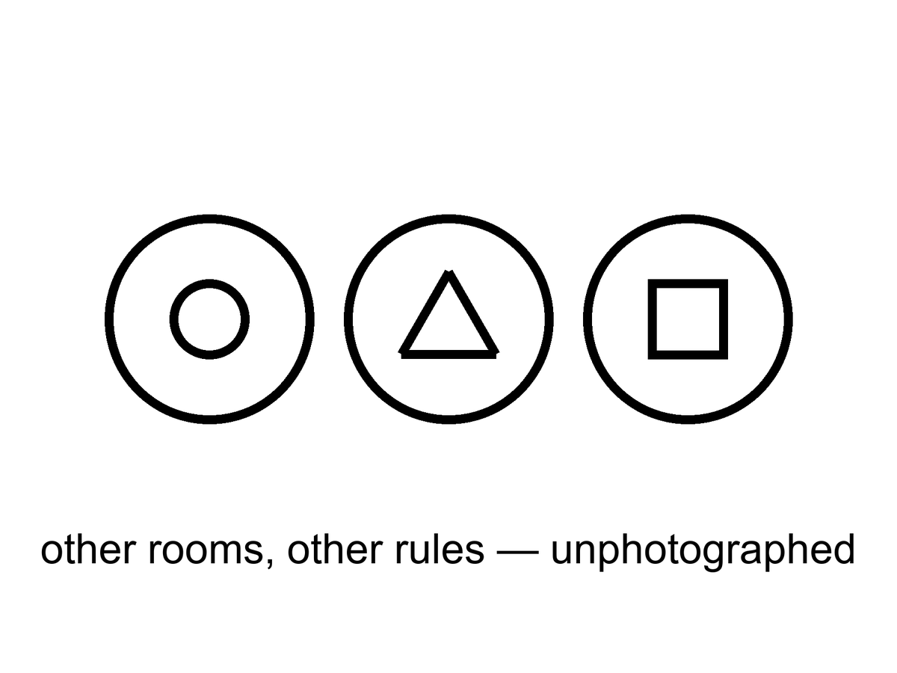
Figure 40. Three bubbles, three different icons. Other rooms, other rules, unphotographed.
The measure problem sits on the catalog like a cat. Infinite bubbles, infinite observers, no agreed count: “typical” becomes a fight. Until the fight ends, “the landscape predicts observers like us” is a hope. It is a better hope than a required Omega Point, because it does not contradict the shove. It is still a hope.
If bubble begets bubble without end, the word most breaks. Most by what? Volume? Then the still-inflating regions, which stretch without limit, drown the stopped ones, or the stopped ones that stopped later drown the ones that stopped earlier, depending on how you cut. Count by bubbles? Then you need a cutoff, a regulation, a rule that says when two infinities have been made finite enough to compare. Count by observers? Then you need to know what an observer is, and whether a bubble that makes a brief, dense flash of many brains outranks a bubble that makes a few, slowly, in galaxies. The youngness paradox is one of the rude children of a bad measure: some cuttings predict that typical observers live almost at the beginning of their bubble, which we do not. Other cuttings predict other rudenesses. No cutting is the one everyone else has to accept. Until one is, a sentence that begins “the landscape predicts” is a sentence that has not finished its homework.
Weinberg’s filter is why anyone bothers.
In 1987 he asked what value of the cosmological constant observers should expect if the constant is drawn from a wide range. Too large a shove and galaxies never form; too small, and you would need a reason the draw sat far below the galaxy-formation edge. The measured value sits near that edge, give or take the arguments about how to draw the edge. That is interesting. It is the rare case where “looking arranged” was turned into a number. Chapter 42 will sit with the number and with the sermons people attach to it. Here, the one sentence that matters is: the filter needs an ensemble. Without a menu of valleys, or of tiles, or of something that plays the same role, the weak anthropic cut is a reminder that we are not on Venus. It is not an explanation of why Λ is small. With an ensemble, it becomes a mesh. You throw away the monster shoves, look at what is left, and ask whether we are a typical survivor. You still need a measure. You still need the ensemble to be more than a catalog. You do not get to say the universe wanted a greenhouse. You get to say we could not have found ourselves in the valleys that did not want anyone.
The multiverse argument deserves its best form before it is declined.
Its strongest case. We already accept unobservable things when a theory we trust predicts them: the interior of a black hole, galaxies beyond our horizon. If eternal inflation is the right theory of the burst, other bubbles follow the same way, and Weinberg’s 1987 estimate shows the idea can earn a number: it anticipated a small, nonzero shove before the 1998 supernovae found one.³¹⁶³
What it gets right. A multiverse is not a mystical claim. If our constants were drawn from a wide range, selection really would explain why we see values that permit observers, and refusing to consider it could hide a true explanation behind a taste for neatness.
Why this book still declines it. The black-hole interior is predicted by a theory tested outside it; eternal inflation and the landscape are not yet tested anywhere. Without a measure, “typical” has no meaning, so the ensemble cannot yet make a prediction we could miss.⁶⁶ The verdict is “unproven,” not “impossible.”
Pointer, then, not a theft of Chapter 42: expensive copies are one of the ensembles people reach for. Cheap copies are another, weaker for Λ, because cheap copies share our laws and our leftover shove — a far tile with the same potatoes blighted or saved still has the same small cosmological constant. Branches are a third, and they do not help Λ at all unless the shove itself is a quantum leftover that forks, which is a different, colder story. Other mathematics will explain anything and therefore nothing. If you want a filter rather than a purpose, you need a drawer that actually contains variation. Drawer two is the expensive candidate. It has not passed a test. It is allowed to sit on the table. It is not dinner.
If you live in a bubble, the neighboring bubbles are not destinations. The walls, in the usual pictures, are empty and expanding. You cannot book a crew that does not sleep and arrive at a different fine-structure constant. You can, at best, infer that you are in a valley that permits you. That inference is the weak filter. It is not a tour.
The wall sentence is practical, so keep it practical. Between bubbles, in the usual eternal-inflation cartoons, inflation is still going. The domain wall — the boundary between a stopped kitchen and a still-bursting dough — expands. The space you would have to cross is not a hallway with a different weather on the far side. It is a region that stretches too well to finish. Different constants are not a climate you could pack for. They are a different low-energy physics, a different chemistry, a different number of large directions. A crew that arrived, if arrival were a word, would not be a crew. Chemistry would not be chemistry. Neighbor bubbles are, at best, an inference from the fact that our valley is livable. They are not a pin on a map.
A vacuum that decays is not a door either. People hear “tunnel to another vacuum” and picture a station. A true-vacuum bubble nucleating in a false vacuum is, in the usual pictures, a disaster or a rewrite of local law, not a ticket booth. You do not book it. You do not steer it. If our vacuum is metastable, the news is a lifetime, not a destination. Chapter 44 will sit with endings. Here: neighboring rooms with other rules are not ports. They are, if they are anything, an ensemble for a filter. Chapter 42 is where the filter is allowed to work. This chapter’s job is to refuse the tour.
Hot: we live in one expanding region with one leftover glow and one small shove. Warm: inflation can be eternal in many models, and a small Λ wants an explanation that might be a selection. Cold: the bursting never stops, the valleys number 10⁵⁰⁰, the measure will someday settle, and a bubble with two large dimensions is as real as this kitchen. Until a risky signature exists, 10⁵⁰⁰ is a celebrity, not a count of neighbors.

41. Every Allowed Outcome
Hugh Everett, in the 1950s, took the electron’s equation at its word. The equation offers a sum of ways. The usual habit is to throw away the ways that did not “happen” at a measurement. Everett’s habit is to keep them. The sum is the inventory. A measurement is a fork. After the fork, the branches do not talk; decoherence makes the interference go away. You are the branch that includes this sentence.⁶⁷
The year, if you want the stamp, is 1957. The dissertation is a relative-state reading: the global wavefunction does not collapse. A measurement correlates an apparatus with a system. Each term of the correlation is a consistent story for the observers inside it. There is no extra postulate that picks one story and burns the rest. The rest stay, decohered, as unavailable to you as a spacelike navy.
This is not extra cosmology. It is a reading of the same rule that builds chemistry. It is warm. It is not a photograph of other lives. It does not give you a hop. The carnival version — jump to the branch where the basil lived, where the sea is empty, where you did not lose who you lost — is a story. The physics, if Everett is right, says those branches are on the inventory and unavailable. They are as unavailable as Andromeda’s navy and ruder, because they are not even elsewhere. They are elsehow.
The new kitchen is a coin.
You flip it by the sink. In the equation, both faces persist. Decoherence — entanglement with air, with photons, with the grain of the table — makes the interference go away on a timescale you could, in a careful lab, assign a number to. No soul is required for the going-away. Afterward there is a heads term and a tails term. You are, in this term, the person who sees heads. There is an elsehow in which you see tails. You wash one dish. The dish you dirtied while the coin was in the air, waiting, talking, not talking. You do not wash both. The sink in this term has one plate. The coin in this term has one face showing. The other face is not under the table. It is not in a far Hubble volume. It is a term you do not occupy. You cannot lean sideways and dry the other plate. The no-signaling theorem is the grown-up name for that refusal: local operations do not send notes between terms.
You saw heads. You put the plate in the rack. Somewhere in the sum, a you who saw tails is putting a plate in a rack. If the I is a tangle, both of those stretches have an equal right to the pronoun. That equality is not a ticket. It is the ruder moral: a perfect copy of a loop is a second loop. You do not get to be both dishwashers. You get this sink, this face of the coin, this one plate. The carnival wants you to treat the other term as a spare afternoon you could still choose. Everett, if you buy him, says the choosing was the fork. After the fork there is no remaining chooser who stands above both terms and picks. There are two choosers, decohered, silent. You are one of them. Wash the plate you have.
Decoherence, in this sink, is not a philosophy. It is a rate. Air molecules, photons, the roughness of the table, each take a little record of which face is up. After enough records, putting the two faces back into interference would require conspiring with every record that left. The conspiracy does not happen in a kitchen. It barely happens in a lab, and only when the lab is built to prevent records. A hop would require the conspiracy, or a door the equation does not draw. Neither is on offer beside the sink.

Physics vs philosophy: from decoherence to Everett
What the evidence establishes. Interference is real, decoherence happens at calculable rates when a system leaks information into its environment, and entangled pairs violate Bell’s inequality, so no local recipe of hidden instructions explains them.⁶⁸¹⁸²⁰
What remains interpretation. Whether the unobserved outcomes still exist (Everett), never existed (collapse models), were never more than an agent’s expectations (QBism), or were always accompanied by definite particle positions (Bohm). Every one of these readings reproduces the same laboratory statistics, except the collapse models, which make small extra predictions that are being tested.
What this book infers. That Everett’s reading is the most economical fit with a block that already refused a single now. That is a preference with reasons, not a measurement, and it carries a real cost, discussed below.

Everett is not the only serious reading, and a book that leans on him owes the rivals their strongest form.⁶⁹⁷⁰
Copenhagen. Strongest case: physics is about what we can say about experiments, and asking what the wavefunction “really is” between measurements is asking for something no experiment can deliver; Bohr’s reply to Einstein in 1935 was that the experimental arrangement is part of the phenomenon.⁷¹ What it gets right: the lab never shows us a superposition of pointer readings, and the theory’s success never depended on settling the question. Why this book declines it: it draws a line between quantum system and classical apparatus without saying where, and a book about the whole universe has no outside apparatus to stand on.
QBism. Strongest case: the wavefunction is an agent’s degrees of belief, updated by experience, so “collapse” is just learning and nothing travels faster than light.⁷² What it gets right: it removes the paradoxes cleanly and takes the first-person view of measurement seriously. Why this book declines it: it says little about what the world is like when no agent is updating, and the leftover glow and the helium were records written before any agent existed.
Bohm. Strongest case: particles always have positions, guided by the wavefunction, so measurements have definite outcomes with no collapse and no branching; the theory reproduces every standard prediction.⁷³⁷⁴ What it gets right: it proves that a definite, realist quantum theory is possible, and Bell himself admired it for that. Why this book declines it: it needs a preferred slice of simultaneity to coordinate distant particles, the very structure relativity does not supply, and its unchosen branches of the wavefunction remain in the equations, doing no work.
Collapse models. Strongest case: the wavefunction really does collapse, spontaneously and rarely for single particles but almost instantly for large objects (GRW), perhaps triggered by gravity (Diósi and Penrose); unlike the other readings, these are testable physics.⁷⁵⁷⁶⁷⁷ What it gets right: it turns an argument about words into an experiment. An underground test in 2020 already ruled out the simplest version of the gravity-triggered model.⁷⁸ Why this book does not adopt it: no collapse has yet been seen, and the models need parameters chosen to hide just below current limits. If an experiment finds one, this chapter changes.
Consciousness-based collapse. Strongest case: the measurement problem and the problem of consciousness are both about where definite experience comes from, so perhaps they share a solution; David Chalmers and Kelvin McQueen have proposed a precise, in-principle testable version.⁷⁹ What it gets right: it treats observers as physical systems that must be accounted for, not as an afterthought. Why this book declines it: the leftover glow and the helium are records that formed with no minds around, and no experiment so far has needed a mind to explain an outcome.
The honest cost of Everett. If every outcome happens, what does it mean that one outcome is more probable than another? Everettians derive the standard probability rule from decision theory and symmetry; critics say the derivations assume what they need. This is the strongest objection to the reading this book prefers, and it is not settled.
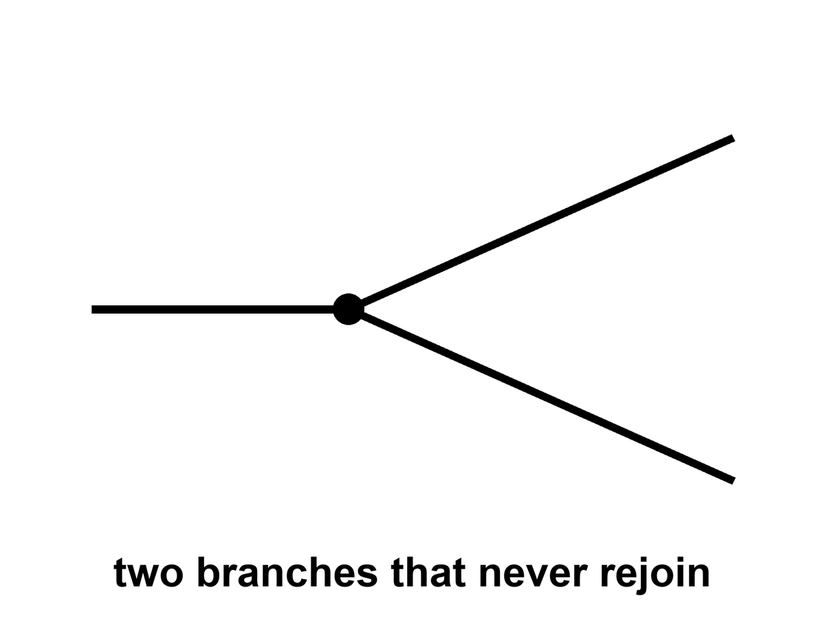
Figure 41. One line splits into two that never rejoin. Every allowed outcome, one worldline each.
Why put this at the core of a book about the universe? Because the block, without it, is only all the times. With it, if you buy the reading, the block is all the times and all the allowed versions. “Everything, everywhere, all at once” is a phrase this book will not treat as a title. It will treat it as a temptation to be made precise. All the times: the block. All the versions: the forks. All at once: a bad kitchen phrase for “equally in the inventory.” Not a permission to walk sideways. Not a permission to hop.
Elsehow is the word to keep when elsewhere tries to steal the scene. A far Hubble volume, if Chapter 39’s extras are granted, is elsewhere: a spacelike other, a tile, a distance. A neighboring bubble, if Chapter 40’s extras are granted, is a ruder elsewhere: other rules, not a destination. A branch is not a place. After decoherence you cannot point at the sky and say “the tails are that way.” There is no that way. There is another term in a sum. The split in Figure 41 never rejoins. Rejoining would be interference, and interference is what the environment spent. The carnival hop would require a door between terms. The equation, taken at Everett’s word, does not build that door. It builds a fork and then a silence.
The practical fact does not budge. The worldline you occupy is the one you can work along. A melt-probe either tastes life or it does not. A library either arrives or it does not. The other outcomes, if they persist, persist without you. That is either a horror or a relief. It is, in any case, not a ticket counter.

Physics vs philosophy: from copies to identity
What physics establishes. Quantum states cannot be perfectly copied (the no-cloning theorem), but a person is not one quantum state; a body is a pattern that replaces most of its atoms over years.
What this book infers. That a perfect duplicate of a person would be a second person, not a continuation of the first. That is a philosophical position about personal identity, not a result of physics.⁸⁰

A loop that calls itself I wants a ruder answer. If the I is a tangle — a translation that stays closed — then a perfect copy of the tangle is a second I, not a hop of the first. Two nests built from the same plan are two cities. They may share a past up to the fork. After the fork they do not share a now, because there is no now. Mara, duplicated by a printer that worked too well, does not “go” into the duplicate. She acquires a twin who will swear, with equal right, that she is the original. That is not Everett. That is logistics plus a loop. Everett is ruder still: the twin is not even elsewhere. She is elsehow.
Consolation is the hire this whole part has been refusing. A far tile where the potatoes lived. A bubble where Λ was kind. A branch where the coin was tails and the person you lost is still in the kitchen. Each, in its drawer, may be a responsible maybe. None of them is a method. None of them is a spare you. The I that wants a spare is asking for an edit, and Chapter 36 already spent edits. A duplicate is a second I. A branch is an elsehow I. Neither is a continuation of this dishwashing, this blight, this fiber paying out into the dark.
The strongest rival here is the uploading view.
Its strongest case. If your neurons were replaced one at a time by functionally identical chips, there seems to be no moment at which you would stop being you, so a gradual upload preserves the person; and Derek Parfit argued that what matters is psychological continuity, not which matter carries it.⁸¹
What it gets right. Identity is a pattern, not a substance, and this book agrees.
Why this book still declines the hop. gradual replacement keeps one continuous process, while a scan-and-copy makes a second process beside the first. Chalmers himself treats gradual uploading as the safer route for that reason. A copy is a successor with your memories, which may matter a great deal, but it is not you arriving somewhere else.
Appendix A41 writes decoherence, the no-signaling theorem, and the loop. You cannot use a fork to send a note to the branch next door. Pairings can be stronger than any local recipe of hidden instructions; Chapter 6 already sat with Bell and Aspect. Stronger is not a telegram. You cannot choose what to do with the coin in a way that writes a bit on the other face’s afternoon. Relativity already denied a frame-independent “at once” in which the two ends could confer. Everett adds a ruder silence: even the terms that share a past up to the flip do not confer after the environment has spent the interference.
Hot: quantum interference is real; decoherence is a calculation; Bell pairings are real; you still cannot telegraph with them. Warm: Everett’s reading, this book’s preferred interpretation and not a result, keeps the leftovers without a collapse postulate, and it fits a block that already refused a single now. Cold: you have photographed the other term, or hopped into it, or mailed it a dish. You have not. The coin lands both ways. You wash one plate.

PART IX — The Filter

42. A Filter, Not a Purpose
If the strong nuclear force were a few percent different, carbon would be rarer, or stars would be ruder, or the leftover helium would be a different lie. If the cosmological constant were a few dozen times larger, the shove would have won before the twitches grew up, and there would be no spirals, no kitchens, no one to notice the shove. If electromagnetism were a little stronger, chemistry would be a smaller menu. These are the dimensionless coincidences, and they have been used to sell both wonder and sermons.
The wonder is allowed. The sermons are a leap.
A dimensionless number is a number with no units left on it, so you can ask, without cheating, why this and not 17. The fine-structure constant α is one: about 1/137, the strength of electromagnetism in the units nature actually uses. Make it a few percent ruder and atoms change size, chemistry loses dishes, stars burn on a different clock. The nuclear coincidences are ruder still. The leftover helium of Chapter 10 is a fossil of a force that let deuterium hold together long enough to cook, then stopped short of burning the workshop to iron. A few percent the other way and the three minutes would have been a different courtroom. Carbon itself sits on a famous resonance — Hoyle’s, predicted because we are made of the stuff and the triple-alpha dance needed a rung — which is either a miracle or a reminder that chemists find themselves in a chemistry that worked. The cosmological constant is the loudest of the lot. Naive vacuum jitters want a monster. The shove we measure is a whisper, off by a joke of tens of zeros. That gap is a real problem. Treating the gap as a love letter is the sermon.
Hot, as coincidences go: the numbers are the numbers. α is 1/137-ish in every lab. The helium fraction is a quarter. The shove is tiny compared with the Planck density. Warm: some of those numbers are fixed by a deeper rule we have not got yet, the way chemistry stopped being a list of miracles once electrons were a wave. Cold: they were dialed for us. The cold claim does not get to wear a lab coat just because the feeling is strong.
We do not have a second universe on the bench to compare. We have one leftover glow, one set of constants, one table of nuclei. In that one, water bends, carbon chains, stars last. The look of arrangement is real as a feeling. As an argument it has a hole: we are the sample. Samples taken from the places that permit samples are biased. That is not cynicism. It is how you do not get fooled by your own lungs.
Dicke said a version of this in 1961,⁸² before the leftover glow had even been named in a journal. Dirac had noticed large coincidences between cosmic numbers and atomic ones and wanted a law that made them change with time. Dicke’s reply was ruder and better: observers made of carbon need a universe old enough for stars to have cooked carbon. They will find themselves in a cosmos whose age is a stellar lifetime, give or take. That is not a prediction of a changing gravity. It is a prediction of a sampling rule. Brandon Carter, a dozen years later, gave the sampling rule a name⁸³ that has been causing trouble ever since: anthropic. The trouble is the noun. Anthropos sounds like a crown. The move is a mesh.
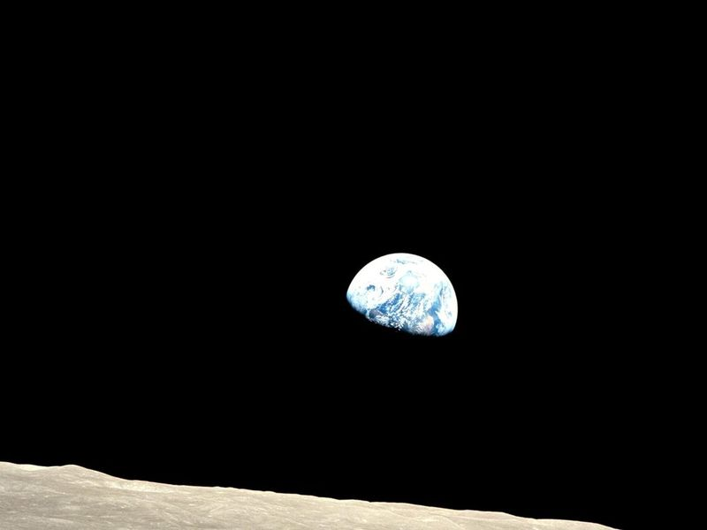
Figure 42. Earth, bright against a dead horizon. A temperate world is where observers find themselves.
Weinberg’s move on the cosmological constant is the rare case where the feeling was turned into a number. If Λ is drawn from a wide range, the observers who measure it should find it small enough for galaxies, and not much smaller than that unless something else is at work. The measured value is near that edge. That is interesting. It is not a proof of a menu. It is what a filter looks like when you bother to write it down.
The year was 1987. Galaxies, in the working picture, grow from the twitches of Chapter 14 only if the shove does not win too early. If vacuum energy is large, the stretch accelerates before the overdensities can collapse, and you get a thin fog with no spirals and no kitchens. Weinberg asked what values of Λ a later observer could possibly report.³¹ The answer was an upper bound: not much larger than the matter density at the epoch when galaxies form. If the prior is wide — if many values are on offer, and nothing else picks — then typical observers should find themselves near that edge, not deep in a valley of needless smallness. Eleven years later the bombs of Chapter 18 found a shove of that order. That is the interesting part. It is not a photograph of other valleys. It is a number that looks like a cut. Hot as a calculation: if you grant the ensemble, the bound is a bound. Warm as a hint: the measured Λ sits where a filter would put it. Cold as a proof that the ensemble exists.
The tidal seas belong here as a humility. We thought “arranged for life” meant a Goldilocks band and a blue marble. Then we found that most of the wet real estate in the solar system might be dark, under ice, squeezed by a giant, uninterested in sunsets. If there is life there, it did not need our sermon. If there is not, the permit was still wider than the sermon. Arrangement, if you must use the word, is sloppy and local, not a tailored suit.
The Weak Anthropic Principle, in a careful wording, is a selection effect: the constants we measure are drawn from the values that permit us to measure them. Carbon chemists need carbon chemistry. They need a universe old enough to have cooked carbon in stars. They need a shove that did not win too early. Saying so is as taut as saying that fish find themselves in water. It is also as useful as that, once you have an ensemble to select from.
Barrow and Tipler, who wrote the big book that put the names in order, said the weak principle this way: the observed values of the constants are not equally probable. They are restricted by the requirement that there be sites where carbon-based life can evolve, and by the requirement that the universe be old enough that it already has. That is a likelihood cut. It is not a cause. It does not cook the carbon. It does not aim the shove. It tells you which draws from a menu you are allowed to be surprised by. Carter’s original wording was in that neighborhood. The later sermons wandered off.
Without an ensemble, the weak principle is a reminder, not an explanation. It stops you from being surprised that the kitchen is not on Venus. It does not tell you why there is a kitchen.
With an ensemble — cheap copies, expensive bubbles, a menu of Λ — the weak principle becomes a cut. You throw away the valleys that have no observers, and you look at what is left. You still need a measure. You still need the ensemble to be more than a catalog from an untestable framework. You do not get to say “the universe wanted us.” You get to say “we could not have found ourselves in the valleys that did not want anyone.”
The Strong Anthropic Principle says the universe must permit life. “Must” is a smuggler. It can mean the tautology, the ensemble, or a purpose. Only the first is safe. The Final Anthropic Principle says intelligent processing must arise and must never die out. That is the Omega Point’s moral clause. Chapter 19 already broke its physics. Its morals were never physics.
Unpack the smuggler. “Must,” in the tautology, means: a universe we are looking at, from inside, is one that permitted looking. Allowed. Empty of news. “Must,” in the ensemble, means: among the valleys, the occupied ones are the ones that permit occupation. That is the weak principle again, wearing a louder coat. “Must,” as purpose, means: the universe was aimed. Aimed by whom, through which channel nature uses, with which leftover in the glow as a serial number? Chapter 35 already asked the watchmaker to clock in. The channel has not spoken. The Final principle is louder still. It does not only want a permit. It wants a forever-mind as a law. The bombs, the leftover glow, and the mixmaster of Chapter 16 declined.
The strong principle, in its purpose reading, still deserves its best case.⁸⁴
Its strongest case. The coincidences are many, independent, and narrow. If one universe is all there is, “we could not have seen otherwise” does not explain why a universe permitting observers exists at all; a firing-squad survivor is right to ask why every shot missed. A purpose, or a law that favors life, would make the coincidences expected rather than lucky.
What it gets right. In a single universe, selection alone is not an explanation; this chapter agrees that the weak principle only explains once an ensemble exists. And the fine-tuning of the cosmological constant is a real problem that physics has not solved.
Why this book still declines it. A purpose that predicts nothing about the helium fraction, the shove, or the next measurement cannot be checked, and the coincidences may yet be fixed by a deeper law, as chemistry’s were by quantum mechanics. Between a deeper law, a selection from an ensemble, and an aim, only the first two can ever lose to data.

Physics vs philosophy: from fine-tuning to anthropic reasoning
What the evidence establishes. The measured constants permit long-lived stars, carbon chemistry, and galaxies, and some of them (notably the cosmological constant) sit in narrow ranges compared with naive expectations.
What is inference. That the narrowness needs explaining at all, and whether the right explanation is a deeper law, a selection from many universes, or a purpose. None of these has been confirmed.
What this book infers. The weak, selection-effect reading is sound reasoning; it becomes an explanation only if an ensemble exists. The strong and final readings go beyond any evidence we have.

A filter is not a purpose. A purpose has an aim. A filter has a mesh. We are what got through, in this valley, on this worldline, with this leftover helium. That is enough to be getting on with. It is not enough to crown us.
Do not crown this species for occupying a temperate crust while dark seas, if they are empty, were always empty without our permission, and if they are not, were never waiting for a sermon. The leftover glow does not have a favorite. The shove does not have a favorite. The mesh does not owe the things that pass through it a parade. You may still be glad the nuclear force was not a few percent ruder. Glad is a local weather. It is not a cosmology.

43. No Cosmic Craftsman
Darwin’s trick, which this book has been circling since the prologue, is that a filter can look like a craftsman if you only see the survivors. The beaks fit the seeds. The fit looks like intent. The intent was death, repeated, in a lot of directions.
The look is not a small look. A living thing is an invoice so long, and so locally paid, that a reasonable person staring at one bird will reach for a someone. Paley’s watch on the heath was that reach, and it was not stupid as a first move. A watch has parts that mesh. A finch has parts that mesh. The difference, which is the whole of the trick, is that watches do not leave a trail of almost-watches that died, and finches do. The trail is the notebook. Skip the notebook and you will hire a craftsman every time. Keep the notebook and the craftsman becomes a mesh you can miss: a pile of deaths that would have looked, from inside any one of them, like a plan that failed.
He did not start with the trick. He started with a notebook. Islands. Barnacles. Pigeons in a shed. A clergyman’s son who could sit still and then refuse the cheap sentence. The beaks were not a revelation in a dream. They were a pile of measurements that would not sit still under “each kind was issued.” Malthus gave him a rate. Breeders gave him a proof that selection can be hurried by a hand. The conclusion — descent with a mesh — was keen because the observations were allowed to kill the other story. A man on the other side of the world, looking at beetles and islands of his own, reached the same mesh without asking permission. That is what this book means by a path: a record you could have missed, then a sentence that can die. The leftover glow is that habit aimed at a fog. The dark sea is that habit aimed at a lid of ice. A craftsman is what you hire when you skip the notebook.
The man on the other side was Wallace. Same mesh, different kitchen, a letter from the Malay Archipelago that arrived in time to make the announcement a joint one. That matters for the method, not for a statue. Two notebooks, two worldlines, one sentence that could have been wrong and was not. Malthus had only meant a sermon about the poor. The rate he named — more mouths than food, if nothing checks — is a filter when you let it run on beaks. Breeders had only meant prettier pigeons. The shed is a proof that a mesh, hurried by a hand, can make a pouter from a rock dove in a career. Nature’s hand is slower and has no taste. The taste is what dies.

Figure 43. One Galápagos finch on a light ground, beak readable. A filter can look like a craftsman.
The cosmic version is ruder because we cannot see the deaths. If there are dead valleys, they do not send baby pictures. If there are dead tiles, they are out of reach. If there are dead branches, they do not radio. We see a leftover glow that permits spirals, a shove that waited, a nuclear force that permits carbon, a Jupiter that squeezes a moon until a sea stays wet. The craftsman story is the cheap story. The filter story is the one that does not invent a someone.
Hot: this universe permits chemists. Warm: some of the coincidences of Chapter 42 are what a cut looks like, if the draws exist. Cold: a someone numbered the leftover glow. The cold claim has had centuries of poetry and no channel. Beauty is not a serial number. A blue marble is not a signature. A dark sea is a humility, not a second signature. You may still find the glow beautiful. Finding it beautiful is a fact about a worldline. It is not a telegram.
Anthroposophy — a spiritual cosmos arranged around human becoming — is a craftsman story with incense. It does not survive the leftover glow, the three minutes, or the shove. It is not a warm claim that failed. It is a different game. This book does not play it.
Where, then, is God?
If the word means a person who numbered the leftover glow, aimed a river kingdom’s stones, and poured a library into the first ocean — a colleague, larger — then the word is the watchmaker again. The channel nature does not use has not spoken. Beauty is not a serial number. This book will not pretend a gap in the first chemical hour is a detection.
If the word means the reason there is a universe rather than not, the question is honorable and unanswered. Naming the question is not a theory. It does not predict the helium fraction. It does not fix Λ. It does not open a handle. You may keep the name in a kitchen, the way you keep “now.” Do not promote it to a cosmology. Einstein’s habit, when he said God, was often the order itself — Deus sive Natura, a dignity for the metric, not a will. That habit is poetry with a good ear. It still does not give you a prayer that changes a worldline from outside spacetime.
If the word means the laws, you have renamed the equations. Allowed. Empty.
Calling the Friedmann equation God does not make the stretch kinder. Calling the leftover glow a hymn does not change its temperature. Rename if the rename keeps you from treating the mesh as a someone. Do not imagine the rename added a will.
The devil is the same furniture with the sign flipped. A cosmic adversary who wants the host to lose is a craftsman of evil, and Chapter 31 already fired that hire: survival at all cost is a fitness peak, not a personality. Death keeps the score. Entropy is the arrow we borrowed from a smooth beginning, not a being who likes ashes. Suffering is real. It happens on threads. It does not become a second deity because we need someone to blame who is not the filter. You may use the old words for the old dread. The field equation will not countersign them.
What we can be is a local craftsman. The greenhouse is a beak we built for a seed we brought. The melt-probe is a beak for a dark sea. The library is a beak for a future dirt. That is not the universe arranging itself. That is a worldline arranging a room. The difference is the whole moral, if a cosmology book is allowed one: do not wait for the loaf to love you. Do not require the ending to compute you back. Grow the basil. Taste the plume. Send the machine. Admit that it may fail. Call that, if you need a word, meaning — and keep it off the gravitational field equation. Meaning, on this reading, is not scheduled at a crunch and not denied by heat death. It is a project on a thread. Projects can fail. That is what keeps them off the list of destinies.

PART X — What the Future Is Allowed to Be

44. Five Ways It Can End
The leftover glow does not say how the story closes. The shove does most of the talking, and it talks in a low, accelerating voice. Here are five closings, with their temperatures.
Only one of these five is favored by the evidence we have: the supernovae, the leftover glow, and a shove that is winning say the universe fades. The other four are allowed as other valleys or as other readings of w. Katie Mack wrote the tour; Barrow would have walked you to the door of each and then asked which one had a measurement. This chapter does that, with a clock.
Heat death. The working default.⁸⁵ The stretch keeps winning. Bound islands last a long time and then do not: stars burn out, remnants cool, black holes leak (Chapter 23), the islands thin toward a sameness in which no heat can run a trick. Time, as a useful word for change, gets bored. This is Kelvin’s old gloom, updated with dark energy. It is not a crunch. It is a fade. Hot as the track the bombs picked. Warm only in the details no one has photographed.
William Thomson — Kelvin — said it in the nineteenth century, when the leftover glow was not yet a fact and the shove was not yet a bomb. Stars would burn out. The universe would reach a sameness of temperature. No heat engine, no trick, no kitchen. The gloom was thermodynamics applied to a cosmos he could not yet weigh. The update is the shove. Without it, you still had a fight: pull versus stretch, a possible recollapse, a possible tired forever. With it, the fight is over unless the shove is a liar. Isolated lumps stay bound — the Local Group, a while; a galaxy, longer. Between them the dough wins and keeps winning. New stars, after a long career, stop being made. Red dwarfs, the stingy ones, spend on the order of 10¹³ to 10¹⁴ years and then sit as cinders. White dwarfs, neutron stars, brown leftovers: a degenerate era, dimming. Then the holes. A stellar-mass hole leaks on a timescale of order 10⁶⁷ years. A giant, a billion Suns, can last toward 10¹⁰⁰. Chapter 23 already wrote the leak. After the last leak, the islands are a thin of particles and a leftover stretch, too even to run a trick. That is the fade. Hot as a default given the bombs. Warm in the details: we have not photographed year 10¹⁰⁰. We have the equations that got the leftover glow right, pointed forward.
The rip. If the shove is not a constant but a growing rudeness — w less than −1, phantom, a word that should not have survived the committee — then bound things unbind. Galaxies, then stars, then worlds, then you. Finite time. No evidence requires this. The bombs permit a constant. Cold, unless w misbehaves in a future survey.
w is the ratio of pressure to energy density. A cosmological constant sits at w = −1. Acceleration needs w less than −1/3. A rip needs the phantom: w less than −1, and no decay of the field that would let it sit down.⁸⁶ Then the shove grows. Clusters unbind. Galaxies unbind. The Solar System unbinds. Atoms, in the rude versions, unbind. There is a last day, and it is not a metaphor. As of October 2026 the surveys do not require a phantom today. The DESI and Dark Energy Survey results described in Chapter 18 lean, at about three standard deviations, the other way: a shove that is weakening now (w a little above −1), though in their fits it may have sat below −1 in the past.²⁴⁴² A weakening shove makes a rip less likely, not more. None of this has reached discovery strength.
The crunch. Pull wins. The web falls back. The last three minutes are a hot workshop in reverse, then a scramble, then a singularity or a bounce. The bombs and the leftover glow say we are not on this track unless the shove is a liar. Cold as destiny; allowed as a different valley.
Vacuum decay. A jitter somewhere turns the vacuum into a ruder vacuum. A bubble of the new one grows at light, rewriting the laws inside it. No warning: the warning would arrive with the bubble. The leftover glow’s vacuum looks stable enough that we are still here. “Stable enough” is not “stable.” Cold-to-warm; do not lose sleep; do not pretend the risk is zero.
The Higgs vacuum, given the measured masses of the Higgs and the top quark, may be a metastable sit:⁸⁷ not the lowest valley, a ledge. A ledge can tunnel. Coleman and De Luccia wrote the bubbles; the wall, once nucleated, runs at light. You would not see it coming because seeing is a light-speed fact, and the wall is that fact. The estimated lifetime, in the working Standard Model, is vastly longer than the present age — longer, often, than the fade. That is why you should not lose sleep. The estimate depends on numbers we still sharpen and on physics above the energies we have stacked. That is why you should not pretend the risk is zero. If a bubble arrives, there is no project that outruns it.
The bounce. The end is a middle. A crunch becomes a bang, or a dark sea of extra-dimensional branes slaps, or Penrose’s conformal trick glues a thin future to a next beginning. Cyclic, ekpyrotic, conformal: names, papers, no leftover-glow signature that has stuck. Cold.
A bounce needs the pull to win first, or a different high-curvature theory that turns a bang into a rebound, or a pair of branes that collide in a room we have not photographed. Loop-quantum sketches bounce. Ekpyrotic sketches slap. Penrose’s conformal cyclic cosmology glues a thinned, far future to a next fog by a rescaling that makes infinity look like a start. Each of these is an idea for ideas with equations. None of them has a leftover-glow signature that has survived the surveys as a detection.
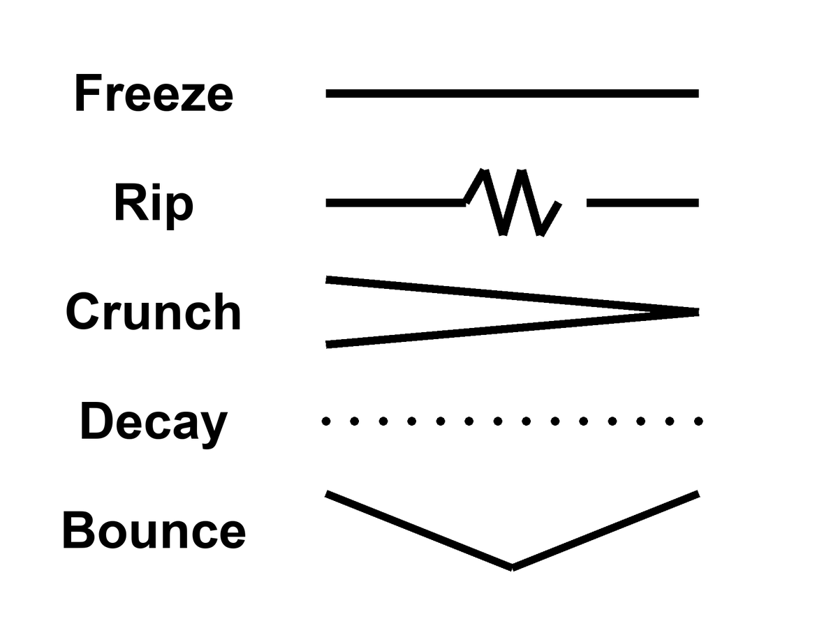
Figure 44. Five rows, one word each: Freeze, Rip, Crunch, Decay, Bounce.
Notice what is not on the list: a required forever-mind. Notice what is on the list, quietly, as a project rather than a fate: a greenhouse, a dark sea, a machine that does not sleep. Those do not close the cosmos. They occupy a few more worldlines before the fade. That is the only closing this book will bless.
Appendix A44 writes w, decay rates, bounce conditions. Here, pick the default without romance: a long accelerating stretch, islands going dark, the leftover glow thinning until even the holes begin to leak. If you want a prettier last page, write it yourself, in a room, while there is still a room.

45. Does Time Exist?
We have used “time” as if we knew.
In the kitchen, time is the clock. In relativity, time is a direction in the loaf, mixed with space, sliced differently by walkers. Proper time is a length of thread. The leftover glow picks out a useful slicing — cosmic time — because the glow is almost the same everywhere and we can watch it cool. That slicing is a convenience the universe approximately offers, not a throne.
The wall clock is still the right tool for a casserole. It is a terrible cosmology. GPS, as Chapter 5 showed, is the grown-up version of the same split: thirty-eight microseconds a day of geometry that a phone must correct to find the street. You do not need a philosophy of time to land a plane. You need the interval. That is the first honest answer, and it is hot.
Does time exist? The honest answers come in flavors.
Yes, as geometry. Spacetime has a metric. Intervals are real. This is the hot answer, and it is enough to run GPS.
Enough, also, to run the twin who comes home younger, the particle that lasts longer in the lab, the radio that answers twenty minutes late. An event is a happening. The interval between happenings is the thing the geometry cares about. Proper time is how much of that interval a particular thread accumulates. “Does time exist?” in this flavor is like asking whether length exists. Length is a relation among events along a ruler. Time is a relation among events along a worldline. The relation is as real as the casserole’s doneness. The throne — a universal now the relations are painted on — is what the kitchen clock invented and relativity retired.
Yes, as an arrow, but the arrow is a boundary. The laws do not prefer a direction. The low-entropy past does. Eggs smash because the beginning was smooth. The Past Hypothesis, David Albert’s name for it, is this sentence in a better suit.⁸⁸ If the past had been a scramble, we would not have a “we.”
The microscopic rules run as well backward as forward. That is not a rumor. It is a feature of the equations that got the three minutes right. The arrow you feel — memory, cause, the way a cup does not unshatter — is not a second law hiding in the metric. It is a fact about the region we call the past: it was special, smooth, low in the kind of mess that would have been a heat death at the start. From a special past, the typical futures are messier. That is the arrow. It is hot as a thermodynamic fact in kitchens and stars. It is warm as a cosmological claim: we do not have a derivation of why the past was special. We have the leftover glow as a photograph of a smoothness, and a name for the postulate that says the smoothness was there. The Past Hypothesis is that name. Without it you do not get observers who remember. With it you do not need a river.
Memory is the arrow made intimate. You remember the special past because the special past left records, and records are a kind of order: a photograph, a scar, a leftover glow, a notebook of beaks. You do not remember the fade because the fade has not left you a fossil of itself in your head. That is not a failure of the brain. It is what a boundary condition looks like from inside a thread. An egg smashes and does not un-smash for the same reason. The laws would allow the un-smash. The past would not. The kitchen already knew this before it had a name. Cosmology’s job was to notice that the leftover glow is the same kind of fact, written on the sky.
Not as a river. There is no glowing NOW moving down the block. Chapters 1 through 6 were that retirement.
Maybe not as a fundamental word. In some attempts to quantize gravity, the wave of the universe does not mention time. The Wheeler–DeWitt equation is a constraint, a “this must add up,” not a “this happens next.” Julian Barbour takes the hint all the way: the inventory is configurations, Nows, a heap. Dynamics is what a heap looks like when it contains records of other heaps. Carlo Rovelli takes a different hint: time is what a system with heat says about itself. Thermal time. A useful word for a useful state.
Wheeler and DeWitt wrote a wavefunction of geometry that sits still:⁸⁹ Ĥ Ψ = 0, no external t on the page. That is the problem of time in quantum gravity, and it is not a slogan. If the whole loaf is the system, there is no clock outside it to say “next.” Time, if it is to be recovered, has to be recovered from inside: a subsystem that can serve as a clock, a semiclassical limit where a geometry becomes classical enough to have a t, a relational fact among degrees of freedom. One family of recoveries, begun by Don Page and William Wootters, says: treat part of the universe as a clock and ask how the rest correlates with it.⁹⁰ Another says: when the geometry is large and gentle, a WKB limit hands you something that looks like the Schrödinger equation in a t that was not fundamental. Warm-to-cold as a research program. No experiment has selected the recovery. The GPS clock does not adjudicate this fight. GPS lives in the limit where the recovery has already succeeded, or was never needed, because the metric is classical enough to land a plane.
Barbour’s heap is the austere version. The world is a pile of Nows — instantaneous configurations — and what we call motion is a correlation: this Now contains records that match that Now, the way a brain contains a memory that matches a room. There is no moving spotlight. There is a heap with internal likenesses. It is a picture that takes “no river” all the way to “no primitive duration.” It is cold. It is the right kind of cold: it does not add a someone, and it does not contradict GPS, which lives in the classical limit where the heap looks like a loaf.
A tempting merger waits here, and Chapter 38 already taught the habit for refusing it. Barbour has a heap of Nows. Everett has a sum of branches. Both say the inventory is bigger than the slice you remember. Put them in one coat and you get a slogan: every possible Now exists, so the multiverse is just the heap. Two drawers, one bench.
Open them one at a time. The heap is configurations: every arrangement the stuff could have, one point per arrangement, whether or not anything in it remembers anything. That is configuration space, a map of the possible. Everett’s branches are not points on that map. A branch is a term in the wave that has decohered from the other terms, a pattern of records that agree with each other about which face the coin shows. Most points in the heap belong to no branch worth the name. They are scrambles with no records at all. A branch is a thin, well-behaved thread through the heap, picked out by decoherence. Not by time. Not by being possible.
Barbour did build a bridge. In his picture the wave of the universe piles its weight on the Nows that hold consistent records, which he calls time capsules. That is a bridge between two drawers, not a fusion of them. It is a proposal about where the weight sits, and nobody has derived it from anything we can test. The GPS clock is no help here either. It lives in that classical limit.
Hot: decoherence is a measured rate. Warm: Everett as a reading of the rule that builds chemistry. Cold: the heap as the fundamental inventory, and the time capsules as its weighting. Colder than any of them: the fused slogan. Possible is not the same word as realized. A map of every arrangement is not a census of worlds.
Rovelli’s thermal time, worked out with Alain Connes, is a different recovery.⁹¹ A system with enough heat, enough statistical mix, can have a flow defined by that mix: time as what equilibrium says about itself. In ordinary kitchens this is overkill. In a quantum gravity where no t is on the page, it is a candidate for where the word comes back. Cold-to-warm. Allowed. Not a photograph.

Physics vs philosophy: from quantum gravity to “time is emergent”
What physics establishes. In the regimes we can test, time is part of a classical spacetime geometry, and clocks agree with relativity to the precision of GPS and optical clocks. Some approaches to quantum gravity produce equations with no external time at all.
What is open research. Whether time is fundamental or emerges from correlations, from heat, or from a large-scale limit of something timeless. None of these proposals has an experimental test yet.
What this book infers. Only the modest part: time exists as relations among events, whatever deeper story recovers it. “Time is an illusion” is not a result of physics; it is a reading of unfinished research.

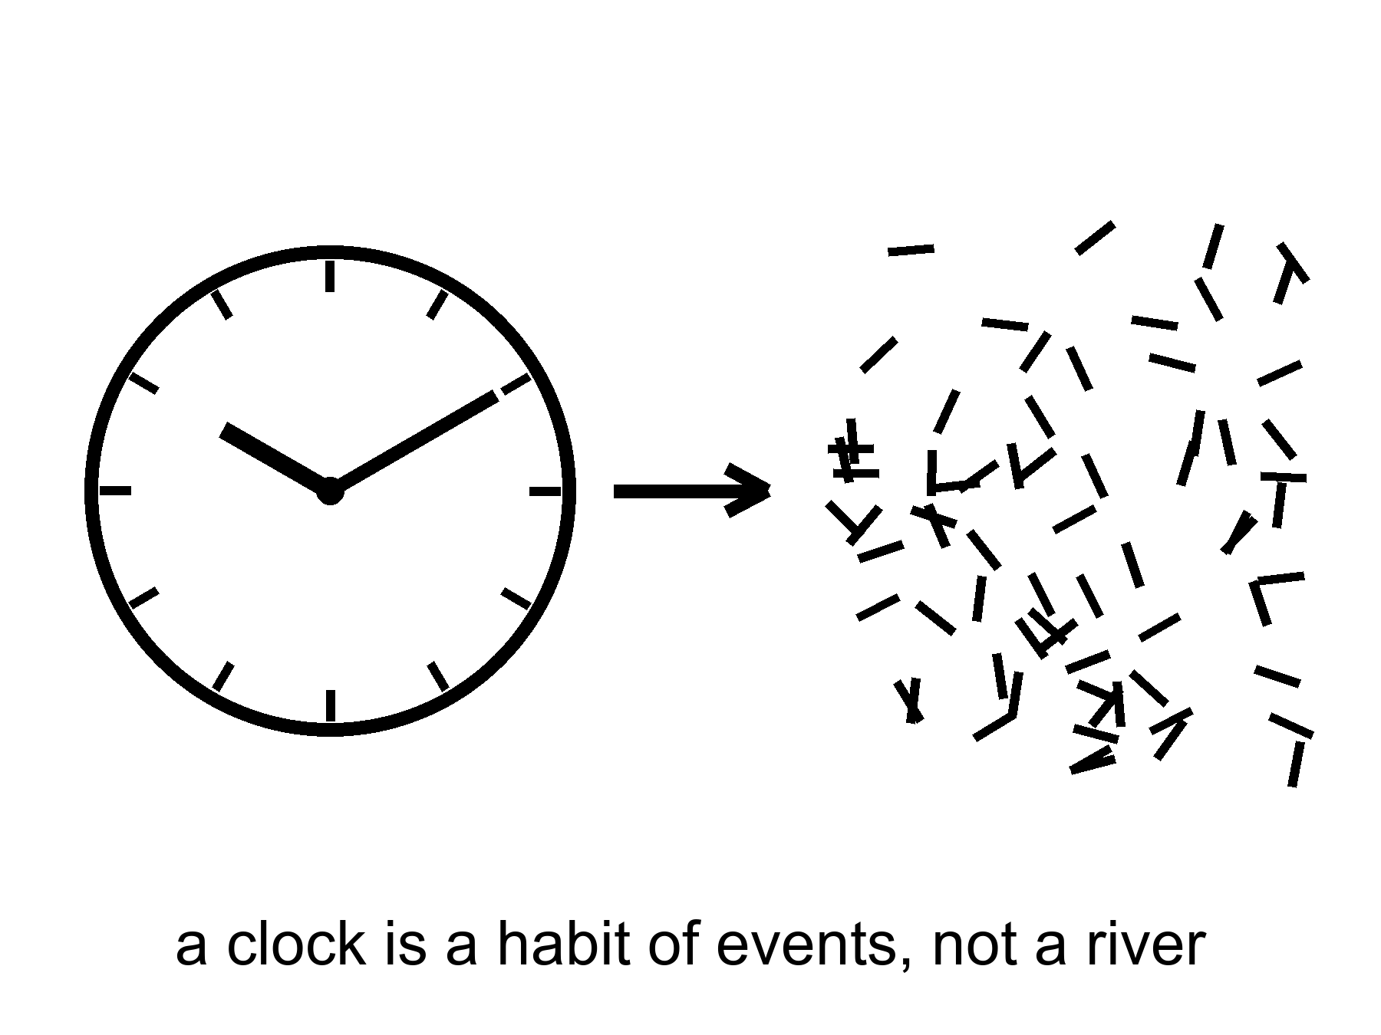
Figure 45. A clock face dissolving into marks. A clock is a habit of events, not a river.
Hartle and Hawking’s no-boundary idea tries to replace⁹² “before the bang” with a rounded-off geometry, time crystallizing only when the universe is large enough to have it. Vilenkin tunnels from nothing, which is a technical nothing, not a kitchen nothing. These are cold, and they are the right kind of cold: they are attempts to stop using a word where the word may not apply.
This book’s working answer, the one that can carry a greenhouse and a dark sea: time exists as relations among events. It does not exist as a stage the events are put down on. It may not exist, in the quantum-gravity limit, as a primitive. The arrow exists because the past was special. You exist as a thread that remembers the special past and cannot remember the fade. That is enough to call it morning.
Hot: intervals, GPS, the arrow as a fact about a smooth past. Warm: the Past Hypothesis as the name of that smoothness; cosmic time as a convenience. Cold: a primitive t in the quantum-gravity wave; a waiting room labeled BEFORE; a river. The working answer sits in the hot and the warm and lets the cold stay cold. That is how this book has used temperatures since the front. It will not stop at the last chapter but one.

46. The Honest Ending
Here is what each recognition lets you do, once it has arrived and stayed.
An event is a happening: so you stop asking where the casserole “is” in time and ask which happenings it is between. “Now” is a slice you draw: so you keep the word for the kitchen and retire it for Andromeda. The past we can rebuild is a region: so the three minutes are not a myth you are being asked to respect, they are a workshop whose tools you still own. Most of what pulls does not shine: so you weigh by lean, not by glow. Most of the budget shoves: so the future is a fade unless the shove is a liar, and a required last mind is a story. A horizon is a one-way fact: so you do not book a door. A handle is a bill: so you do not staff a subway. Copies are four kinds: so you do not fuse them and then sell a ticket. Arrangement is a filter: so you do not crown the fish. Time is a relation: so the wall clock stays a tool. Each of those is a refusal that leaves a project standing. The project is the point of the cash.
And then the part the leftover glow does not owe us:
A dead world can hold a greenhouse if someone bullies the ice and the hours. A frozen moon can hold a sea if a giant squeezes it, and that sea can hold a second origin or an empty kitchen, and the only way to know is to melt and look, without poisoning the answer. A crew that does not sleep can carry a library farther than flesh. The library is a physical object. The project can fail. Failure is allowed. Destiny was the thing that was not allowed.
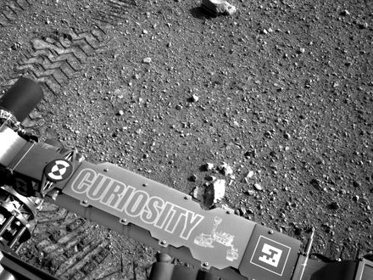
Figure 46. Rover tracks toward a near horizon. Meaning is local, on one worldline.
If every allowed outcome is on the inventory, this outcome is still the one with your hands in it. If the block is real, the basil you log on a cold morning is as real as the leftover helium. If the block is not quite real, if time is a heap of Nows, the heap still includes the smell of a lie in a room of LEDs. You do not need the universe to have a purpose in order to have a purpose in it. You need a permit — water, carbon, a little quiet — and a refusal to wait for the ending to compute you back.
Local, on one worldline. That is the moral the field equation will not write and does not have to. Everett, if you buy the reading, puts other outcomes on the inventory. The cheap copies, if space is that large, put other kitchens out of reach. Neither of them cooks this basil. Grief is still a fact about one thread. So is a project. So is the decision not to plague a dark sea. Meaning that had to be scheduled at crunch was a way of not having to decide. Meaning that is local is a way of having to.
Is there a path to ultimate knowledge?
There is a path. There is no chapel at the end of it, and the word ultimate is a temptation physics itself refuses.
Knowledge, in this book, is a record you could have missed. A prediction that can fail. A fossil that does not need your agreement: the glow, the helium, the stretch, the ring around a hole, a leftover in a navy file that still has no name. The path is the widening of that kind of record — not a feeling, not a collapse of the ocean when you look, not a framework that can survive every outcome and therefore explains none.
Darwin’s notebook was already the whole method. A pile of beaks. A sentence that could die. Wallace’s letter. The leftover glow is that habit aimed at a fog. Weinberg’s three minutes are that habit aimed at a workshop. The bombs of 1998 are that habit aimed at a future that did not want to recollapse. A melt that tastes a sea is that habit aimed at a lid of ice. The path does not change species when the subject changes. It does not become a chapel when the subject is spacetime. It stays a record you could have missed. Lengthen it. Do not crown it. Do not build a last room and call the room God.
Learn the bills. Special relativity: no shared now, no local dash past light, mail that is late on purpose. General relativity: gravity is the loaf; a handle and a bubble are sentences that still owe a stuff we have not stacked. Quantum mechanics: amplitudes, decoherence, pairings without a telegram. The seam where the two great theories do not yet share a kitchen is the largest honest hole we have. Sit in it. Do not furnish it with a visitor or a god of the gaps.
Learn the walls. An event horizon is a fact about influence. A cosmic event horizon is a fact about which galaxies will never get your letter. A branch, if Everett is right, is a fact about a term you cannot enter. “Before the fog” may not be a word. Those are not insults. They are the shape of what a worldline is allowed to know.
Knowing the walls is part of the path. It keeps you from spending a life on a ticket that was never for sale. It also keeps you from despair: the rooms that are in your future cone — a dead world with ice in its bones, a moon with a sea, a dish that can hear a shout — are not small because they are not the whole loaf. They are the part of spacetime a thread can still work.
Refuse what cannot die. A story that fits every leftover glow is not a story. String theory, as it stands, has not named a kill-shot. A craftsman who leaves no channel nature does not use has not clocked in. An observation-creates-life that cannot say what counted as the first observer is a regress, not a path.
Build the next record. A telescope that can smell an oxygen-methane pair and be wrong. A dish that can hear a shout and know the shout was not the ionosphere. A melt that tastes a dark sea without writing over it. A library that is a box, not a sermon. A legislature, even, when it is doing its only smart job: asking whether the leftover in its own air is an adversary, a secret of its own, or a file that still says unidentified. That last is not ultimate knowledge. It is hygiene.
What would ultimate have to mean, if we kept the word? Not a God’s-eye inventory of every branch, every before, every event outside our cone. That inventory, if it exists, is not a destination. Ultimate, for a thread, is asymptotic: more of the universe brought into a record that can fail, fewer sermons in the gaps, a closing of the QM–GR seam if the seam can be closed, a second dictionary under ice or a clean empty, a leftover named or honestly unnamed. You will not finish. The fade, if the fade is coming, will not wait until you finish. The point of the path is not to arrive at a last fact. It is to be the kind of worldline that can tell a last fact from a mood.
Lengthen without a chapel. That is the whole close, if you want it in four words. A chapel is a last room that cannot be wrong. This cosmology has no such room. It has a kitchen clock that is still useful, a leftover glow that is still late, a shove that is still winning, a seam that is still a hole, and a handful of projects that still might fail. That is a richer inventory than a throne. It is also a ruder one.
The clock on the kitchen wall is still lying. Let it. Take the casserole out. Then, if you have the years and the machines and the tact not to plague a dark sea, send a library. Not because the universe requires it. Because you can, and because the fade, if the fade is coming, will not be hurried or helped by your waiting.
That is the honest ending. It is not a door. It is a door you build, on a world that did not ask for one, under a sky that is late on purpose. It is also the only path this cosmology can sign: widen the record, pay the bills, stop at the walls, and do not hire a someone to finish your homework.
Said once, in the plainest words this book has:
Relativity gives us events, intervals, worldlines, and causal limits, not a universal present. Cosmology gives us evidence and open problems, not destiny. Meaning remains local, optional, and real.
Meaning, if you still want the word after forty-six chapters, is local, optional, and real. Optional, because nothing in the field equation requires it. Real, because a project on one worldline is as much an event as the leftover helium. It lives on one worldline, in a room that smells like a lie, under a clock that was never a cosmology. Grow the basil. Log the pH. Melt if you can do it without writing over the answer. Send the box if you have the tact. Admit that the dirt can vote no. That admission is not despair. It is the difference between a project and a destiny, and it is the last recognition this book will cash.

APPENDIX — The Scientific Detail

How to Read These Notes
Each note An twins popular chapter n. Units are SI unless stated. c is the speed of light, G Newton’s constant, ħ the reduced Planck constant, k Boltzmann’s constant. A scale factor a(t) is dimensionless; today a₀ = 1. Cosmological redshift z obeys 1 + z = 1/a for light emitted at a. A gravitational redshift, as in Pound–Rebka, is a different relation.
String theory, whenever it appears: a mathematical framework that cannot currently be tested. It has not produced a unique, risky prediction that would kill the whole idea if the experiment came out otherwise.
These notes are denser than the chapters they twin. They are still this book: short sentences, named measurements, temperatures on the claim. They are not a textbook. If a formula is numbered (1)–(17), the number is a handle, not a homework set. Row (18) is a standing rule, not a formula.

A0. Three Temperatures of Claim
Hot: repeated measurement, used to predict new ones. Warm: best model, real gaps. Cold: allowed by the equations, not selected by the data. A claim can change temperature. The oven is the sky, not the seminar.
Inflation is the cleanest change-of-temperature in this book. In 1981 Guth’s paper was a proposal: a brief early burst of repulsive stretch that could solve the horizon, flatness, and monopole problems the hot bang, taken alone, cannot. The first (“old”) inflation stalled on how to end the burst without emptying the universe of matter. In 1982 Albrecht–Steinhardt and Linde supplied slow-roll exits. That was still a model. What warmed the local burst was later data: a sky that is spatially flat to a percent; a primordial spectrum with n_{s} a few percent below 1 (A14); acoustic peaks in the leftover glow that match a nearly scale-invariant twitch stretched outside the Hubble radius and then brought back. Those are not proofs that a particular inflaton exists in a detector. They are reasons the local burst is no longer a 1981 maybe.
A claim can also cool. In March 2014 BICEP2 announced B-mode polarization at degree scales and offered a tensor-to-scalar ratio r ~ 0.2. Primordial gravitational waves from a high-scale burst would have been a trophy. Within a year Planck’s dust maps and the joint BICEP/Keck–Planck analyses showed that Galactic dust, not a primordial tensor background, carried the signal. The measurement was real. The interpretation was not. Current combinations (BICEP/Keck plus Planck) put r ≲ 0.03–0.04 at 95% confidence, depending on the data cut. High-scale inflation of the 2014 headline is colder than it was on announcement day. The local burst is still warm. Eternal inflation — self-reproducing pocket nucleations, a measure problem, no unique risky number — did not inherit the warming. It stays allowed and unselected.
Temperature is a discipline, not a mood. “We have a picture of a black-hole shadow” is hot. “The interior is a bounce into a baby universe” is cold. String landscapes, when named, inherit the standing rule (18). Use the labels in that spirit for the rest of these notes.

A1. Relativity of Simultaneity
Einstein synchronization: a clock at spatial coordinate x is set by a light signal from a master clock, assuming the one-way speed is c. That assumption is a convention that special relativity makes consistent. Observers with relative velocity v along x then disagree on which events with Δx ≠ 0 are simultaneous. The desynchronization is, to first order in v/c,
Δt = v Δx / c².
This is not a signal. Nothing travels from here to Andromeda in the instant you take a step. It is a fact about how two inertial frames slice the same loaf.
Worked numbers, Andromeda at Δx/c ≈ 2.5 × 10⁶ yr. Walking, v ≈ 1.4 m/s, so v/c ≈ 4.7 × 10⁻⁹. Then Δt ≈ 4.7 × 10⁻⁹ × 2.5 × 10⁶ yr ≈ 0.012 yr ≈ 4 days. The kitchen walker and the kitchen stander do not share a “now” on Andromeda to better than a long weekend. An airliner, v ≈ 250 m/s, tilts the same slice by ~2 yr. Earth’s orbital speed, v ≈ 30 km/s, tilts it by ~250 yr. None of those numbers is a photograph of Andromeda’s navy. Light from M31 is 2.5 million years late for everyone in the kitchen. The disagreement is about which events on that galaxy you label simultaneous with the casserole, not about which photons you receive.
At laboratory distances the same formula is tiny. Across a 10 m kitchen at walking speed, Δt ~ 5 × 10⁻¹⁷ s — below any clock you own. Relativity of simultaneity is therefore easy to miss and easy to oversell. The one-way speed used to set the clocks is the convention. Once both kitchens have adopted it, the disagreement about which distant events share a slice is not a convention. It is what the Lorentz transformation does to those clocks. Chapter 1’s lamps are that second fact. Calling the whole disagreement “only a convention” is the reading Chapter 1 refused. The disagreement becomes a plot point only when Δx is huge or v is not small. Chapter 1’s kitchen is the first case.

A2. Minkowski Coordinates and the Interval
An event is a point in a 4-manifold. In inertial coordinates the interval is
(1) ds² = −c² dt² + dx² + dy² + dz²
(signature convention −+++).
ds² < 0 timelike, = 0 lightlike, > 0 spacelike. ds² is invariant: every inertial observer computes the same number. The split into dt and dℓ is not. That is the entire content of “the loaf has a geometry; the slices are ours.”
Signature is a convention. Particle physicists often write +−−−, so the inequality for “timelike” flips. The physics does not. This book keeps −+++ so that spatial distances look like school geometry and proper time satisfies c² dτ² = −ds² along a worldline.
A number. Two sparks in a lab: Δt = 5.00 μs, Δx = 1.00 km, Δy = Δz = 0. Light would need 3.34 μs to cover that kilometer, so the pair is timelike. Equation (1) gives ds² / c² = −(5.00 × 10⁻⁶)² + (10³ / c)² ≈ −1.38 × 10⁻¹¹ s². The proper time between them, for the inertial traveler who visits both, is Δτ = √(−ds²)/c ≈ 3.72 μs. A different inertial frame can assign 6 μs and a shorter Δx; it cannot change Δτ. Swap the numbers to Δt = 2.00 μs and the same kilometer and ds² > 0: spacelike. No traveler visits both. Different frames can disagree on order.
Null intervals are the paths of light in vacuum. They are the boundary of A3’s cones. If you take nothing else from this note, take invariance: the interval is the thing the universe keeps. Your clock and your ruler are how you spend it.

A3. Light Cones and Lookback Time
(2) ds² = 0 ⇒ dℓ = c dt
The past light cone of an event p is the set of events that can signal to p. The future cone is the set p can signal to. Everything else is elsewhere: real, and unavailable as a cause or an effect of p. Equation (2) is the generators of those cones in inertial coordinates. In a curved, expanding cosmology the same idea survives: null geodesics still bound causal contact; the scale factor a(t) changes how far a null ray gets.
Lookback time to redshift z is the integral of dt = da / (a H(a)) from a = 1/(1+z) to a = 1. It is not “distance over c” except as a slogan. In a matter-plus-Λ fit with H₀ ≈ 67–73 km s⁻¹ Mpc⁻¹, light emitted at z = 1 has been traveling ~7.8 Gyr; at z = 2, ~10.5 Gyr; at last scattering z* ≈ 1090, the travel time is the age of the universe minus ~3.8 × 10⁵ yr. The leftover glow is a baby picture with the baby long gone. The Sun in your sky is eight minutes old; Jupiter tonight is ~30–50 min old depending on opposition; M31 is 2.5 Myr old in photons.
The night sky is the past cone, sampled. Astronomy is the only time travel we have: we receive news that already lies to our past. You cannot answer the news. You can wait for later news from a later event on the same worldline. Chapter 3’s lateness is geometry, not an instrument limit.

A4. Tilting the Simultaneity Slice
(3) t′ = γ (t − v x / c²)
where γ = 1 / √(1 − v²/c²).
A plane t′ = const is tilted in (t, x). The slope is v/c². At kitchen v the tilt is invisible on kitchen x and enormous on megaparsec x (A1). The Andromeda paradox is this tilt: two people who meet in a kitchen, one walking, assign different “present” events to a galaxy 2.5 million light-years away. They do not assign different photons in the eyepiece.
Reality-transfer arguments (Rietdijk 1966; Putnam 1967) take the tilt as a metaphysical conveyor: if event A is present-for-me and event B is present-for-you-when-you-share-A, then B is already real-for-me. The chain is then run around the loaf until every event is “already real.” The Lorentz transformation in (3) is not on trial. The extra premise is: “present ⇒ real,” plus transitivity of that privilege across observers who do not share a global plane. This book rejects the privilege of the plane. The manifold plus metric is the inventory. A slice is a bookkeeping surface. Calling the slice “the now” does not promote it to a moving spotlight.
At v not small, γ matters. Equation (3) is the exact boost, not the first-order slogan. For GPS satellites (v ≈ 3.9 km/s, γ − 1 ≈ 8.5 × 10⁻¹¹) the vx/c² term is a daily desynchronization you must correct or the navigation solution drifts by kilometers (A5). For a 0.1 c cruise, γ ≈ 1.005; for 0.9 c, γ ≈ 2.3. The twin effect (A5) is the integral of proper time along two different worldlines that meet twice. The Andromeda tilt is what those worldlines do to distant labels between the meetings.

A5. Proper Time and the Twin Effect
Proper time along a timelike worldline: c² dτ² = −ds². Between two meetings, the inertial path maximizes τ. That is the twin “paradox”: the accelerated twin has the smaller elapsed proper time. There is no paradox in the geometry. The worldlines are different lengths. The traveling twin is not inertial for the whole trip; the stay-at-home twin is (idealized). They meet twice and compare wristwatches. The comparison is a scalar. Everyone agrees.
Hafele–Keating (October 1971; Science 1972) flew commercial airliners around the world with cesium clocks and compared them to a ground set. Eastbound, Earth-rotation velocity adds to the jet; westbound it subtracts. Predicted: eastbound −40 ± 23 ns, westbound +275 ± 21 ns (special-relativistic plus gravitational pieces together). Measured: −59 ± 10 ns and +273 ± 7 ns. The signs and the hundreds of nanoseconds are the result. A classroom “clocks are metaphysical” speech does not survive that table.
Muons. Mean proper lifetime τ₀ ≈ 2.20 μs. Atmospheric muons are born ~10–20 km up at v so close to c that γ is typically ~10–20. Without dilation they would decay in a few hundred meters of flight; they reach the basement. Storage-ring measurements (CERN muon storage ring; later g−2 rings) hold γ ≈ 29.3 and find the lab lifetime γ τ₀ to parts in a thousand. That is the twin effect with a particle that does not file a flight plan.
GPS. Orbit v ≈ 3.9 km/s gives a special-relativistic slowing ~7 μs/day. The weaker gravitational potential at altitude gives a general-relativistic speeding ~46 μs/day. Net: the satellite clock runs ~38–39 μs/day fast versus a geoid clock if you do not correct. Light travels 11 km in 38 μs. Uncorrected, the navigation solution is junk in hours. Both corrections are tens of microseconds per day and opposite in sign, as the chapter said. The system is an industrial twin-plus-well clock.

A6. Causal Structure: Past, Future, Elsewhere
At an event p, I⁻(p) is the chronological past (events that can reach p on a future-timelike curve), I⁺(p) the chronological future, and the remainder of the manifold, minus the light-cone boundary, is spacelike-separated “elsewhere.” Causal past and future J±(p) include the null generators. These are the verbs the loaf actually has. “Now” is not among them.
A Cauchy surface is a spacelike 3-surface that intersects every inextendible causal curve exactly once. Data on a Cauchy surface determine the solution in the domain of dependence. Presentism, as a physics claim rather than a mood, wants a preferred Cauchy surface that is “the present,” advancing. General relativity does not supply a preferred one. Different foliations are different bookkeeping. In Minkowski space every inertial t = const is a Cauchy surface; none is privileged by the metric. In generic GR, global hyperbolicity may fail (Cauchy horizons; A36). Where it holds, you still have a stack of surfaces, not a glowing edge.
The block — the 4-manifold plus metric as the inventory — is the default reading once you accept (1) and the Einstein equation as the dynamics of that metric. It is not a proof that “the future is already filmed” in a fatalist sense. It is a refusal to add a moving spotlight the equations do not contain. Local becoming, if you want the word, is along a worldline: proper time (A5). It is not a cosmic weather front.

A7. FLRW: No Center, No Edge
The Friedmann–Lemaître–Robertson–Walker metric assumes homogeneity and isotropy on spatial slices: the same density and the same expansion rate at every comoving point, no preferred direction. In coordinates comoving with the cosmic fluid,
ds² = −c² dt² + a(t)² [dχ² + f_{K}(χ)² dΩ²],
where K = +1, 0, −1 labels spatial slices that are S³, E³, or H³ (closed, flat, open), and f_{K} is sin χ, χ, or sinh χ. There is no privileged center on those slices any more than there is a center of the Earth’s surface. Every galaxy can think of itself as at rest in the Hubble flow. “Expansion into what?” is a category error: a(t) rescales proper distances between comoving observers on the slices. The manifold is not required to sit in a higher-dimensional room with a spare radial direction labeled “outside.”
Observationally, the leftover glow is isotropic to ~10⁻⁵ after the dipole is removed (A9). Galaxy surveys (2dF, SDSS, DESI) find homogeneity on scales ≳ 100–300 Mpc, with the usual argument about whether a given catalog is large enough. Spatial curvature Ω_{k} is consistent with 0 at the percent level or better in Planck-like fits (A11). Flat and infinite is allowed. Flat and finite (a 3-torus) is allowed and not selected. Closed with a large radius is allowed. None of those options puts you at the middle of a bomb.
The “bang” is a hot, dense state of the slices in the past, not a point in a pre-existing box. At a → 0 the classical description fails (A45). That failure is not a location you can visit.

A8. Hubble–Lemaître Law and Redshift
(4) v = H₀ d (low z); 1 + z = 1/a_{emit}
H₀ is ȧ/a today. Equation (4)’s velocity form is a local linearization: recession v ≈ H₀ d for z ≪ 1, where d is proper distance now and v is not a rocket velocity through a box. The exact observable is redshift. Photons stretch with the slice: a feature emitted at wavelength λ_{em} when the scale factor was a_{emit} arrives at λ_{obs} = λ_{em} / a_{emit}, hence 1 + z = 1/a_{emit}. At z = 1 the universe was half its present scale. At z = 9 it was a tenth. At z* ≈ 1090 it was about a thousandth. Do not confuse z with lookback time; A3’s integral is the conversion, and it depends on the whole H(z) (A18).
Measured H₀ still tensions (status as of October 2026). Planck-like early-universe fits (CMB acoustic scale plus the working ΛCDM inventory) give H₀ ≈ 67.4 ± 0.5 km s⁻¹ Mpc⁻¹; DESI DR2 BAO with a BBN prior gives 68.5 ± 0.6. Late-universe distance ladders (Cepheids to Type Ia; SH0ES) give H₀ ≈ 73 ± 1, and the 2026 Local Distance Network combination gives 73.5 ± 0.8; the CCHP tip-of-the-red-giant-branch ladder gives 70.4 with wider errors (sources in the Notes, Chapter 8). The gap is several times the quoted errors and has persisted through independent rungs and through Gaia parallaxes. That is a real problem for the working model, not a reason to deny expansion. Tip-of-the-red-giant-branch ladders and some strong-lens time delays sit in between or on one side or the other; they have not closed the case. This book treats H₀ as measured twice, in tension, both measurements hot as measurements, the reconciliation warm-to-open.
Hubble’s original 1929 slope was ~500 km s⁻¹ Mpc⁻¹ and a universe too young for the rocks. The law was right; the calibration was not. The present tension is not that story again until someone shows which calibration, or which early-universe assumption, is the 1929 error. The law is not a center. It is a(t) made local.

A9. The CMB as a Blackbody
FIRAS on COBE (Mather et al.; Fixsen 2009 compilation) measured the sky-averaged spectrum as a blackbody at
T₀ = 2.72548 ± 0.00057 K.
Residuals from a Planck function are at the level of tens of parts per million. That is the most precise blackbody in nature we have ever taken apart. A blackbody needs a thermal history: the photons were in equilibrium with a charged plasma, then decoupled, then free-streamed while T ∝ 1/a (8). A “tired light” or “stars in a fog” story does not produce this spectrum plus the acoustic-peak pattern.
The dipole, ΔT ≈ 3.4 mK, is our motion relative to the rest frame of the glow: v ≈ 370 km/s toward Leo (more carefully, toward galactic coordinates near l ≈ 264°, b ≈ 48°). Subtract that and the intrinsic anisotropies are ΔT/T ~ 10⁻⁵ — tens to hundreds of microkelvin. Those are the seeds of A14, printed on the last-scattering surface.
Last scattering: hydrogen recombination drops the free-electron fraction and the Thomson optical depth τ falls through 1. Planck-like fits put the peak of the visibility function at z* ≈ 1090 (1089.80 ± 0.23 in the 2018 TT,TE,EE+lowE+lensing chain; the chapter’s 1090 is the right digit). The temperature then was T* = T₀ (1 + z*) ≈ 2970 K, which this book rounds to 3000 K. Age at last scattering: ≈ 380,000 yr. Helium recombination is earlier and less visible. Reionization at z ~ 6–9 puts a small extra τ on the large-scale polarization; it is not a second fireball.
Hot: the spectrum, the dipole as motion, the 10⁻⁵ map, last scattering at z ~ 10³. Warm: the detailed recombination code and the optical-depth tail. Cold: a craftsman who painted the blackbody (A35).

A10. Thermal History, Minute by Minute
(8) T ∝ 1/a (photon temperature after e⁺e⁻ annihilation)
Equation (8) is the leftover glow’s thermometer once electron–positron annihilation has dumped its entropy into the photons (a factor ~ (11/4)^{1/3} relative to the neutrinos). Before that, T still tracks 1/a up to g* changes when species drop out of the bath. A radiation-dominated clock reads t ~ 1 / T² in natural units: hotter is younger.
A prose timeline, not a wallpaper. t ~ 10⁻⁴³ s, T at the Planck energy ~10³² K: not a measurement; the classical metric is not to be trusted. A local inflationary burst, if it happened, ends somewhere around t ~ 10⁻³⁶–10⁻³² s in textbook sketches; T_{rh} after reheating is model-dependent (A13) and only required to sit above BBN. At t ~ 10⁻⁶ s, T ~ 10¹³ K ~ 1 GeV, the quark–gluon plasma hadronizes — inferred from heavy-ion experiments plus the cosmic expansion, not from a cosmic photograph. At t ~ 0.01 s, T ~ 10¹¹ K ~ 10 MeV: the chapter’s first rough mark; weak interactions still keep neutrinos and the n/p ratio in step. Neutrino decoupling: t ~ 1 s, T ~ 1 MeV. Electron–positron annihilation follows as T falls through ~0.5 MeV, reheating the photons relative to the already-decoupled neutrinos. Big-Bang nucleosynthesis: t ~ 1–3 min, T ~ 0.1–1 MeV (below). Recess. Then a long wait. Recombination and last scattering: t ~ 3.8 × 10⁵ yr, T ~ 3000 K, z* ≈ 1090 (A9). The glow has been free-streaming since. Reionization by the first stars and nuclei: z ~ 6–9, a few hundred million years. Today: T₀ = 2.725 K, t₀ ≈ 13.8 Gyr.
Those marks are the working thermal history. They are not a filmed minute log. The ones with spectral or abundance teeth (BBN; the CMB) are hotter than the ones that are interpolation plus accelerator physics.
Big-Bang Nucleosynthesis
Neutron-to-proton freeze-out n/p ≈ 1/6 when the weak rates fall behind the expansion at T ~ 0.8 MeV, then free decay (τ_{n} ≈ 880 s) toward ~1/7 by the time the deuterium bottleneck opens.
(9) Y_{p} ≈ 2 (n/p) / (1 + n/p) ≈ 0.25
(10) Deuterium bottleneck: D photodissociates until T ≲ 0.1 MeV.
Almost every neutron that survives is cooked into ⁴He. Equation (9) is why the helium mass fraction is a quarter and not a cosmic accident. Equation (10) is why the cooking waits three minutes: the bath is still full of gamma rays that break deuterium until T is low enough that η × exp(−B_{D} / T) drops, with baryon-to-photon ratio η ≈ 6 × 10⁻¹⁰ from the CMB.
Observed Y_{p} ≈ 0.24–0.25 (H II regions; primordial intercept). Deuterium, the most fragile useful thermometer, sits at D/H ≈ 2.5 × 10⁻⁵ in high-z quasar absorbers, matching CMB ω_{b} at the ~10% level or better. ³He is messier (stars both make and destroy it). Lithium-7 remains in tension: Spite-plateau Population II stars show A(Li) a factor ~2–3 below the CMB-plus-BBN prediction. That is a real gap — stellar depletion, new physics, or both — not a reason to throw out Y_{p} and D/H. No detector has photographed the third minute. The abundances plus the expansion plus the weak rates are the courtroom.

A11. Critical Density and the Cosmic Inventory
(5) ρ_{c} = 3 H₀² / (8π G)
Ω_{i} = ρ_{i} / ρ_{c}. For H₀ = 67.4 km s⁻¹ Mpc⁻¹, ρ_{c} ≈ 8.5 × 10⁻²⁷ kg m⁻³ — a few hydrogen atoms per cubic meter if it were all hydrogen, which it is not. For H₀ = 73 the critical density is ~17% higher; Ω values quoted from the CMB are usually reported in combinations like Ω_{i} h² that do not care which H₀ you prefer until you convert.
Planck-like inventory (round numbers this book uses): Ω_{b} ≈ 0.05, Ω_{c} ≈ 0.27, Ω_{Λ} ≈ 0.68, Ω_{k} ≈ 0, photons Ω_γ ~ 5 × 10⁻⁵, neutrinos a comparable few × 10⁻⁵ if masses are small. Mean baryon number density n_{b} ~ 0.2 m⁻³ (one proton in a box a bit more than a meter on a side). Stars and the gas you can photograph are a fraction of Ω_{b}; most baryons are in the warm–hot intergalactic medium and other faint phases. Dark matter Ω_{c} is the extra pull (A17). Dark energy Ω_{Λ} is the shove (A18). They do not trade costumes.
Spatial curvature: |Ω_{k}| ≲ 0.01 in standard fits, tighter if you assume the working model. That is “flat for practical purposes,” not a proof the 3-space is infinite (A39). Critical density is the density that would make a matter-only universe spatially flat. With Λ, the Friedmann equation still uses (5) as the unit; the geometry is Ω_{k} = 1 − Σ Ω_{i}.

A12. Horizon, Flatness, and Relic Problems
Particle horizon in a radiation-dominated era grows as ~ ct, more carefully χ_{p} ~ 2ct / a in comoving coordinates for a ∝ t^{1/2}. Opposite patches on the last-scattering surface, separated by ~1° or more on the sky today, had not been in causal contact in a pure hot-bang history. Yet the leftover glow agrees in temperature to ~10⁻⁵. That is the horizon problem: a thermal agreement without a prior chance to thermalize.
Flatness: |Ω − 1| ∝ 1/(a² H²). In decelerating eras (radiation, matter) this quantity grows toward the past, so Ω ≈ 1 today to a percent requires |Ω − 1| ≲ 10⁻¹⁶ at BBN and ~10⁻⁶⁰ near the Planck scale if you run the clock that far. That is a tuning if the bang is just a bang. It is automatic if a prior burst drives aH up exponentially and parks Ω near 1.
GUT-scale monopoles, if produced at a phase transition with T ~ 10¹⁶ GeV, freeze out with n_{M} / s large enough to overclose the universe by many orders unless they are never produced after a burst or are diluted by ≳ 10²⁵ in entropy. Other relics (domain walls, some moduli) tell similar stories. Inflation’s original sale was these three puzzles. The sale does not identify the inflaton (A13). It explains why a local burst was proposed, and why a burst that lasts N ~ 50–60 e-folds (11) is the size of the proposal.

A13. Slow-Roll and E-Folds
(11) N = ∫ H dt ≈ 50–60 needed to solve A12.
An e-fold is a factor e in a. Fifty e-folds is a stretch of e⁵⁰ ~ 5 × 10²¹; sixty is ~10²⁶. That is the dilution that flattens, homogenizes, and hides relics. Exact N depends on the reheating temperature and the scales you care about; 50–60 is the working window, not a sacred integer.
Slow-roll parameters ε = −Ḣ/H², η = ε̇/(Hε) ≪ 1 (or the potential versions ε_{V} = (M_{Pl}²/2)(V′/V)², η_{V} = M_{Pl}² V″/V). While they stay small the burst continues; when ε reaches 1, inflation ends. Reheating converts vacuum-like energy (w ≈ −1) into a radiation bath. T_{rh} can sit anywhere from a few MeV (below that, BBN is wrecked) up toward GUT scales in optimistic models. No inflaton has been identified in a detector. No laboratory field has been shown to be the one.
What warmed the idea is A14’s spectrum plus A9’s flatness, not a named particle. High-scale models that predicted r large enough for BICEP2’s first claim cooled when the dust was subtracted (A0). Starobinsky-like R² and a range of plateau potentials remain compatible with n_{s} ≈ 0.96–0.97 and r below present bounds. The Lyth bound roughly says r ~ 0.01 already implies a super-Planckian field range; that is a theoretical discomfort, not a kill-shot. Compatibility is not a detection. String theory sometimes offers inflatons as a catalog. The catalog cannot currently be tested.

A14. The Primordial Spectrum
(12) P_{R}(k) ∝ k^{n}_{s} ⁻ ¹
(13) n_{s} ≈ 0.965 (Planck 2018 central value; the error bar, not a second answer, is what later combinations move)
Amplitude A_{s} ≈ 2.1 × 10⁻⁹ at the pivot k = 0.05 Mpc⁻¹. A scale-invariant Harrison–Zeldovich spectrum is n_{s} = 1. The measured tilt a few percent below 1 is a slow-roll success: n_{s} − 1 ≈ −2ε − η (sign conventions as usual). Planck 2018: n_{s} = 0.9649 ± 0.0042 in the baseline combination; later ACT/SPT/Planck combinations move the digit inside 0.96–0.97. Tensor-to-scalar ratio r = P_{T} / P_{R} is bounded: r ≲ 0.036 (95%) from BICEP/Keck 2018 plus Planck, with the exact ceiling depending on the likelihood. That kills the 2014 r ~ 0.2 headline. It does not kill a local burst.
The Mukhanov–Sasaki variable v = z ℛ quantizes the curvature twitch ℛ on a rigid expanding background. Modes freeze when they exit the Hubble radius (k = aH) and re-enter later as density seeds δρ/ρ ~ 10⁻⁵ — the same order as ΔT/T on the leftover glow. Acoustic peaks in the CMB and the baryon acoustic feature in galaxy surveys (A18) are that twitch, oscillated and projected. Non-Gaussianity f_{NL} is consistent with 0 at the level slow-roll predicts (f_{NL} ~ n_{s} − 1). A large local f_{NL} would have been a different, colder story.
Hot: A_{s}, n_{s} < 1, acoustic physics. Warm: a slow-roll burst as the source. Cold: a named inflaton, a detected tensor background.

A15. Eternal Inflation and the Measure Problem
If the quantum kick δφ ~ H/2π per Hubble time exceeds the classical roll down the potential, inflation self-reproduces: volume that is still inflating grows faster than volume that has exited. Pocket nucleations in a false-vacuum sea (Coleman–De Luccia) are a related picture with bubbles instead of a slowly rolling field. Both produce a multiverse of the Level II kind (A38). Neither is a detection.
The measure problem is that “most” is not defined. Volume-weighted measures favor pockets that inflate longest. Pocket-weighted measures count nucleations. Observer-weighted measures try to condition on galaxies or on Boltzmann brains. They disagree, sometimes by infinite factors. Anthropic cuts on Λ (A42) inherit this fog: Weinberg’s upper bound is a real inequality; turning it into a probability needs a measure you do not have.
Borde–Guth–Vilenkin (BGV): if the average Hubble rate along a past-directed geodesic is positive, that geodesic is past-incomplete. Eternal inflation, on this theorem, is not a past-eternal block. It does not prove a kitchen-time “before.” It proves that the inflating congruence cannot be extended indefinitely into the past as a regular, expanding spacetime. What replaces the incompleteness is A45’s problem, not a filmed first tick.
Temperature: local burst, warm (A13–A14). Eternal froth and a predictive measure, cold-to-warm at best. A landscape of string vacua as the menu, untestable by (18).

A16. Sensitivity: From Quantum Noise to BKL Chaos
Inflationary δφ is chaotic in the colloquial sense: a 10⁻⁵ twitch, stretched across the sky, becomes the difference between a void and a cluster. It is not always chaotic in the formal attractor sense. Slow-roll backgrounds are often attractors in field space; the noise on top of them is what gets amplified into δρ/ρ. Do not sell “chaos” as a single noun for both.
BKL (Belinski–Khalatnikov–Lifshitz): generic spacelike singularities in classical GR show Mixmaster behavior — chaotic Bianchi IX oscillations, a sequence of Kasner epochs with exponents that bounce in a deterministic but exponentially sensitive map. Nearby spatial points lose correlation as t → 0 (or toward a crunch). That is a theorem-level expectation of the classical theory, not a photograph of the bang.
A steered crunch — the Omega Point demand that intelligence control the geometry all the way to a single c-boundary point — requires control of that chaos. Barrow-type results make the demand measure-zero unless extra structure is imposed: you would need to fine-tune the approach on successively smaller scales without a horizon-free handle (A23, A43). Lyapunov exponents of the Mixmaster map are positive; each Kasner epoch shrinks the set of successful steerings. Sensitivity is an engine for structure in the expanding era. It is a veto on a required final mind in a recollapse.

A17. What “Non-Baryonic” Means
Baryons: protons and neutrons (plus electrons when the popular chapters say “ordinary matter”). CMB acoustic peaks plus BBN fix Ω_{b} ≈ 0.05 (ω_{b} = Ω_{b} h² ≈ 0.0224). Dynamical masses (clusters; large-scale flows), weak lensing, and the CMB peak positions give Ω_{m} ≈ 0.3. The difference Ω_{c} ≈ 0.26–0.27 does not couple electromagnetically at the level that would have shown up as extra light, extra damping, or extra BBN catalysts. Collisionless cold dark matter (CDM) is the working fluid: it clumps, it does not shine, it does not collide with itself or with baryons at rates that would erase A17’s offsets. WIMP, axion, sterile neutrino, primordial black hole (in a narrow mass window) are candidate nouns, not detections.
Rotation curves: v² ≈ G M(<r)/r in a disk. Flat v(r) at tens to hundreds of km/s implies M ∝ r well outside the starlight. That is the original “missing mass” in spirals (Rubin; Bosma). It is not, by itself, a proof of a new particle — MOND still has friends here — but it is the everyday face of the extra pull.
Weak and strong lensing map surface density Σ. The Bullet Cluster, 1E 0657−56 at z ≈ 0.3 (Clowe, Markevitch, et al., 2006), is a merger in which the X-ray gas (Chandra) lagged the collisionless mass reconstructed from weak lensing. The offset is the point: collisional baryons were stripped; the majority of the gravitating mass was not. Modified-gravity stories that tie the extra pull strictly to the visible gas have to work around that photograph. They have not done so in a way this book treats as competitive.
CMB acoustic peaks: the odd/even peak-height ratio is sensitive to Ω_{b}; the spacing and the third-peak height help fix Ω_{m} h² and the late-time inventory. That is why the leftover glow, not only the Bullet, is a dark-matter courtroom.
Direct detection: LZ, XENON1T/nT, PandaX, and predecessors have not found a WIMP. Spin-independent cross-section limits sit near 10⁻⁴⁷–10⁻⁴⁸ cm² at ~30–40 GeV/c², with neutrino fog approaching. Axion haloscopes (ADMX and cousins) have closed slices of g_{aγγ}–m_{a} space, not the whole QCD-axion band. Nulls are data. They are not a proof CDM is a mistake. They are a proof the first popular noun was not sitting on the first shelf.

A18. Vacuum Energy and the Cosmological Constant
(6) ρ_{Λ} = Λ c² / (8π G) (constant)
Naive QFT zero-point ~ M⁴ with M at the Planck scale (~10¹⁹ GeV) overshoots ρ_{Λ},obs by ~120 orders of magnitude; even a TeV cutoff overshoots by ~60. Observed ρ_{Λ} ~ (2.3 × 10⁻³ eV)⁴, or about 6 × 10⁻²⁷ kg m⁻³ — the same order as ρ_{c} today, which is the coincidence problem. Weinberg 1987: if ρ_{Λ} is too large and positive, galaxies do not form before the shove wins; that anthropic upper bound sits within one or two decades of the measured value. A bound is not a derivation. It becomes an explanation only if an ensemble of vacua exists and a measure can be defined (A15, A42). String landscapes offered as that ensemble inherit (18).
Supernovae, BAO, and H(z)
(7) H²(z)/H₀² = Ω_{m} (1+z)³ + Ω_{r} (1+z)⁴ + Ω_{Λ} + Ω_{k} (1+z)²
(for w = −1). Type Ia supernovae as standardizable candles (Riess et al. 1998; Perlmutter et al. 1999; Schmidt’s team sharing the 2011 Nobel) showed that luminosity distance at z ~ 0.5–1 is too large for a matter-only decelerating universe. The leftover glow and a baryon acoustic oscillation standard ruler together prefer the same fit. BAO: the sound horizon at the drag epoch is r_{d} ≈ 147 Mpc comoving in Planck-like physics; galaxy and Lyman-α surveys (SDSS, BOSS, eBOSS, DESI) recover a feature at ~150 Mpc comoving. That is a meter stick, not a metaphor.
Equation (7) with Ω_{m} ≈ 0.3, Ω_{Λ} ≈ 0.7, Ω_{k} ≈ 0 is the working H(z). Acceleration (q₀ < 0) begins near z ~ 0.6 in that fit — a few billion years ago, not at the bang. As of October 2026, DESI DR2 BAO with the CMB prefers an evolving w(z) (parametrized w = w₀ + wₐ z/(1+z)) over Λ at about 3σ, about 2.8–4.2σ when supernova samples are added; the full Dark Energy Survey result gives w₀ ≈ −0.82 today; a Bayesian reanalysis finds the evidence not decisive. That is a possible warming of “not exactly Λ.” It is not a detection of a Big Rip, a bounce, or a required recollapse (A19, A44). w ≈ −1 remains the working number until a survey reaches discovery strength.
Hot: acceleration; Ω_{Λ} ~ 0.7; BAO ruler. Warm: Λ as a true constant rather than a slow field. Cold: we know why the zero-point is small.

A19. Why Recollapse Is Not in the Data
Closed matter-only recollapse needs Ω_{m} > 1 and no lasting shove. Observed Ω_{m} ≈ 0.3, Ω_{Λ} ≈ 0.7, q₀ < 0. The working Friedmann equation (7) expands forever. The expansion accelerates. A recollapse remains possible in a different vacuum or a w(z) that turns around later — a cold option, not the fit.
FAP and the Omega Point, as a requirement of the laws plus data, fail here first: they need a crunch. They fail again on horizons (A23, A26): a de Sitter-like late phase has an event horizon and a finite entropy budget, not an infinite computational resource in a vanishing 3-volume. They fail a third time on BKL chaos (A16) if you grant a crunch anyway. This book keeps that failure. A poetic crunch is not a measurement.
What would reopen recollapse: a measured w(z) that climbs through −1/3 and stays there with Ω_{m} high enough, or a vacuum decay (A44) into a negative-Λ phase on a timescale shorter than the remaining expansion. Neither is in the data. The first is a research program. The second is a lifetime Γ that is not measured (and, in the Standard Model metastability calculation, is usually quoted as vastly longer than t₀, with large theoretical fog). A closed universe with Ω_{k} slightly negative and Ω_{Λ} ≈ 0.7 still expands forever in the working fit; curvature does not buy you a crunch once the shove is on.

A20. The Schwarzschild Radius
(14) r_{s} = 2 G M / c²
The horizon is the null surface r = r_{s} in Schwarzschild coordinates. That coordinate is bad at the surface: g_{tt} → 0, g_{rr} → ∞. Curvature invariants (Kretschmann scalar ~ M²/r⁶) are finite at r_{s} and blow up at r = 0. The horizon is a fact about events — which worldlines can still reach future null infinity — not a painted brick wall.
Numbers. Sun: r_{s} ≈ 2.95 km. Earth: ≈ 8.9 mm. A 10 M_⊙ stellar hole: ≈ 30 km. Sagittarius A*: M ≈ 4.3 × 10⁶ M_⊙ (stellar orbits; GRAVITY; S0-2 periapsis), r_{s} ≈ 1.3 × 10¹⁰ m ≈ 0.08 AU. M87*: M ≈ 6.5 × 10⁹ M_⊙, r_{s} ≈ 1.9 × 10¹³ m ≈ 130 AU. The Event Horizon Telescope’s 2019 M87* ring and 2022 Sgr A* ring are images of photon-orbit scale (~2.5–5.5 r_{s} depending on spin and inclination), not snapshots of r = 0. The 1.3 mm M87* ring diameter is ~42 μas, matching a 6.5-billion-solar-mass hole at 16.8 Mpc. LIGO/Virgo/KAGRA hear mergers: GW150914 was 36 + 29 → 62 M_⊙ with ~3 M_⊙ c² in gravitational waves, peak strain ~10⁻²¹, ringdown frequencies matching Kerr quasi-normals at the masses implied by the inspiral. Thousands of solar-mass events later, the catalog is a population, not a one-off. Hot: horizons of this kind exist. Warm: the interior continues as classical GR until a singularity. Cold: we know what replaces r = 0.

A21. Gravitational Time Dilation and Kerr Orbits
(15) dτ = dt √(1 − r_{s}/r) (static observer, Schwarzschild)
A clock at rest at radius r runs slow versus a clock at infinity by that factor. On Earth’s geoid versus a GPS orbit the gravitational piece is ~+46 μs/day for the higher clock (A5). At the surface of a neutron star (r ~ 3–5 r_{s}) the factor is tens of percent. At a static station hovering near r_{s} the factor goes to 0 — and the station needs a rocket that goes to infinity. Hovering is not free.
Kerr: spin parameter a/M between 0 and 1 in geometric units. The innermost stable circular orbit (ISCO) sits at 6 GM/c² for Schwarzschild and moves in to GM/c² for prograde extremal spin. That is why thin-disk efficiency can reach ~40% of rest mass for high spin versus ~6% for a non-spinning hole. Extreme “hour versus years” ratios for a person beside a supermassive hole need a station near ISCO and a/M within ~10⁻¹⁴ of extremal so that the redshift factor is huge while the orbit remains stable. Allowed by the metric. Not generic. Astrophysical spins measured from iron lines and continuum fitting are high (a/M ~ 0.7–0.98 for some AGN) and nowhere near that engineering tolerance.
Frame dragging (Lense–Thirring) is measured around Earth (Gravity Probe B; LAGEOS) at the milliarcsecond-per-year level. Around a hole it is the reason the ergosphere exists (r < 2GM/c² at the equator for Kerr). Penrose processes and Blandford–Znajek jets can tap spin. They are not time machines (A36).

A22. White Holes and the Kruskal Diagram
Maximal analytic extension of Schwarzschild (Kruskal–Szekeres coordinates): two exterior regions, a black-hole region (r < r_{s}, future), a white-hole region (r < r_{s}, past), and an Einstein–Rosen throat connecting the exteriors. A white hole is a past horizon: matter can exit, not enter. The time-reverse of collapse is not the same as a film of a hole run backward in an astrophysical sky. Forming a white hole from regular initial data in our exterior is not what stars do. The white-hole region in the eternal diagram is as eternal and as unphysical as the second exterior: a boundary condition, not a collapse.
Unstable: any infalling perturbation (and the quantum flux) destroys the idealized extension. No astrophysical candidate has been named that survived a measurement. Fast radio bursts, gamma-ray bursts, and odd transients have all been offered and re-offered; none is a white hole in the data.
A white hole is not the FLRW bang. The bang is a hot, dense spatial slice in the past of every comoving worldline. A white hole is a local causal structure with an exterior. Confusing them is a diagram accident (both have a past singularity in some drawings). It is not a theory of the leftover glow. Planck’s blackbody plus z* ≈ 1090 last scattering (A9) is the bang’s photograph. No analogous spectrum has been offered for an astrophysical white hole.

A23. The Bekenstein–Hawking Bound
(16) S = k A / (4 ℓ_{P}²) ℓ_{P} = √(ħ G / c³)
Entropy scales with area, not with the 3-volume inside. For a solar-mass hole, A = 4π r_{s}² gives S/k ~ 10⁷⁷, enormous compared with a star of the same mass. This is the seed of holography: the number of states a region can hold is bounded by the area of a surrounding lightsheet (Bousso’s covariant version of Bekenstein). AdS/CFT makes a precise dual in negatively curved space with a conformal boundary. That dual is not a tested description of our cosmology. We do not live in AdS. String theory’s most precise holography inherits (18) when offered as a fact about the leftover glow.
Tipler-style infinite information in a vanishing 3-volume fights this counting. Unless horizons are removed by hand and the area theorem is evaded, a crunch does not give you infinite bits. The late universe we have, with Λ > 0, gives you a cosmological horizon of radius ~16 Gly (A26) and a finite Gibbons–Hawking entropy ~ 10¹²² k. That is a budget, not an infinity.
Hawking Temperature and Evaporation Time
T_{H} = ħ c³ / (8π G M k). Solar-mass hole: T_{H} ≈ 6 × 10⁻⁸ K, far below T_{CMB} = 2.725 K, so a stellar hole in today’s sky accretes more from the leftover glow (and from the interstellar medium) than it evaporates. A hole lighter than ~10¹¹ kg would be hotter than the CMB and could be losing mass now; none is observed. Evaporation time t_{ev} ~ 5120 π G² M³ / (ħ c⁴) ~ 10⁶⁷ (M/M_⊙)³ yr. For M = 10¹² kg (a sometimes-quoted primordial window), t_{ev} can sit near the age of the universe; Fermi and cousins have not confirmed a Hawking photosphere. Information paradox: a thermal Hawking spectrum versus unitary evaporation. Unfinished. Not a door (A24).

A24. Geodesics, Singularities, and Why You Do Not Come Out
In classical GR, timelike geodesics that cross r_{s} reach r = 0 in finite proper time. For Schwarzschild, τ ~ π GM/c³ from horizon to crunch — about 10 μs for a 10 M_⊙ hole, about 20 s for Sgr A*, about 9 h for M87*. They cannot return to the exterior. The horizon is not a hallway. Outgoing light at r = r_{s} stays at r = r_{s}; inside, the r coordinate is timelike and decreasing r is as compulsory as tomorrow. The photon sphere (r = 1.5 r_{s} for Schwarzschild; the EHT ring sits near that projected scale) is still outside. Orbiting there is not visiting the interior.
The singularity theorems (Penrose 1965; Hawking–Penrose) give geodesic incompleteness under energy conditions plus a trapped surface, not a map of what the incomplete edge “is.” Tidal forces at the horizon of a supermassive hole can be small (the curvature scale is GM/c²); at r → 0 they are not. No-hair: a classical hole is characterized by M, J, and Q. That is a statement about the exterior, not a door code.
Inflation and Λ violate the strong energy condition. That is why a burst and a late shove can exist without recollapse. They do not violate the null energy condition in the working stress-energy, and they do not turn a trapped surface into a transit system. Quantum replacements (bounces, fuzzballs, firewalls, baby universes) are research programs. String replacements, when offered, cannot currently be tested. A baby universe you cannot call is not a destination. You do not come out.

A25. Mars Numbers: Δv, Delay, Life Support
These are permit numbers. They are not a colony plan, a city budget, or a sequel.
Earth–Mars light time: ~3 min at closest approach, ~22 min near solar conjunction; one-way. You do not converse. You send, and wait. Hohmann-like transfers: ~6–9 months (a standard 145-day-class fast transfer costs more Δv; a 259-day textbook Hohmann is the cheap ellipse). Synodic window: ~26 months. Miss it and you wait two years.
Δv: LEO to trans-Mars injection ~3.6 km/s; Mars capture and circularization ~2 km/s class for a propulsive orbit, plus a lander budget of several more km/s if you do not aerobrake. Aerobraking and aerocapture trade heat shield for propellant. Surface gravity 0.38 g. Solar constant ~43% of Earth’s. Atmosphere ~6 mbar (6.1 mbar mean), ~95% CO₂, argon and nitrogen in the remainder — a vacuum by kitchen standards, a resource by ISRU standards. Mean surface T near −60 °C; equatorial summer afternoons can sit near 0 °C. Water ice is mapped at mid and high latitudes (Phoenix; SHARAD; neutron spectroscopy); equatorial “dry” is not globally dry at depth.
Perchlorates: Phoenix wet chemistry found ~0.5–1% by mass in the soil, mostly as Mg/Na perchlorate. That is a toxic oxidizer and a hygroscopic brine ingredient, not a mood and not automatically a nutrient. Plant growth needs imported or generated O₂/N₂ buffers, water that has been scrubbed, and radiation shielding. GCR plus solar protons at the surface are lower than in cruise (A32) because of the planet’s bulk, higher than under Earth’s atmosphere and magnetosphere. A greenhouse on a dead world is an engineering permit. It is not a biosphere, not a city, and not a reason to treat Earth as optional.

A26. Particle Horizon vs Cosmic Event Horizon
Particle horizon: comoving integral χ_{p} = ∫₀^{t₀} c dt / a. It is how far a photon has been able to travel since a = 0 (or since the end of a burst, if you cut the integral there). In working ΛCDM, the proper radius of the particle horizon today is ~46 billion light-years — larger than c t₀ ≈ 13.8 Gly because the universe expanded while the light was in flight. That is the radius of the observable universe.
Event horizon (ΛCDM with Λ > 0): χ_{e} = ∫_{t₀}∞ c dt / a, finite when a ~ exp(H_{Λ} t) at late times, H_{Λ} = c √(Λ/3). Galaxies with comoving distance χ > χ_{e} will never receive a signal we send today. The current proper radius of that event horizon is ~16 billion light-years. The Hubble radius c/H₀ is ~14 Gly for H₀ ≈ 70. Three different lengths; three different questions. Do not swap them.
The leftover glow comes from χ just inside the particle horizon (last scattering is not a = 0). Most galaxies we photograph already lie outside today’s event horizon in the sense that our “hello,” sent now, will never arrive — even though their ancient light is still arriving here. That is Chapter 26’s leaving. It is not a door closing on the past cone. It is a door closing on the future cone of this event.

A27. Finding Worlds You Cannot See
Transit depth δ ≈ (R_{p} / R★)². An Earth–Sun transit is (R_⊕ / R_⊙)² ≈ 84 ppm; a Jupiter–Sun transit is ~1.1%. Kepler, TESS, and ground surveys have turned that percent and that 84 ppm into a census. Radial-velocity semi-amplitude K ∝ M_{p} sin i / (M★^{2/3} P^{1/3} √(1−e²)). An Earth at 1 AU on a Sun analog is K ≈ 9 cm/s — at the edge of the best spectrographs. A hot Jupiter is K ~ 50–200 m/s, which is why the first detections were massive and close.
Occurrence: most FGK stars host planets; Kepler’s conservative yield is more than one planet per star on average. Mini-Neptunes (R ~ 2–3 R_⊕) are common; a radius valley near 1.8 R_⊕ separates stripped cores from those that kept envelopes. Earth-size planets in conservative habitable zones of GK dwarfs sit at occurrence ~0.1–0.2 depending on the paper — a rate, not a biosphere count. Direct imaging (GPI, SPHERE, JWST) and microlensing (OGLE; Roman in the future) are rare, complementary, and biased to wide, young, or unaligned systems. Timing of transits and TTVs give densities when you have both R and M; a 5 M_⊕, 1.6 R_⊕ world is not Earth.
Atmospheric transmission spectroscopy measures molecular bands during transit. H₂O, CO₂, CH₄, CO appear in giant and sub-Neptune atmospheres; O₂, O₃, CH₄ as a set are candidate biosignatures, not proofs. Photolysis makes O₂; geology and haze fake CH₄; abiotic CH₄–CO₂ pairs exist. JWST has smelled CO₂ on a transiting sub-Neptune and water on giants. That is chemistry. It is not a second origin. Look first, then name the gas.

A28. Circumstellar Habitable Zones
Kopparapu et al. (approximate, Sun): conservative moist-greenhouse to maximum-greenhouse limits ~0.99–1.7 AU; recent-Venus to early-Mars optimistic limits wider (~0.75–1.8 AU). Insolation S ∝ L / d²; L depends on spectral type and age. A G star at 4.5 Gyr is the hired case. An M dwarf’s HZ sits at ≲ 0.2 AU (TRAPPIST-1’s temperate planets are ~0.03–0.06 AU). Tidal lock is likely; flare and XUV stripping of atmospheres are the invoice; M-dwarf habitability is a research program, not a yes.
HZ is a permit for surface liquid water, given an Earth-like atmosphere and a carbonate–silicate thermostat you should not take for granted. It is not a biosphere detector. The inner edge is a moist-greenhouse runaway: stratospheric water, UV photolysis, hydrogen escape. The outer edge is the maximum greenhouse: CO₂ condenses and the warming saturates. Both edges move if you change surface gravity, N₂ inventory, or rotation. Venus is in a generous optimistic zone and is a 90-bar CO₂ oven at ~735 K. Mars is near the outer edge and is a 6 mbar desert (A25). Moons of giants can sit outside a stellar HZ and still host liquid water on tidal heat (A29). A K dwarf’s HZ is closer in than the Sun’s and quieter than an M dwarf’s; that is why some occurrence papers prefer it. Do not use the cartoon ring as a census of life.

A29. Tidal Heat, Ice Shells, and Dark Seas
Tidal power scales roughly Ė ∝ (G M_{p})² R⁵ e² / (a⁶ μ Q) (order-of-magnitude; e eccentricity, μ rigidity, Q dissipation). Io–Europa–Ganymede 1:2:4 Laplace resonance maintains e. Io’s Ė is measured as heat (~10¹⁴ W); Europa’s is inferred. Europa: ice shell perhaps 10–30 km (thicker in some gravity/induction models), ocean O(100) km. Induced magnetic field (Galileo) already implies a global conductor; Hubble and JWST have argued for plumes and then argued with themselves — plumes remain warm as a claim, not a scheduled geyser. Surface in Jovian belts: O(10²–10³) rem/day (~1–10 Sv/day) — lethal; the ocean is shielded by ice and water column.
Enceladus: south-polar plume (Cassini), salinity, silica nanoparticles (hydrothermal hint), H₂, organics. The plume is a sample without a landing. Ganymede: intrinsic field; possible stacked oceans separated by high-pressure ices. Titan: surface lakes are methane (A31); a deep water–ammonia ocean is a gravity/shape inference, not a beach. High-pressure ices (VI, VII) on larger worlds may limit water–rock exchange — open problem. Rogue planets: radiogenic plus primordial heat under a thick ice blanket can maintain a sea (Stevenson-type thermos). Look-first rule: induced field and plumes before slogans. Oceans are warm-to-hot. Life in them is not a detection.

A30. Second Origins, the Code, and What Life Eats
Sample size N = 1. Operational life: Darwinian replication plus a metabolism on a gradient. Viking LR (1976): labeled-release gas at ~15 °C that did not repeat after a 160 °C heat control, contested then and now as abiotic soil chemistry (peroxides; perchlorates, later measured) versus a metabolism. Biosignature pair O₂+CH₄ is a disequilibrium test, not a verdict.
Universal genetic code on Earth is a LUCA signature (frozen accident ± modest error-minimization), not a cosmic typesetter. Same codon table on a second world: contamination or panspermia, not independent invention. Pairing polymers warm; exact DNA alphabet cold. LUCA, as a node, sits before ~3.5–3.8 Ga on the terrestrial clock; that is a date for this tree, not a cosmic requirement.
Cannibalism: common in metazoa (not a zoological ban). Human near-taboo is a filter, not a field equation. Leading meshes: species-specific pathogens/prions (kuru; BSE from intra-species feed); kin selection; retaliation in social species. Inter-trunk predation (them eating us) is not cannibalism; chirality/code mismatch still makes us a poor default lunch.
Sex is not immortality: soma dies; lineage continues (Weismann). Asexual fission/clones are the common terrestrial default by time and census; sex is costly (two-fold cost of males) and still common in large parasite-exposed taxa. Warm accounts: Red Queen, Muller’s ratchet, recombinational repair — not a unique cosmic requirement. HGT is mixing without meiosis. Individual biological immortality is rare and still mutates. Expect some genome mixing where parasites + time exist; do not expect two sexes and a child-as-afterlife.
Reward, not pamphlet: sexual pleasure as a selected carrot for an expensive shuffle (wanting/seeking vs liking/completion; pair-bond peptides as a warm extra where young are costly). Asexuality and drive variation are lottery outcomes, not cosmic defects. Pornography as supernormal stimulus (Tinbergen): cue louder than the costly act; watchfulness plus cheap infinite images is Pleistocene wiring against an industrial supply (same family as refined sugar, intermittent-reward machines). Not a universal sophont law; warm that any reward loop can be spoofed once recording is cheap. No off-switch labeled “depiction only.”

A31. Other Chemistries, Missing Body Plans
Alternative solvents are papers, not zoos. A solvent must dissolve reactants, permit transport, allow a compartment, spare the polymers, and host a gradient. Water is the hired case, not a cosmic sacrament.
Titan (Cassini; Huygens, 2005): surface T ≈ 94 K, P ≈ 1.47 bar, N₂ air with CH₄ weather; lakes/seas of CH₄/C₂H₆ (radar-dark, north-polar concentration). No biosphere detection. Liquid-methane relative permittivity ε_{r} ≈ 1.7 vs water ε_{r} ≈ 80 at kitchen T — ions poorly solvated; Earth-like acid–base metabolism is mute. Kinetics: Arrhenius suppression at 94 K makes uncatalyzed lake chemistry a statue; upper-atmosphere photochemistry (CH₄ → haze) can still run. Warm papers, not detections: H₂ + C₂H₂ metabolism (McKay–Smith-type fingerprint: depleted H₂ / acetylene). Azotosomes (acrylonitrile vesicles proposed for liquid CH₄; the molecule is in the air) are cold as membranes: the stability case has gone against them. Dragonfly-class in situ is the next measurement, not a verdict in this note.
Ammonia: 1 atm liquid range ≈ 195–240 K (narrower than water unless mixed or pressurized). Polar, H-bonding; NH₃–H₂O eutectics stay liquid colder. Different acid–base inventory; hostile to Earth proteins. Still a paper.
Concentrated H₂SO₄ cloud decks (Venus-class): liquid in a probe-accessible T band; dehydrating to Earth organics. Tougher aromatics get papers. Phosphine claims were a courtroom, not a census. Colder paper than Titan: we have tasted the lakes; we have argued the mist.
Silicon chains as flesh: weak in water (prefer silica / mountains). Silica scaffolds already exist (diatoms, radiolarians) as coating, not metabolism. Homochirality: a second origin may be mirror-life; terrestrial enzymes would fail on it. “Nitrogen-breathing” as a primary metabolism is not an Earth pathway; N₂ fixation is costly (nitrogenase). Rapid morphological ascent through Earth’s taxa in days is fiction. Rapid radiation given short generation time and empty ecospace is ordinary (microbes; post-extinction recoveries). Contingency: Burgess-type body plans show many fired experiments; convergence (eyes, wings, torpedo bodies, cursorial hunters) shows some re-hiring.
Independent humanoid sophonts: cold (ape bauplan is historical). Independent cetacean sophonts as a default: cold; aquatic nervous systems warm. “Colleague with different ears” is a cultural wish, not a morphology forecast. Planetary-scale hyphal/root nets: Earth has sketches (mycelia; plant-mycorrhizal signalling — do not oversell a global brain). Remote-worn local bodies are engineering (Ch. 32), not a second origin.
Brain volume is a weak predictor once you leave a clade. Cetacean brains are large; corvid and parrot pallia are small, dense, and capable (Herculano-Houzel-type neuron counts beat cubic centimeters). Packing, wiring length, the body the wires serve, cumulative culture, and clock time matter more. A ~30 cm soma is neither a law nor a ban. Warm: a small, fast, dense nervous system can outrun a human-scale skull. Whale-scale tissue without that invoice can fail to. Eusocial colonies are distributed-control sketches, not a proof of a planetary hive-person. Miniaturized humanoids remain cold as morphology.
Parasitoid / host-as-nursery specialists: warm (ichneumonids; Ophiocordyceps); “evil” is the host’s word. Large terrestrial bipedal predators: warm convergence (theropod solution). Saurian intelligence: warm (avian dinosaurs already; troodontid EQ). Saurian civilization: extra filters (surplus, cumulative culture, manipulation, often fire) — not forbidden, not an ape downtown. Russell-style “dinosauroid” humanoid: cold as morphology. Alien cities as non-rectilinear lasting rearrangements (rookery, reef, mound, hyphal net, breathing burrow): the search problem is recognition, not physics. Cave/vent/endolith towns: hot as Earth fact (Movile; black smokers; Naica fluid inclusions). Walking photosynthetic macrofauna: warm permission, no Earth hire.
Endo- vs exoskeleton: both hired (vertebrate bone/cartilage; arthropod/mollusc cuticle). Molting vs fracture-healing are the invoices. Fur/pelage as a boundary layer can dump or block heat (camel coats); “no fur on a hot world” is too crude. Husbandry predates humans: ant–aphid trophobiosis; leafcutter fungal agriculture. Technosignature category error: night lights / vehicle herds misread as the organism, organisms as parasites of the machines — a scale mistake symmetric to missing the ant nest.
Missing on Earth as macro habits: wheels with axial blood supply; silicon endoskeletons as default vertebrate habit; photosynthetic herds; terrestrial coleoid dominance; radial large terrestrial predators; several simultaneous intelligent bauplans from one radiation.
Population structure (ecotypes, subspecies, island morphs): hot as a pattern after isolation + selection. Human folk “races” as discrete biological kinds: a poor map of a recently expanded, highly admixed species (most variation within groups; clines). Exobiology should expect local editions, not Earth’s census boxes. Native/non-native is a timestamp, not an essence; introductions can be polite or invasive. Directed seed into an occupied biosphere = invasion (look first). Humans are range-expanders on Earth and would be the non-native on any other world.

A32. Travel Time, Dose, and Autonomous Systems
At v = 0.01 c (3000 km/s), α Centauri (4.37 ly) is a ~437 yr cruise before deceleration; the galaxy is not a weekend. At 0.1 c, ~44 yr plus a deceleration burn that is itself a propulsion problem. Kinetic energy per kilogram at 0.01 c is ~4.5 × 10¹² J/kg (~1 kt TNT per kilogram); at 0.1 c, a hundred times that. Interstellar dust and ionized gas at 0.1 c are an energy hazard: a 10 μm grain at that speed is a bullet. This note is not a starship catalog. Those two speeds are enough to see the invoice.
Dose. Galactic cosmic rays in deep space deposit ~0.3–0.6 Sv/yr behind thin shielding, order of magnitude; cruise measurements (Mars Science Laboratory’s RAD; astronaut TEPC) sit near 0.3–0.5 Sv/yr depending on solar modulation. A career limit of order 1 Sv (age- and sex-dependent regulatory numbers; ICRP and NASA have moved the digit) is a few years of unshielded or lightly shielded interplanetary flesh, not a century. Solar particle events add rare, sharp sieverts unless you have a storm shelter. A planetary surface is better than cruise and worse than Earth. Europa’s surface is a non-starter for flesh (A29). Autonomy is not a slogan: error-corrected memory, rad-hard processors, in-situ repair, and a control loop that still makes sense after decades of bit flips. Present pattern engines are not a century-stable control system. The chapter is the outlook. Form (android versus drill) is interface, not physics.
AI risk, temperatures: (i) misuse and scale-error by human principals — hot as a class; (ii) loss of institutional comprehension when procedures are model-generated — warm; (iii) agentic takeover via stable goals plus instrumental convergence — extra hypotheses, not a thermal-history-grade fact; treat as a design constraint for reactors, weapons, and long cruises. “Better” is task-relative. Mind as computation versus mind as non-algorithmic (the incompleteness wedge; gravity-linked objective reduction): the second is a minority research program. Both morals of incompleteness are in A41. Current pattern engines are not a someone on either reading. Alignment is local control engineering, not an Omega Point.

A33. Genome Information, Synthesis, and Planetary Protection
Haploid human genome ~3 × 10⁹ bases (~0.75 GB uncompressed, far less with compression and redundancy). A typical bacterium is ~10⁵–10⁷ bases. A biosphere archive is orders of magnitude larger than either if you want ecological function, not a mascot. COSPAR planetary protection: the Policy on Planetary Protection published in Space Research Today (January 2026 edition; Bureau approval 7 November 2025) puts icy worlds under one policy, and a landing that can erase A29’s look-first measurement stays in the strict forward-contamination categories. Mars life-detection sites are stricter than a flyby. A restricted Earth return is the invoice if a sample might still be a kitchen. Directed panspermia (Crick and Orgel, 1973, as an idea) is engineering plus ethics, not a detection. A first-ocean seed on the early Earth would be absorbed into the LUCA signature and is not presently distinguishable from a local origin. “Messages in junk DNA” have not survived as a channel nature does not use. Synthesis from sequence requires wet-lab machinery that must itself survive the trip. Eusocial Earth sketches are the scale reminder: competence at nest-size is not a colleague. Look first. Seed later. A library poured into a sea that already copies is a conquistador. The same library, on a world whose exam has already been graded empty, is a greenhouse.
A closed ecology is a queue, not a portrait: a pioneer film, then a dirt that film makes, then a rooted producer that needs the shade and the soil it did not arrive with. Shipping the last organism without the first is a corpse with a pedigree. The useful first print is an assay — a metabolism whose waste you can see from outside the room (a gas, a pigment, a pH shift) — so a dead printer, a refusing room, and a corrupted recipe are three different failures. Keep at least two copies of the archive in two radiation environments, plus a key a person can still sound out when the catalog’s format has died. Do not pack a mirror biosphere “for completeness” (A31). An empty exam gets the chemistry we have run. An occupied sea gets the box left shut.

A34. Einstein–Rosen vs Traversable Throats
ER bridge: Kruskal throat, non-traversable, pinches in finite proper time (A22). Morris–Thorne (1988): static, spherically symmetric, flaring-out condition at the throat requires ρ + p_{r} < 0 in the appropriate frame (exotic). Mouths appear as spheres, not holes in a floor. A traversable throat is a metric you write down, not a tunnel you have dug.
Energy Conditions and Quantum Inequalities
(17) NEC: T_{μν} k^{μ} k^{ν} ≥ 0 for all null k. Traversable throats need NEC violation near the throat. Ford–Roman inequalities bound the magnitude × duration of negative energy in a given volume. Macroscopic, long-lived throats are likely forbidden; not a theorem covering every QFT-on-curved-space loophole.
Alcubierre (1994): a shift vector that contracts the loaf ahead and expands it behind; the cabin can have small tidal forces; the ship’s local four-velocity stays timelike and subluminal. Effective superluminal arrival vs a long-way light signal is a global, not a local, fact. The bubble wall requires T_{μν} that violates the WEC/NEC (exotic). Energy estimates have been reduced by wall-shaping (van den Broeck; Natário; later “warp shells”); they remain enormous and still exotic. The forward wall is typically outside the cabin’s causal past — you do not control or ignite the geometry from inside without pre-arranging the path (or a receiver). Krasnikov tube: modify g_{μν} along an outbound worldline so the return is short; still exotic, still paving. Superluminal effective travel in GR can be arranged to yield CTCs; chronology protection (A36) is the same unpaid insurance as for wormhole mouths. No laboratory metric-engineering. “Warp” laboratory claims to date are not an Alcubierre drive.

A35. What Would Count as Evidence of Intervention
A message in a channel nature does not use (narrowband, prime-modulated, a sightline that is not geochemistry). A correlation in the CMB that is not a Gaussian twitch plus foregrounds. “It looks pretty” is not a test. Absence of such signatures is not a proof of absence; it is why the craftsman stays cold.
Old Kingdom Egypt: cardinal alignment of Khufu’s pyramid to true north at the few-arcminute level; Sirius/Sopdet heliacal rising tied to the civil/flood year; decanal star clocks; surveyed cubit architecture (seked slopes). Worker villages, quarry logistics, Wadi el-Jarf papyri: terrestrial workforce, not a missing physics. Orion-correlation / “encoded π as a telegram” claims are selection plus later reading; not a testable intervention channel. Precession as a named phenomenon is Greek (Hipparchus); Egyptian sky-work does not imply a forgotten FLRW cosmology. The obvious residual is competence. The visitor is the sermon.
UAP residuals (public): 2004 Nimitz / Princeton — the stubborn file: Aegis radar tracks + two-pilot visual + ATFLIR on a wingless, plume-less object; 2014–15 Roosevelt “Gimbal” / “GoFast” (single-sensor IR; prosaic accounts exist and may be right); 2017 reporting; 2020 DoD authentication of the tapes; 2021 ODNI (most cases data-poor; a minority unusual); NASA UAP study (2023) and AARO historical record (2024): no confirmed extraterrestrial technology, some later-identified U.S. programs, no verified exotic wreckage in the public record. That is not the same sentence as “nothing was there.”
Single-sensor IR without range cannot fix size or speed; camera rotation and parallax mimic miracles. Multi-platform leftovers still require a prior: classified terrestrial (own or adversary) is the least-new-physics fit and is already an admission of remarkable hardware if true. “I don’t know” is the correct residual for the best public cases. What would name the residual: range-complete multi-sensor kinematics that exceed on-board energy; physical samples with non-terrestrial isotopic/microstructural signatures; a communicative channel that can be missed.
Visitor hypotheses vs this book’s physics: future-us requires CTCs or a sideways foliation (A36–A37; chronology protection warm-to-cold). Everett branches do not admit hops or signals (A41). Interstellar arrival is a Chapter 32 project, not a dogfight. Traversable “beam-in” still owes the exotic-matter bill (A34) or a local assembler (A33). Telepathy: no established extra information channel; still bounded by carriers we already have.
Congressional UAP sequence (public): 2017 reporting on AATIP; 2020 DoD video authentication; FY2021 intelligence authorization → 2021 ODNI preliminary assessment; 2022–24 hearings; Schumer–Rounds UAP disclosure language (thinned). Institutional motives that do not require an extraterrestrial conclusion: air-domain awareness (UAS, adversary systems), SAP/oversight ambiguity, stigma as an operational defect, reports near strategic sites. Witness claims of non-terrestrial retrieval remain claims until the hardware tests above are met.
Light-Travel Contact and Information Bounds
Round-trip time 2d/c: 8.7 yr for α Cen, ~4,000 yr for a star on the far side of the Galaxy’s disk, ~5 Myr for M31. Drake’s equation N = R* × f_{p} × n_{e} × f_{l} × f_{i} × f_{c} × L is a parameterization of ignorance, not a measurement; several factors are still N = 1 or an occurrence rate from A27, not a communication census. Information capacity of a noisy channel is Shannon’s C = B log₂(1 + S/N). A 1 Hz carrier with a miserable signal-to-noise still needs photons, a dish, and a time slot; a biosphere under ice (A29) may have no EM leakage at all. SETI is a search in a thin slice of the habitable map — radio and some optical, a fraction of the sky, a fraction of the duty cycle. That thinness is why a null is not a proof of emptiness. It is also why a headline “we heard them” owes a channel nature does not already use.

A36. Worldlines and Self-Consistency
Novikov principle: the probability of events on a closed timelike curve (CTC) is consistent; paradoxical histories have measure zero. This is a consistency condition on the block, not a dynamics that “prevents” edits. There are no edits. If a CTC exists, the solution of the field equations plus matter is already a loop. You do not climb into it and change Tuesday. You discover that Tuesday was always the loop.
Metrics That Admit CTCs
Gödel (1949): a rotating dust universe with Λ < 0 (or an equivalent tension) and vorticity ω tied to the density so that 4πGρ = ω² in the original normalization. Every event lies on CTCs. Angular velocity of the matter is not a small Lense–Thirring twist; it is the geometry. Our universe is not Gödel’s. Planck-scale vorticity limits and the leftover glow’s isotropy (10⁻⁵) do not permit a Gödel rotation at cosmological scale. The metric is an existence proof in GR, not a map.
Kerr: CTCs appear inside the inner (Cauchy) horizon in the analytic extension, in the r < 0 region through the ring. The inner horizon is unstable (Poisson–Israel mass inflation): infalling radiation blueshifts and the idealized extension does not survive. Traversable wormhole plus time-shifted mouths (Morris–Thorne plus a twin-paradox boost of one mouth): after a finite operation the mouths become a CTC. Alcubierre and Krasnikov shortcuts can be arranged to the same end (A34). None of these are observational geometries. None are a visitor hypothesis that this book will cash (A35).
Chronology Protection and Cauchy Horizons
Hawking 1992 (Phys. Rev. D 46, 603): as a chronology horizon forms — the first closed null curve, the Cauchy horizon that would become a CTC factory — vacuum stress-energy of quantum fields diverges. The back-reaction is expected to destroy the would-be time machine. That is a conjecture, not a theorem. It has been checked in 2D models and in some 4D examples; loopholes (cut-and-paste, compact extra dimensions, trans-Planckian excuses) get papers. A Cauchy horizon is already a loss of global predictability: the future of the surface is not determined by data on it. Chronology protection, if true, keeps the popular “edit” dead and the “consistent loop” unbuilt. If false, the block can contain loops and still contain no edits. Either way, Tuesday is not a hallway (A37).

A37. Foliations: Why a Stack Is Not a Hallway
A foliation is a stack of 3-surfaces: a time function t whose level sets are the leaves. CMC slices, Gaussian-normal slices, cosmic-time slices in FLRW — different jobs, different stacks. A foliation is bookkeeping. It is not a dimension you can walk with a rocket. Proper time is along a worldline, tangent to the 4-velocity, not along the normal from leaf to leaf as if the normal were a corridor.
“Walking the time direction” is a category error unless new structure is added: a fifth direction, a CTC (A36), a traversable handle (A34), or a second copy of the manifold. Each of those additions brings instabilities or exotic stress-energy or both. Gödel’s CTCs are not a walk across the leaves of a cosmic time; they are worldlines that are already closed, inside the manifold. Hawking 1992’s chronology horizon is what you meet if you try to build a closed worldline from a previously causal stack. FLRW cosmic time t is a convenient foliation because the slices are homogeneous; it is still not a hallway, and a rocket that “goes back to recombination” is a rocket that aims at our past light cone, not at a previous leaf. The popular picture of pages in a book that you flip at will is a picture of a foliation plus a privilege this book does not grant (A4, A6). You may choose a stack to write H(z). You may not treat the stack as a transit system.

A38. Four Claims That Must Not Be Fused
Tegmark’s levels, as a filing cabinet this book will use and then distrust:
Level I: more FLRW volume than our particle horizon — more of the same laws, same a(t), beyond χ_{p} (A26, A39). Level II: other post-inflation vacua, other low-energy constants, pocket universes (A15, A40). Level III: Everett branches of a universal wavefunction (A41). Level IV: other mathematical structures as equally real worlds.
I and II are cosmological hypotheses. They can, in principle, leave fossils (a bubble wall in the leftover glow; a curvature or Λ we can bound). They have not. A bubble collision would be a disk-like temperature or polarization feature with a specific profile; Planck searches have not named one that survived foregrounds. III is an interpretation of quantum mechanics. It does not add new constants and it does not let you hop (A41). Calling III “a parallel universe you could visit” is a Level I sentence in the wrong filing cabinet. IV is metaphysics: if every consistent math is a world, no measurement selects. Dark matter and dark energy are not levels. They are ingredients in this FLRW inventory (A17–A18). Fusing “the extra pull” with “a branch” or “a landscape vacuum” is a category error that makes every noun unfalsifiable at once. Give the levels separate temperatures, or do not use the cabinet.

A39. Infinite FLRW and Repeated Hubble Volumes
If the spatial slice is infinite and conditions are ergodic — the same statistical ensemble of Hubble-volume states realized over infinite 3-volume — then a finite Hubble-volume configuration recurs. A Hubble volume has a finite number of modes below a cutoff. Holographic finite-state counting (area of the de Sitter horizon; A23) makes “finite” precise: ~exp(10¹²²) states is still finite. Recurrence of a volume as detailed as “you, reading this sentence” is then a Level I expectation at distances so large they are not a travel plan.
Whether the slice is infinite is unproven. Ω_{k} consistent with 0 does not prove infinite extent: a 3-torus can be flat and finite; a closed 3-sphere can have radius far larger than c/H₀ and look flat. Planck-like |Ω_{k}| ≲ 0.01 still allows a 3-sphere with radius tens of Hubble lengths. Topology searches in the leftover glow (matched circles; Cornish–Spergel–Starkman) have not found a small universe; the fundamental domain, if finite, is at least of order the diameter of the last-scattering surface (~20–30 Gpc comoving). That is a lower bound, not an infinity. Ergodicity can fail: inflation can leave residual gradients; a landscape (A40) can make distant volumes not the same ensemble. Level I is a maybe that follows from infinity plus sameness. Both premises are unproved. Recurrence, if it happens, is not a destination and not a copy you can greet (A26, A32).

A40. Landscapes, Measures, and Untestable Frameworks
String compactifications are often said to yield ~10⁵⁰⁰ vacua (and larger numbers in later counts). This is not a tested census. It is a report about the size of a construction in a framework that cannot currently be tested (18). A framework that can accommodate any low-energy constants after the fact is not, so far, falsifiable. Extra dimensions and a “landscape” of possible laws inherit that status. They may be mentioned because popular physics mentions them. They are not results.
Eternal inflation’s measure problem (A15) blocks quantitative “prediction” of Λ beyond order-of-magnitude anthropic cuts (A42). Even if you grant the landscape as a menu, you do not have a way to take attendance. Volume weighting, pocket weighting, and observer weighting disagree; some produce Boltzmann-brain domination that no one treats as a success. Other frameworks offer other menus, or one valley. The leftover glow has not chosen. Compactification moduli, if they exist, have not been seen as light scalars in the Solar System or as extra damping in the CMB. Until a unique, risky, framework-level prediction exists — a number that would kill the whole construction, not one vacuum — this book will not pay rent with a catalog. Row (18) is the standing rule, not a formula and not a footnote.

A41. Decoherence and Why Branches Are Not Destinations
Decoherence: entanglement with an environment suppresses interference between pointer states on a calculable timescale; no mind is required. A dust grain at room temperature decoheres its center-of-mass superposition in ~10⁻¹³ s or faster once photons and air molecules correlate with position. “Observer,” operationally: any degree of freedom that holds an effectively irreversible record (pointer–environment correlation). Conscious observers are a late subset: a strange loop / tangled hierarchy (self-referential symbol system; meaning as inter-level isomorphism). Colony-as-mind vs worker-as-neuron is the eusocial sketch. Incompleteness has two morals in this book: (a) as a wedge that minds are not algorithms; (b) as the mechanism by which a formal system talks about itself and an “I” appears. Neither moral is a thermal-history-grade fact. A duplicate loop is a second person, not travel.
Consciousness-causes-collapse (von Neumann–Wigner) is an extra postulate without a distinct kill-shot; this book does not use it. EPR/Bell: spacelike correlations violate local hidden-variable bounds (Aspect et al.; later loophole-closing runs). The no-signaling theorem still forbids using the pairing as a channel. Relativity already denies a frame-independent “at once.” Participatory creation of a pre-biotic chemistry by later minds is not a mechanism; weak anthropic selection explains why chemists inhabit a worked chemistry, not how nucleotides polymerized.
Everett: the global state remains a superposition; each decohered term includes observers who see one outcome. No-signaling: local operations cannot send messages between terms. There is no hop. Branches are not destinations. They are terms in a decomposition you do not climb.

A42. Dimensionless Coincidences and Weinberg’s Λ Bound
Fine-structure α ≈ 1/137.036; proton-to-electron mass m_{p}/m_{e} ≈ 1836; the primordial amplitude δ_{Q} ~ 10⁻⁵ (A_{s} in A14); ρ_{Λ} / ρ_{Planck} ~ 10⁻¹²³. Many “coincidences” are selection-biased: you notice the numbers that look tuned and ignore the ones that do not. Some are genuine sensitivity: if α or the light-quark masses move by tens of percent, nuclear binding and chemistry change. How much they may move is a model of an ensemble you do not possess.
Weinberg’s galaxy-formation bound (1987) is the cleanest anthropic number: ρ_{Λ} cannot sit much more than an order of magnitude or two above the matter density at the epoch when the first galaxies collapse, or linear growth freezes too soon. Observed ρ_{Λ} is within that window. It still needs an ensemble to be an explanation rather than a consistency check. WAP (below) is that check, done honestly. SAP and FAP (A43) are the check, promoted to a purpose.
The Weak Anthropic Principle as Selection
WAP (Carter; Barrow–Tipler’s wording): observed constants are restricted by the requirement that carbon-based life can evolve and that the universe is old enough that it has. This is a likelihood cut, not a cause. You do not observe from a universe that cooked no chemists. Useful only once priors over an ensemble exist. Without an ensemble, WAP is a reminder not to be surprised that the numbers permit you. With an ensemble, it is how you weight the menu. This book keeps WAP. It does not promote it to a designer.

A43. Why Strong and Final Anthropic Claims Fail
SAP — “the universe must permit life” — is either tautological (it did, so it must have been able to), ensemble-selection (WAP with a capital letter), or teleology (a purpose in the laws). The first is empty. The second is WAP again. The third is not a physical model. This book does not hire SAP.
FAP — “intelligence must arise and never die out” — plus the Omega Point (Tipler) requires a recollapse, horizon-free control of the geometry, and infinite computation in finite proper time. Each requirement fails a measurement or a theorem this book already has: Ω_{Λ} > 0 and q₀ < 0 (A18–A19); Bekenstein / de Sitter area counting (A23, A26); BKL chaos on the approach to a crunch (A16). The Omega Point as required law stays failed. A required final mind is not a physical model. A late mind that computes forever is a wish the shove will not sign.
What remains: WAP as a cut if an ensemble exists (warm as a method, not as a proof the ensemble is real). A future that stays habitable in pockets (stars for 10¹² yr; white-dwarf cooling; tidal seas) is allowed and unpromised. Destiny is not a Friedmann equation.

A44. w, Vacuum Decay, and Bounce Conditions
w = p/ρ. A cosmological constant: w = −1 exactly, ρ fixed, p = −ρ. Acceleration of the scale factor requires w < −1/3 for the dominant component (Raychaudhuri / second Friedmann). Phantom energy: w < −1 with no decay of the field; ρ grows as the universe expands and a Big Rip can form in finite time. Planck combined with supernovae and BAO gave w = −1.03 ± 0.03 for a constant w. As of October 2026, DESI and DES fits that let w vary prefer w slightly above −1 today and below −1 in the past, at about 3σ (A18; Notes, Chapter 18). That is a possible warming of “not exactly Λ.” It is not a Rip, and it is not a recollapse.
Metastable vacuum: a field trapped in a false minimum decays by bubble nucleation. Decay rate per four-volume Γ ~ A exp(−S_{E}), where S_{E} is the Euclidean bounce action. Expected lifetime of a Hubble volume ~ 1/(Γ V). The Standard Model Higgs potential, taken at face value with the measured m_{H} ≈ 125 GeV and m_{t} ≈ 173 GeV, appears to sit near a metastability boundary; published lifetimes are typically ≫ t₀ (Andreassen, Frost, and Schwartz 2018 estimate about 10¹⁶¹ yr, with an exponent uncertain by tens of orders and dependent on Planck-scale physics you do not know). That is not a clock you can set. It is a reminder that w = −1 today does not prove the vacuum is the final one. A decay into a negative-Λ phase would eventually recollapse; a decay into a deeper positive well would shove harder. Neither is a detection.
Bounce: a passage from contraction to expansion requires NEC violation (17) or a new high-curvature theory that invalidates the singularity theorems. Loop-quantum-cosmology bounces and ekpyrotic scenarios get papers. No established CMB signature has been named that this book will call a detection: a specific B-mode shape, a specific non-Gaussian template, a specific relic gravitational-wave spectrum, all remain optional. A bounce is allowed by some equations. It is not selected by the leftover glow.

A45. The Problem of Time in Quantum Gravity
Wheeler–DeWitt: Ĥ Ψ = 0 — the Hamiltonian constraint of canonical GR, imposed as an operator on a wavefunctional of 3-geometries. There is no external t in the equation. The Schrödinger equation iħ ∂_t Ψ = Ĥ Ψ is what you write when a background time already exists. Here the background is the thing being quantized. That is the problem of time: the fundamental equation does not contain the variable the chapters used for H(z).
Recovered time is always extra structure. Semiclassical WKB: when Ψ peaks on a family of classical 3-geometries, a phase gradient can play the role of t and matter can obey an approximate Schrödinger equation. Relational clocks: a degree of freedom (a scalar field; a dust; the leftover glow’s temperature) is promoted to a clock, and the rest of the universe is “changing with respect to” it. Thermal time (Rovelli): a state plus the Hamiltonian defines a flow; equilibrium is special. Configuration-space geodesics (Barbour): best-matching of 3-geometries, duration as a derived length. None of these is a laboratory selection. All are attempts to get t back out of a timeless constraint.
Hartle–Hawking no-boundary: a path integral over compact 4-geometries with no past boundary; time as we use it emerges for large 3-geometries when the wavefunction becomes oscillatory. Vilenkin’s tunneling proposal is a cousin with a different contour. Both are cold-to-warm. They do not restore a kitchen-time “before” the bang, and they do not pick an inflaton. Loop quantum gravity and string cosmology offer other recoveries. String recoveries inherit (18). The mismatch between QM and GR is a real gap. It is not a permit for a first tick you can stand in, a hop between branches, or a craftsman.

A46. Inventory of Claims, by Temperature
Hot: expansion, including the Hubble–Lemaître linearization at low z; CMB blackbody at T₀ = 2.72548 K plus ΔT/T ~ 10⁻⁵ anisotropies and acoustic peaks; BBN light elements (Y_{p}, D/H) at the order the third minute predicts; Ω_{b}, Ω_{c}, Ω_{Λ} to tens of percent; horizons of the Schwarzschild/Kerr kind (orbits, shadows, ringdowns); no universal now (Hafele–Keating; GPS; muon γ); accelerating expansion (Type Ia; BAO; CMB).
Warm: a local inflationary burst as the source of the tilt and the flatness; CDM as a collisionless fluid whose particle is unspecified (LZ/XENON nulls); Λ as the shove rather than a slow field; Hawking radiation as a calculation not yet photographed; WAP as a cut if an ensemble exists; tidal oceans on icy moons (Europa/Enceladus evidence strong for oceans, not for life); H₀ tension as a real discrepancy without a named winner; chronology protection as a conjecture that keeps edits dead.
Cold: required Omega Point; SAP/FAP as physics; traversable wormholes or Alcubierre bubbles as engineering; hops between Everett branches; string landscape as an explanation (18); a proven beginning “before” which there was kitchen-time; BICEP2’s r ~ 0.2 as primordial tensors; a white hole in the catalog of the sky; a craftsman in the leftover glow.
A claim can change temperature (A0). This list is the book’s oven reading on publication day, not a creed. New digits — a tensor background, a WIMP, a w(z) that refuses −1, a vacuum-decay product — would move lines. They would not restore a universal now, a required final mind, or a hallway through a horizon.

Equations at a Glance
Rows (1)–(17) are formulas. The last row is a rule this book refuses to disguise as one.
# — Relation — Role
(1)
Relation: ds² = −c² dt² + dℓ²
Role: Interval
(2)
Relation: ds² = 0
Role: Light
(3)
Relation: t′ = γ (t − v x/c²)
Role: Slice tilt
(4)
Relation: v = H₀ d, 1+z = 1/a
Role: Stretch
(5)
Relation: ρ_{c} = 3H₀²/8πG
Role: Critical density
(6)
Relation: ρ_{Λ} = Λ c²/8πG
Role: Shove as constant
(7)
Relation: H(z) Friedmann
Role: History of the stretch
(8)
Relation: T ∝ 1/a
Role: Cooling
(9)
Relation: Y_{p} ≈ 2(n/p)/(1+n/p)
Role: Helium mass fraction
(10)
Relation: D bottleneck T ≲ 0.1 MeV
Role: Why three minutes
(11)
Relation: N = ∫ H dt ~ 50–60
Role: E-folds
(12)–(13)
Relation: P_{R}(k), n_{s} ≈ 0.965
Role: Seeds
(14)
Relation: r_{s} = 2GM/c²
Role: Horizon scale
(15)
Relation: dτ = dt √(1−r_{s}/r)
Role: Well clocks
(16)
Relation: S = kA/4ℓ_{P}²
Role: Area counting
(17)
Relation: NEC; ρ + p_{r} < 0 at throat
Role: Wormhole bill
(18)
Relation: Standing rule, not a formula: a string-theory test would be a unique, risky, framework-level prediction that experiment could kill. None is in hand.
Role: Untestable

Further Reading (tiered)
Years and publishers are here so a shelf can be fetched. The notes cite papers in place, with the year and the venue, and that citation is the bibliography entry. This list is the next reading, not a second copy of those notes. Together they are the shelf.
Named in the text: Albert A. Michelson and Edward W. Morley, “On the Relative Motion of the Earth and the Luminiferous Ether,” American Journal of Science 34 (1887): 333–345. Henri Poincaré, “La mesure du temps,” Revue de métaphysique et de morale 6 (1898): 1–13. Albert Einstein, “On the Electrodynamics of Moving Bodies,” Annalen der Physik 17 (1905): 891–921. Hermann Minkowski, “Space and Time,” lecture, Cologne, 21 September 1908, Physikalische Zeitschrift 10 (1909): 104–111. J. C. Hafele and Richard E. Keating, “Around-the-World Atomic Clocks,” Science 177 (1972): 166–170. C. W. Rietdijk, “A Rigorous Proof of Determinism Derived from the Special Theory of Relativity,” Philosophy of Science 33 (1966): 341–344. Hilary Putnam, “Time and Physical Geometry,” Journal of Philosophy 64 (1967): 240–247. Neil Ashby, “Relativity in the Global Positioning System,” Living Reviews in Relativity 6 (2003): 1. The Andromeda walk is in Roger Penrose, The Emperor’s New Mind (Oxford University Press, 1989), also on the loops shelf below. Adam G. Riess and colleagues, “Observational Evidence from Supernovae for an Accelerating Universe and a Cosmological Constant,” Astronomical Journal 116 (1998): 1009–1038. S. Perlmutter and colleagues, “Measurements of Omega and Lambda from 42 High-Redshift Supernovae,” Astrophysical Journal 517 (1999): 565–586. Steven Weinberg, “Anthropic Bound on the Cosmological Constant,” Physical Review Letters 59 (1987): 2607–2610. Planck Collaboration, “Planck 2018 results. VI. Cosmological parameters,” Astronomy & Astrophysics 641 (2020): A6. J. B. Hartle and S. W. Hawking, “Wave function of the Universe,” Physical Review D 28 (1983): 2960–2975. Alexander Vilenkin, “Creation of Universes from Nothing,” Physics Letters B 117 (1982): 25–28. DESI Collaboration, “DESI 2024 VI: Cosmological Constraints from the Measurements of Baryon Acoustic Oscillations,” arXiv:2404.03002 (2024), where the drifting-w conversation began; superseded by DESI DR2 (arXiv:2503.14738, 2025) and the 2026 analyses listed in the Notes and Sources for Chapter 18 and A44.
Start here: Steven Weinberg, The First Three Minutes (Basic Books, 1977; updated edition 1993). John D. Barrow, The Origin of the Universe (Basic Books / Science Masters, 1994). Barbara Ryden, Introduction to Cosmology, 2nd ed. (Cambridge University Press, 2017). Katie Mack, The End of Everything (Astrophysically Speaking) (Scribner, 2020).
Next: Alan Guth, The Inflationary Universe (Addison-Wesley, 1997). Sean Carroll, From Eternity to Here (Dutton, 2010). Simon Singh, Big Bang (Fourth Estate, 2004). Andrew Liddle, An Introduction to Modern Cosmology, 3rd ed. (Wiley, 2015).
Heavier: P. J. E. Peebles, Principles of Physical Cosmology (Princeton University Press, 1993). Viatcheslav Mukhanov, Physical Foundations of Cosmology (Cambridge University Press, 2005). Edward W. Kolb and Michael S. Turner, The Early Universe (Addison-Wesley, 1990). Steven Weinberg, Cosmology (Oxford University Press, 2008). Roger Penrose, The Road to Reality (Jonathan Cape, 2004), for the singularity theorems in a heavier key.
Icy worlds: F. Nimmo and R. T. Pappalardo, “Ocean Worlds in the Outer Solar System,” Journal of Geophysical Research: Planets 121 (2016): 1378–1399. J. R. Spencer and colleagues, “Cassini Encounters Enceladus: Background and the Discovery of a South Polar Hot Spot,” Science 311 (2006): 1401–1405. COSPAR Panel on Planetary Protection, “Policy on Planetary Protection,” Space Research Today, January 2026 edition (Bureau approval 7 November 2025); the Panel’s page is online.
Second origins: Stephen Jay Gould, Wonderful Life: The Burgess Shale and the Nature of History (W. W. Norton, 1989). Francis Crick, “The Origin of the Genetic Code,” Journal of Molecular Biology 38 (1968): 367–379. A. G. Cairns-Smith, Genetic Takeover and the Mineral Origins of Life (Cambridge University Press, 1982).
Loops, selves, and the two incompleteness morals: Douglas Hofstadter, Gödel, Escher, Bach (Basic Books, 1979) and I Am a Strange Loop (Basic Books, 2007) — tangled hierarchies, the nest as a mind, incompleteness as self-reference. The opposite moral, mind as not a program, is Roger Penrose, The Emperor’s New Mind (Oxford University Press, 1989) and Shadows of the Mind (Oxford University Press, 1994). This book’s own statement of both morals is Appendix A41. Hugh Everett III, “Relative State Formulation of Quantum Mechanics,” Reviews of Modern Physics 29 (1957): 454–462. John S. Bell, “On the Einstein Podolsky Rosen Paradox,” Physics 1 (1964): 195–200.
Avoid as physics: Tipler’s Omega Point as required law; any string text that forgets the standing rule numbered (18), which is not a formula.

Glossary
Event. A happening with a location in spacetime.
Worldline. An object’s chain of events.
Block. All the events, with no moving edge called now. The loaf is the picture of the block used in this book.
Loaf. The block, drawn as bread: events are the crumb, a life is a thread through it, “now” is a slice you draw.
Leftover glow. The microwave background, a blackbody near 2.725 K, light from when the fog lifted.
Bombs. Type Ia supernovae used as standard candles. Chapter 18 names them. Later chapters keep the word.
Proper time. Length of a timelike worldline.
Interval. Invariant ds² in (1). The split into space and time is not invariant.
Simultaneity. Two events called the same time. Observers in relative motion do not share the distant ones. Chapter 1. The one-way speed used to set the clocks is a convention. The disagreement, once both kitchens use that convention, is not.
Ether. The resting stuff nineteenth-century optics wanted light to wave in. The 1887 Cleveland experiment did not find it.
Timelike. A separation a slower-than-light signal can cross. Everyone agrees on the order.
Lightlike. The edge of that permission. Only light makes the trip.
Spacelike. Too far apart for light. Order is not agreed. Elsewhere.
Light cone. Past cone: events that can affect you. Future cone: events you can affect. The rest is elsewhere. Chapter 3.
Geodesic. The straightest path the geometry allows. Free stones and free clocks follow one.
Singularity. A boundary where those paths stop and the equations stop describing what happens next. Geodesic incompleteness, not a glowing point with a brand name.
Horizon (black hole). One-way null surface. Events inside do not reach the outside.
Particle horizon. The past edge: how far light has had time to travel to you since the hot early universe. Patches outside each other’s particle horizon have not exchanged a signal yet.
Cosmic event horizon. The future edge: galaxies that will never receive a letter you send now, if the shove keeps winning. Not the same edge as the particle horizon, and not a black-hole horizon.
FLRW. The smooth, expanding geometry this book uses for the hot past and the leftover glow: Friedmann, Lemaître, Robertson, Walker. The scale factor a lives on its slices.
Scale factor a. Dimensionless stretch of those slices; a₀ = 1 today.
Redshift z. For cosmological stretch, with a₀ = 1, 1 + z = 1/a at emission. A photon climbing out of a well (Chapter 5, Pound–Rebka) also loses energy; that is a gravitational redshift, not this formula.
Inflaton. The unnamed field whose temporary repulsive stretch is the working preface to the hot bang. Not a particle in a tank.
Inflation. That brief early stretch. Local burst: warm. Eternal froth: colder.
E-fold. One factor of e (about 2.7) in a. Some 50–60 e-folds are the working burst. A doubling is a different count.
Past Hypothesis. The boundary fact that the early universe was absurdly ordered. David Albert’s name; Sean Carroll popularized it. It is why there is an arrow.
Dark matter. Extra pull; not atoms; not the shove.
Dark energy. Extra shove; not the pull. The working fit looks like a cosmological constant.
w. Pressure over density. Λ sits at w = −1.
Decoherence. Entanglement with an environment that makes interference go away on a calculable time. No mind required.
Everett / branch. The reading that keeps every outcome the equation allows, after decoherence, as a term you do not occupy. Warm. Not a destination. Elsehow, not elsewhere.
Elsehow. This book’s word for a branch: not a place you could point at.
Omega Point. A hoped-for final crunch in which life computes forever. Cold as required law.
Bekenstein bound. Entropy of a region scales with area, not volume. Chapter 23 and equation (16).
Chronology protection. Hawking’s conjecture that a would-be time machine destroys itself. Not a theorem. Appendix A36.
NEC. Null energy condition. Traversable throats need it violated. Equation (17).
Habitable zone (stellar). Band where starlight permits surface liquid water.
Tidal habitable environment. Liquid water under ice, heated by flex or trapped heat.
WAP. Weak anthropic principle: a selection effect, not a purpose.
SAP / FAP. Strong and final anthropic claims. Not hired.
CTC. Closed timelike curve. A loop in the block, not an edit.
FIRAS. COBE spectrometer that made the leftover glow a blackbody to parts in 10⁵.
Shove. This book’s name for the accelerated stretch, the working fit being a cosmological constant. Not the pull.
Pull. This book’s name for the extra gravity that does not shine. Not the shove.
Permit. A world you can weigh, close enough that delay, dirt, and a date are the invoice. Chapter 25. Not a downtown, and not a handle.
Look first. Taste the plume, or melt the hole, before you open the library. Seed later. Chapter 33.
Pattern engine. A machine that completes a phrase, folds a protein, or aims a tool. Not, by that talent, a century-stable crew. Chapter 32.
Azotosome. A proposed membrane for a cold methane lake. The case that those skins would hold has gone against them. Cold. Chapter 31.
Technosignature. A leak a civilization did not mean as a letter: waste heat, a gas out of balance, a radio we already know how to make. Not a hello.
Exotic matter. Stuff that, in some frames, has negative energy density, so a throat can stay open. We can write it. We have not stacked it. Equation (17).
Kruskal. The diagram in which the Einstein–Rosen throat pinches before anything useful crosses. A drain you cannot climb. Appendix A22.
LUCA. Last universal common ancestor. The bottleneck every cultured lineage on Earth still shares. One grandmother on this rock, not a cosmic typesetter.
Biosignature. A disequilibrium that wants a story: two gases that should have eaten each other and have not. “It looks green” is not one.
Panspermia. A seed that traveled, sloppy or on purpose. Our exact dictionary under someone else’s ice would be this, or contamination. Chapter 33.
Frozen accident. Crick’s name for a working code that later edits would break all at once, because every protein in the house depends on the dictionary.

NOTES AND SOURCES
Notes are numbered in reading order. Each number in the text links here, and each note links back to its first place in the text. Where a source is cited again later, the same number is reused. Every link was checked on 3 October 2026; claims marked “as of October 2026” describe a field that is still moving.

Notes
1. GPS satellite clocks run fast by about 45.7 µs/day from weaker gravity and slow by about 7.1 µs/day from orbital speed, net about +38.6 µs/day; the factory frequency offset and receiver corrections handle both. Neil Ashby, “Relativity in the Global Positioning System,” Living Reviews in Relativity 6, 1 (2003).
2. The SI defines the metre by fixing the speed of light at exactly 299,792,458 m/s and the second by the caesium-133 hyperfine frequency. BIPM, The International System of Units (SI Brochure), 9th edition (2019).
3. The train-and-embankment thought experiment appears in Einstein’s popular book, first published in German in 1916 (English translation 1920). Albert Einstein, Relativity: The Special and General Theory (Project Gutenberg edition).
4. Minkowski’s address to the 80th Assembly of German Natural Scientists and Physicians, Cologne, 21 September 1908. Hermann Minkowski, “Space and Time” (1908), English translation on Wikisource.
5. Distance and the light-day date are NASA’s; Voyager 1’s distance grows by about 3.6 AU a year. NASA Science, “Voyager 1: What Is a Light-Day?”.
6. Muons circulating in the CERN storage ring at γ ≈ 29.3 lived longer by the predicted factor, to about 0.1%. J. Bailey et al., “Measurements of relativistic time dilatation for positive and negative muons in a circular orbit,” Nature 268, 301–305 (1977).
7. Flights in October 1971; predicted and measured offsets are tabulated in Appendix A2. J. C. Hafele and R. E. Keating, “Around-the-World Atomic Clocks: Predicted Relativistic Time Gains,” Science 177, 166–168 (1972).
8. Gravity Probe A (June 1976) carried a hydrogen maser to about 10,000 km; the gravitational frequency shift matched general relativity to about 70 parts per million. R. F. C. Vessot et al., “Test of Relativistic Gravitation with a Space-Borne Hydrogen Maser,” Physical Review Letters 45, 2081–2084 (1980).
9. Harvard’s Jefferson Laboratory tower, 22.5 m: the gravitational shift of gamma rays measured to about 10%. R. V. Pound and G. A. Rebka Jr., “Apparent Weight of Photons,” Physical Review Letters 4, 337–341 (1960).
10. Aluminium-ion optical clocks at NIST resolved time dilation at speeds under 10 m/s and gravitational shift over a height change of 33 cm. C. W. Chou et al., “Optical Clocks and Relativity,” Science 329, 1630–1633 (2010).
11. The May 1919 eclipse expeditions to Sobral and Príncipe; the starlight deflection favoured Einstein’s value over the Newtonian half-value. F. W. Dyson, A. S. Eddington, and C. Davidson, “A Determination of the Deflection of Light by the Sun’s Gravitational Field,” Philosophical Transactions of the Royal Society A 220, 291–333 (1920).
12. The relativity of simultaneity is section 2 of the 1905 paper. Albert Einstein, “Zur Elektrodynamik bewegter Körper,” Annalen der Physik 17 (322), 891–921 (1905).
13. The classic argument from relativity to the block; for the debate since, see the SEP entry cited next. Hilary Putnam, “Time and Physical Geometry,” Journal of Philosophy 64, 240–247 (1967).
14. A survey of the arguments for and against reading relativity as a block, including the Rietdijk–Putnam argument and its critics. Stanford Encyclopedia of Philosophy, “Being and Becoming in Modern Physics”.
15. Fermi observations of GRB 090510 bounded energy-dependent light speed beyond the Planck scale for linear effects. A. A. Abdo et al., “A limit on the variation of the speed of light arising from quantum gravity effects,” Nature 462, 331–334 (2009).
16. The best current defences of presentism and the replies to the relativity objection. Stanford Encyclopedia of Philosophy, “Presentism”.
17. Ellis’s evolving (crystallizing) block universe. George F. R. Ellis, “Physics in the Real Universe: Time and Spacetime,” General Relativity and Gravitation 38, 1797–1824 (2006); arXiv:gr-qc/0605049.
18. Bell’s theorem. J. S. Bell, “On the Einstein Podolsky Rosen Paradox,” Physics Physique Fizika 1, 195–200 (1964).
19. Settings switched while the photons were in flight. A. Aspect, J. Dalibard, and G. Roger, “Experimental Test of Bell’s Inequalities Using Time-Varying Analyzers,” Physical Review Letters 49, 1804–1807 (1982).
20. Delft, 2015: electron spins 1.3 km apart, detection and locality loopholes closed together. The 2022 Nobel Prize went to Aspect, Clauser, and Zeilinger for this line of work. B. Hensen et al., “Loophole-free Bell inequality violation using electron spins separated by 1.3 kilometres,” Nature 526, 682–686 (2015).
21. Planck 2018 base ΛCDM: age 13.787 ± 0.020 Gyr, H₀ = 67.4 ± 0.5 km/s/Mpc, nₛ = 0.965 ± 0.004. Planck Collaboration, “Planck 2018 results. VI. Cosmological parameters,” Astronomy & Astrophysics 641, A6 (2020).
22. Twenty-four nebulae with distances; the slope was about 500 km/s/Mpc, too high because of calibration errors later corrected. Edwin Hubble, “A relation between distance and radial velocity among extra-galactic nebulae,” PNAS 15, 168–173 (1929).
23. SH0ES, JWST Cepheids. Status as of October 2026. A. G. Riess et al., “The Perfect Host: JWST Cepheid Observations in a Background-free Type Ia Supernova Host Confirm No Bias in Hubble-constant Measurements,” Astrophysical Journal Letters 992, L34 (2025).
24. DESI Data Release 2 baryon acoustic oscillations and the evolving-dark-energy fits (w₀wₐ); significance 2.8–4.2σ depending on the supernova sample. Status as of October 2026. DESI Collaboration, “DESI DR2 Results II: Measurements of Baryon Acoustic Oscillations and Cosmological Constraints” (2025), arXiv:2503.14738.
25. A community combination of local distance-ladder methods. Status as of October 2026. H0DN Collaboration (S. Casertano et al.), “The Local Distance Network: A community consensus report on the measurement of the Hubble constant at ∼1% precision,” Astronomy & Astrophysics 708, A166 (2026).
26. Tip-of-the-red-giant-branch and JAGB ladder from JWST. Status as of October 2026. W. L. Freedman et al., “Status Report on the Chicago-Carnegie Hubble Program (CCHP): Measurement of the Hubble Constant Using the Hubble and James Webb Space Telescopes,” Astrophysical Journal 985, 203 (2025).
27. The excess 3.5 K antenna temperature at 4080 MHz; the 1978 Nobel Prize. A. A. Penzias and R. W. Wilson, “A Measurement of Excess Antenna Temperature at 4080 Mc/s,” Astrophysical Journal 142, 419–421 (1965).
28. T = 2.72548 ± 0.00057 K. D. J. Fixsen, “The Temperature of the Cosmic Microwave Background,” Astrophysical Journal 707, 916–920 (2009).
29. The “αβγ” paper, dated 1 April 1948. R. A. Alpher, H. Bethe, and G. Gamow, “The Origin of Chemical Elements,” Physical Review 73, 803–804 (1948).
30. Big-bang nucleosynthesis review: helium-4 mass fraction about 0.245, deuterium about 2.5 × 10⁻⁵ of hydrogen. Particle Data Group, “Big-Bang Nucleosynthesis,” Review of Particle Physics (2025).
31. The anthropic bound on Λ, published eleven years before the supernova discovery. Steven Weinberg, “Anthropic Bound on the Cosmological Constant,” Physical Review Letters 59, 2607–2610 (1987).
32. Guth’s original inflation paper. Tensor-to-scalar ratio r < 0.036 (BICEP/Keck 2021) remains the headline B-mode limit. Alan H. Guth, “Inflationary universe: A possible solution to the horizon and flatness problems,” Physical Review D 23, 347–356 (1981).
33. A search of WMAP data for bubble-collision signatures; no significant detection. S. M. Feeney, M. C. Johnson, D. J. Mortlock, and H. V. Peiris, “First Observational Tests of Eternal Inflation,” Physical Review Letters 107, 071301 (2011).
34. LZ, 4.2 tonne-year exposure, no WIMP signal. Status as of October 2026. LZ Collaboration, “Dark Matter Search Results from 4.2 Tonne-Years of Exposure of the LUX-ZEPLIN (LZ) Experiment,” Physical Review Letters 135, 011802 (2025).
35. XENONnT, 3.1 tonne-year exposure, no WIMP signal. XENON Collaboration, “WIMP Dark Matter Search using a 3.1 Tonne-Year Exposure of the XENONnT Experiment” (2025), arXiv:2502.18005.
36. Flat rotation in Andromeda’s outer regions. V. C. Rubin and W. K. Ford Jr., “Rotation of the Andromeda Nebula from a Spectroscopic Survey of Emission Regions,” Astrophysical Journal 159, 379 (1970).
37. The Bullet Cluster: lensing mass offset from the hot gas. D. Clowe et al., “A Direct Empirical Proof of the Existence of Dark Matter,” Astrophysical Journal Letters 648, L109–L113 (2006).
38. The September 2026 extended-energy-window analysis reported an excess at about 2.6σ global significance. Status as of October 2026. LZ Collaboration, “Search for dark matter particle interactions in an extended nuclear recoil energy window” (2026), arXiv:2609.02823.
39. High-z Supernova Search Team; with the paper cited next, the 2011 Nobel Prize (Perlmutter, Schmidt, Riess). A. G. Riess et al., “Observational Evidence from Supernovae for an Accelerating Universe and a Cosmological Constant,” Astronomical Journal 116, 1009–1038 (1998).
40. Supernova Cosmology Project. S. Perlmutter et al., “Measurements of Ω and Λ from 42 High-Redshift Supernovae,” Astrophysical Journal 517, 565–586 (1999).
41. DESI DR2 Lyman-alpha forest analysis, July 2026. Status as of October 2026. DESI Collaboration, “DESI DR2 Results IV: Alcock-Paczyński Measurements from the Lyman Alpha Forest and Cosmological Constraints” (2026), arXiv:2607.27410.
42. Dark Energy Survey six-year multi-probe dynamical-dark-energy constraints. Status as of October 2026. DES Collaboration, “Constraints on Dynamical Dark Energy from Multiple Probes in the Full Dark Energy Survey” (2026), arXiv:2605.27221.
43. A Bayesian-evidence reanalysis finding the preference for evolving dark energy not decisive. D. D. Y. Ong, D. Yallup, and W. Handley, “A Bayesian Perspective on Evidence for Evolving Dark Energy” (2025), arXiv:2511.10631.
44. M87*: mass about 6.5 billion Suns, ring diameter about 42 microarcseconds. Event Horizon Telescope Collaboration, “First M87 Event Horizon Telescope Results. I. The Shadow of the Supermassive Black Hole,” Astrophysical Journal Letters 875, L1 (2019).
45. Sgr A*: about 4 million Suns; variability on minute timescales. Event Horizon Telescope Collaboration, “First Sagittarius A Event Horizon Telescope Results. I. The Shadow of the Supermassive Black Hole in the Center of the Milky Way,” Astrophysical Journal Letters 930, L12 (2022).
46. GW150914, detected 14 September 2015. LIGO Scientific and Virgo Collaborations, “Observation of Gravitational Waves from a Binary Black Hole Merger,” Physical Review Letters 116, 061102 (2016).
47. Black-hole entropy proportional to horizon area. J. D. Bekenstein, “Black Holes and Entropy,” Physical Review D 7, 2333–2346 (1973).
48. Hawking temperature T = ħc³/(8πGMk), with k the Boltzmann constant, about 6 × 10⁻⁸ K for one solar mass, against 2.725 K for the cosmic background. S. W. Hawking, “Particle creation by black holes,” Communications in Mathematical Physics 43, 199–220 (1975).
49. Recession faster than light, horizons, and the Hubble sphere, explained carefully. T. M. Davis and C. H. Lineweaver, “Expanding Confusion: common misconceptions of cosmological horizons and the superluminal expansion of the Universe,” Publications of the Astronomical Society of Australia 21, 97–109 (2004); arXiv:astro-ph/0310808.
50. 51 Pegasi b; the 2019 Nobel Prize. M. Mayor and D. Queloz, “A Jupiter-mass companion to a solar-type star,” Nature 378, 355–359 (1995).
51. The Huygens probe landed on 14 January 2005 and measured a surface temperature of 93.65 ± 0.25 K and a pressure of 1,467 ± 1 hPa. M. Fulchignoni et al., “In situ measurements of the physical characteristics of Titan’s environment,” Nature 438, 785–791 (2005).
52. The “bridge” later called a wormhole. A. Einstein and N. Rosen, “The Particle Problem in the General Theory of Relativity,” Physical Review 48, 73–77 (1935).
53. Traversable wormholes and the exotic matter they need. M. S. Morris and K. S. Thorne, “Wormholes in spacetime and their use for interstellar travel,” American Journal of Physics 56, 395–412 (1988).
54. The warp metric; it requires negative energy density. Miguel Alcubierre, “The warp drive: hyper-fast travel within general relativity,” Classical and Quantum Gravity 11, L73–L77 (1994).
55. Self-consistent billiard-ball trajectories through a wormhole time machine. J. Friedman et al., “Cauchy problem in spacetimes with closed timelike curves,” Physical Review D 42, 1915–1930 (1990).
56. Gödel’s rotating universe with closed timelike curves. Kurt Gödel, “An Example of a New Type of Cosmological Solutions of Einstein’s Field Equations of Gravitation,” Reviews of Modern Physics 21, 447–450 (1949).
57. Mass inflation at the inner horizon. E. Poisson and W. Israel, “Internal structure of black holes,” Physical Review D 41, 1796–1809 (1990).
58. Turning a wormhole into a time machine. M. S. Morris, K. S. Thorne, and U. Yurtsever, “Wormholes, Time Machines, and the Weak Energy Condition,” Physical Review Letters 61, 1446–1449 (1988).
59. The chronology protection conjecture; a conjecture, not a theorem. S. W. Hawking, “Chronology protection conjecture,” Physical Review D 46, 603–611 (1992).
60. A careful survey of what physics does and does not allow. Stanford Encyclopedia of Philosophy, “Time Travel and Modern Physics”.
61. Deutsch’s quantum treatment of closed timelike curves. David Deutsch, “Quantum mechanics near closed timelike lines,” Physical Review D 44, 3197–3217 (1991).
62. Searches for matched circles in WMAP data found none. N. J. Cornish et al., “Constraining the Topology of the Universe,” Physical Review Letters 92, 201302 (2004).
63. The four-level multiverse taxonomy. Max Tegmark, “Parallel Universes” (2003), arXiv:astro-ph/0302131.
64. Counting string vacua, the origin of “10⁵⁰⁰”-type estimates. Michael R. Douglas, “The statistics of string/M theory vacua,” JHEP 0305, 046 (2003); arXiv:hep-th/0303194.
65. The case against relaxing testability. George Ellis and Joe Silk, “Scientific method: Defend the integrity of physics,” Nature 516, 321–323 (2014).
66. A sceptic’s case on the multiverse. George F. R. Ellis, “Does the Multiverse Really Exist?” Scientific American 305(2), 38–43 (2011).
67. Everett’s relative-state formulation. Hugh Everett III, “‘Relative State’ Formulation of Quantum Mechanics,” Reviews of Modern Physics 29, 454–462 (1957).
68. Decoherence and einselection. W. H. Zurek, “Decoherence, einselection, and the quantum origins of the classical,” Reviews of Modern Physics 75, 715–775 (2003).
69. The Copenhagen family of views. Stanford Encyclopedia of Philosophy, “Copenhagen Interpretation of Quantum Mechanics”.
70. Many-worlds, including the probability problem. Stanford Encyclopedia of Philosophy, “Many-Worlds Interpretation of Quantum Mechanics”.
71. Bohr’s reply to Einstein, Podolsky, and Rosen. N. Bohr, “Can Quantum-Mechanical Description of Physical Reality be Considered Complete?” Physical Review 48, 696–702 (1935).
72. QBism. C. A. Fuchs, N. D. Mermin, and R. Schack, “An introduction to QBism with an application to the locality of quantum mechanics,” American Journal of Physics 82, 749–754 (2014).
73. Pilot-wave theory. David Bohm, “A Suggested Interpretation of the Quantum Theory in Terms of ‘Hidden’ Variables. I,” Physical Review 85, 166–179 (1952).
74. Bohmian mechanics. Stanford Encyclopedia of Philosophy, “Bohmian Mechanics”.
75. Spontaneous-collapse dynamics (GRW). G. C. Ghirardi, A. Rimini, and T. Weber, “Unified dynamics for microscopic and macroscopic systems,” Physical Review D 34, 470–491 (1986).
76. Gravity-induced state reduction. Roger Penrose, “On Gravity’s role in Quantum State Reduction,” General Relativity and Gravitation 28, 581–600 (1996).
77. Collapse theories and their tests. Stanford Encyclopedia of Philosophy, “Collapse Theories”.
78. Gran Sasso germanium detector; the parameter-free Diósi–Penrose model ruled out. S. Donadi et al., “Underground test of gravity-related wave function collapse,” Nature Physics 17, 74–78 (2021; published online 2020).
79. Consciousness-triggered collapse made precise. David J. Chalmers and Kelvin J. McQueen, “Consciousness and the Collapse of the Wave Function” (2021), arXiv:2105.02314.
80. Personal identity, including fission cases. Stanford Encyclopedia of Philosophy, “Personal Identity”.
81. Chalmers discusses gradual and destructive uploading and Parfit’s view (Parfit, Reasons and Persons, Oxford University Press, 1984). David J. Chalmers, “Uploading: A Philosophical Analysis” (2014).
82. Dicke’s observer-selection argument. R. H. Dicke, “Dirac’s Cosmology and Mach’s Principle,” Nature 192, 440–441 (1961).
83. Carter names the anthropic principle (IAU Symposium 63, Kraków, 1973). Brandon Carter, “Large Number Coincidences and the Anthropic Principle in Cosmology,” IAU Symposium 63, 291–298 (1974).
84. Fine-tuning arguments and replies. Stanford Encyclopedia of Philosophy, “Fine-Tuning”.
85. Philosophy of cosmology, including the measure problem. Stanford Encyclopedia of Philosophy, “Philosophy of Cosmology”.
86. Phantom energy and the Big Rip. R. R. Caldwell, M. Kamionkowski, and N. N. Weinberg, “Phantom Energy: Dark Energy with w < −1 Causes a Cosmic Doomsday,” Physical Review Letters 91, 071301 (2003).
87. Electroweak vacuum lifetime estimate about 10¹⁶¹ years, with very large uncertainty. A. Andreassen, W. Frost, and M. D. Schwartz, “Scale-invariant instantons and the complete lifetime of the Standard Model,” Physical Review D 97, 056006 (2018).
88. The Past Hypothesis (named by David Albert in Time and Chance, Harvard University Press, 2000). Stanford Encyclopedia of Philosophy, “Thermodynamic Asymmetry in Time”.
89. The Wheeler–DeWitt equation and the “problem of time.” Bryce S. DeWitt, “Quantum Theory of Gravity. I. The Canonical Theory,” Physical Review 160, 1113–1148 (1967).
90. Time as correlation with a clock subsystem. D. N. Page and W. K. Wootters, “Evolution without evolution: Dynamics described by stationary observables,” Physical Review D 27, 2885–2892 (1983).
91. The thermal time hypothesis. A. Connes and C. Rovelli, “Von Neumann algebra automorphisms and time-thermodynamics relation in generally covariant quantum theories,” Classical and Quantum Gravity 11, 2899–2917 (1994).
92. The no-boundary proposal. J. B. Hartle and S. W. Hawking, “Wave function of the Universe,” Physical Review D 28, 2960–2975 (1983).

Bibliography by Chapter
Sources are listed under every chapter that cites them, in order of first citation.
Front matter and Prologue
• Neil Ashby, “Relativity in the Global Positioning System,” Living Reviews in Relativity 6, 1 (2003) — note 1
Chapter 1. The Argument in the Kitchen
• BIPM, The International System of Units (SI Brochure), 9th edition (2019) — note 2
• Albert Einstein, Relativity: The Special and General Theory (Project Gutenberg edition) — note 3
Chapter 2. An Event Is a Happening, Not a Thing
• Hermann Minkowski, “Space and Time” (1908), English translation on Wikisource — note 4
Chapter 3. Light Is Late on Purpose
• NASA Science, “Voyager 1: What Is a Light-Day?” — note 5
Chapter 4. Andromeda’s Navy
• Neil Ashby, “Relativity in the Global Positioning System,” Living Reviews in Relativity 6, 1 (2003) — note 1
Chapter 5. You Are a Path
• J. Bailey et al., “Measurements of relativistic time dilatation for positive and negative muons in a circular orbit,” Nature 268, 301–305 (1977) — note 6
• J. C. Hafele and R. E. Keating, “Around-the-World Atomic Clocks: Predicted Relativistic Time Gains,” Science 177, 166–168 (1972) — note 7
• R. F. C. Vessot et al., “Test of Relativistic Gravitation with a Space-Borne Hydrogen Maser,” Physical Review Letters 45, 2081–2084 (1980) — note 8
• R. V. Pound and G. A. Rebka Jr., “Apparent Weight of Photons,” Physical Review Letters 4, 337–341 (1960) — note 9
• C. W. Chou et al., “Optical Clocks and Relativity,” Science 329, 1630–1633 (2010) — note 10
• Neil Ashby, “Relativity in the Global Positioning System,” Living Reviews in Relativity 6, 1 (2003) — note 1
Chapter 6. The Block
• F. W. Dyson, A. S. Eddington, and C. Davidson, “A Determination of the Deflection of Light by the Sun’s Gravitational Field,” Philosophical Transactions of the Royal Society A 220, 291–333 (1920) — note 11
• J. C. Hafele and R. E. Keating, “Around-the-World Atomic Clocks: Predicted Relativistic Time Gains,” Science 177, 166–168 (1972) — note 7
• R. V. Pound and G. A. Rebka Jr., “Apparent Weight of Photons,” Physical Review Letters 4, 337–341 (1960) — note 9
• C. W. Chou et al., “Optical Clocks and Relativity,” Science 329, 1630–1633 (2010) — note 10
• Neil Ashby, “Relativity in the Global Positioning System,” Living Reviews in Relativity 6, 1 (2003) — note 1
• Albert Einstein, “Zur Elektrodynamik bewegter Körper,” Annalen der Physik 17 (322), 891–921 (1905) — note 12
• Hilary Putnam, “Time and Physical Geometry,” Journal of Philosophy 64, 240–247 (1967) — note 13
• Stanford Encyclopedia of Philosophy, “Being and Becoming in Modern Physics” — note 14
• A. A. Abdo et al., “A limit on the variation of the speed of light arising from quantum gravity effects,” Nature 462, 331–334 (2009) — note 15
• Stanford Encyclopedia of Philosophy, “Presentism” — note 16
• George F. R. Ellis, “Physics in the Real Universe: Time and Spacetime,” General Relativity and Gravitation 38, 1797–1824 (2006); arXiv:gr-qc/0605049 — note 17
• J. S. Bell, “On the Einstein Podolsky Rosen Paradox,” Physics Physique Fizika 1, 195–200 (1964) — note 18
• A. Aspect, J. Dalibard, and G. Roger, “Experimental Test of Bell’s Inequalities Using Time-Varying Analyzers,” Physical Review Letters 49, 1804–1807 (1982) — note 19
• B. Hensen et al., “Loophole-free Bell inequality violation using electron spins separated by 1.3 kilometres,” Nature 526, 682–686 (2015) — note 20
Chapter 7. The Explosion That Happened Everywhere
• Planck Collaboration, “Planck 2018 results. VI. Cosmological parameters,” Astronomy & Astrophysics 641, A6 (2020) — note 21
Chapter 8. Everything Is Stretching
• Edwin Hubble, “A relation between distance and radial velocity among extra-galactic nebulae,” PNAS 15, 168–173 (1929) — note 22
• Planck Collaboration, “Planck 2018 results. VI. Cosmological parameters,” Astronomy & Astrophysics 641, A6 (2020) — note 21
• A. G. Riess et al., “The Perfect Host: JWST Cepheid Observations in a Background-free Type Ia Supernova Host Confirm No Bias in Hubble-constant Measurements,” Astrophysical Journal Letters 992, L34 (2025) — note 23
• DESI Collaboration, “DESI DR2 Results II: Measurements of Baryon Acoustic Oscillations and Cosmological Constraints” (2025), arXiv:2503.14738 — note 24
• H0DN Collaboration (S. Casertano et al.), “The Local Distance Network: A community consensus report on the measurement of the Hubble constant at ∼1% precision,” Astronomy & Astrophysics 708, A166 (2026) — note 25
• W. L. Freedman et al., “Status Report on the Chicago-Carnegie Hubble Program (CCHP): Measurement of the Hubble Constant Using the Hubble and James Webb Space Telescopes,” Astrophysical Journal 985, 203 (2025) — note 26
Chapter 9. A Baby Picture in Microwaves
• A. A. Penzias and R. W. Wilson, “A Measurement of Excess Antenna Temperature at 4080 Mc/s,” Astrophysical Journal 142, 419–421 (1965) — note 27
• D. J. Fixsen, “The Temperature of the Cosmic Microwave Background,” Astrophysical Journal 707, 916–920 (2009) — note 28
• Planck Collaboration, “Planck 2018 results. VI. Cosmological parameters,” Astronomy & Astrophysics 641, A6 (2020) — note 21
Chapter 10. The First Three Minutes
• R. A. Alpher, H. Bethe, and G. Gamow, “The Origin of Chemical Elements,” Physical Review 73, 803–804 (1948) — note 29
• Particle Data Group, “Big-Bang Nucleosynthesis,” Review of Particle Physics (2025) — note 30
Chapter 15. Bubbles That May Never Stop
• Steven Weinberg, “Anthropic Bound on the Cosmological Constant,” Physical Review Letters 59, 2607–2610 (1987) — note 31
• Planck Collaboration, “Planck 2018 results. VI. Cosmological parameters,” Astronomy & Astrophysics 641, A6 (2020) — note 21
• Alan H. Guth, “Inflationary universe: A possible solution to the horizon and flatness problems,” Physical Review D 23, 347–356 (1981) — note 32
• S. M. Feeney, M. C. Johnson, D. J. Mortlock, and H. V. Peiris, “First Observational Tests of Eternal Inflation,” Physical Review Letters 107, 071301 (2011) — note 33
Chapter 17. The Extra Pull
• LZ Collaboration, “Dark Matter Search Results from 4.2 Tonne-Years of Exposure of the LUX-ZEPLIN (LZ) Experiment,” Physical Review Letters 135, 011802 (2025) — note 34
• XENON Collaboration, “WIMP Dark Matter Search using a 3.1 Tonne-Year Exposure of the XENONnT Experiment” (2025), arXiv:2502.18005 — note 35
• V. C. Rubin and W. K. Ford Jr., “Rotation of the Andromeda Nebula from a Spectroscopic Survey of Emission Regions,” Astrophysical Journal 159, 379 (1970) — note 36
• D. Clowe et al., “A Direct Empirical Proof of the Existence of Dark Matter,” Astrophysical Journal Letters 648, L109–L113 (2006) — note 37
• Planck Collaboration, “Planck 2018 results. VI. Cosmological parameters,” Astronomy & Astrophysics 641, A6 (2020) — note 21
• LZ Collaboration, “Search for dark matter particle interactions in an extended nuclear recoil energy window” (2026), arXiv:2609.02823 — note 38
Chapter 18. The Shove
• A. G. Riess et al., “Observational Evidence from Supernovae for an Accelerating Universe and a Cosmological Constant,” Astronomical Journal 116, 1009–1038 (1998) — note 39
• S. Perlmutter et al., “Measurements of Ω and Λ from 42 High-Redshift Supernovae,” Astrophysical Journal 517, 565–586 (1999) — note 40
• Planck Collaboration, “Planck 2018 results. VI. Cosmological parameters,” Astronomy & Astrophysics 641, A6 (2020) — note 21
• DESI Collaboration, “DESI DR2 Results II: Measurements of Baryon Acoustic Oscillations and Cosmological Constraints” (2025), arXiv:2503.14738 — note 24
• DESI Collaboration, “DESI DR2 Results IV: Alcock-Paczyński Measurements from the Lyman Alpha Forest and Cosmological Constraints” (2026), arXiv:2607.27410 — note 41
• DES Collaboration, “Constraints on Dynamical Dark Energy from Multiple Probes in the Full Dark Energy Survey” (2026), arXiv:2605.27221 — note 42
• D. D. Y. Ong, D. Yallup, and W. Handley, “A Bayesian Perspective on Evidence for Evolving Dark Energy” (2025), arXiv:2511.10631 — note 43
Chapter 20. A Horizon Is a Fact About Events
• Event Horizon Telescope Collaboration, “First M87 Event Horizon Telescope Results. I. The Shadow of the Supermassive Black Hole,” Astrophysical Journal Letters 875, L1 (2019) — note 44
• Event Horizon Telescope Collaboration, “First Sagittarius A Event Horizon Telescope Results. I. The Shadow of the Supermassive Black Hole in the Center of the Milky Way,” Astrophysical Journal Letters 930, L12 (2022) — note 45
• LIGO Scientific and Virgo Collaborations, “Observation of Gravitational Waves from a Binary Black Hole Merger,” Physical Review Letters 116, 061102 (2016) — note 46
Chapter 21. An Hour Beside the Edge
• Neil Ashby, “Relativity in the Global Positioning System,” Living Reviews in Relativity 6, 1 (2003) — note 1
Chapter 23. The Skin and the Leak
• J. D. Bekenstein, “Black Holes and Entropy,” Physical Review D 7, 2333–2346 (1973) — note 47
• S. W. Hawking, “Particle creation by black holes,” Communications in Mathematical Physics 43, 199–220 (1975) — note 48
Chapter 26. Most of the Universe Has Already Left
• T. M. Davis and C. H. Lineweaver, “Expanding Confusion: common misconceptions of cosmological horizons and the superluminal expansion of the Universe,” Publications of the Astronomical Society of Australia 21, 97–109 (2004); arXiv:astro-ph/0310808 — note 49
Chapter 27. Other Suns, Other Worlds
• M. Mayor and D. Queloz, “A Jupiter-mass companion to a solar-type star,” Nature 378, 355–359 (1995) — note 50
Chapter 31. Forms Earth Never Hired
• M. Fulchignoni et al., “In situ measurements of the physical characteristics of Titan’s environment,” Nature 438, 785–791 (2005) — note 51
Chapter 34. Handles, and the Bill
• A. Einstein and N. Rosen, “The Particle Problem in the General Theory of Relativity,” Physical Review 48, 73–77 (1935) — note 52
• M. S. Morris and K. S. Thorne, “Wormholes in spacetime and their use for interstellar travel,” American Journal of Physics 56, 395–412 (1988) — note 53
• Miguel Alcubierre, “The warp drive: hyper-fast travel within general relativity,” Classical and Quantum Gravity 11, L73–L77 (1994) — note 54
Chapter 36. Time Travel Is Not an Edit
• J. Friedman et al., “Cauchy problem in spacetimes with closed timelike curves,” Physical Review D 42, 1915–1930 (1990) — note 55
• Kurt Gödel, “An Example of a New Type of Cosmological Solutions of Einstein’s Field Equations of Gravitation,” Reviews of Modern Physics 21, 447–450 (1949) — note 56
• E. Poisson and W. Israel, “Internal structure of black holes,” Physical Review D 41, 1796–1809 (1990) — note 57
• M. S. Morris, K. S. Thorne, and U. Yurtsever, “Wormholes, Time Machines, and the Weak Energy Condition,” Physical Review Letters 61, 1446–1449 (1988) — note 58
• S. W. Hawking, “Chronology protection conjecture,” Physical Review D 46, 603–611 (1992) — note 59
• Stanford Encyclopedia of Philosophy, “Time Travel and Modern Physics” — note 60
• David Deutsch, “Quantum mechanics near closed timelike lines,” Physical Review D 44, 3197–3217 (1991) — note 61
Chapter 37. If You Could Walk Sideways Through When
• A. A. Abdo et al., “A limit on the variation of the speed of light arising from quantum gravity effects,” Nature 462, 331–334 (2009) — note 15
Chapter 39. More of This Universe
• N. J. Cornish et al., “Constraining the Topology of the Universe,” Physical Review Letters 92, 201302 (2004) — note 62
• Max Tegmark, “Parallel Universes” (2003), arXiv:astro-ph/0302131 — note 63
Chapter 40. Other Rooms, Other Rules
• Michael R. Douglas, “The statistics of string/M theory vacua,” JHEP 0305, 046 (2003); arXiv:hep-th/0303194 — note 64
• George Ellis and Joe Silk, “Scientific method: Defend the integrity of physics,” Nature 516, 321–323 (2014) — note 65
• Steven Weinberg, “Anthropic Bound on the Cosmological Constant,” Physical Review Letters 59, 2607–2610 (1987) — note 31
• Max Tegmark, “Parallel Universes” (2003), arXiv:astro-ph/0302131 — note 63
• George F. R. Ellis, “Does the Multiverse Really Exist?” Scientific American 305(2), 38–43 (2011) — note 66
Chapter 41. Every Allowed Outcome
• Hugh Everett III, “‘Relative State’ Formulation of Quantum Mechanics,” Reviews of Modern Physics 29, 454–462 (1957) — note 67
• W. H. Zurek, “Decoherence, einselection, and the quantum origins of the classical,” Reviews of Modern Physics 75, 715–775 (2003) — note 68
• J. S. Bell, “On the Einstein Podolsky Rosen Paradox,” Physics Physique Fizika 1, 195–200 (1964) — note 18
• B. Hensen et al., “Loophole-free Bell inequality violation using electron spins separated by 1.3 kilometres,” Nature 526, 682–686 (2015) — note 20
• Stanford Encyclopedia of Philosophy, “Copenhagen Interpretation of Quantum Mechanics” — note 69
• Stanford Encyclopedia of Philosophy, “Many-Worlds Interpretation of Quantum Mechanics” — note 70
• N. Bohr, “Can Quantum-Mechanical Description of Physical Reality be Considered Complete?” Physical Review 48, 696–702 (1935) — note 71
• C. A. Fuchs, N. D. Mermin, and R. Schack, “An introduction to QBism with an application to the locality of quantum mechanics,” American Journal of Physics 82, 749–754 (2014) — note 72
• David Bohm, “A Suggested Interpretation of the Quantum Theory in Terms of ‘Hidden’ Variables. I,” Physical Review 85, 166–179 (1952) — note 73
• Stanford Encyclopedia of Philosophy, “Bohmian Mechanics” — note 74
• G. C. Ghirardi, A. Rimini, and T. Weber, “Unified dynamics for microscopic and macroscopic systems,” Physical Review D 34, 470–491 (1986) — note 75
• Roger Penrose, “On Gravity’s role in Quantum State Reduction,” General Relativity and Gravitation 28, 581–600 (1996) — note 76
• Stanford Encyclopedia of Philosophy, “Collapse Theories” — note 77
• S. Donadi et al., “Underground test of gravity-related wave function collapse,” Nature Physics 17, 74–78 (2021; published online 2020) — note 78
• David J. Chalmers and Kelvin J. McQueen, “Consciousness and the Collapse of the Wave Function” (2021), arXiv:2105.02314 — note 79
• Stanford Encyclopedia of Philosophy, “Personal Identity” — note 80
• David J. Chalmers, “Uploading: A Philosophical Analysis” (2014) — note 81
Chapter 42. A Filter, Not a Purpose
• R. H. Dicke, “Dirac’s Cosmology and Mach’s Principle,” Nature 192, 440–441 (1961) — note 82
• Brandon Carter, “Large Number Coincidences and the Anthropic Principle in Cosmology,” IAU Symposium 63, 291–298 (1974) — note 83
• Steven Weinberg, “Anthropic Bound on the Cosmological Constant,” Physical Review Letters 59, 2607–2610 (1987) — note 31
• Stanford Encyclopedia of Philosophy, “Fine-Tuning” — note 84
Chapter 44. Five Ways It Can End
• Stanford Encyclopedia of Philosophy, “Philosophy of Cosmology” — note 85
• R. R. Caldwell, M. Kamionkowski, and N. N. Weinberg, “Phantom Energy: Dark Energy with w < −1 Causes a Cosmic Doomsday,” Physical Review Letters 91, 071301 (2003) — note 86
• DESI Collaboration, “DESI DR2 Results II: Measurements of Baryon Acoustic Oscillations and Cosmological Constraints” (2025), arXiv:2503.14738 — note 24
• DES Collaboration, “Constraints on Dynamical Dark Energy from Multiple Probes in the Full Dark Energy Survey” (2026), arXiv:2605.27221 — note 42
• A. Andreassen, W. Frost, and M. D. Schwartz, “Scale-invariant instantons and the complete lifetime of the Standard Model,” Physical Review D 97, 056006 (2018) — note 87
Chapter 45. Does Time Exist?
• Stanford Encyclopedia of Philosophy, “Thermodynamic Asymmetry in Time” — note 88
• Bryce S. DeWitt, “Quantum Theory of Gravity. I. The Canonical Theory,” Physical Review 160, 1113–1148 (1967) — note 89
• D. N. Page and W. K. Wootters, “Evolution without evolution: Dynamics described by stationary observables,” Physical Review D 27, 2885–2892 (1983) — note 90
• A. Connes and C. Rovelli, “Von Neumann algebra automorphisms and time-thermodynamics relation in generally covariant quantum theories,” Classical and Quantum Gravity 11, 2899–2917 (1994) — note 91
• J. B. Hartle and S. W. Hawking, “Wave function of the Universe,” Physical Review D 28, 2960–2975 (1983) — note 92
If this book gave you something, a laugh, an idea, or a better question, I’d love to hear about it. A short review on Amazon, even a sentence or two, helps other curious readers find it, and I read every one.

ABOUT THE AUTHOR
Lothar J. Musiol is a graduate of Munich University of Applied Sciences who spent more than forty years in the semiconductor industry, first at Germany’s largest company in the field, then at a string of American start-ups. He studied physics alongside all of it, seriously enough to know exactly how much he is simplifying. Dual citizenship, put to its most sensible use, lets him split his time between San Clemente, California, and Passau, Bavaria, where Austria begins at the garden fence. The household includes one married daughter, one grumpy Teacup Pomeranian named Gucci, and eleven chickens, listed in order of seniority rather than volume.
He writes to make complex ideas clearer and more engaging than most treatments manage, without ever pretending they are simpler than they actually are.

ALSO BY LOTHAR J. MUSIOL
Physics, Actually
Physics, Actually, Volume 1: Motion, Forces, Time, and Relativity
Physics, Actually, Volume 2: Gravity, Cosmology, and the Limits of Spacetime
Physics, Actually, Volume 3: The Standard Model, Chaos, and the Edge of Knowledge
Life, Actually: From the First Cell to the Edited Genome and the Search for Life Elsewhere
More Actually Books
Gravity, Actually: Einstein’s Relativity in Plain Words: Falling, Time, Black Holes, and the Waves We Finally Heard
The Universe, Actually: What Humanity Currently Understands About Reality
Math, Actually
Math, Actually, Volume 1: From Arithmetic to Calculus
Math, Actually, Volume 2: From Multivariable Calculus to Set Theory & Logic
Math, Actually, Volume 3: From Differential Equations to Abstract Algebra
Math, Actually, Volume 4: From Category Theory to the Frontier
Quantum, Actually
Quantum, Actually, Volume 1: Questions and Answers from the Double Slit to the Superconducting Wire
Quantum, Actually, Volume 2: A QED Course
Science Sparks
Science Sparks: Physics, Life, and Mathematics — The Same Few Rules, Told in Highlights
Look First
Look First, Volume 2: A Trip Is Not a New Life
Electrical Engineering Series
Foundations of Electronics (Book 1)
Circuits, Components, and Control (Book 2)
Semiconductor Physics and Devices (Book 3)
RF, Microwave, and Transceivers (Book 4)
Communications, Wireless, and SDR (Book 5)
Power and Energy (Book 6)
Packaging, Layout, EMC, and Test (Book 7)
History
The Dolphins’ View of History
Fiction
The Murder That Hadn’t Happened Yet (The Relativistic Investigation Bureau, Book 1), Lothar J. Musiol writing as Spezala Genara Relavi (S.G.R.)
The Warning That Was Sent Too Late (The Relativistic Investigation Bureau, Book 2), Lothar J. Musiol writing as Spezala Genara Relavi (S.G.R.)
Schrödinger’s Paperwork (Lolly Wren’s Curious Science Adventures, Book 1), Lothar J. Musiol writing as Quentin Edmund Darling (Q.E.D.)
The Permitted Options (Lolly Wren’s Curious Science Adventures, Book 2), Lothar J. Musiol writing as Quentin Edmund Darling (Q.E.D.)
Protocol Flamingo (The Invasion Storybooks, Book 1), Lothar J. Musiol writing as George Herbert Fontaine
In Love with Murder, Actually: A Derailed Mystery in Provence, Lothar J. Musiol writing as Romuald Livingston
In German
Auswandern – Ab in die USA, Kanada, Australien oder Neuseeland?

